**Summary of Results**

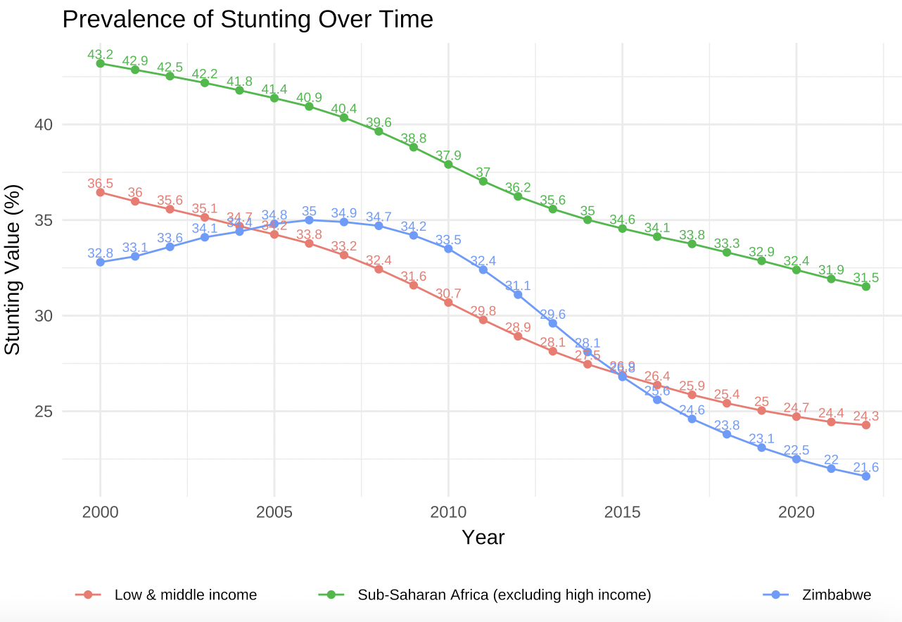

*Figure 1.*

Since 2000, the overall prevalence of stunting has declined around the developing world. As observed in Figure 1, stunting in Lower & Middle Income countries (LMICs) has declined from a two-decade high value of 43.2% in 2000 to 31.5% in 2022 in line with the Sustainable Development Goals framework under SDG 2 and SDG target 2.2: “By 2030, end all forms of malnutrition, including achieving, by 2025, the internationally agreed targets on stunting and wasting in children under 5 years of age, and address the nutritional needs of adolescent girls, pregnant and lactating women and older persons” (Alderman et.al, 2016). Zimbabwe on the other hand, has been outperforming both LMICs and SSA regions in this indicator. Up until 2006, stunting level rose to a decadal high of 35% only to fall steeply to 21.6% in 2022.

| Iso3c | Region | Year | Stunting Prevalence |
| --- | --- | --- | --- |
| LMY | Low & middle income | 2022 | 24.28000 |
| SSA | Sub-Saharan Africa (excluding high income) | 2022 | 31.52079 |
| ZWE | Zimbabwe | 2022 | 21.60000 |

*Table 1*

It is well documented that undernourishment has dire effects on the cognitive and physical abilities of children (UNICEF, WHO, World Bank 2015). Indicators for literacy and mathematical ability among children in Zimbabwe rises slightly from 0.15 levels to when they are 36 months old to 0.2 levels in 58 months which is still very low. Even though the learning index (Figure 2) hovers largely between the range of 0.75- 0.85 levels, both physical (Figure 3) and socio-emotional (Figure 4) indices fall drastically from the age of approximately 3 years till 5 years. All of this inevitably points towards the centrality for the international community to ramp up their developmental spending in Zimbabwe despite an environment of constrained resources.

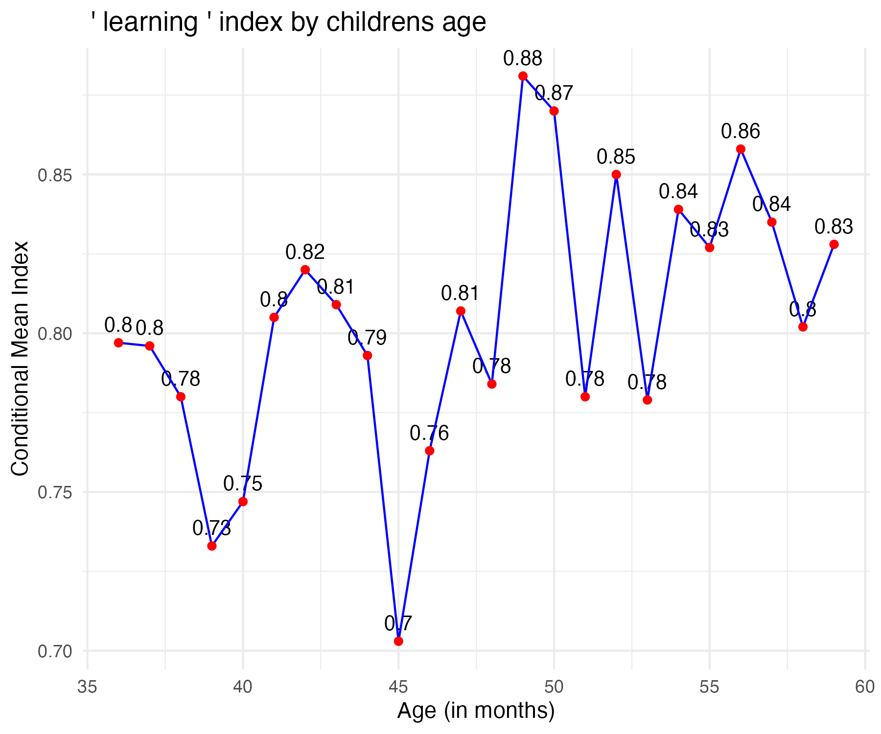

*Figure 2*

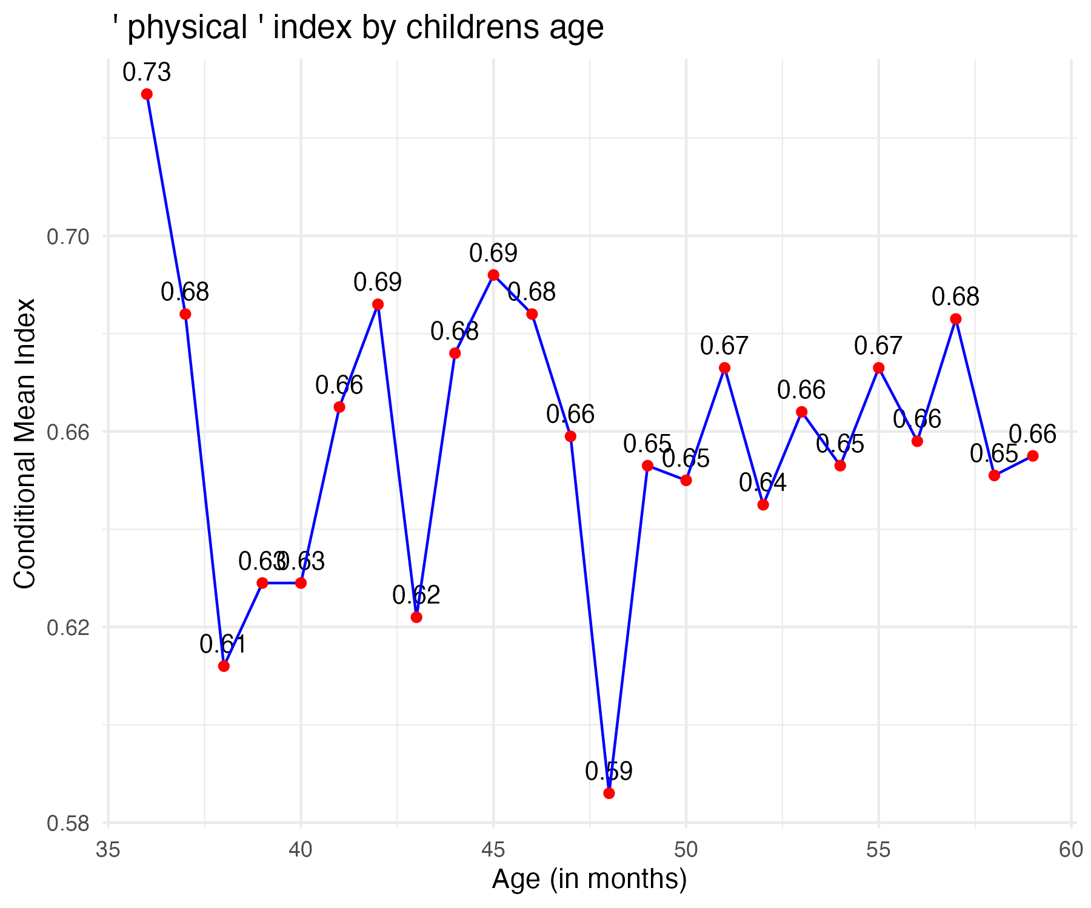

*Figure 3*

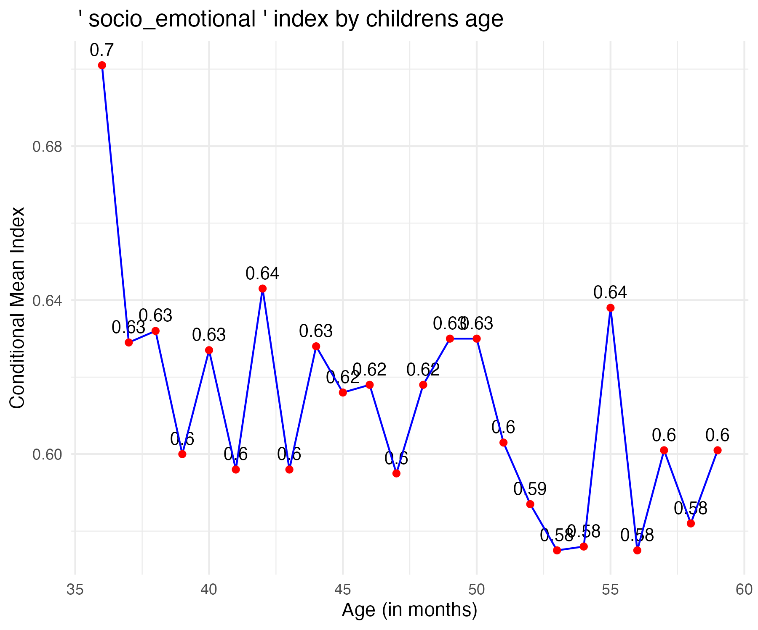

*Figure 4*

References:

Alderman , H ., J. R. Behrman , and C. Puett . 2016 . “ Big Numbers about Small Children: Estimating the Economic Benefits of Addressing Undernutrition .” World Bank Research Observer 31 ( 2 ).

UNICEF, WHO, and World Bank (United Nations Children’s Fund, World Health Organization, and World Bank). 2015. Joint Child Malnutrition Estimates. Global Database on Child Growth and Malnutrition.