Report Writting in R

Oluwafemi Oyedele

2022-03-10

# Abstract

# Introduction

Yam production in Nigeria is one of the largest agricultural produce (Pérez-Flores et al. 2017). Knowing the nutrient composition of litter is useful for planning nutrient management of plantations (Bai et al. 2022). In Cocoa (*Theobroma* cacao* L.) plantations, tree species are combined in different vertical strata (Fontes et al. 2014; Pérez-Flores et al. 2017). Cocoa litter has a poor quality Fontes et al. (2014) reported N rate in cocoa litter was low .

The objectives of this work is to identify the socio-economy characteristics of the farmers.

# Materials and Methods

Study area

The study was conducted in the ejido Miguel Hi dalgo. Climate is hot and wet abundant rain in summer.

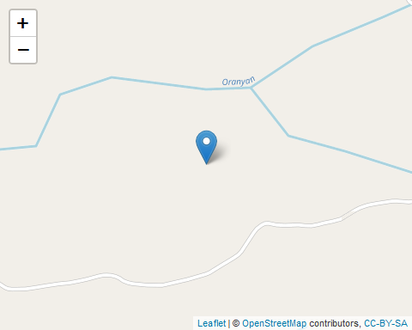

The experiment was a factorial laid out in a RCBD with three replicates.

# Statistical analysis

The data collected was analyzed using analysis of variance (ANOVA) and significantly different means were seperated using Tukey’s HSD at (P<0.05).

# Result

50% of the females staying in the community are traders, 30% are teachers while 20% are farmers.

Socio-economic characteristics of the female farmers

| Sex | Occupation | Result |
| --- | --- | --- |
| Female | Trader | 50 |
| Female | Teacher | 30 |
| Female | Farmer | 20 |

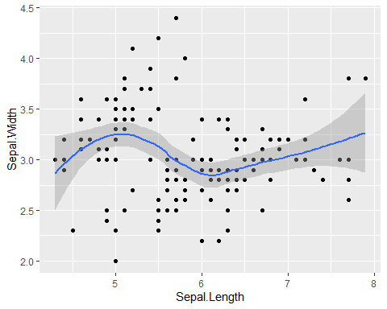

plot1

# Discussion

The traders were selling agricultural produce for the farmers. 50% of the traders were female, 30% were teachers and 20% were farmers which shows that majority of the female living in the community were traders (Table 1) (Adebayo et al. 2020).

According to plot1 the Sepal length has a strong negative relationship with Sepal Width.

# Conclusion

It is concluded that majority of the female traders focus more on agricultural produce.

# Acknowledgement

I am pleased to appreciate Prof Fatimah from University of Ibadan Nigeria for assisting me throughout the computation of this manuscript. I appreciate Dr Mr Femi for all hard work in encouraging me throughout the research.

**References**

Adebayo, SA, O Bolarin, OJ Malomo, and OF Sulaimon. 2020. “Assessment of Agricultural Extension Services Delivery to Cotton Farmers in Oyo State, Nigeria.” *PAT* 16 (1): 60–74.

Bai, Shahla Hosseini, Marta Gallart, Kanika Singh, Godfrey Hannet, Birte Komolong, David Yinil, Damien J Field, Bushra Muqaddas, and Helen M Wallace. 2022. “Leaf Litter Species Affects Decomposition Rate and Nutrient Release in a Cocoa Plantation.” *Agriculture, Ecosystems & Environment* 324: 107705.

Fontes, AG, AC Gama-Rodrigues, EF Gama-Rodrigues, MVS Sales, MG Costa, and RCR Machado. 2014. “Nutrient Stocks in Litterfall and Litter in Cocoa Agroforests in Brazil.” *Plant and Soil* 383 (1): 313–35.

Pérez-Flores, Julián, Alejandra Arias Pérez, Yesenia Primo Suárez, Vinicio Calderón Bolaina, and Asunción López Quiroga. 2017. “Leaf Litter and Its Nutrient Contribution in the Cacao Agroforestry System.” *Agroforestry Systems*, June. <https://doi.org/10.1007/s10457-017-0096-3>.