Example Competition

Final Results

*Report Generated: 2025-08-28 22:45*

# Scoring Methodology

* The final scores were calculated based on the following settings:
* Custom Weights: Enabled

# Score Visualization

The following chart displays the final scores for each submission across all categories.

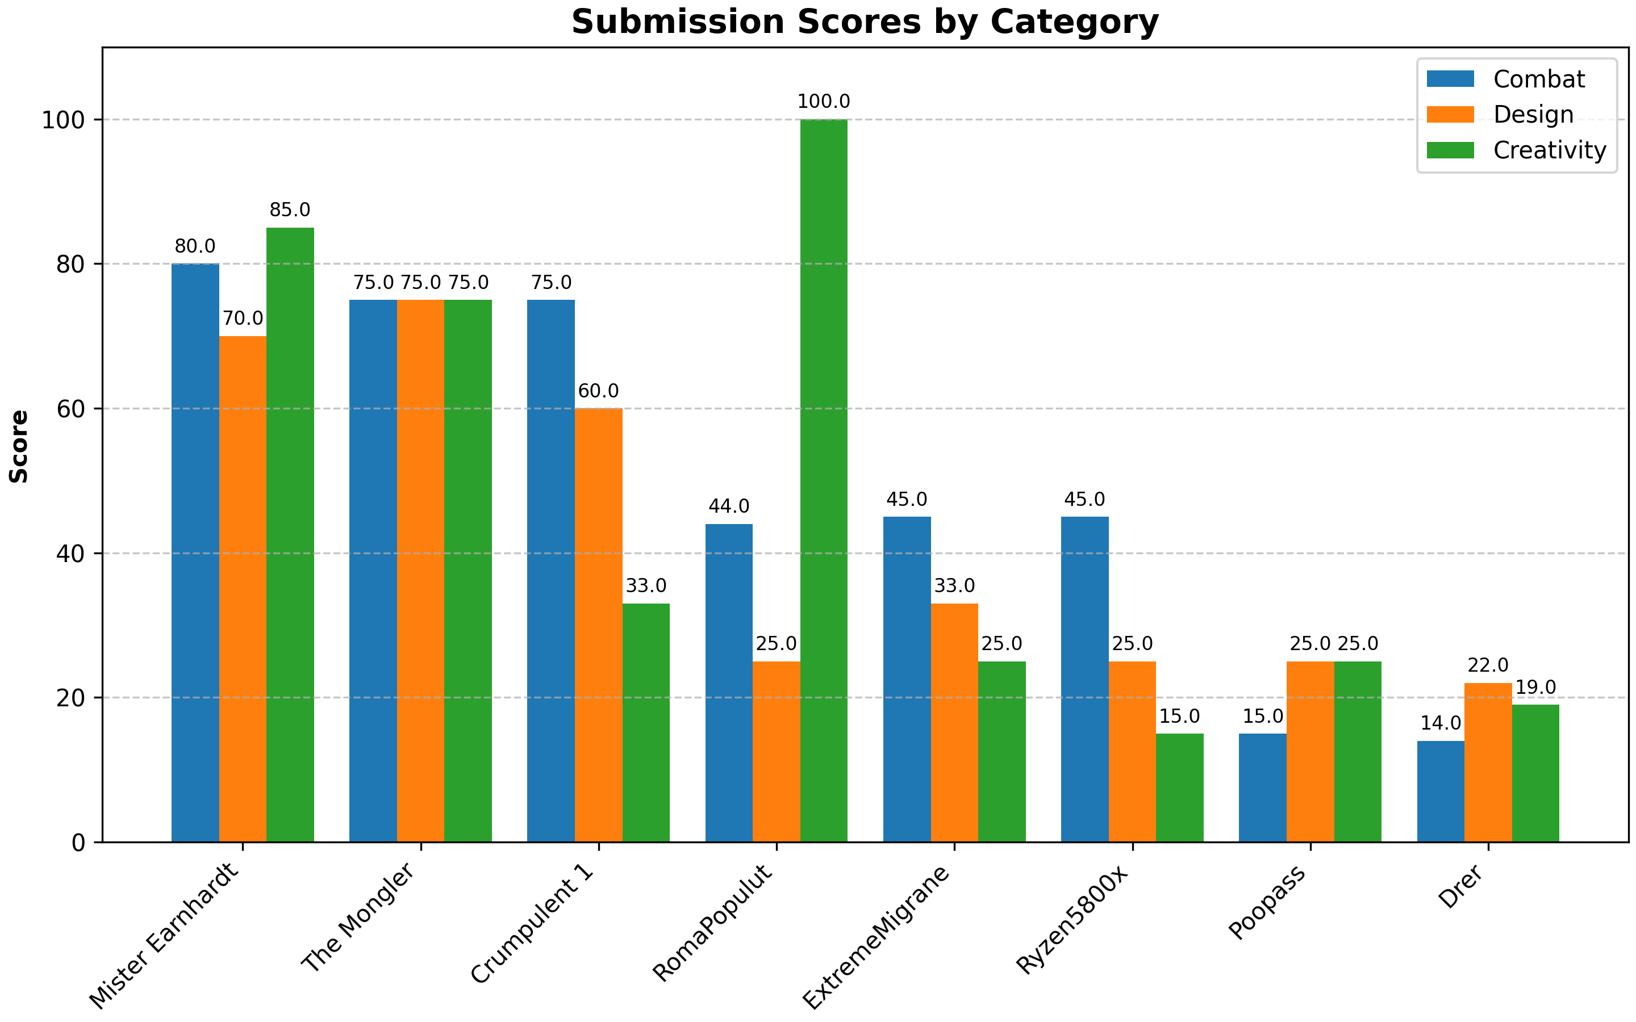

# Final Rankings

|  |  |  |  |  |  |
| --- | --- | --- | --- | --- | --- |
| **Rank** | **Submission Name** | **Final Score** | **Combat** | **Design** | **Creativity** |
| 1 | Mister Earnhardt | 79.00 | 80.0 | 70.0 | 85.0 |
| 2 | The Mongler | 75.00 | 75.0 | 75.0 | 75.0 |
| 3 | Crumpulent 1 | 63.60 | 75.0 | 60.0 | 33.0 |
| 4 | RomaPopulut | 51.40 | 44.0 | 25.0 | 100.0 |
| 5 | ExtremeMigrane | 38.60 | 45.0 | 33.0 | 25.0 |
| 6 | Ryzen5800x | 35.00 | 45.0 | 25.0 | 15.0 |
| 7 | Poopass | 19.00 | 15.0 | 25.0 | 25.0 |
| 8 | Drer | 16.60 | 14.0 | 22.0 | 19.0 |

# Category Winners (Highest Raw Score)

* **Combat:** Mister Earnhardt (80.0 pts)
* **Design:** The Mongler (75.0 pts)
* **Creativity:** RomaPopulut (100.0 pts)