CAPPP Lab - Homework 1

Blarry Wang

# Question 5

This graph shows the mean GPD per capita over the years on e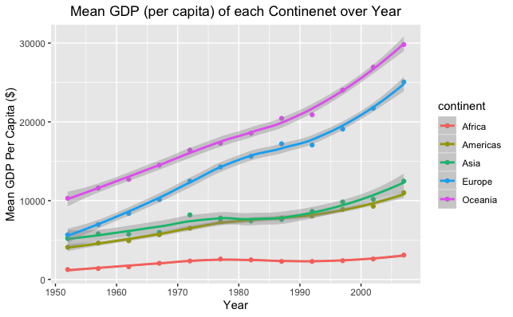ach continent. It is helpful for looking at trends over each continent and compare relative values each year.

# Question 6

This graph shows the mean GPD per capita over the years on each continent. It is helpful for looking at trends overall over year and the proportion of each continent's GDP compare to each other.

# Question 7

Both gather and spread transforms the table. Gather collects the variables that are in the columns and make them into one column. Spread distributes the values from a column into multiple columns.

# Question 8

The dataset I’m using for measuring state level party polarization is from Shor and McCarty (<https://americanlegislatures.com/data/>). It includes 1200 observations with 31 features.

The dataset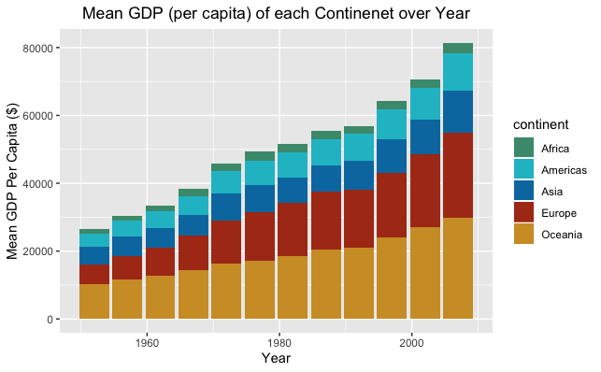 is mostly clean, except for some missing data in earlier years. However, it should not be a problem since I will be focusing on a recent year before the elections.

Two of the features in the dataset are *s_diff* and *h_hiff —* they represent the ideological “difference in party means”. The greater *_diff the greater the level of party polarization. I will first subset the data to get the year and states I want, then pick out only these *_diff features along either state identifiers. This way, I will be able to get a clean set of polarization level for each state at a given year.

# Acknowledgements

This project is in collaboration with Veronica, Kaley, Nikita, Kaisa, Batoul, Raina, and Maha.