**Part I:**

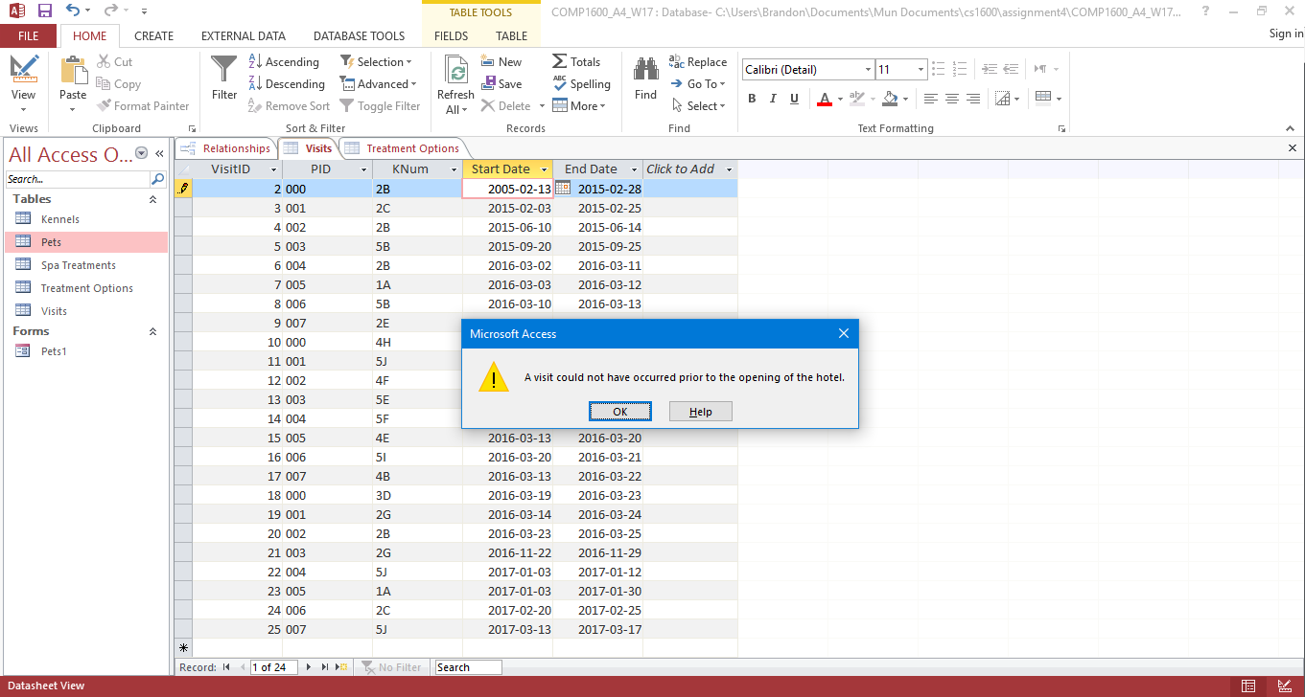2.)

a.

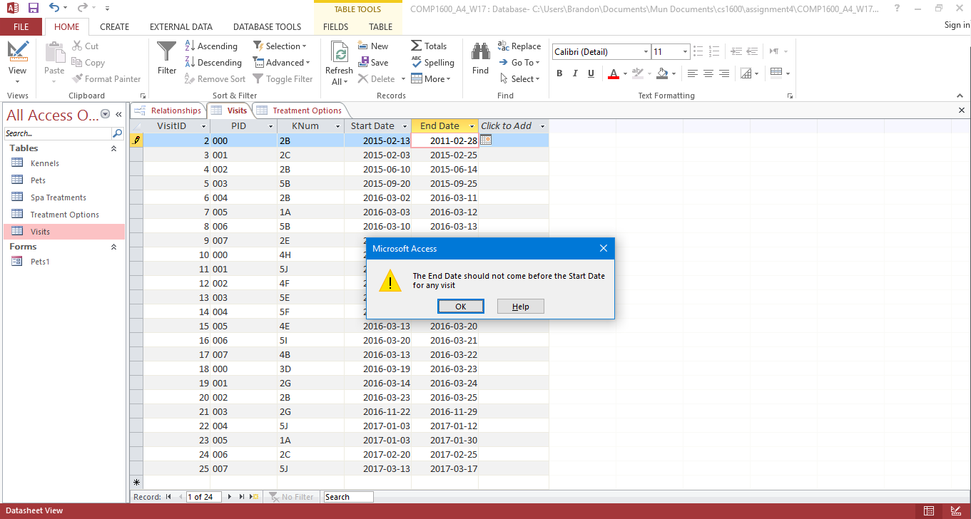b.

c.

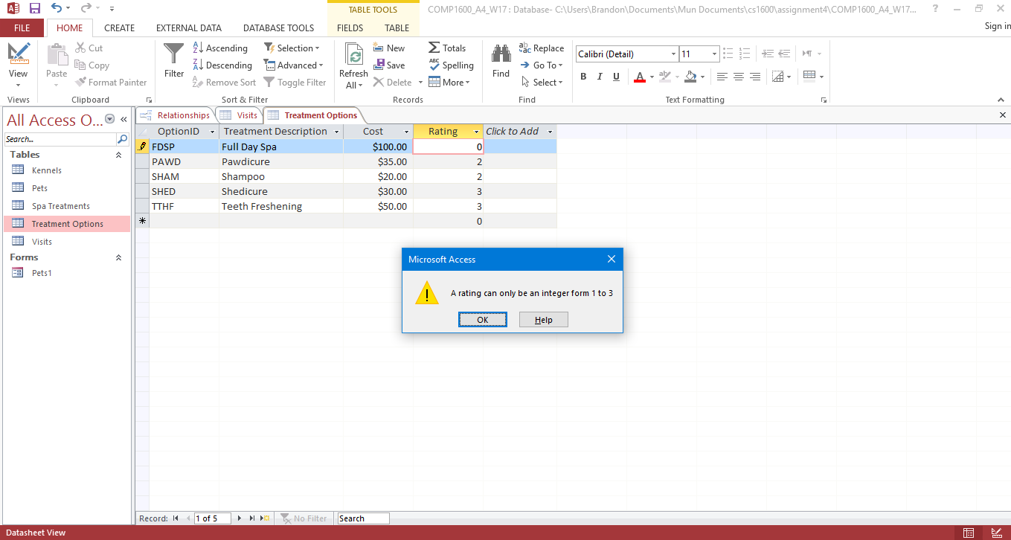

3.)

a.

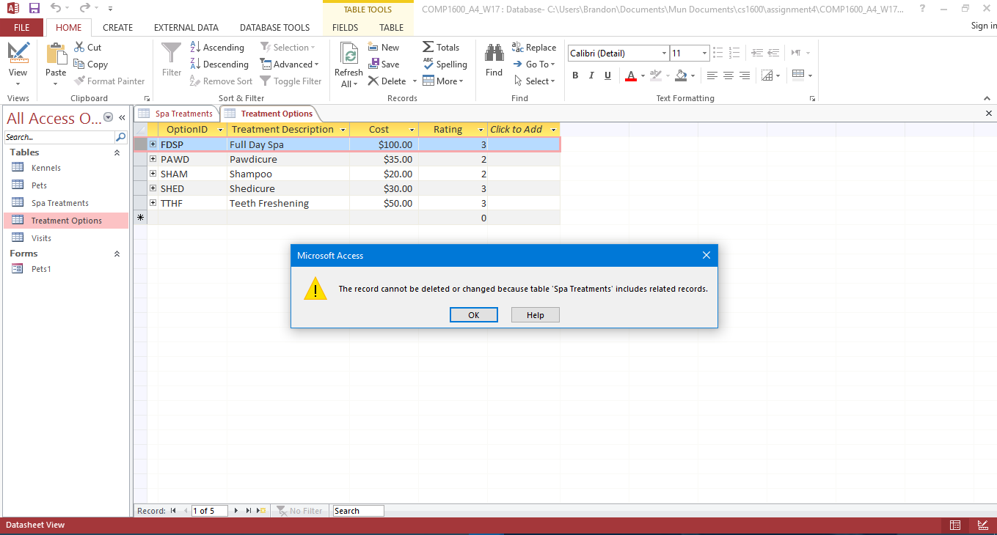

b.

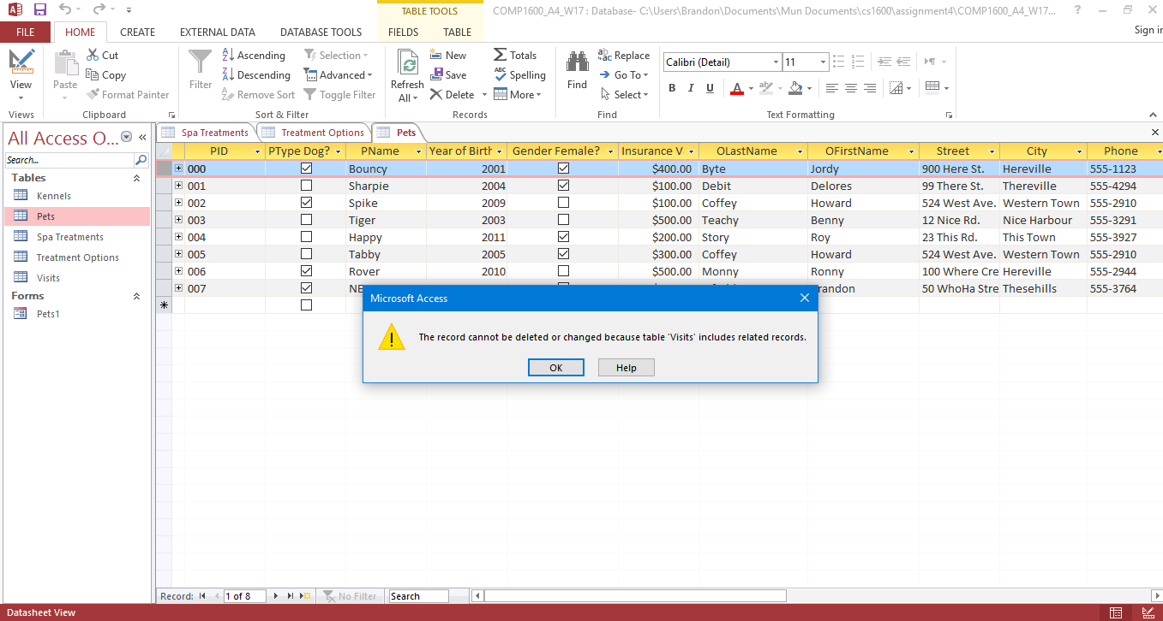

**Part II:**

**1.)**

|  |  |  |  |  |  |  |  |
| --- | --- | --- | --- | --- | --- | --- | --- |
| **Field:** | PID | PName | Gender Female? | Year of Birth | Insurance V | OLastName | OFirstName |
| **Table:** | Pets | Pets | Pets | Pets | Pets | Pets | Pets |
| **Total:** |  |  |  |  |  |  |  |
| **Sort:** | Ascending |  |  |  |  |  |  |
| **Show(Y/N):** | Y | Y | Y | Y | Y | N | N |
| **Criteria:** |  |  |  |  |  | “Monny” | “Ronny” |
| **Or:** |  |  |  |  |  |  |  |

**2.)**

|  |  |  |  |  |  |  |  |
| --- | --- | --- | --- | --- | --- | --- | --- |
| **Field:** | OLastName | PName | OFirstName | Street | City | Phone |  |
| **Table:** | Pets | Pets | Pets | Pets | Pets | Pets |  |
| **Total:** |  |  |  |  |  |  |  |
| **Sort:** |  |  | Ascending |  |  |  |  |
| **Show(Y/N):** | N | N | Y | Y | Y | Y |  |
| **Criteria:** | “Coffey” |  |  |  |  |  |  |
| **Or:** |  | “Bouncy” |  |  |  |  |  |

**3.)**

|  |  |  |  |  |  |  |  |
| --- | --- | --- | --- | --- | --- | --- | --- |
| **Field:** | KNum | KSize | PName | Number of Days: [Visits]![End Date]-[Visits]![Start Date] |  |  |  |
| **Table:** | Visits | Kennels | Pets |  |  |  |  |
| **Total:** |  |  |  |  |  |  |  |
| **Sort:** |  |  |  |  |  |  |  |
| **Show(Y/N):** | Y | Y | N | Y |  |  |  |
| **Criteria:** |  |  | “Sharpie” |  |  |  |  |
| **Or:** |  |  |  |  |  |  |  |

|  |  |  |  |
| --- | --- | --- | --- |
| **From Table** | **From Field** | **To Table** | **To Field** |
| Kennels | KNum | Visits | KNum |
| Pets | PID | Visits | PID |
|  |  |  |  |
|  |  |  |  |
|  |  |  |  |
|  |  |  |  |

**4.)**

|  |  |  |  |  |  |  |  |
| --- | --- | --- | --- | --- | --- | --- | --- |
| **Field:** | KNum | PName | PType | Insurance V | Start Date | End Date |  |
| **Table:** | Visits | Pets | Pets | Pets | Visits | Visits |  |
| **Total:** |  |  |  |  |  |  |  |
| **Sort:** |  |  |  |  |  |  |  |
| **Show(Y/N):** | Y | Y | Y | Y | N | N |  |
| **Criteria:** |  |  |  |  | <=14/2/2015 | >=14/2/2015 |  |
| **Or:** |  |  |  |  |  |  |  |

|  |  |  |  |
| --- | --- | --- | --- |
| **From Table** | **From Field** | **To Table** | **To Field** |
| Pets | PID | Visits | PID |
|  |  |  |  |
|  |  |  |  |
|  |  |  |  |
|  |  |  |  |
|  |  |  |  |

**5.)**

|  |  |  |  |  |  |  |  |
| --- | --- | --- | --- | --- | --- | --- | --- |
| **Field:** | PName | OLastName | OFirstName | KSize | Amount Owed: ([Visits]![End Date]-[Visits]![Start Date])*25 | End Date |  |
| **Table:** | Pets | Pets | Pets | Kennels |  | Visits |  |
| **Total:** |  |  |  |  |  |  |  |
| **Sort:** | Ascending | Ascending | Ascending |  |  |  |  |
| **Show(Y/N):** | Y | Y | Y | Y | Y | B |  |
| **Criteria:** |  |  |  |  |  | **=**Date() |  |
| **Or:** |  |  |  |  |  |  |  |

|  |  |  |  |
| --- | --- | --- | --- |
| **From Table** | **From Field** | **To Table** | **To Field** |
| Pets | PID | Visits | PID |
| Kennels | KNum | Visits | KNum |
|  |  |  |  |
|  |  |  |  |
|  |  |  |  |
|  |  |  |  |

**6.)**

|  |  |  |  |  |  |
| --- | --- | --- | --- | --- | --- |
| **Field:** | KSize | KNum | Start Date | End Date |  |
| **Table:** | Kennels | Visits | Visits | Visits |  |
| **Total:** | Group by | Count |  |  |  |
| **Sort:** |  |  |  |  |  |
| **Show(Y/N):** | Y | Y | N | N |  |
| **Criteria:** |  |  | <= Date() | >=Date() |  |
| **Or:** |  |  |  |  |  |

|  |  |  |  |
| --- | --- | --- | --- |
| **From Table** | **From Field** | **To Table** | **To Field** |
| Kennels | KNum | Visits | KNum |
|  |  |  |  |
|  |  |  |  |
|  |  |  |  |
|  |  |  |  |
|  |  |  |  |

**7.)**

|  |  |  |  |  |  |
| --- | --- | --- | --- | --- | --- |
| **Field:** | KSize | Total:[Visits]![End Date]-[Visits]![Start Date] | Average:[Visits]![End Date]-[Visits]![Start Date] | Maximum:[Visits]![End Date]-[Visits]![Start Date] | Minimum:[Visits]![End Date]-[Visits]![Start Date] |
| **Table:** | Kennels | Visits | Visits | Visits | Visits |
| **Total:** | Group by | Sum | Avg | Max | Min |
| **Sort:** |  |  |  |  |  |
| **Show(Y/N):** | Y | Y | Y | Y | Y |
| **Criteria:** |  |  |  |  |  |
| **Or:** |  |  |  |  |  |

|  |  |  |  |
| --- | --- | --- | --- |
| **From Table** | **From Field** | **To Table** | **To Field** |
| Kennels | KNum | Visits | KNum |
|  |  |  |  |
|  |  |  |  |
|  |  |  |  |
|  |  |  |  |
|  |  |  |  |

**8.)**

|  |  |  |  |  |
| --- | --- | --- | --- | --- |
| **Field:** | Cost |  |  |  |
| **Table:** | Treatment Options |  |  |  |
| **Update To:** | [Cost]*1.05 |  |  |  |
| **Show(Y/N):** | Y |  |  |  |
| **Criteria:** |  |  |  |  |
| **Or:** |  |  |  |  |