Screenshot after server launched.

The first client has successfully connected and uploaded file:

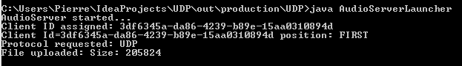

Screenshot after client launched.

The client has successfully connected and uploaded file:

