Monitors

xrandr - displays monitors + details
xrandr –listmonitors

If DP-1, DP-2 disconnected, ensure that Secure Boot is Turned Off in the Bios (Press F2 for EFI, F12 for Grub)

uname -d - check the kernal is up todate

sudo displaylink-installer uninstall - u may need to uninstall the driver.

lsusb -d 17e9: check if the USB recognizes the display link as shown below.... -->

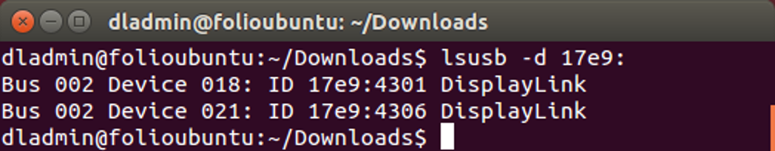

The problem may be connected to nvidia conflicts:

sudo apt-get purge ‘nvidia*’
sudo add-apt-repository ppa:graphics-drivers
sudo apt-get update
sudo ubuntu-drivers autoinstall

The problem may be connected to xserver conflicts:

sudo apt-get purge xserver-xorg-video-intel

Wifi

Check Crash Logs

dmesg – kernel log...run at crash time to see what is causing the wifi crash.
https://askubuntu.com/questions/1063679/ath10k-and-qca6174-causing-pcie-errors-firmware-crashes-and-connection-drops

journalctl -e /usr/sbin/NetworkManager

Check If Driver Installed

sudo lsusb – check that that the kernal can see the internal wifi-dongle driver is on the usb bus
sudo lspci – check that the kernel can see the wifi chip on the bus
lshw -C network – check that UBUNTU can see the wifi driver

Check Correct Driver Version - ath10k/QCA6174

sudo nautilus – for acceess to private file space

cd lib/firmware/ath10k/QCA6174/hw3.0 - local driver stored here

Check current driver version determined by the end numbers of the file (00151-QCARMSWPZ-2) notice.txt_WLAN.RM.4.4.1-00151-QCARMSWPZ-2 compare with latest version on: https://github.com/kvalo/ath10k-firmware/tree/master/QCA6174/hw3.0

Reinstall Driver

Try Automatic update through ubuntu repository:
sudo apt update
sudo apt install --reinstall linux-firmware

Try Manual Update Method:
https://www.dell.com/support/article/en-us/sln306440/killer-n1535-wireless-firmware-manual-update-guide-for-ubuntu-systems?lang=en

https://askubuntu.com/questions/1063679/ath10k-and-qca6174-causing-pcie-errors-firmware-crashes-and-connection-drops

Check, Find & Start Wifi Connection

nmcli - lists all network and wifi interfaces/devices and drivers in detail
nmcli d - lists network and wifi interfaces in brief detail

nmcli r - WWAN is cellular connection. -HW is the hardeare comomponet
WIFI-HW WIFI WWAN-HW WWAN
enabled enabled enabled enabled
nmcli r wifi off – Switch off wifi if wifi device shows disconnected following nmcli d
nmcli r wifi on – Switch on wifi.

nmcli d wifi list – Lists wifi with speed and signal strength

nmcli d wifi connect <wifi name> password <wifi password> - connect a secure pasword

nmcli device show – shows the fine detail of the wifi connection

sudo service network-manager restart - Re-Connects the Wifi

sudo iw reg set SG – Set wifi domain to Singapore
sudo iw reg get – Check wifi domain is set to Singapore

REGDOMAIN=AU" into /etc/default/crda and also "COUNTRY=AU" into the relevant /etc/wpa_supplicant/*.conf and some way or another it worked

