MSc Computer Science
Programming in Java

Pedro Ferreira
[pferre08] <pbf@frameweb.net>

13 Nov 2016

Coursework 1

Code
class Travelcard {
String type;
int zone;
}

class OysterCard {
boolean autotopup;
boolean registered;
double amount;
Travelcard travelcardAttached;
}

boolean yellowReader(OysterCard card, int zone) {
double fare = getFare(zone);
double cost = 0.0;
if(card.travelcardAttached != null) {
if(card.travelcardAttached.zone >= zone) {
return true;
}
}
if (card.amount > fare) {
card.amount -= fare;
return true;
}
return false;
}

double getFare(int zone) {
double fare=0.0;
if (zone <= 2) {
fare = 2.3;
} else if (zone <= 4) {
fare = 4.6;
} else {
fare = 6.2;
}
return fare
}

OysterCard card1 = new OysterCard();
card1.autotopup = true;
card1.registered = false;
card1.amount = 50.0;
card1.travelcardAttached = null;
Travelcard tcard = new Travelcard();
tcard.type = "week";
tcard.zone = 2;
OysterCard card2 = new OysterCard();
card2.autotopup = false;
card2.registered = true;
card2.amount = 6.3;
card2.travelcardAttached = tcard;
// Point 1

println(yellowReader(card1, 2) ? "pass" : "problem with card");
println(yellowReader(card1, 6) ? "pass" : "problem with card");
println(yellowReader(card2, 4) ? "pass" : "problem with card");
println(yellowReader(card2, 5) ? "pass" : "problem with card");
// Point 2

Point 1
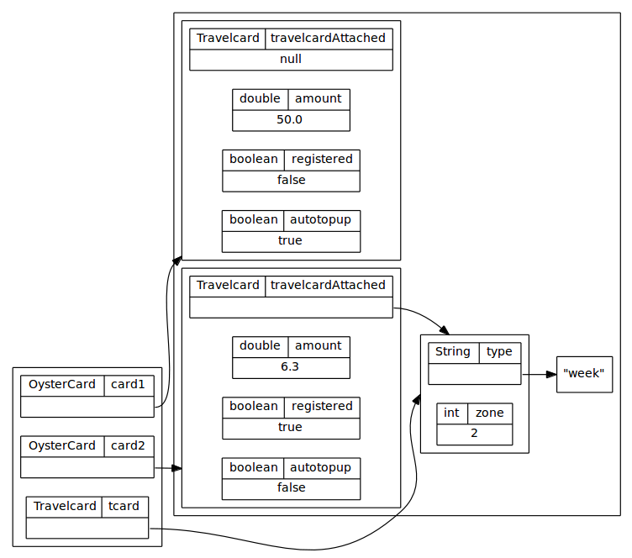

Point 2
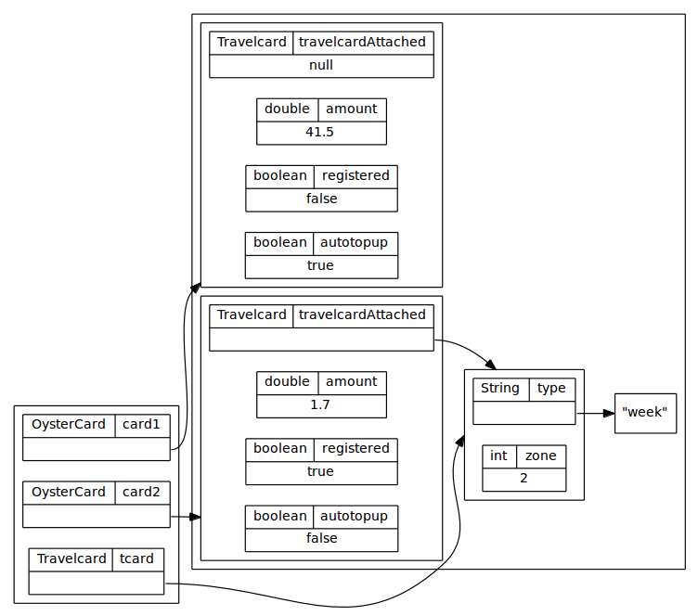

Notes
- Diagrams drawn with Graphviz dot language [http://www.graphviz.org]
- Coursework sources available at https://github.com/BBK-PiJ-2016-66/exercises/tree/master/cw1

