<https://code-maze.com/asp-net-core-web-api-with-ef-core-db-first-approach/>

<http://localhost:51868>

<http://localhost:51868>/WeatherForecast

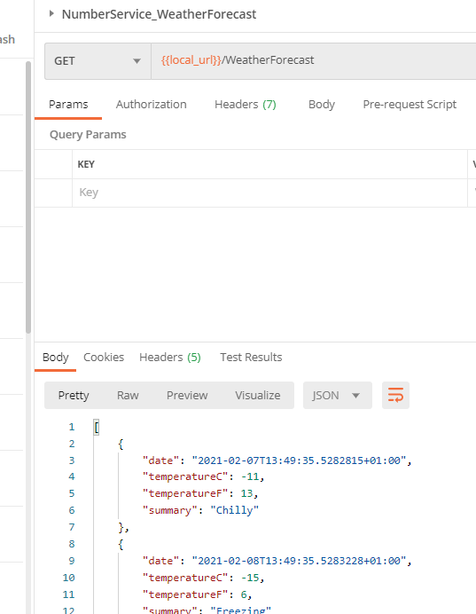

Install-Package Microsoft.EntityFrameworkCore.Tools

Install-Package Microsoft.EntityFrameworkCore.SqlServer

Scaffold-DbContext "Server=MES-NB012;Database=Numberservice;Trusted_Connection=True;" Microsoft.EntityFrameworkCore.SqlServer -OutputDir Models

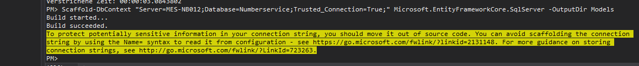

To protect potentially sensitive information in your connection string, you should move it out of source code. You can avoid scaffolding the connection string by using the Name= syntax to read it from configuration - see https://go.microsoft.com/fwlink/?linkid=2131148. For more guidance on storing connection strings, see http://go.microsoft.com/fwlink/?LinkId=723263.

C:\Users\b.korn\Desktop\My\Nummernservice\NumberServiceSpike\NumberService\API\Startup.cs

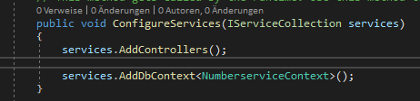

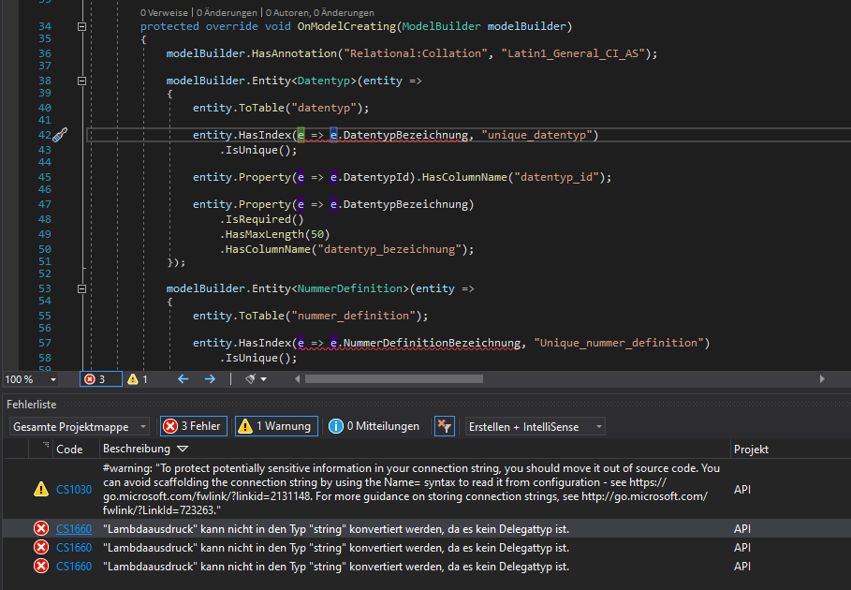

Auskommentiert(HasIndex wird nicht benötigt)

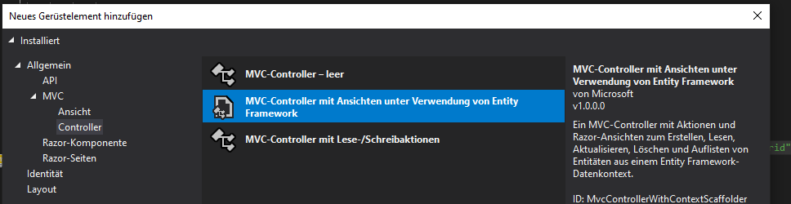

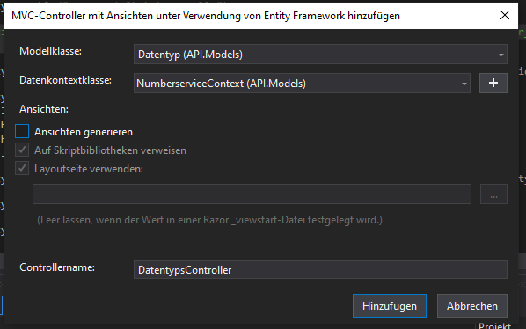

[Route("api/[controller]")]

[ApiController]

<https://www.codeproject.com/Articles/1166099/Entity-Framework-Storing-complex-properties-as-JSON>

<https://www.learnentityframeworkcore.com/raw-sql>

System.Text.Json.JsonException: A possible object cycle was detected which is not supported. This can either be due to a cycle or if the object depth is larger than the maximum allowed depth of 32.

https://stackoverflow.com/questions/59199593/net-core-3-0-possible-object-cycle-was-detected-which-is-not-supported

?

114

**.NET Core 3.1** Install the package Microsoft.AspNetCore.Mvc.NewtonsoftJson

**Startup.cs** Add service

services.AddControllers().AddNewtonsoftJson(options =>

options.SerializerSettings.ReferenceLoopHandling = Newtonsoft.Json.ReferenceLoopHandling.Ignore

);