<https://www.entityframeworktutorial.net/efcore/create-model-for-existing-database-in-ef-core.aspx>





Scaffold-DbContext "Server=.\SQLExpress;Database=Numberservice;Trusted_Connection=True;" Microsoft.EntityFrameworkCore.SqlServer -OutputDir Models

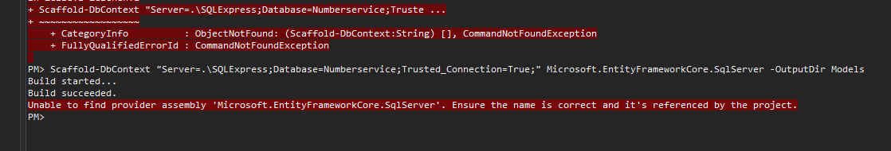

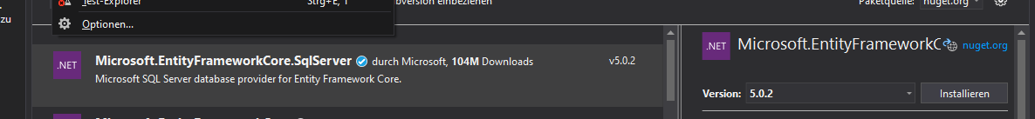



Build succeeded.

To protect potentially sensitive information in your connection string, you should move it out of source code. You can avoid scaffolding the connection string by using the Name= syntax to read it from configuration - see https://go.microsoft.com/fwlink/?linkid=2131148. For more guidance on storing connection strings, see http://go.microsoft.com/fwlink/?LinkId=723263.



A network-related or instance-specific error occurred while establishing a connection to SQL Server. The server was not found or was not accessible. Verify that the instance name is correct and that SQL Server is configured to allow remote connections. (provider: SNI_PN11, error: 26 - Error Locating Server/Instance Specified)

Scaffold-DbContext "Server=MES-NB012;Database=Numberservice;Trusted_Connection=True;" Microsoft.EntityFrameworkCore.SqlServer -OutputDir Models

