<https://docs.microsoft.com/de-de/aspnet/core/tutorials/first-web-api?view=aspnetcore-3.1&tabs=visual-studio>

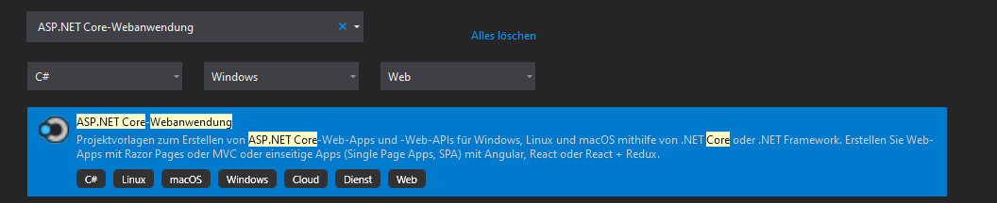

SemVerTest1

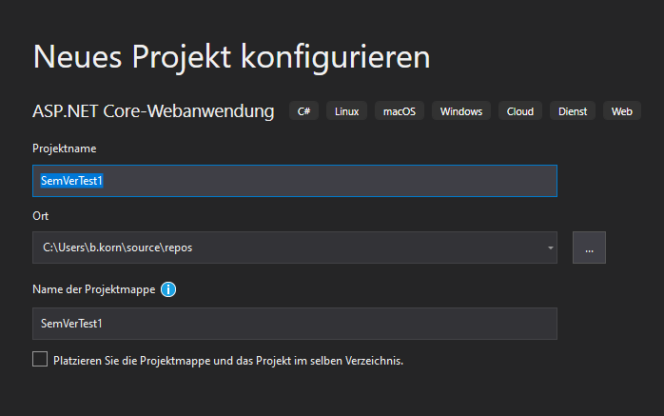

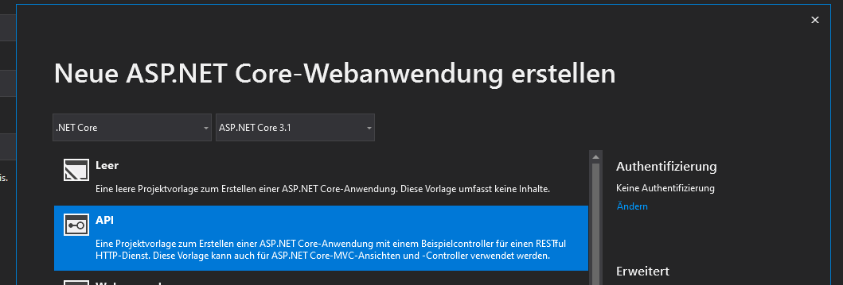

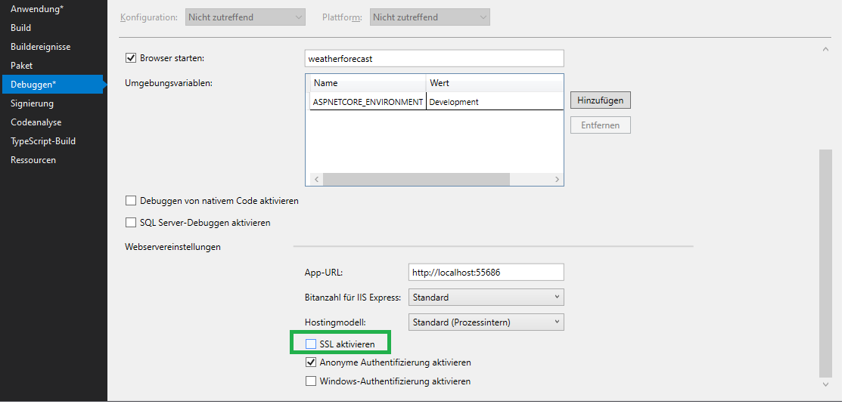

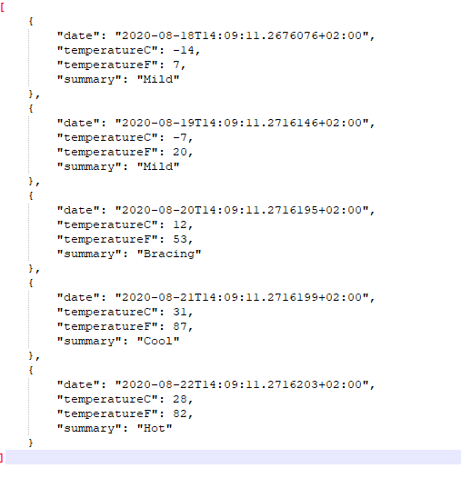

C:\Users\b.korn\source\repos\SemVerTest1\SemVerTest1\Startup.cs

public void ConfigureServices(IServiceCollection services)

{

    services.AddDbContext<TodoContext>(opt =>

      opt.UseInMemoryDatabase("TodoList"));

    services.AddControllers();

}

Install-Package Microsoft.EntityFrameworkCore.InMemory

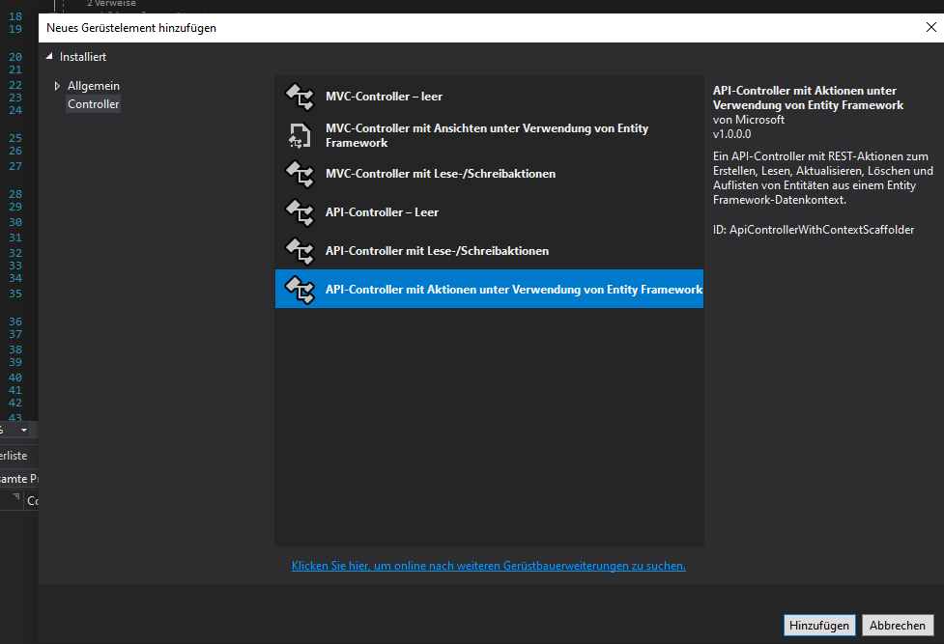

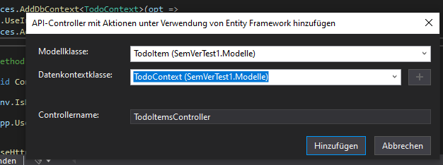

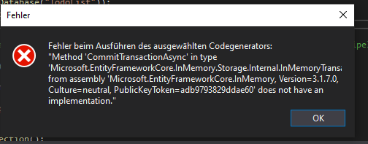

Auf 5.0.0.0 aktualisiert.

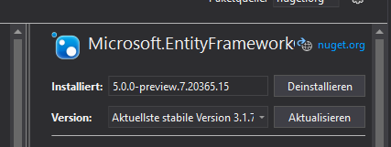

Erneute Controllererstellung.

http://localhost: 56076 / TodoItems/

<https://stackoverflow.com/questions/43024054/web-api-error-on-localhost>

C:\Users\b.korn\source\repos\SemVerTest1\SemVerTest1\Properties\launchSettings.json

"IIS Express": {

  "commandName": "IISExpress",

  "launchBrowser": false,

  "environmentVariables": {

    "ASPNETCORE_ENVIRONMENT": "Development"

  }

},