<https://jasonwatmore.com/post/2018/07/14/vue-vuex-user-registration-and-login-tutorial-example>

vue init pwa myproject

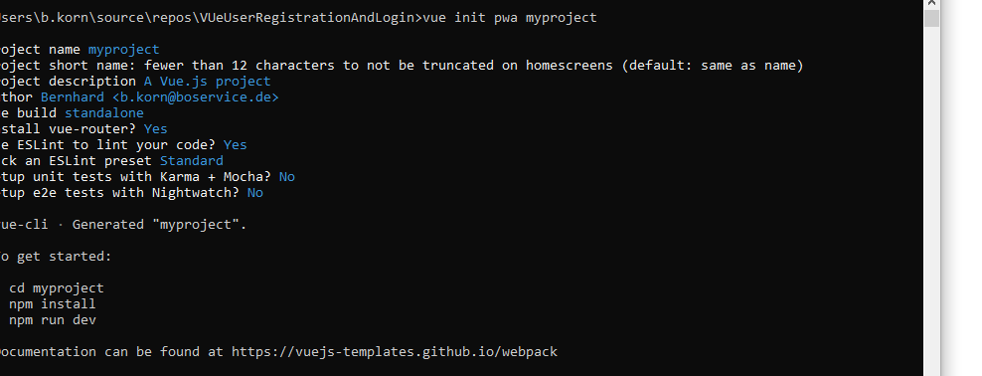

cd myproject

npm install

npm run dev

