<https://blog.sqreen.com/authentication-best-practices-vue/>

vue init pwa myproject

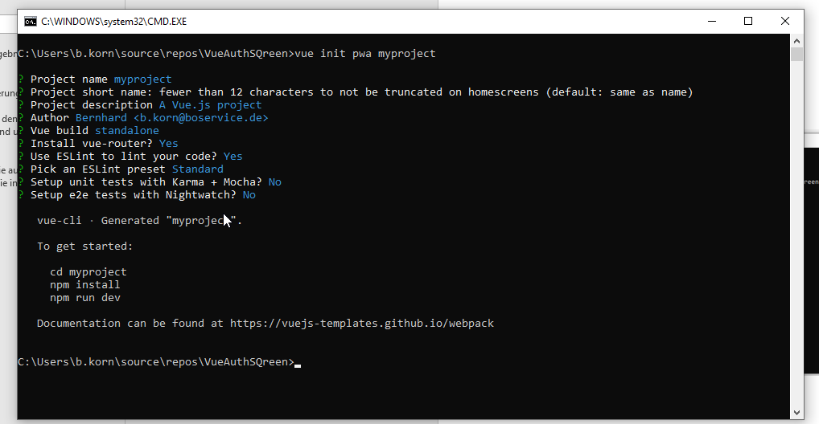

cd myproject

npm install

npm run dev

