<https://auth0.com/blog/beginner-vuejs-tutorial-with-user-login/>

C:\Users\b.korn\source\repos\VueAuthTest1

npx @vue/cli create events-app

Note: npx allows you to use the Vue CLI without installing it globally. It's [available](https://blog.npmjs.org/post/162869356040/introducing-npx-an-npm-package-runner" \t "_blank) in versions of npm >= 5.2.0.

Konfiguration saiehe Anleitung oben.

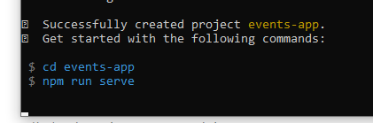

<http://localhost:8080/>

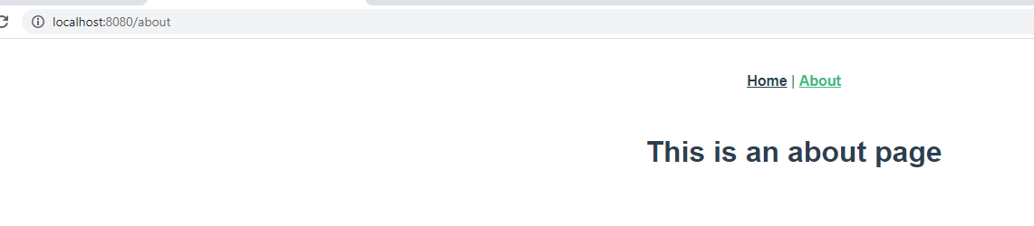

BulmaCSS-Framework

<https://bulma.io/>

npm install bulma

nächster Schritt:

**Adding Data to your Vue App**

Fertig

Nächster Schritt:

## Adding Authentication to your Vue App

Auth0 Account eingerichtet.

npm install @auth0/auth0-spa-js

mkdir src/auth

**Teil2:**

<https://auth0.com/blog/how-to-make-secure-http-requests-with-vue-and-express/>