<https://www.youtube.com/watch?v=yNrqlxn0nc0>

3:27/9:22/ fertig

<https://developer.school/how-to-use-vue-js-json-server-and-axios/>

C:\Users\b.korn\source\repos\VueRestAxiosTest

Vue create hello-axios

Default configuration

Cd hello-axios

Code .

Npm run serve

<http://localhost:8080/>

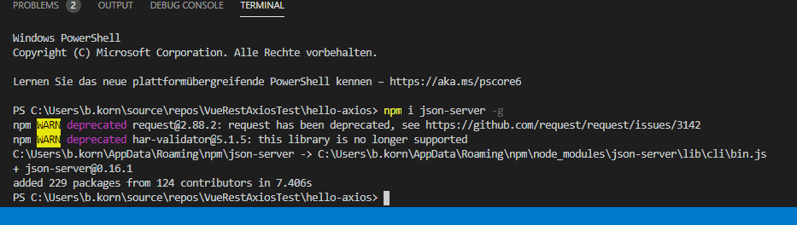

Json-server db.json

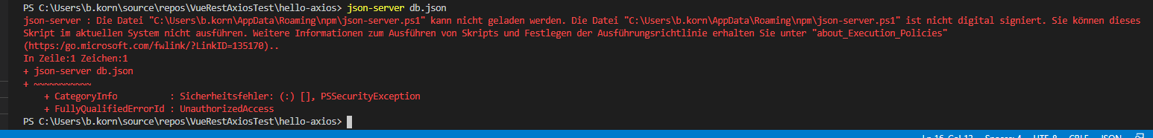

<https://github.com/microsoft/TypeScript/issues/35606>

Ausweichen auf eigene Web-API

ToDoWebAPI:

Url.

http://localhost:57230

Löschen(Delete)

DELETE http://localhost:57230/api/TodoItems/1

Alle(Read)

GET http://localhost:57230 /api/TodoItems

Aktualisieren(Update)

PUT http://localhost:57230/api/TodoItems/1

Ein Eintrag(Read)

GET http://localhost:57230/api/TodoItems/1

<http://localhost:57230>

Neuer Eintrag(Create)

POST http://localhost:57230/api/TodoItems

TOItem:

{

        "id": 1,

        "name": "walk dog",

        "isComplete": true

    }

Weiter:

Axios installieren

npm i axios

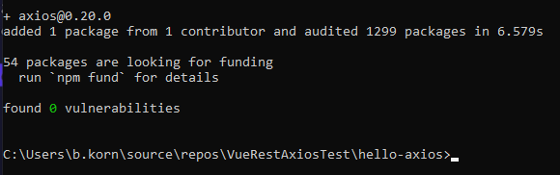

const baseUrl = "http://localhost:57230/api/TodoItems";

localhost/:1 Access to XMLHttpRequest at 'http://localhost:57230/api/TodoItems' from origin 'http://localhost:8080' has been blocked by CORS policy: No 'Access-Control-Allow-Origin' header is present on the requested resource.

:57230/api/TodoItems:1 Failed to load resource: net::ERR_FAILED

Access to XMLHttpRequest at 'http://localhost:57230/api/TodoItems' from origin 'http://localhost:8080' has been blocked by CORS policy: No 'Access-Control-Allow-Origin' header is present on the requested resource.

**Aktivieren von Cross-Origin-Anforderungen (cors) in ASP.net Core**

<https://docs.microsoft.com/de-de/aspnet/core/security/cors?view=aspnetcore-3.1>