**BBM 384 – SOFTWARE ENGINEERING**

**LABORATORY**

**SOCIAL INTEREST E-CLUB**

**SOFTWARE DESIGN DESCRIPTION**

|  |  |
| --- | --- |
| **COPY-PASTERS** |  |
| **HAZAL UZAR** | **21727834** |
| **HACI KERİM ARSLAN** | **21726928** |
| **İBRAHİM KOZ** | **21786303** |
| **BAŞAK ŞÜKRAN MELAHAT ÇONTU** | **21827282** |
| **FATMA NUR DEMİRBAŞ** | **21727116** |

Social Interest e-Club

Software Design Description

# Revision History

|  |  |  |  |
| --- | --- | --- | --- |
| ***Version*** | ***Date*** | ***Author*** | ***Change Description*** |
| 0.1 | 14.05.2021 | Başak Şükran Melahat Çontu | User Interface Design added. |
| 0.2 | 15.05.2021 | Hazal Uzar | Purpose and Scope, Document Overview and some of the Abbreviations are added. User Interface Design is extended. |
| 0.3 | 15.05.2021 | Fatma Nur Demirbaş | Design Constraints and Decisions added. |
| 0.4 | 16.05.2021 | Hacı Kerim Arslan | Sequence and State Diagrams added. |
| 0.5 | 16.05.2021 | İbrahim Koz | Traceability Matrix added. |
| 0.6 | 16.05.2021 | Hacı Kerim Arslan  İbrahim Koz | Class Diagram and ER Diagram added. Design Constraints and Decisions are extended. System overview added. |
| 1.0 | 16.05.2021 | All members | The document is revised and added to GitHub repository. |

# INTRODUCTION

## Purpose and Scope

The aim of this document is explaining the design of the Social Interest e-Club. This explanation includes several diagrams about the system, details of some use cases, software and user interface designs. Also, the design constraints and decisions will be explained.

## Document Overview

The document consists of six different parts:

**1. Revision History:** Shows the changes that are made to this document and gives details, who made the change and when s/he did it.

**2. Introduction:** This part is divided into five subsections:

2.1 Purpose and Scope: Explains the purpose and content of the document.

2.2 Document Overview: Explains the sections of the document.

2.3 System Overview: Describes the complete system.

2.4 Definitions, Acronyms, and Abbreviations: Includes non-standard terms, acronyms and abbreviations that are unique to this document.

2.5 References: Provide references for any pertinent document.

**3. Design Constraints and Decisions:** Explains the constraints and decisions that we applied to the application.

**4. Design Details:** This section is divided into four subsections:

4.1 Software Components: Includes the class diagram.

4.2 Software Behavior: Includes the sequence diagrams (will be given in the annex document) and the state diagram.

4.3 Data Model (E-R Diagram)

4.4 User Interface Design: Explains the user interface design and the usage of the web pages.

**5. Requirements Traceability:** Describes the traceability relationship between the requirements and the software design.

**6. Annexes**

## System Overview

This system is an Online E-Club system where people who share same interests can communicate with each other. There are mainly 3 types of users in the system: System Admin, Sub-Club Admin and Member. Unregistered users can also browse the system, but no interaction will be allowed unless they register to the system. There are Clubs and Sub-Clubs Clubs. Each Club can have more than one Sub-Club. However, each Sub-Club is required to be under a Club. Members of the system can join those Sub-Clubs and interact with other members of the Sub-Club.

This system is mainly developed as two parts: Frontend and Backend. In the backend part, MVC architecture is preferred. Microsoft’s Entity framework is employed for database operations and processes.

## Definitions, Acronyms, and Abbreviations

|  |  |
| --- | --- |
| ***Term/Acronym*** | ***Definition*** |
| MVC | Model-View-Controller |
| GUI | Graphical User Interface |
| ER | Entity-Relationship |
| SDD | Software Design Description |

## References

There is no reference.

# Design Constraints and Decisions

* The GUI is designed with Figma and built with HTML, CSS, JS and Vue.js. Sass is used while coding the design of the GUI.
* To make the connection between front-end and the database, Axios.js is used.
* The system provides functionality and a user-friendly GUI.
* Axios and Vuex is used to maintain the data flow.
* GitHub is used to store files, documents, codes and to track the versions.
* Actors (members, non-registered users, admins) need available internet connection to use the application.
* System must be working 24/7.
* To join the sub-clubs, the users must register to the system and be logged in.
* The admins control all the members, clubs and requests. The sub-club admins control their own sub-club and the bad behavior reports.
* MVC architectural design will be used to develop the system.
* There are different 5 components. These are models, controllers, view, services and repositories.
* Backend is developed with C# and ASP.NET Core.
* Error handling will be done to avoid the crashes and vulnerabilities.
* At first, we preferred Visual Paradigm and draw.io to create diagrams of the system. Later, we found PlantUML to be easier and clearer because it allowed us to create diagrams from the components of the system.
* For the backend development, we have preferred Rider from JetBrains. We preferred this IDE over Visual Studio because it was easier to use, and it had more plugin supports.

# Design Details

Note for all Diagrams: Club and Sub-Club words are used interchangeably. Sub-Club always means Sub-Club, Club sometimes refers to Sub-Club which can be inferred from the context. This is preferred to increase readability of the diagrams. Also, in the system Club is used in some specific places where Club and Sub-Club distinction is clear. So, this will not lead any conflicts or misunderstandings.

## Software Components

Class Diagram:

Class Diagram is attached to this document. Please see section 6.

## Software Behavior

Sequence Diagrams:

* Apply Questionnaire
* Apply to Be Admin
* Ban Member
* Join New Club
* Post to TimeLine
* Send Private Message
* Report Member
* Request New Club/Sub-Club
* Review and Rate Sub-Club
* Send Message to Sub-Club

Sequence Diagrams are attached to this document. Please see section 6.

State Diagrams:

* Club State Diagram
* Member State Diagram
* State Chart Diagram [extra]

P.S. About the State Chart Diagram: This diagram is designed to represent the states of all the system (more abstract). Though it is not requested, we found it to be useful. So, that is also added to this document.

State Diagrams are attached to this document. Please see section 6.

## Data Model (E-R Diagram)

ER Diagram is attached to this document. Please see section 6.

## User Interface Design

First, the user will see the homepage of the website. He/she can select to login or sign up with buttons on the right corner. If the user doesn’t have an account, the user will register to the system and after signing up the user will encounter the ‘Questionnaire/Selecting Club’ page. This page includes categories for the sub-clubs and when the user chooses a category, its sub-clubs are listed below. Selected sub-clubs will be shown at the bottom of the page as pictures while the user selects them. If the user wants to cancel any selection, the user can click on the picture of the sub-club and cancel the selection easily.

After selecting the sub-clubs, the ‘Questionnaire Page’ will come out, it contains selected sub-clubs’ questions. When the user answered these questions, user will see his/her result and he/she can join these sub-clubs based on results.

If the user is already a member, he/she will see ‘Entry Page’ after logging in which contains user’s sub-clubs. From this page the user can go to the pages of his/her sub-clubs or select ‘Join More Sub-Clubs’ section to join more sub-clubs. If the user wants to join new clubs and selects the section from entry page, a new page opens that the user can see newly opened sub-clubs and other sub-clubs.

In the sub-club pages, the user can see information about the sub-club, rating and reviews. The user can select ‘Apply the Questionnaire’ if he/she wants to join that sub-club. If the user is already a member of the sub-club, he/she can see the timeline, members of the sub-club, chat room, events on these sections and can rate, comment and write reviews for the sub-club in the ‘Rate & Review’ section. The timeline consists of the posts that are posted by the members of the sub-club, and the member can post text and/or media. The members can also comment on the posts. At the members section, the admin and the members of the sub-club can be seen. The chat room is the messaging platform of the sub-club. In the events section, the upcoming events that are created by the sub-club admin can be seen. The member can click the ‘Send New Event Request’ button to request a new event, and this button directs the member to the private message between the member and the sub-club admin. The event details can also be seen from the events page and the details are type, subject, date, platform and invitation link. If the event isn’t an online meeting, the address info is given instead of invitation link.

When the user is logged in, from any page by using the buttons in the header, he/she can go to his/her profile page, support page and the messaging page that is used for private messaging. Also, the user can use the search bar to search for other users and sub-clubs.

The user can see his/her sub-clubs, can enter biography, and can change profile settings on their own profile page. On support page, if the user is just a member, he/she will just see the ‘Send a Request’ section where the member can select between ‘Report a member,’ ‘Request a new club’ and ‘Nominate to be a sub-club admin’. If the user is a sub-club admin, he/she will also see the ‘Manage Requests’ section. The sub-club admin can view reports by selecting ‘Go to Member Reports’ or can manage the members of the sub-club by selecting ‘Manage Members’. In this page he/she can see the members, ban them temporarily, see how many times they have been banned, and if a member is banned more than three times the admin can dismiss the member from the sub-club.

We handled the errors like giving missing or wrong information (such as creating a password that does not include any numbers or shorter than 6 characters). Also, we made some fields required in the forms to prevent empty answers. If they try to, the system will give an error message to the user. So, the user freedom is restricted.

We used Figma to design the GUI. We chose colors to be harmonic with each other to make sure the GUI is unobtrusive. We emphasized some of the areas by using the different shades of our main color to create a contrast. We tried to use the buttons where they can easily be seen and reached. We aimed the user can find anything he/she searches easily. We used CSS Grid to make sure every element of the page stays in the correct position even if the page size gets smaller.

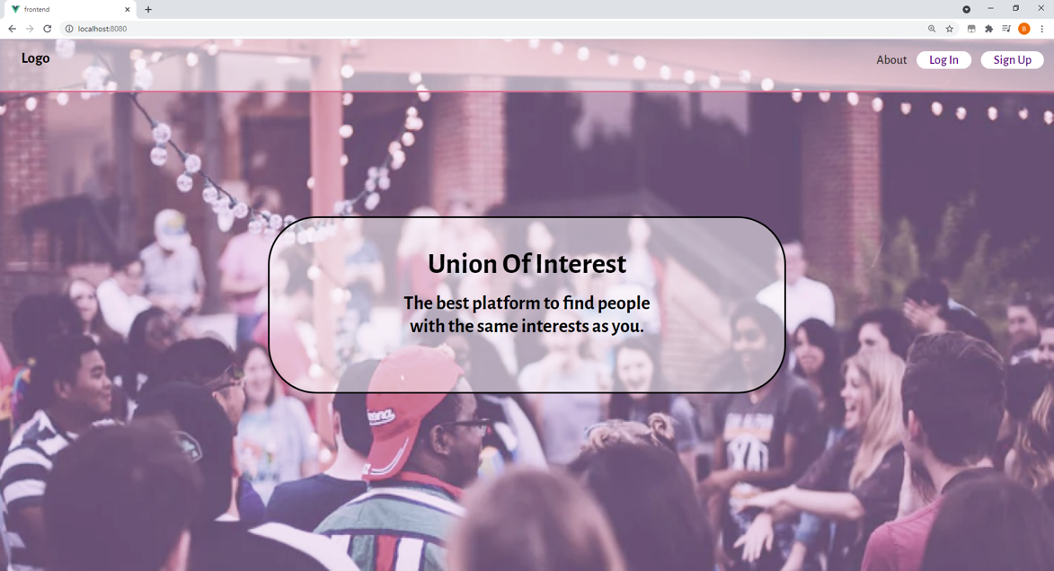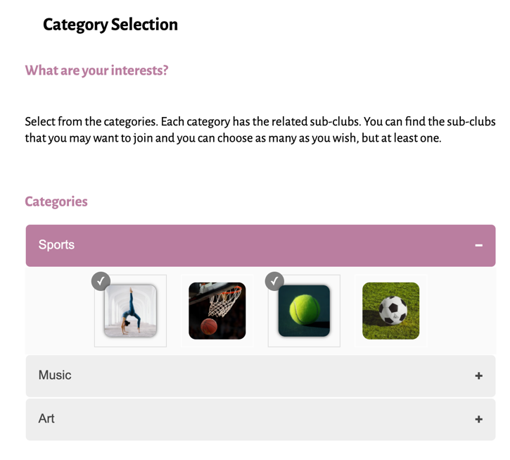

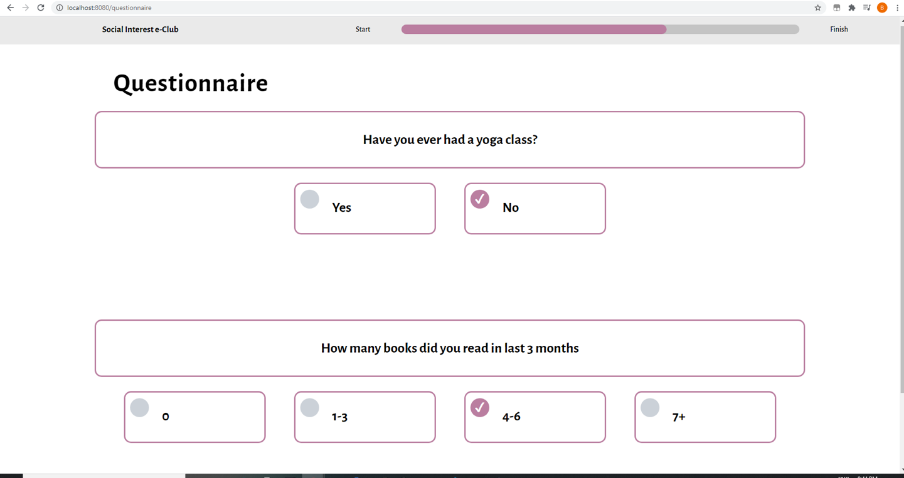

# Requirements Traceability

Traceability Matrix is attached to this document. Please see section 6.

# Annexes

For the attachments in section 4:

* Class Diagram is available under Class Diagram folder,
* ER Diagram is available under ER Diagram folder,
* Sequence Diagrams are available under Sequence Diagrams folder,
* State Diagrams are available under State Diagrams folder in GitHub.

For traceability Matrix in section 5:

* Traceability Matrix is available under Traceability Matrix folder