Mechanical Analysis Protocol

This protocol demonstrates how to use our custom MATLAB code *Mech_prop_bbml.m* or *bend_bose_excelgeom_fc.m* to analyze force displacement data from the mechanical tests.

1. Make a new folder. Compile data below (A, B, and C) into this **one folder**.
2. MATLAB CODE: *Mech_prop_bbml.m* (copy and paste from protocol folder, images show old version of code)
3. CORTICAL PROPERTIES: *CTgeom_avg.xlsx* (this is the EXACT file you obtained from the cortical MATLAB code)
4. ALL the load displacement data from the mechanical testing
   * These files **must be** named in a specific format (download/open the ReNamer software for mass renaming of all of the excel files from the mechanical tests)



* + The first part MUST be a number (CANNOT include an letters)
  + The second part MUST be the limb identifier (RF= right femur, LT = left tibia, etc)

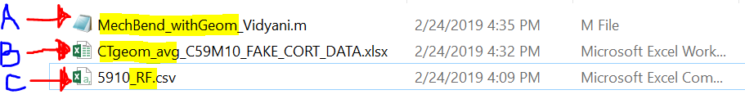

1. Open MATLAB and go to your folder you created in Step 1.
   1. Open the MATLAB code in the editor window

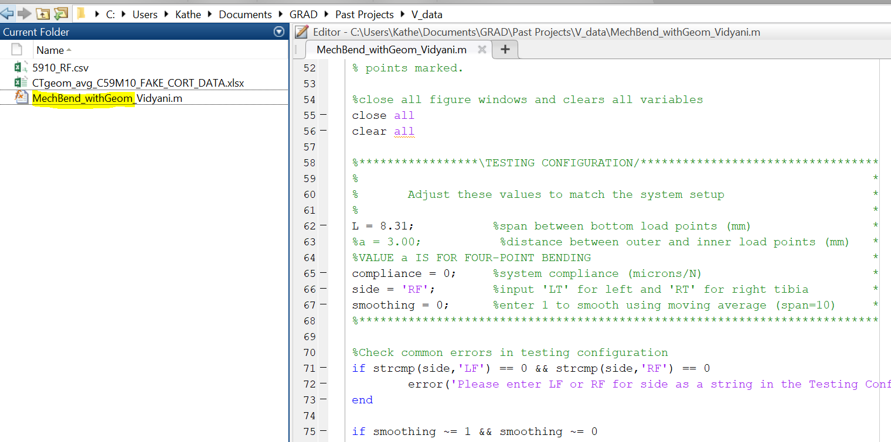

1. Change the testing configuration in the file
   1. L = the span between your bottom load points, change accordingly
   2. A = the span between the top loading beams – ONLY USED IN 4PT BENDING
   3. Side = the limb you are analyzing (RF, LF, RT, or LT)

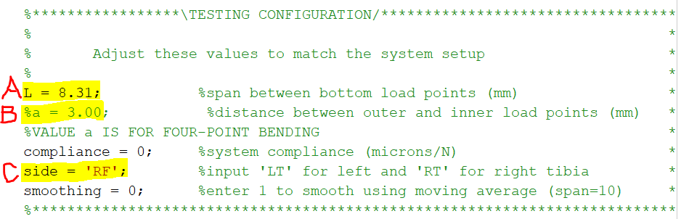

1. Run the MATLAB file (can do with green run button at the top). The dialogue box shown below will pop up to prompt you to confirm that you have edited the testing configuration values.

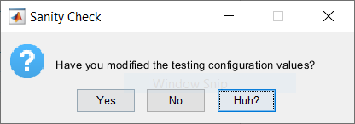

Click “Yes” to start the code, “No” to go back and edit, and “Huh?” to get an explanation of where in the code you need to edit values.

1. After you click “Yes”, the window below will pop up and ask you to choose the file with the geometry of the cortical data.
   1. Double click the file with the cortical data
   2. OR Click the file with the cortical data, then click Open

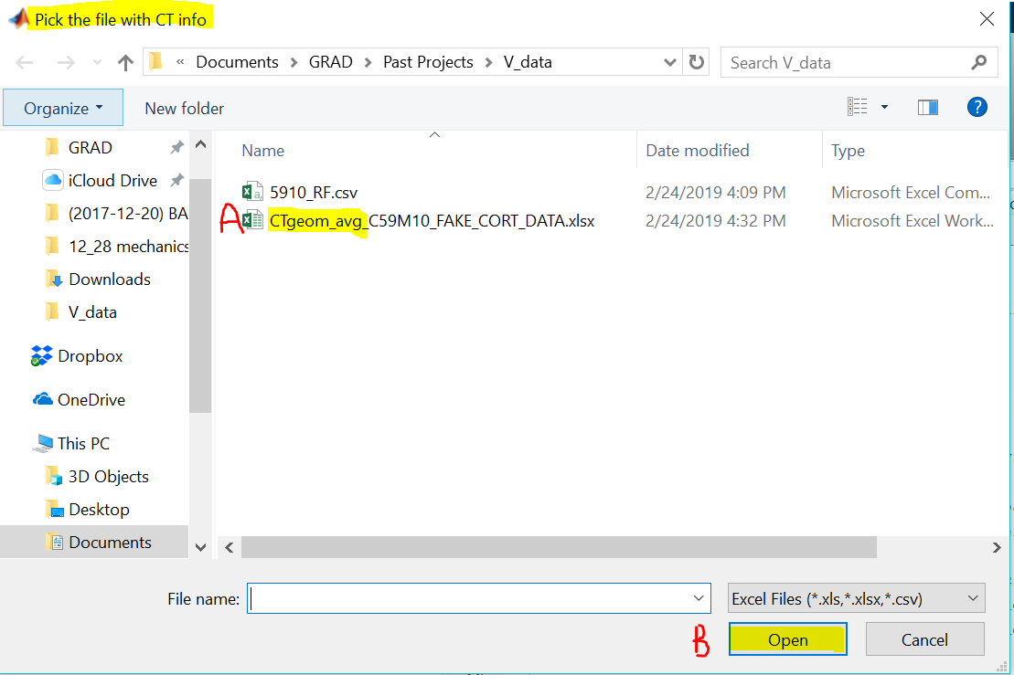

1. The code will then ask you to input the bone number you want to analyze first.
   1. AGAIN, this MUST be a NUMBER and cannot contain any letters

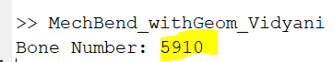

1. The window below will pop up. Choose the failure point on the graph
   1. NOTE: you may have to choose **just left** of the actually failure point as choosing too far right and PAST the end of the data *will result in an error*

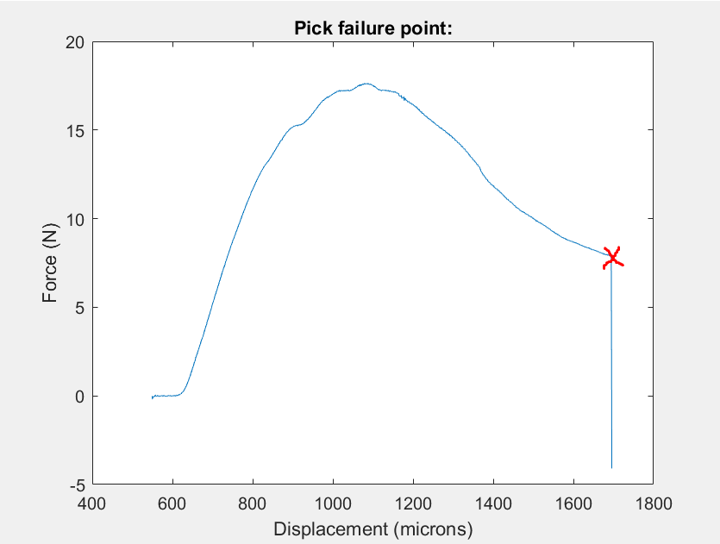

1. The window will reset based upon the selected failure point, and the window below will show. Choose the beginning point of the ELASTIC region of the graph.
   1. NOTE: if your graph is similar to the one below, you will have to choose a point PAST the first few data points as we are looking for the start of the **LINEAR** region

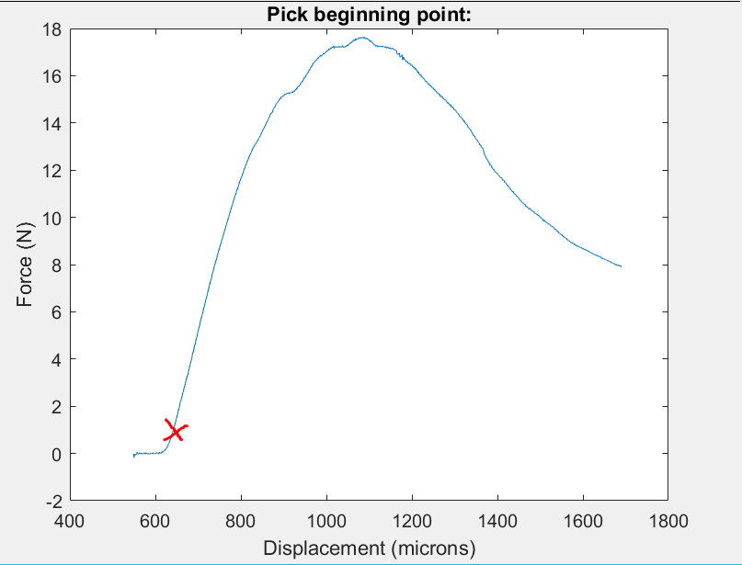

1. The graph will again reset and turn into a *stress-strain curve* based on the cortical geometry values. Choose **TWO points** to define the elastic modulus.
   1. NOTE: choose the bottom point first, and the top point second (nothing will happen/the screen will not change after you choose your 1st point🡪 just continue to choose your 2nd point)

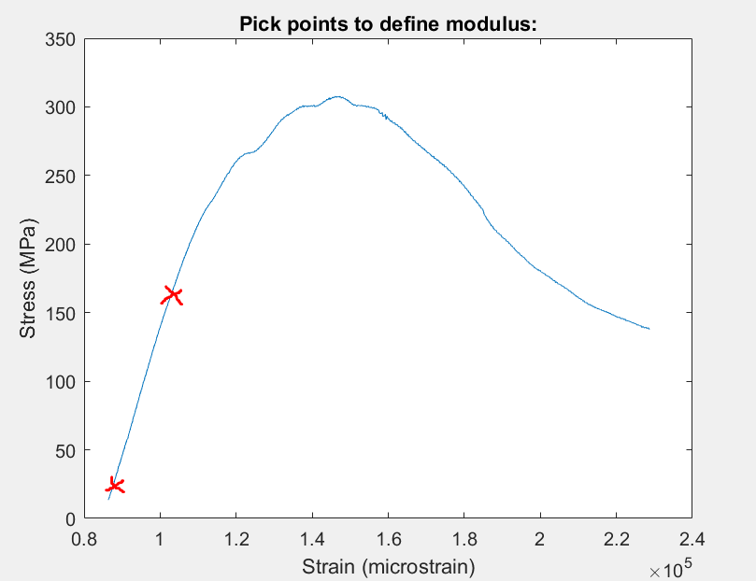

1. The window will reset as below. ANOTHER option will pop up and ask if you would like to reselect these points. Usually say no, but if the points are very bad, you can reselect
   1. NOTE: if you repeatedly reselect the points, the code may get confuse and mess up your data, eventually resulting in an error.

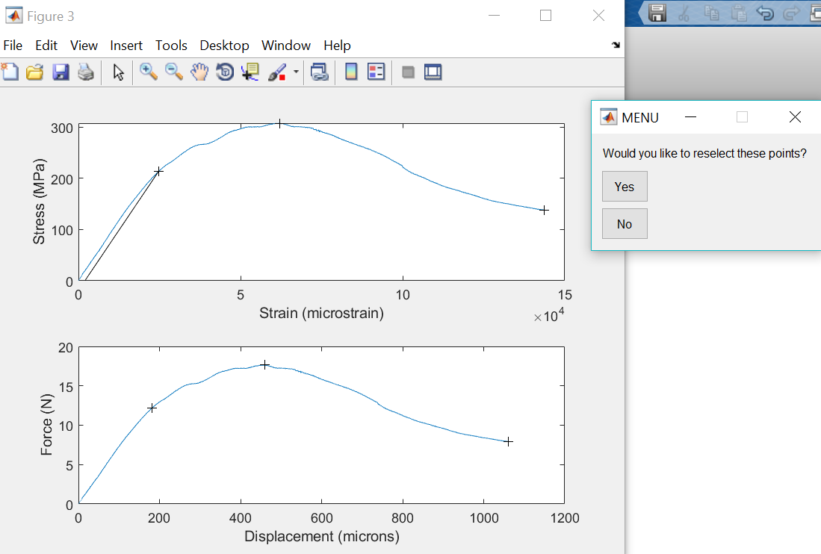

1. After you select “NO” in the previous step, another window will pop up and ask if you have more data to analyze. Answer accordingly.
   1. If you say yes, the code will loop back to step 5
   2. If you say no, the code is finished and no other steps need to be taken

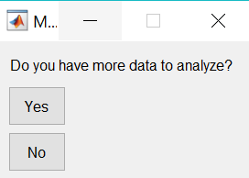

1. The code will create two type of files
   1. “4pt_mechanics”= ALL of the mechanical data the code analyzed
      * each row is a sample
      * if you throw and error in the middle of the code, RENAME THIS FILE, as re-running the code and picking back where you left off, will OVERWRITE this file
   2. It will also create a PNG image of the window created in step 9 (this will create an image for each sample you analyze)

