Cortical Analysis Protocol

This protocol demonstrates how to determine cortical regions of interest and how to use our custom MATLAB code for analysis.

To be completed after the phantom has been calibrated. Can be performed in junction with trabecular analysis.

**Please use excel sheet template “Femur_Analysis_Organization” or “Tibia_Analysis_Organization” to keep track of your bones, scanning days, and regions of interest. Ensure to save the file with the name of your study.**

1. Make a folder specifically for cortical regions of interest.

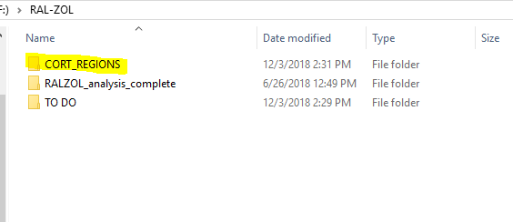

1. Created a subfolder for each day of scanning

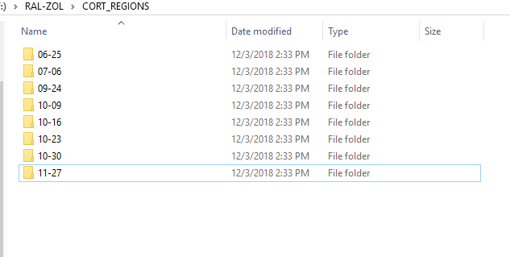

1. Open CTan to select your cortical ROI. Save cortical ROI from CTan into appropriate folder. **NOTE**: Specimen name used for folder should match naming convention used later for mechanical test files. This will save time when running auto mechanical analysis code. E.g. if analyzing the RT of specimen 123A, name both the cortical folder and the mechanical test file ‘123A_RT’.

There are numerous ways to determine cortical ROI. ***Cortical region HAS to be uniform for ALL bones***. The excel sheet mentioned above has an automated formula to determine your appropriate ROI using variables such as bone length, slice at the bottom of the bone, location where the growth plate ends, and location of trochanter.

* 1. **Femoral cortical ROI**.
     + Can be taken at 50% of bone length OR
     + Region JUST under where the trochanter starts. Using template sheet “Femur_Analysis_Organization”, insert location of where the trochanter appears 2x the width of the bone (slices will be usually be in the region of number 600-800)

*The excel sheet is programmed to find the length between the growth plate and the trochanter, and select a 10 slices at 75% of that length.*

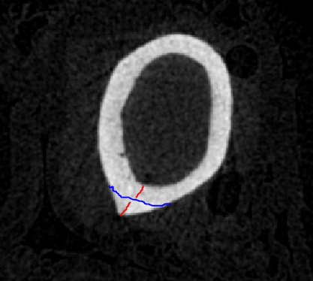

* 1. **Tibial cortical ROI**
     + take at **50% length** (usual region to tibiae)
     + the excel sheet with use the length of the bone and the location of the top of the bone to determine the 10 slices at 50%
     + NOTE: some regions may exceed the bounds of the ROI. If so change to taking at the 37.5% point.
     + It’s important to note that the process of rotation can sometimes cut off some of the bone in slices [0,20]. If you ROI is near the bottom, check the slices to ensure the entire slice is intact, or the MATLAB code will run an error and disrupt your analysis

1. Save cortical region for each bone in their own subfolder.

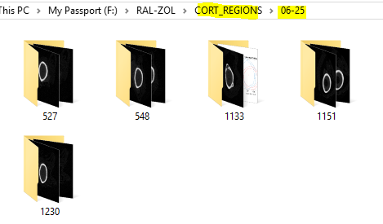

1. Once all cortical regions are saved for each of their respective scanning days, analysis can begin! NOTE: You will need to have the calibration values for each scanning day.
   1. Open Matlab. Run file “CTgeom_v20”
2. Code will ask you to select directory to open. Choose the generic folder with all of the scanning day subfolders.

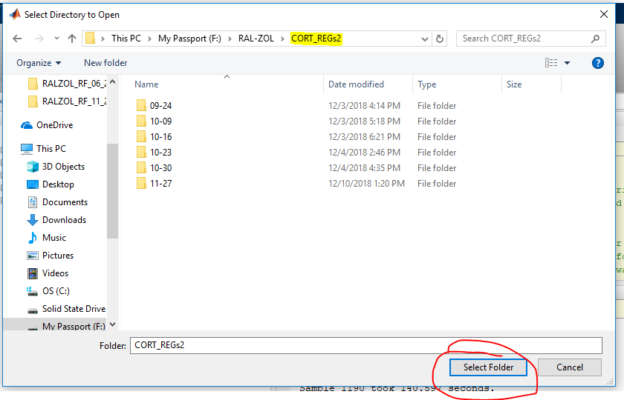

1. Matlab will prompt you the input numerous parameter. Input as below. Input phantom AC values for each day based on your own calibration constants.

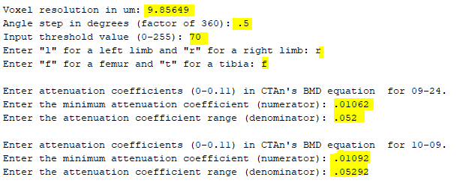

1. Once MATLAB has all of its input values needed, it will start to run through each sample, one by one. Each sample takes ~15 sec.
2. After completing each sample, MATLAB will gave 2 files, one for the geometric properties and one with the profile data. The geometric property files encompasses all of the properties that are needed for analysis. You will also need to EXACT (unaltered) file for later mechanical analysis. The profile file is used to create images of the cortical profile for visual proposes.

NOTE: if the code runs an error before completing each sample, the excel file will SAVE all of the data prior to that error.