一、灰尘检测模块

int dustPin=0;

int dustVal=0;

int ledPower=2;

int delayTime=280;

int delayTime2=40;

float offTime=9680;

void setup() {

Serial. begin (9600) ;

pinMode (ledPower, OUTPUT) ;

pinMode(4, OUTPUT) ;

}

void loop(){

// 1edPower t. * T9I+ JArduino_ EA'JD25I JДIl.

// D25I IiEtE1355 JtI

digitalWrite (ledPower, LOW); // power on the LED

delayMicroseconds (delayTime) ;

dustVal=analogRead (dustPin); // read the dust value via pin 5 on the sensor

delayMicroseconds (delayTime2);

digitalWrite(ledPower, HIGH); // turn the LED off

delayMicroseconds (offTime) ;

delay (3000) ;

Serial.println(dustVal) ;

}

//温湿度的数据针脚

#define DHT11PIN 7

//温湿度库对应的头文件

#include <dht11.h>

//全局变量

dht11 DHT11;

//数据

String strData;

#include <LiquidCrystal.h>

// initialize the library with the numbers of the interface pins

LiquidCrystal lcd(12, 11, 5, 4, 3, 2);

//初始化函数

void setup()

{

//设置串口的波特率

Serial.begin(9600);

//设置针脚端口的模式

pinMode(DHT11PIN, OUTPUT);

pinMode(7,OUTPUT);

// set up the LCD's number of columns and rows:

lcd.begin(16, 2);

}

//循环执行

void loop()

{

//读取温湿度的数据

int chk = DHT11.read(DHT11PIN);

//温度

float temp = (float)DHT11.temperature;

Serial.print("Tep: ");

Serial.print(temp);

Serial.println("C");

//湿度

float humi = (float)DHT11.humidity;

Serial.print("Hum: ");

Serial.print((float)DHT11.humidity);

Serial.println("%");

delay(500);

digitalWrite(7,HIGH);

lcd.setCursor(0, 0);

lcd.print("Tep: ");

lcd.print((float)DHT11.temperature, 2);

lcd.print("C");

if((float)DHT11.temperature >30)

{

digitalWrite(7,LOW);

}

// set the cursor to column 0, line 1

// (note: line 1 is the second row, since counting begins with 0):

lcd.setCursor(0, 1);

// print the number of seconds since reset:

lcd.print("Hum: ");

lcd.print((float)DHT11.humidity, 2);

lcd.print("%");

delay(200);

}

超声波：

#define Trig 8 //引脚Tring 连接 IO D8

#define Echo 9 //引脚Echo 连接 IO D9

float cm; //距离变量

float temp; //

void setup() {

Serial.begin(9600);

pinMode(Trig, OUTPUT);

pinMode(Echo, INPUT);

}

void loop() {

//给Trig发送一个低高低的短时间脉冲,触发测距

digitalWrite(Trig, LOW); //给Trig发送一个低电平

delayMicroseconds(2); //等待 2微妙

digitalWrite(Trig, HIGH); //给Trig发送一个高电平

delayMicroseconds(10); //等待 10微妙

digitalWrite(Trig, LOW); //给Trig发送一个低电平

temp = float(pulseIn(Echo, HIGH)); //存储回波等待时间,

//pulseIn函数会等待引脚变为HIGH,开始计算时间,再等待变为LOW并停止计时

//返回脉冲的长度

//声速是:340m/1s 换算成 34000cm / 1000000μs => 34 / 1000

//因为发送到接收,实际是相同距离走了2回,所以要除以2

//距离(厘米) = (回波时间 * (34 / 1000)) / 2

//简化后的计算公式为 (回波时间 * 17)/ 1000

cm = (temp * 17) / 1000; //把回波时间换算成cm

Serial.print("Echo =");

Serial.print(temp);//串口输出等待时间的原始数据

Serial.print(" | | Distance = ");

Serial.print(cm);//串口输出距离换算成cm的结果

Serial.println("cm");

delay(500);

}

通过串口监视器观察值。

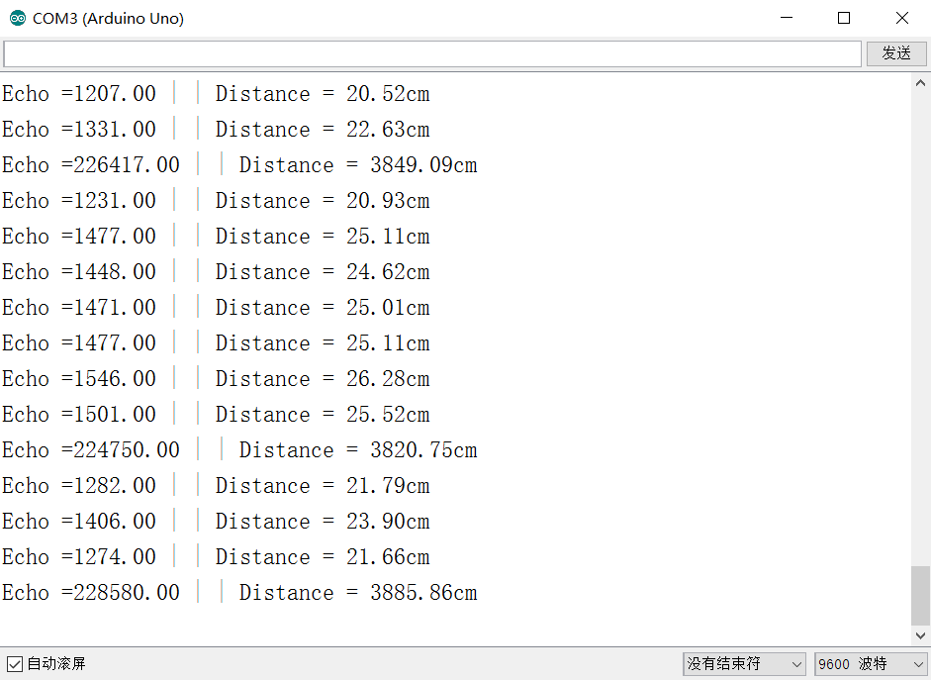

最终成品:

//温湿度的数据针脚

#define DHT11PIN 7

//温湿度库对应的头文件

#include <dht11.h>

//全局变量

dht11 DHT11;

//数据

String strData;

#define Trig 8 //引脚Tring 连接 IO D8

#define Echo 9 //引脚Echo 连接 IO D9

float cm; //距离变量

float temp; //

int dustPin=0;

int dustVal=0;

int ledPower=13;

int delayTime=280;

int delayTime2=40;

float offTime=9680;

#include <LiquidCrystal.h>

// initialize the library with the numbers of the interface pins

LiquidCrystal lcd(12, 11, 5, 4, 3, 2);

//初始化函数

void setup()

{

//设置串口的波特率

Serial.begin(9600);

//设置针脚端口的模式

pinMode(DHT11PIN, OUTPUT);

pinMode(6,OUTPUT);

pinMode(7,OUTPUT);

// set up the LCD's number of columns and rows:

lcd.begin(16, 2);

pinMode(Trig, OUTPUT);

pinMode(Echo, INPUT);

pinMode (ledPower, OUTPUT) ;

pinMode(10, OUTPUT) ;

}

//循环执行

void loop()

{

//给Trig发送一个低高低的短时间脉冲,触发测距

digitalWrite(Trig, LOW); //给Trig发送一个低电平

delayMicroseconds(2); //等待 2微妙

digitalWrite(Trig, HIGH); //给Trig发送一个高电平

delayMicroseconds(10); //等待 10微妙

digitalWrite(Trig, LOW); //给Trig发送一个低电平

temp = float(pulseIn(Echo, HIGH)); //存储回波等待时间,

//pulseIn函数会等待引脚变为HIGH,开始计算时间,再等待变为LOW并停止计时

//返回脉冲的长度

//声速是:340m/1s 换算成 34000cm / 1000000μs => 34 / 1000

//因为发送到接收,实际是相同距离走了2回,所以要除以2

//距离(厘米) = (回波时间 * (34 / 1000)) / 2

//简化后的计算公式为 (回波时间 * 17)/ 1000

cm = (temp * 17) / 1000; //把回波时间换算成cm

Serial.print("Echo =");

Serial.print(temp);//串口输出等待时间的原始数据

Serial.print(" | | Distance = ");

Serial.print(cm);//串口输出距离换算成cm的结果

Serial.println("cm");

if(cm<=15){

digitalWrite(6,LOW);

}

//读取温湿度的数据

int chk = DHT11.read(DHT11PIN);

//温度

float temp = (float)DHT11.temperature;

Serial.print("Tep: ");

Serial.print(temp);

Serial.println("C");

if(temp>30){

digitalWrite(1,HIGH);

}

//湿度

float humi = (float)DHT11.humidity;

Serial.print("Hum: ");

Serial.print((float)DHT11.humidity);

Serial.println("%");

digitalWrite(7,HIGH);

lcd.setCursor(0, 0);

lcd.print("Tep: ");

lcd.print((float)DHT11.temperature, 2);

lcd.print("C");

if((float)DHT11.temperature >30)

{

digitalWrite(7,LOW);

}

// set the cursor to column 0, line 1

// (note: line 1 is the second row, since counting begins with 0):

lcd.setCursor(0, 1);

// print the number of seconds since reset:

lcd.print("Hum: ");

lcd.print((float)DHT11.humidity, 2);

lcd.print("%");

if(cm<=15){

delay(2500);

}

lcd.clear();

digitalWrite (ledPower, LOW); // power on the LED

delayMicroseconds (delayTime) ;

dustVal=analogRead (dustPin); // read the dust value via pin 5 on the sensor

delayMicroseconds (delayTime2);

digitalWrite(ledPower, HIGH); // turn the LED off

delayMicroseconds (offTime) ;

lcd.setCursor(0, 0);

lcd.print("pm2.5 ");

lcd.setCursor(0, 1);

lcd.print((float)dustVal, 2);

if(cm<=15){

delay (2500) ;

}

Serial.println(dustVal) ;

digitalWrite(6,HIGH);

}