Recommended User Interface Screens for Manuscript Inclusion
Real-Time Monitoring System of the Automated Poultry Egg Weighing and Sorting Device
This document compiles the user interface screens that are suitable for inclusion in the manuscript. The screenshots were captured from the local demonstration environment with representative records so the major monitoring, administrative, and farm-operation features are visible in presentation-ready form.
Suggested placement:
- Use the login, registration, dashboard, and machine blueprint figures in the system overview or implementation chapter.
- Use the user management, device registry, and farm map figures in the administration or deployment discussion.
- Use the batch monitoring, price monitoring, My Farms, and inventory figures in the results, operations, or user workflow section.
- Replace Figure X with the final numbering required by the manuscript format, such as Figure 4.1, Figure 4.2, and so on.

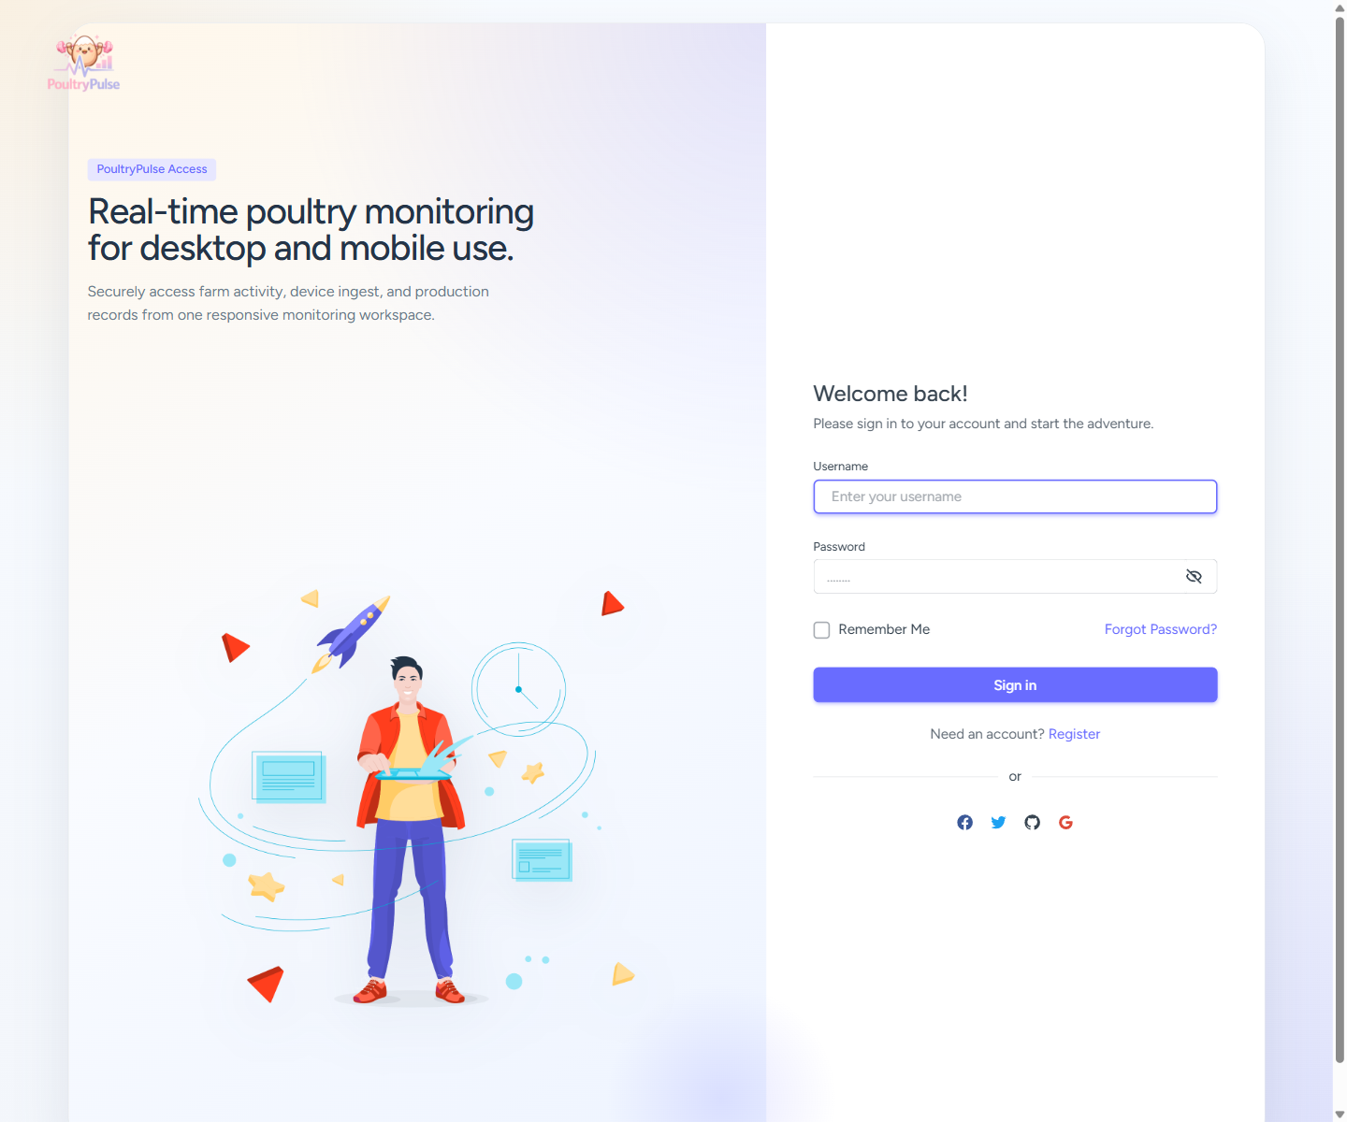
Figure X. Login interface of the Real-Time Monitoring System.
The login interface provides secure entry to the system using a username and password. It serves as the initial access point for all user roles and presents the responsive entry layout used across desktop and mobile devices.

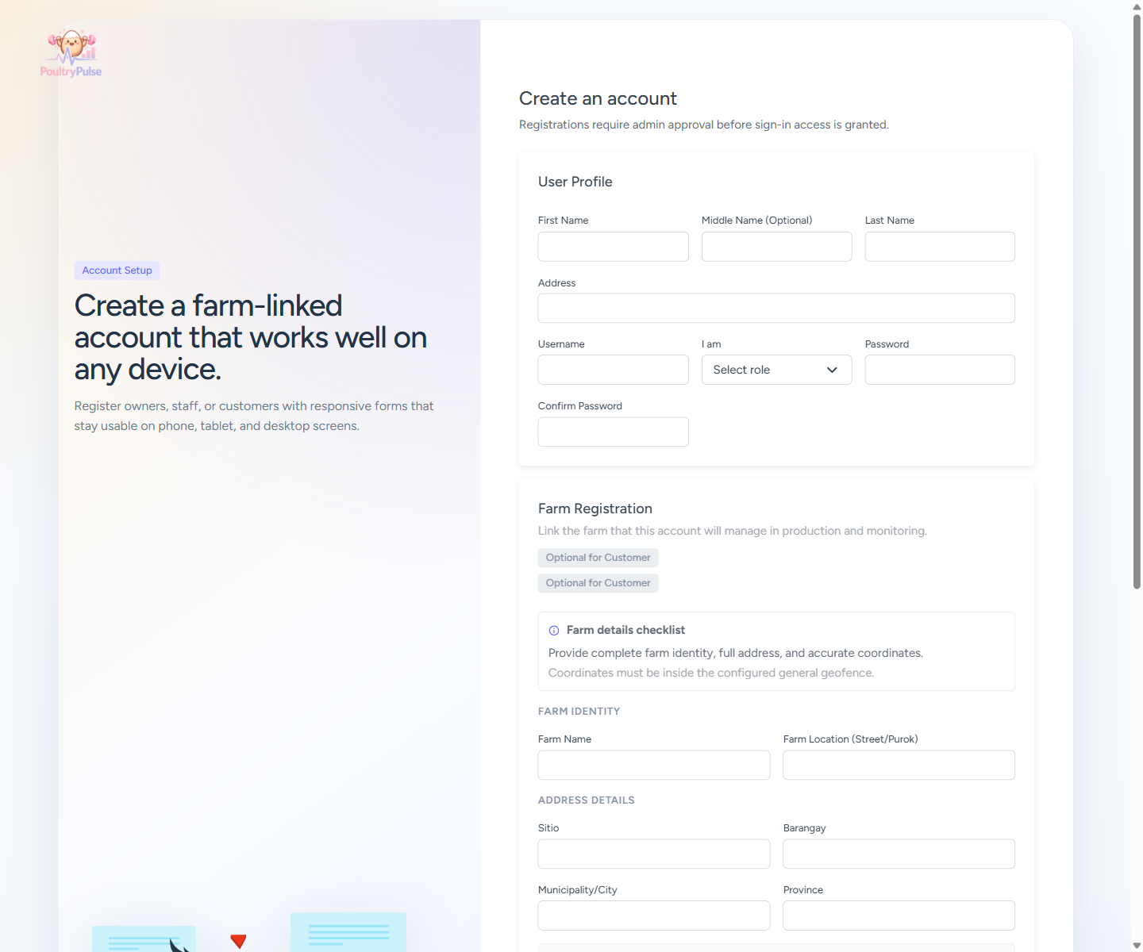
Figure X. Registration interface for new users and farm-linked accounts.
The registration interface allows prospective users to submit account details, select their role, and, when applicable, encode farm information and map coordinates. This supports controlled onboarding subject to administrator approval.

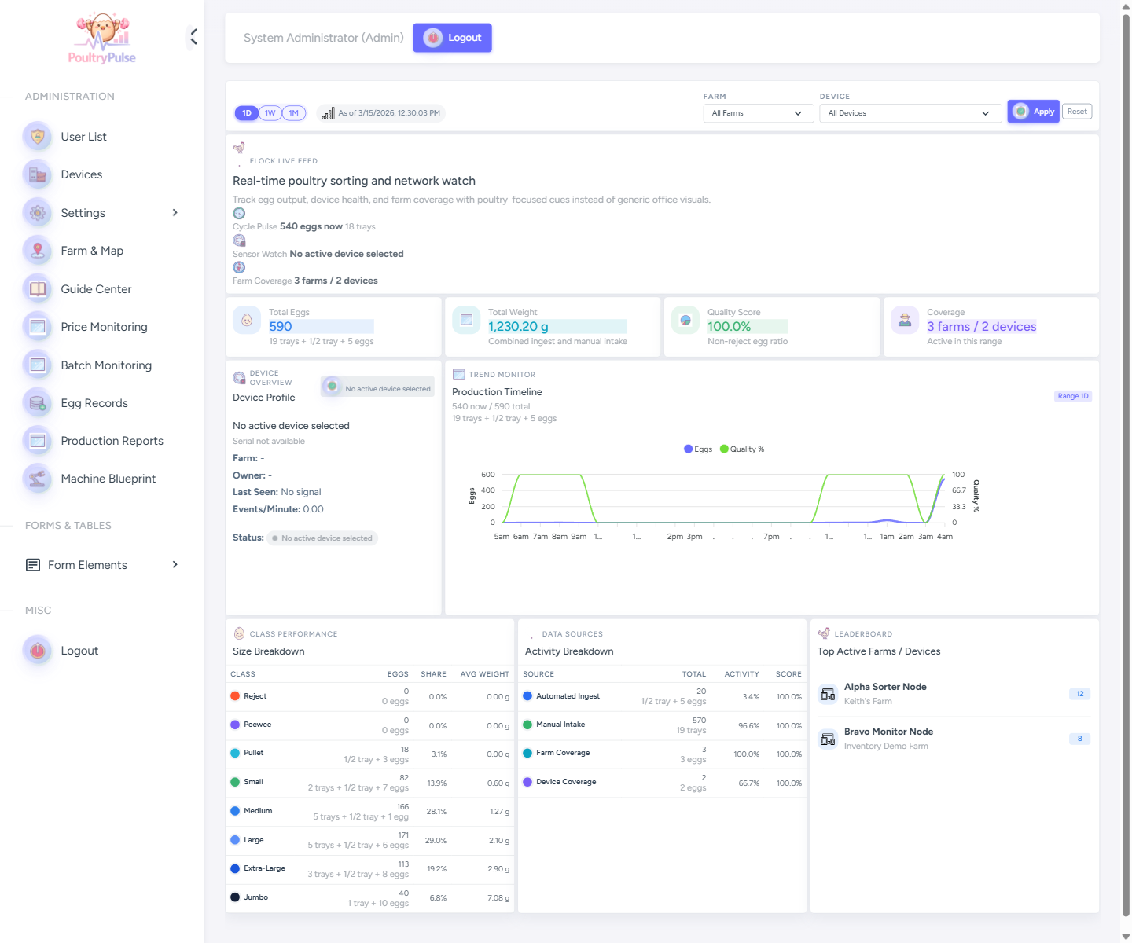
Figure X. Administrative dashboard showing real-time production and monitoring indicators.
The dashboard summarizes egg counts, total weight, quality score, farm coverage, device coverage, production timelines, and size classification breakdowns. It is the primary real-time monitoring page used for supervisory review.

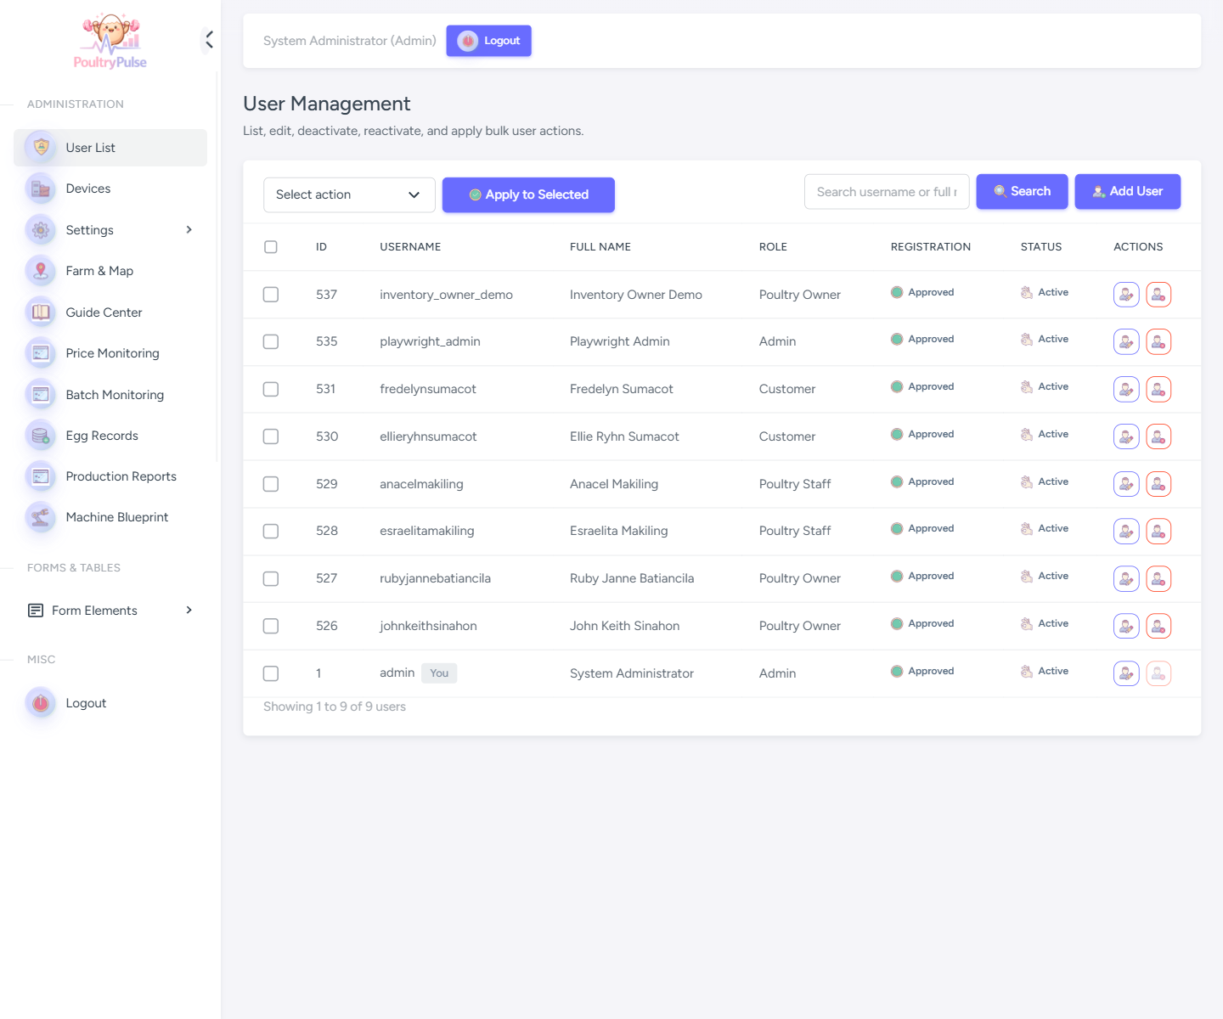
Figure X. User management interface for role administration and account control.
This interface allows the administrator to review registered accounts, inspect current roles, apply bulk actions, and manage activation or deactivation status. It supports role-based governance of the monitoring system.

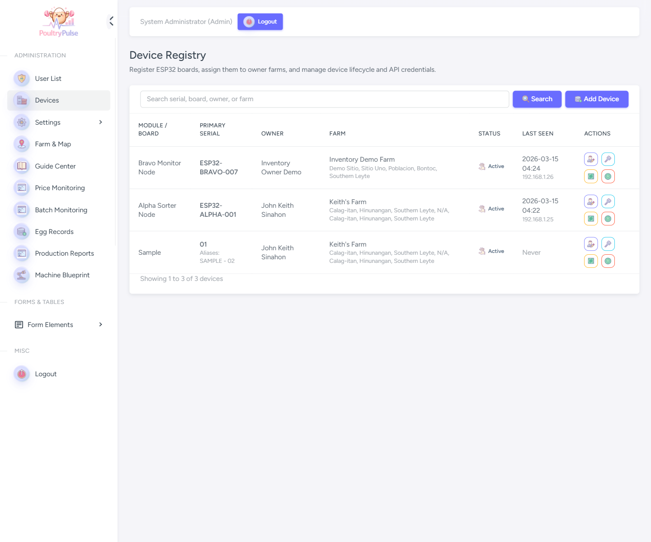
Figure X. Device registry interface for ESP32 board assignment and lifecycle management.
The device registry lists registered ESP32 units together with serial numbers, assigned owners, farm associations, operational status, and recent connectivity metadata. It is used to manage the hardware endpoints that feed egg records into the system.

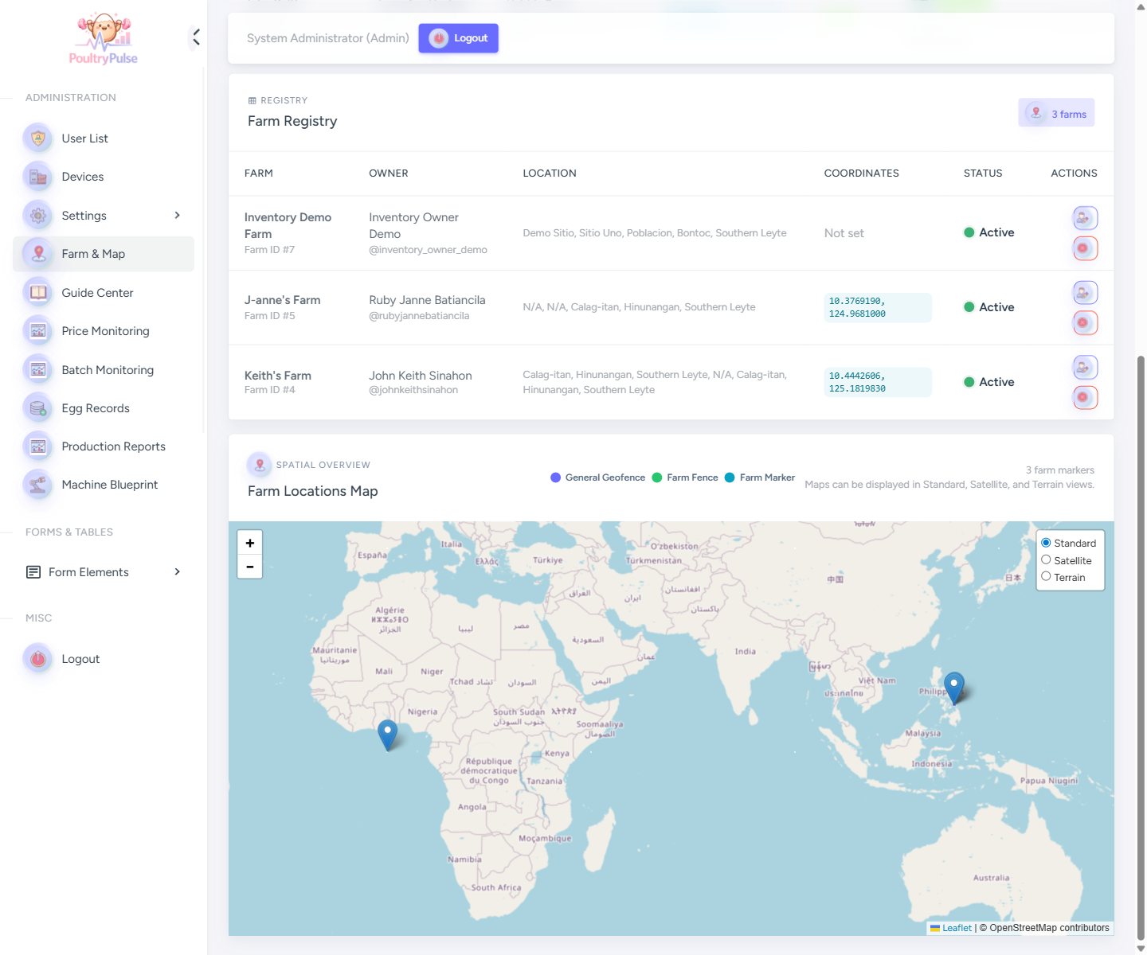
Figure X. Farm and map management interface with farm registry and spatial overview.
The farm and map page integrates farm records with geographic visualization, allowing the administrator to review owner-linked farms, monitor geofence configuration, and inspect mapped locations relevant to system access and device deployment.

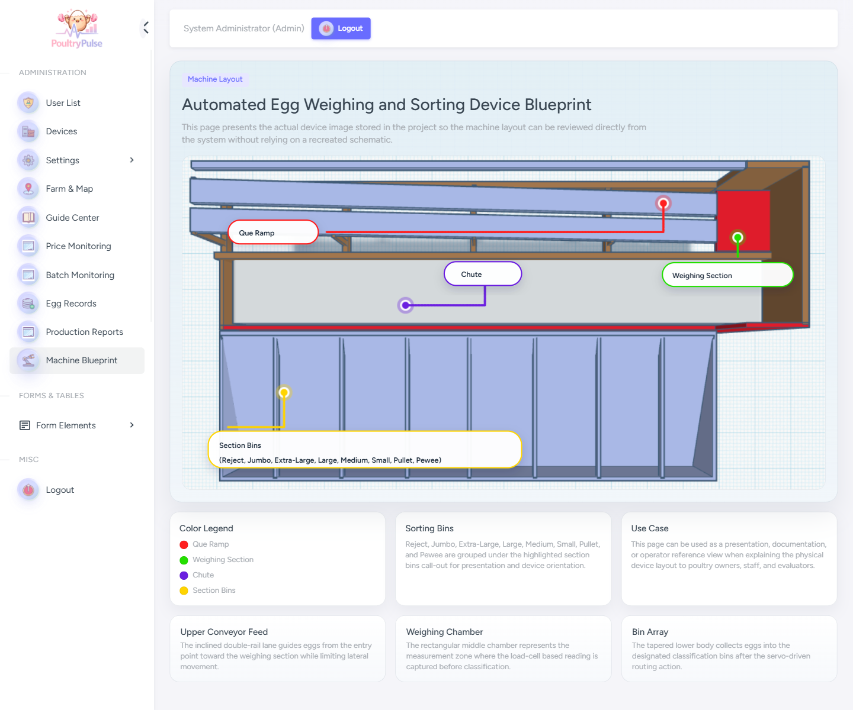
Figure X. Machine blueprint interface showing the physical egg weighing and sorting device.
The machine blueprint page presents the actual device layout with labeled sections such as the queue ramp, weighing section, chute, and classification bins. It is intended for documentation, demonstration, and operator orientation.

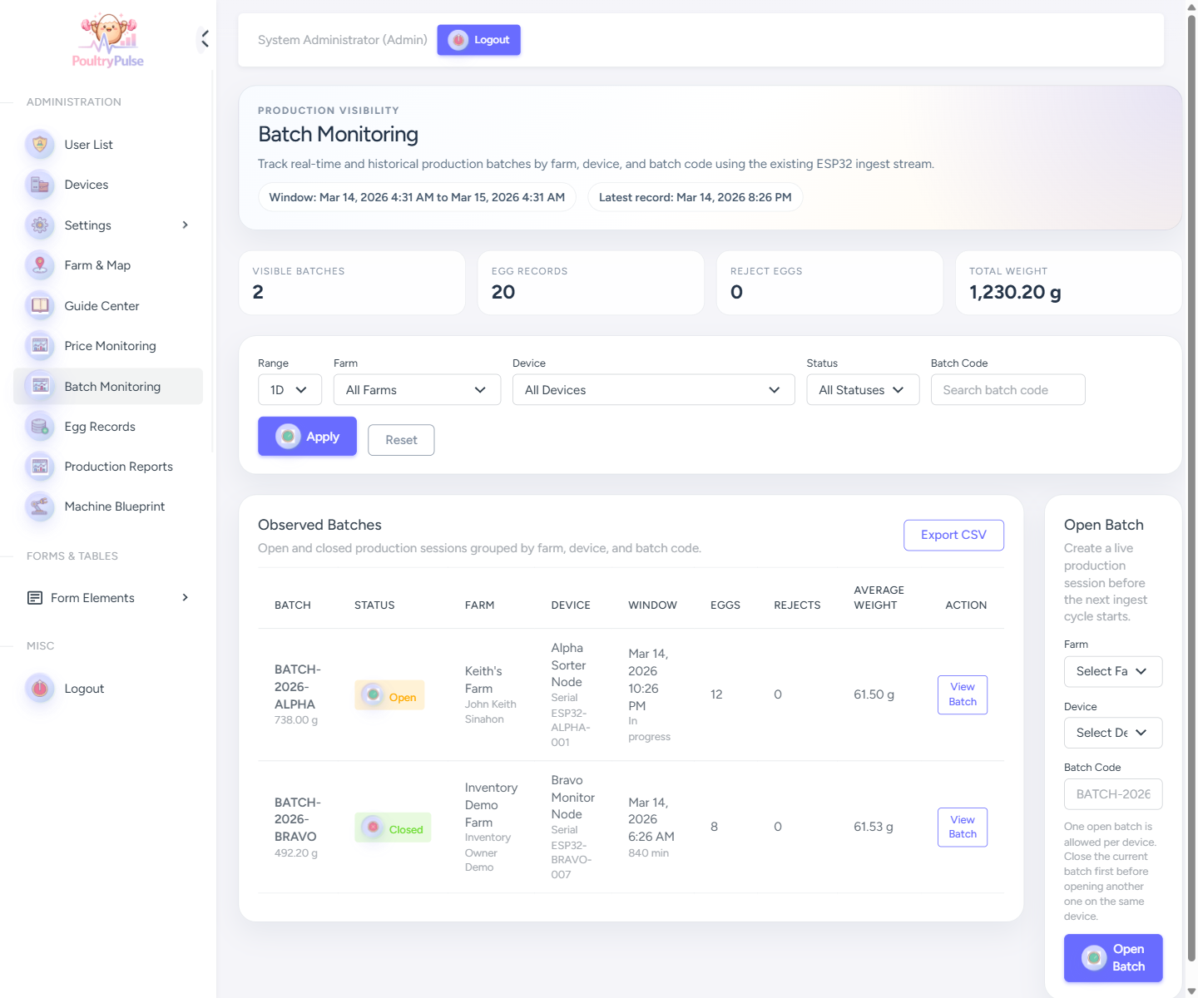
Figure X. Batch monitoring interface for real-time and historical production sessions.
The batch monitoring page groups egg records by batch code, farm, and device, and displays production windows, egg totals, and average weights. It supports traceability of operational runs and historical review of batch output.

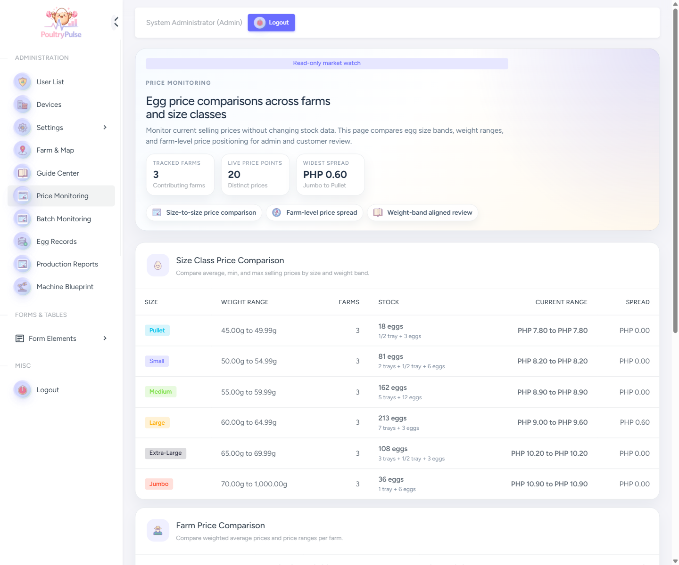
Figure X. Price monitoring interface for egg price comparisons across farms and size classes.
The price monitoring interface compares egg prices across farms and size classes using weight-aligned bands. It provides a read-only market view intended for administrators and customers who need visibility into farm-level selling prices.

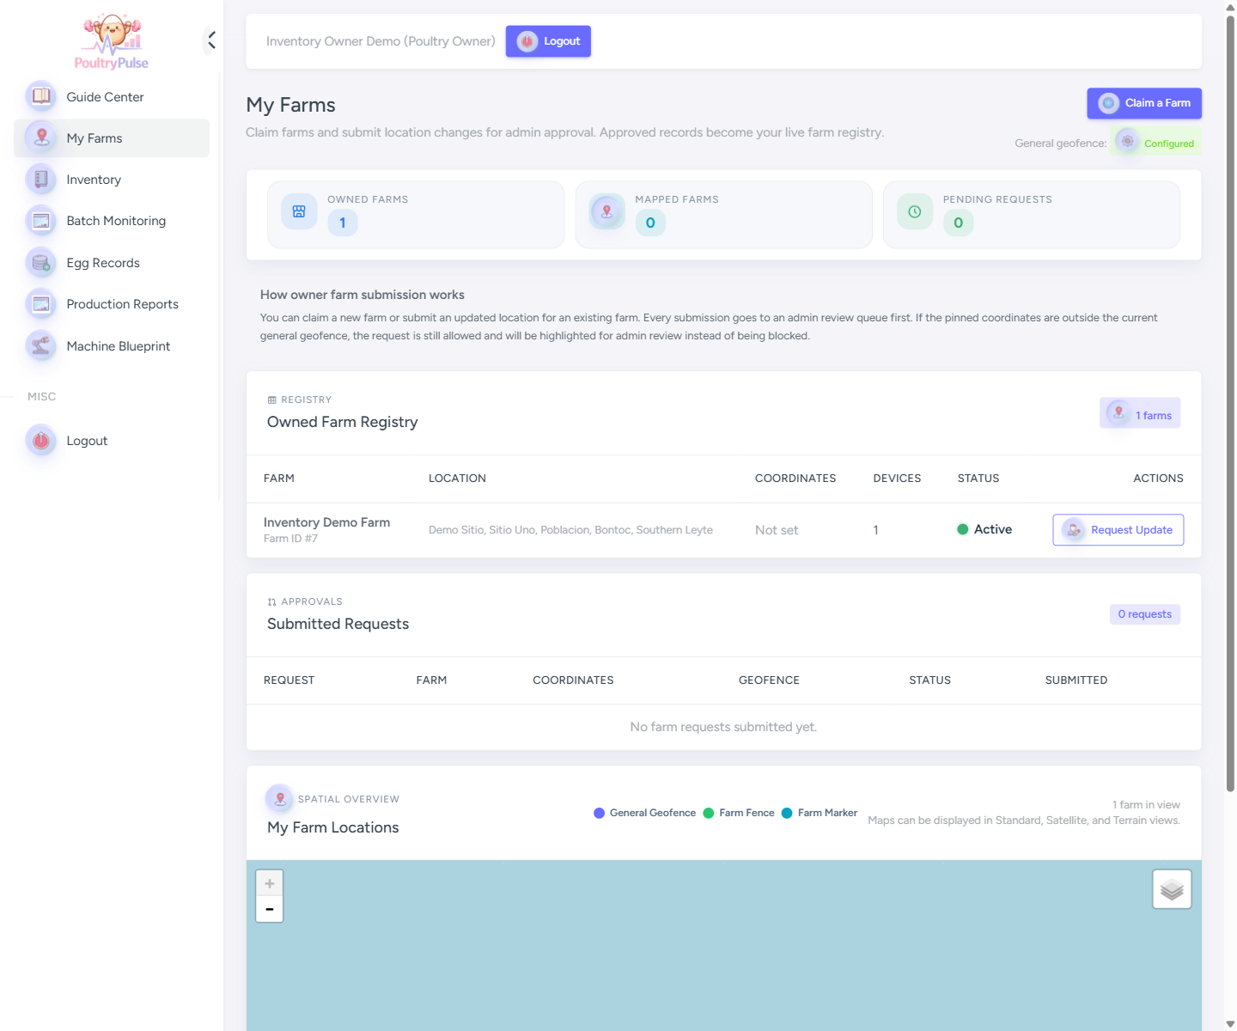
Figure X. Poultry owner interface for farm registry review and location requests.
The My Farms page allows a poultry owner to review the farms under their account, inspect current status, submit location-related requests, and view a map of owned farm locations within the configured spatial context.

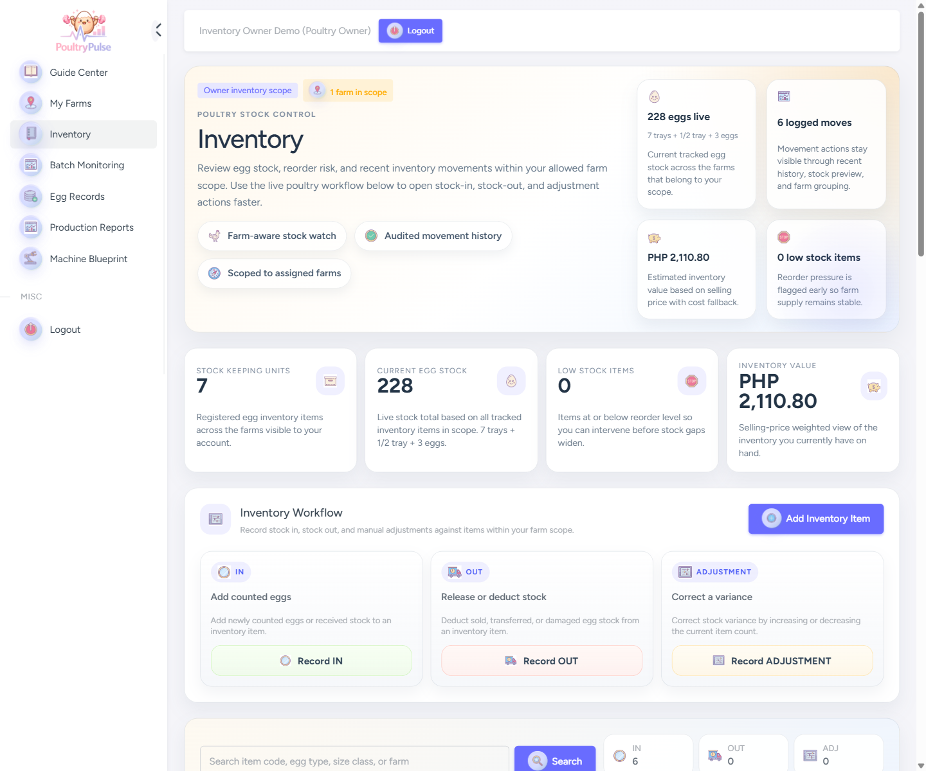
Figure X. Poultry owner inventory interface for stock control and movement recording.
The inventory page allows the owner to monitor available stock, assess inventory value, review low-stock indicators, and initiate stock-in, stock-out, and adjustment actions. It functions as the farm-scoped inventory control workspace of the system.

