System Process Flowcharts by Account
Real-Time Monitoring System of the Automated Poultry Egg Weighing and Sorting Device
This document provides a thesis-ready set of flowchart materials for the system process per account. It includes a formal overview figure, separate role-based figures, reusable Mermaid source code, and layout guidance for PNG or PDF export in Chapter 4 or the Appendix.
Formal Figure Captions
Figure X. Overall system process of the Real-Time Monitoring System of the Automated Poultry Egg Weighing and Sorting Device.
Figure X. Administrative process flow for access control, farm mapping, device assignment, and monitoring supervision.
Figure X. Process flow for the Poultry Owner account in monitoring farm operations and requesting farm record updates.
Figure X. Process flow for the Poultry Staff account under assigned farm and premises restrictions.
Figure X. Process flow for the Customer account under restricted dashboard and price-monitoring access.
Flowchart Figures
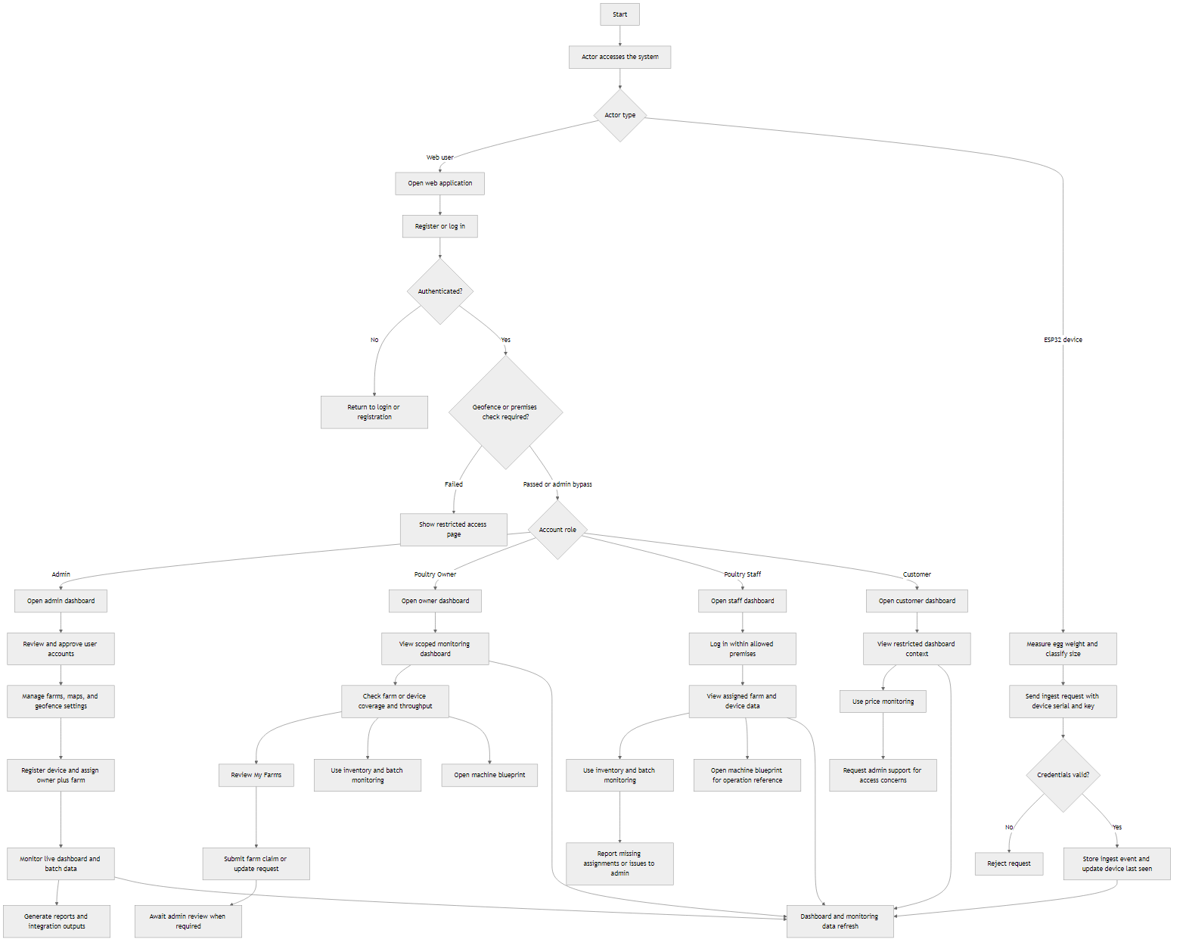
Figure X. Overall system process of the Real-Time Monitoring System of the Automated Poultry Egg Weighing and Sorting Device.
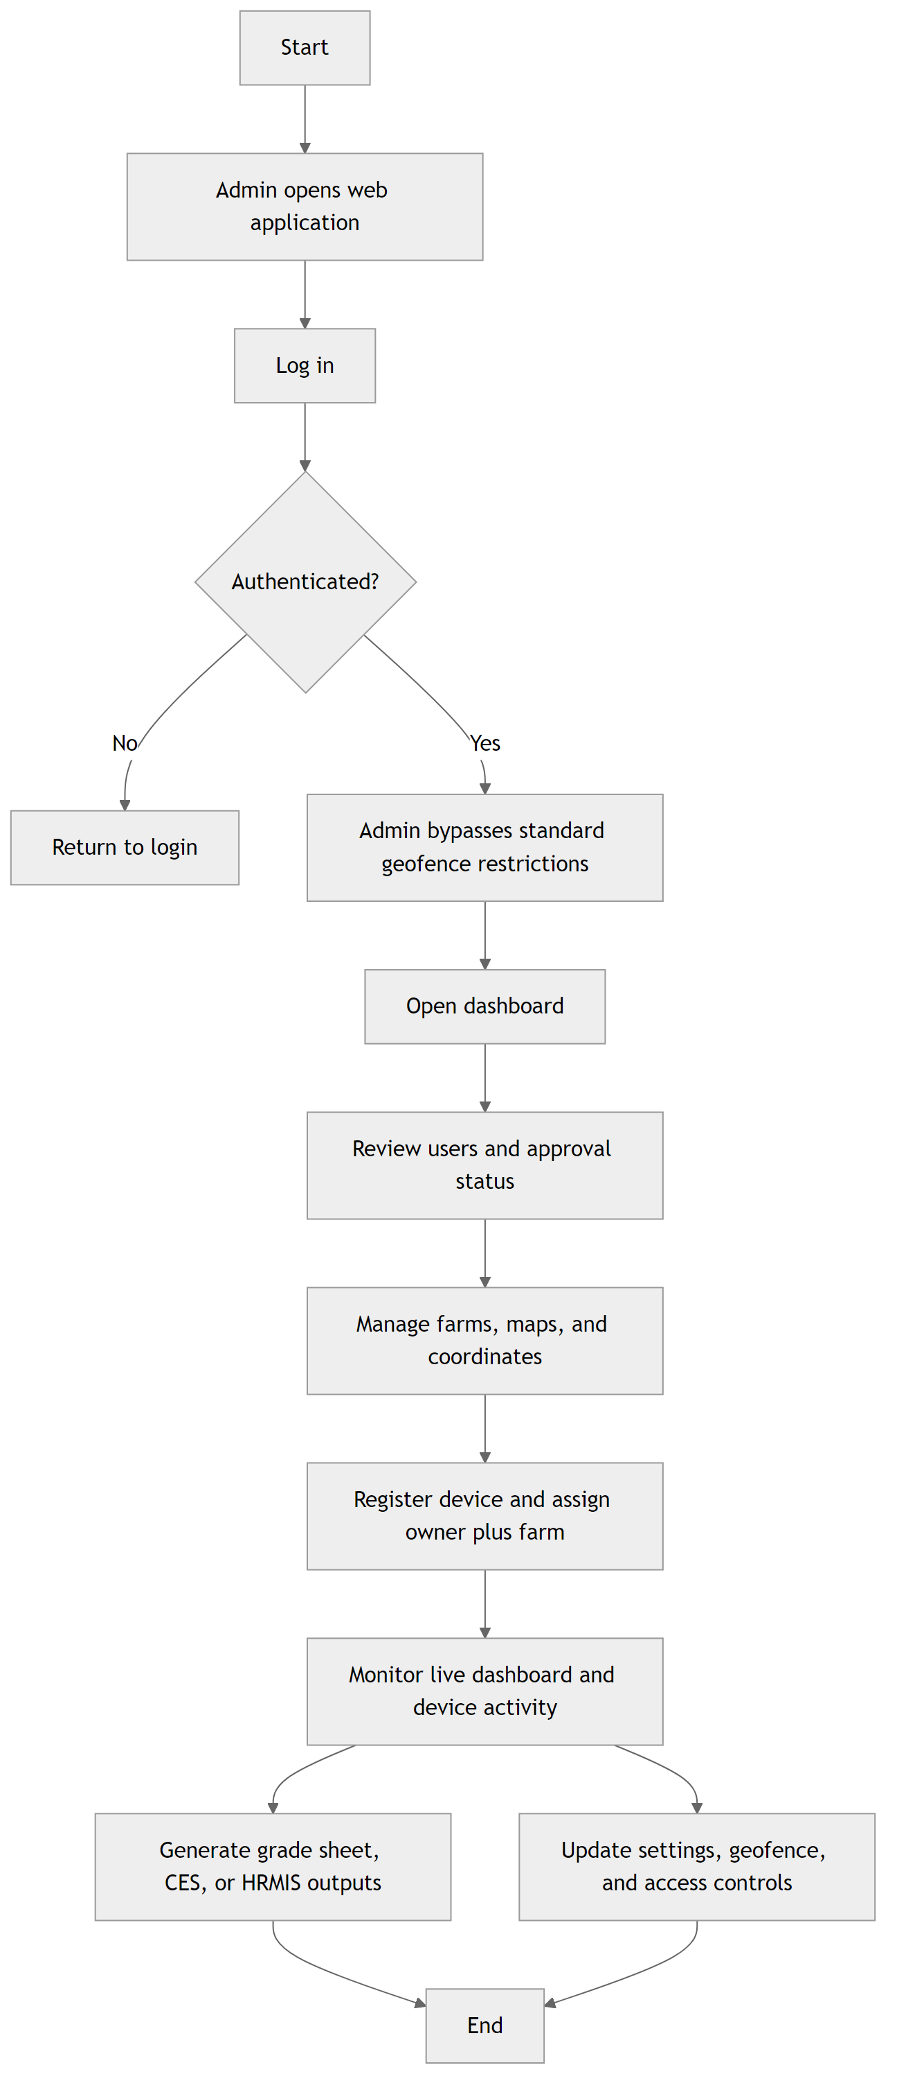
Figure X. Administrative process flow for access control, farm mapping, device assignment, and monitoring supervision.
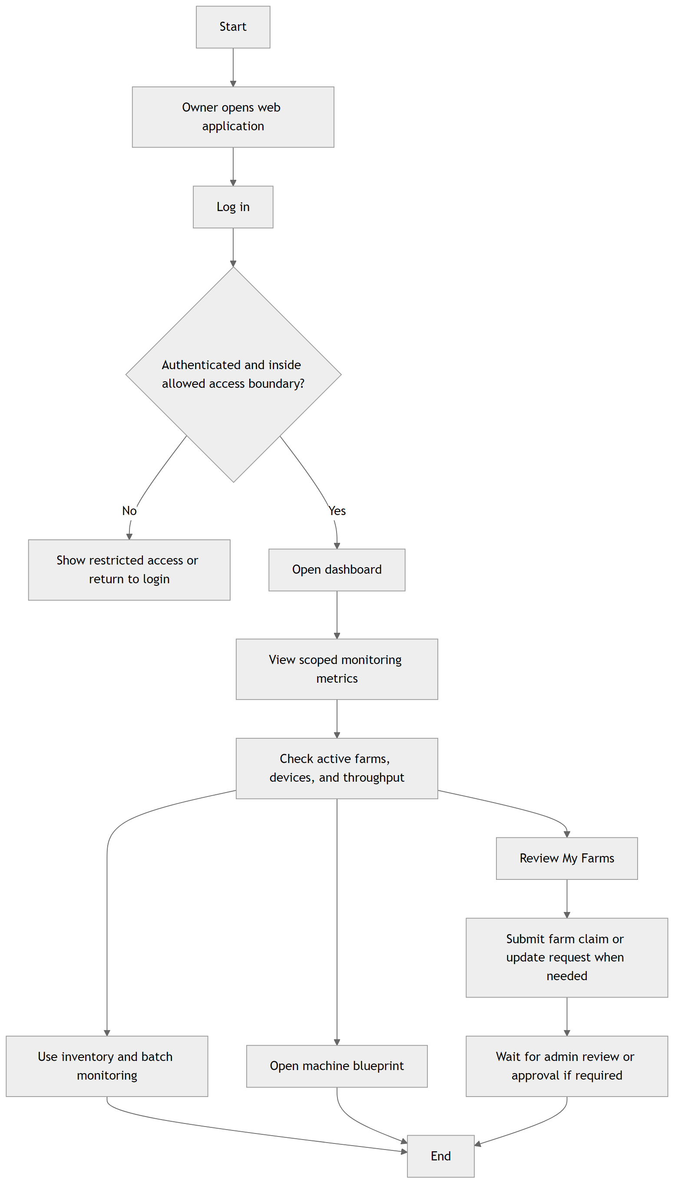
Figure X. Process flow for the Poultry Owner account in monitoring farm operations and requesting farm record updates.
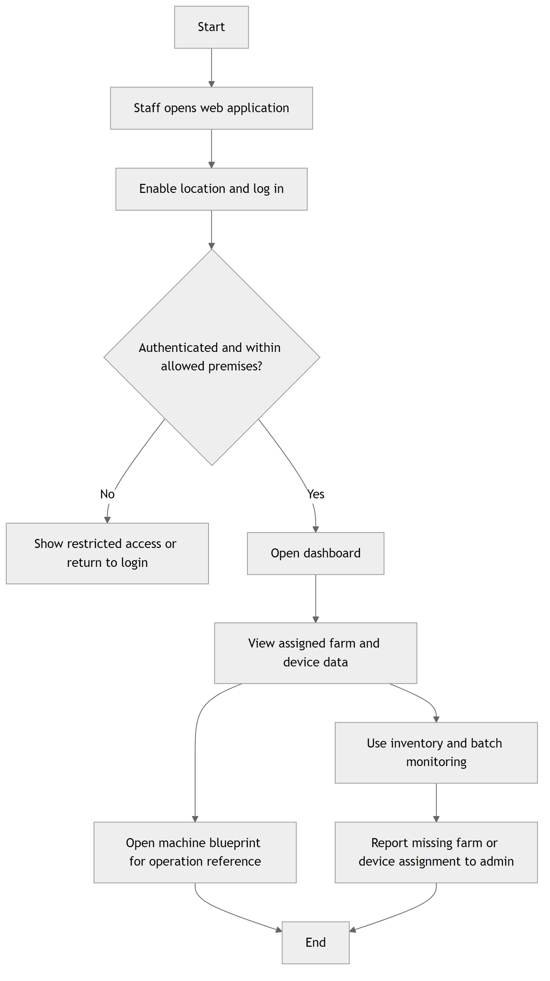
Figure X. Process flow for the Poultry Staff account under assigned farm and premises restrictions.
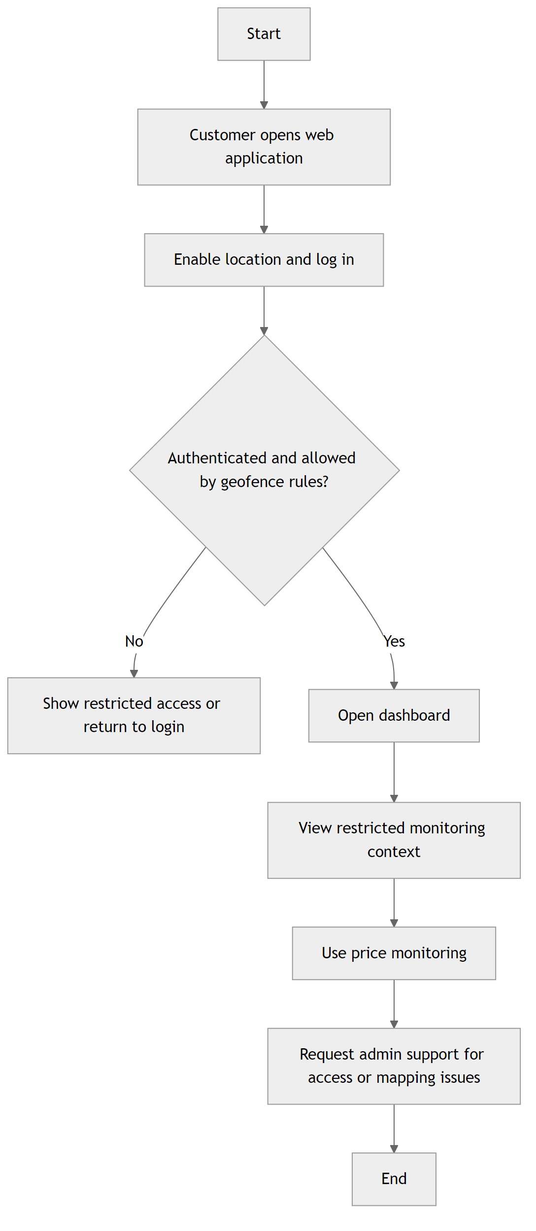
Figure X. Process flow for the Customer account under restricted dashboard and price-monitoring access.

Appendix A. Mermaid Source Code
The following Mermaid blocks may be pasted into documentation systems that support Mermaid rendering, such as Markdown-based repositories, documentation portals, or Mermaid-compatible editors.
Admin Mermaid Block
flowchart TD
A["Start"] --> B["Admin opens web application"]
B --> C["Log in"]
C --> D{"Authenticated?"}
D -->|"No"| E["Return to login"]
D -->|"Yes"| F["Admin bypasses standard geofence restrictions"]
F --> G["Open dashboard"]
G --> H["Review users and approval status"]
H --> I["Manage farms, maps, and coordinates"]
I --> J["Register device and assign owner plus farm"]
J --> K["Monitor live dashboard and device activity"]
K --> L["Generate grade sheet, CES, or HRMIS outputs"]
K --> M["Update settings, geofence, and access controls"]
L --> N["End"]
M --> N
Owner Mermaid Block
flowchart TD
A["Start"] --> B["Owner opens web application"]
B --> C["Log in"]
C --> D{"Authenticated and inside allowed access boundary?"}
D -->|"No"| E["Show restricted access or return to login"]
D -->|"Yes"| F["Open dashboard"]
F --> G["View scoped monitoring metrics"]
G --> H["Check active farms, devices, and throughput"]
H --> I["Review My Farms"]
I --> J["Submit farm claim or update request when needed"]
H --> K["Use inventory and batch monitoring"]
H --> L["Open machine blueprint"]
J --> M["Wait for admin review or approval if required"]
K --> N["End"]
L --> N
M --> N
Staff Mermaid Block
flowchart TD
A["Start"] --> B["Staff opens web application"]
B --> C["Enable location and log in"]
C --> D{"Authenticated and within allowed premises?"}
D -->|"No"| E["Show restricted access or return to login"]
D -->|"Yes"| F["Open dashboard"]
F --> G["View assigned farm and device data"]
G --> H["Use inventory and batch monitoring"]
G --> I["Open machine blueprint for operation reference"]
H --> J["Report missing farm or device assignment to admin"]
I --> K["End"]
J --> K
Customer Mermaid Block
flowchart TD
A["Start"] --> B["Customer opens web application"]
B --> C["Enable location and log in"]
C --> D{"Authenticated and allowed by geofence rules?"}
D -->|"No"| E["Show restricted access or return to login"]
D -->|"Yes"| F["Open dashboard"]
F --> G["View restricted monitoring context"]
G --> H["Use price monitoring"]
H --> I["Request admin support for access or mapping issues"]
I --> J["End"]
Overall Mermaid Block
flowchart TD
A["Start"] --> B["Actor accesses the system"]
B --> C{"Actor type"}
C -->|"Web user"| D["Open web application"]
C -->|"ESP32 device"| Z1["Measure egg weight and classify size"]
D --> E["Register or log in"]
E --> F{"Authenticated?"}
F -->|"No"| G["Return to login or registration"]
F -->|"Yes"| H{"Geofence or premises check required?"}
H -->|"Failed"| I["Show restricted access page"]
H -->|"Passed or admin bypass"| J{"Account role"}
J -->|"Admin"| K1["Open admin dashboard"]
J -->|"Poultry Owner"| L1["Open owner dashboard"]
J -->|"Poultry Staff"| M1["Open staff dashboard"]
J -->|"Customer"| N1["Open customer dashboard"]
K1 --> K2["Review and approve user accounts"]
K2 --> K3["Manage farms, maps, and geofence settings"]
K3 --> K4["Register device and assign owner plus farm"]
K4 --> K5["Monitor live dashboard and batch data"]
K5 --> K6["Generate reports and integration outputs"]
L1 --> L2["View scoped monitoring dashboard"]
L2 --> L3["Check farm or device coverage and throughput"]
L3 --> L4["Review My Farms"]
L4 --> L5["Submit farm claim or update request"]
L3 --> L6["Use inventory and batch monitoring"]
L3 --> L7["Open machine blueprint"]
L5 --> L8["Await admin review when required"]
M1 --> M2["Log in within allowed premises"]
M2 --> M3["View assigned farm and device data"]
M3 --> M4["Use inventory and batch monitoring"]
M3 --> M5["Open machine blueprint for operation reference"]
M4 --> M6["Report missing assignments or issues to admin"]
N1 --> N2["View restricted dashboard context"]
N2 --> N3["Use price monitoring"]
N3 --> N4["Request admin support for access concerns"]
Z1 --> Z2["Send ingest request with device serial and key"]
Z2 --> Z3{"Credentials valid?"}
Z3 -->|"No"| Z4["Reject request"]
Z3 -->|"Yes"| Z5["Store ingest event and update device last seen"]
Z5 --> Z6["Dashboard and monitoring data refresh"]
K5 --> Z6
L2 --> Z6
M3 --> Z6
N2 --> Z6
Appendix B. PNG and PDF Layout Suggestion
1. For Chapter 4 placement, use the overall figure first as the primary process overview, followed by the role-specific figures only when a discussion of account-based access or workflow scope is required.
2. For Appendix placement, group the role-specific figures after the overall figure and label them sequentially as Figure A.1, Figure A.2, Figure A.3, and so on.
3. When exporting to PNG, use a white background and maintain a minimum width of 1800 pixels for the overall figure and 1300 pixels for the role-specific figures to preserve label readability.
4. When exporting to PDF, place one figure per page with the caption directly below the image and avoid shrinking tall role-based flowcharts below readable text size.
5. If the thesis template permits, center each figure on the page and keep explanatory discussion in the body text immediately after the figure reference for consistent academic formatting.

