Benjamin Belden

INFS 6790

Dr. Stoney Brooks

Homework 3

September 20, 2018

-- 1 --

/* logon as SYS */

-- 2 --

CREATE USER bpb2v IDENTIFIED BY M00438355

DEFAULT TABLESPACE USERS TEMPORARY TABLESPACE TEMP;

GRANT CREATE SESSION TO bpb2v WITH ADMIN OPTION;

-- 3 --

GRANT DBA, SYSDBA TO bpb2v;

-- 4 --

DBA is a role that contains most database system privileges, whereas SYSDBA is a system privilege that allows the user the same operations as the SYS user.

-- 5 –

/* logoff as SYS, logon as bpb2v */

-- 6 --

ALTER DATABASE ADD supplemental Log data;

-- 7 --

CREATE TABLESPACE bpb2v_space

DATAFILE 'C:\app\OracleOwner\oradata\bb6790\bpb2v_space01.dbf'

SIZE 75M

AUTOALLOCATE

SEGMENT SPACE MANAGEMENT auto;

-- 8 --

ALTER TABLESPACE bpb2v_space

ADD DATAFILE 'C:\app\OracleOwner\oradata\bb6790\bpb2v_space02.dbf'

SIZE 50M;

-- 9 --

CREATE USER NORMALGUY IDENTIFIED BY "norm!!"

DEFAULT TABLESPACE bpb2v_space TEMPORARY TABLESPACE TEMP;

CREATE USER SUPERGAL IDENTIFIED BY "super!!"

DEFAULT TABLESPACE bpb2v_space TEMPORARY TABLESPACE TEMP;

CREATE USER SLBROOKS IDENTIFIED BY profe$$or

DEFAULT TABLESPACE bpb2v_space TEMPORARY TABLESPACE TEMP;

CREATE USER THATDUDE IDENTIFIED BY Or4cl3P4$$

DEFAULT TABLESPACE bpb2v_space TEMPORARY TABLESPACE TEMP;

-- 10 --

CREATE ROLE role6790;

GRANT CONNECT TO role6790;

GRANT RESOURCE TO role6790;

GRANT CREATE SESSION TO role6790;

GRANT CREATE TABLE TO role6790;

-- 11 --

GRANT role6790 TO NORMALGUY;

GRANT role6790 TO SUPERGAL;

-- 12 --

GRANT DBA TO SLBROOKS;

GRANT DBA, SYSDBA TO THATDUDE;

-- 13 --

ALTER USER NORMALGUY QUOTA 20M ON USERS QUOTA 30M ON bpb2v_space;

ALTER USER SUPERGAL QUOTA 20M ON USERS QUOTA 30M ON bpb2v_space;

-- 14 --

ALTER PROFILE DEFAULT limit FAILED_LOGIN_ATTEMPTS 4;

-- 15 --

ALTER system SET AUDIT_TRAIL=db,extended scope=spfile;

SELECT name, Value FROM V$PARAMETER WHERE name LIKE 'audit%';

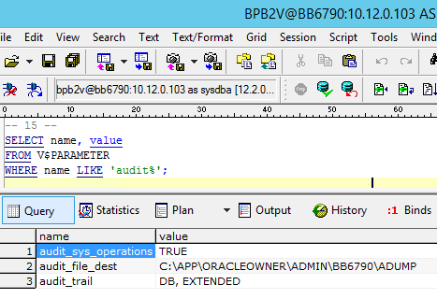

-- 16 --

AUDIT CREATE SESSION BY NORMALGUY;

AUDIT CREATE TABLE BY NORMALGUY;

AUDIT CREATE SESSION BY SUPERGAL;

AUDIT CREATE TABLE BY SUPERGAL;

-- 17 --

AUDIT SELECT ON DEFAULT BY ACCESS;

-- 18 --

/* logoff as bpb2v, logon as NORMALGUY */

CREATE TABLE People(

Person_ID INT,

Last_Name VARCHAR(255),

First_Name VARCHAR(255)

);

INSERT INTO People VALUES(1,'One','First');

INSERT INTO People VALUES(2,'Two','Second');

INSERT INTO People VALUES(3,'Three','Third');

INSERT INTO People VALUES(4,'Four','Fourth');

INSERT INTO People VALUES(5,'Five','Fifth');

SELECT * FROM People;

/* logoff as NORMALGUY, logon as bpb2v */

SELECT username,TIMESTAMP,action_name,sql_text

FROM dba_audit_trail ORDER BY timestamp;

