Benjamin Belden

INFS 6790

Dr. Stoney Brooks

Homework 5

October 11, 2018

1. I’m not 100% sure why my database wouldn’t start. I think that there were some data files missing. So my procedure was as documented in the following screenshots:  
   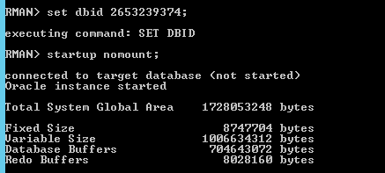

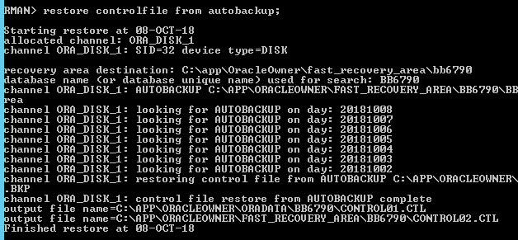  
  
  
  
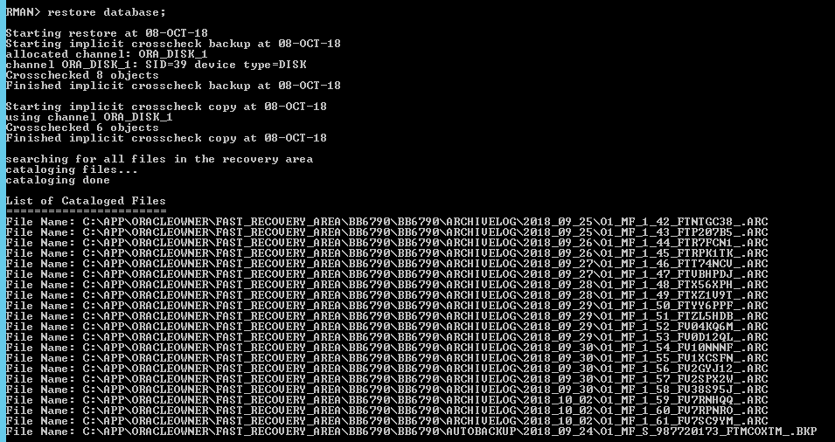  
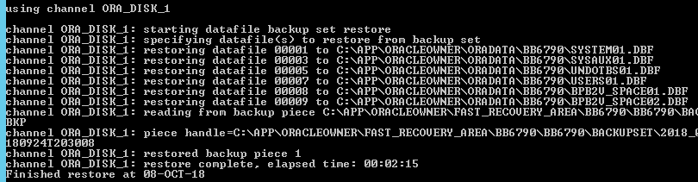  
  
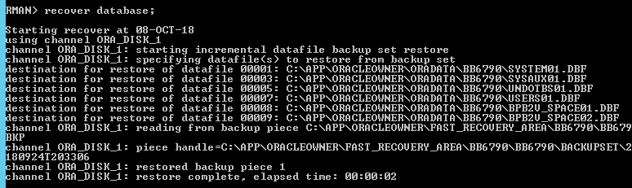  
  
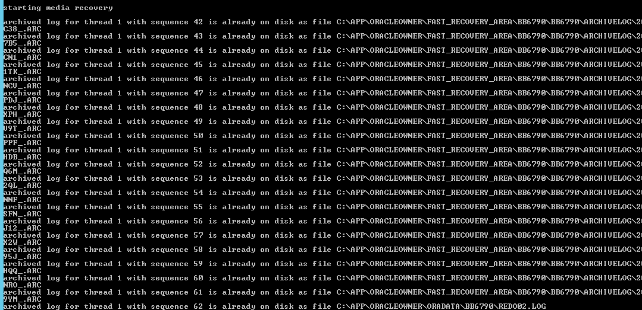  
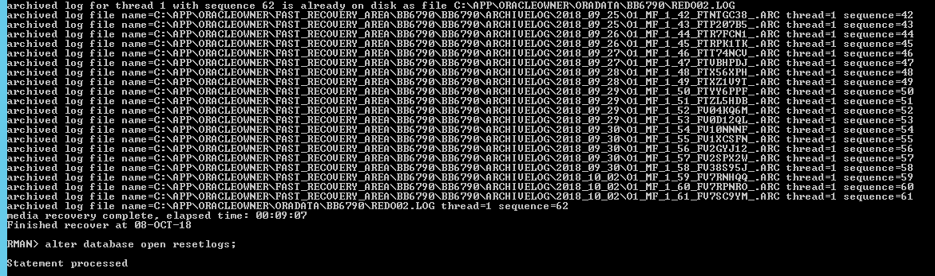  
  
Tada! I was able to connect!  
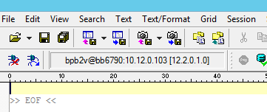  
  
I’m not sure if what I did was correct, as this was the first time I’ve done anything like this, but it sure was fun.

1. 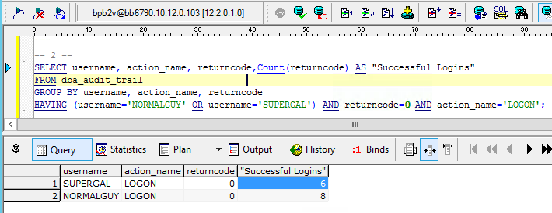
2. 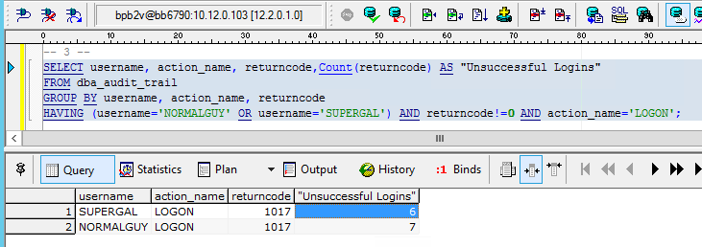
3. 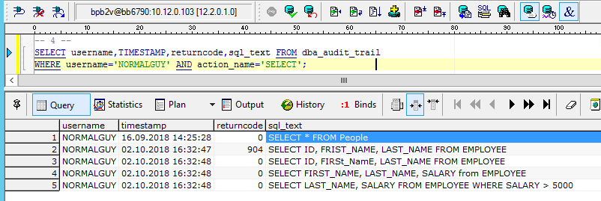
4. 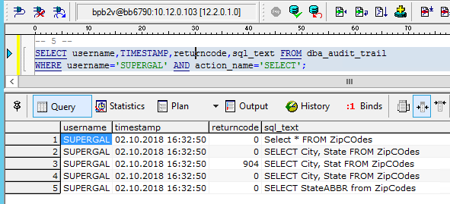
5. So, this is where things got a little hairy for me. First, from the wording on the assignment sheet, my understanding was that there should have only been one new table created by either NORMALGUY or SUPERGAL, but I found two new tables, one created by each of them.   
   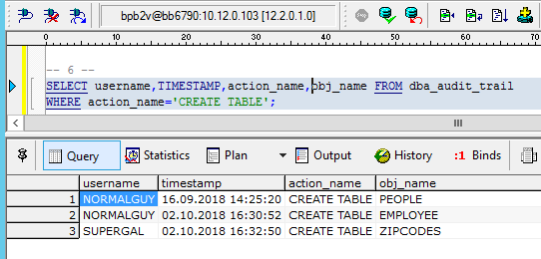  
     
     
     
     
     
     
     
     
     
     
     
     
     
     
   So, I screenshotted them both. NORMALGUY:  
   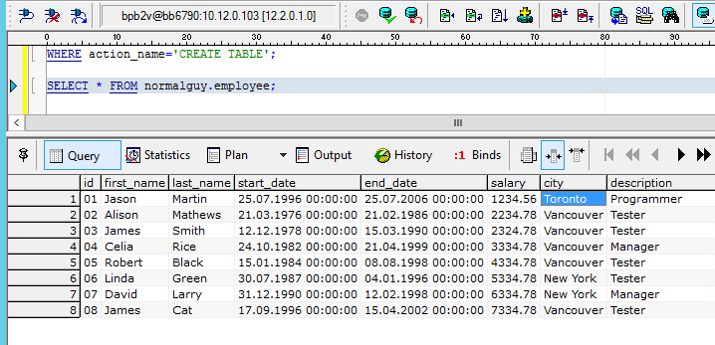  
     
   and SUPERGAL:  
   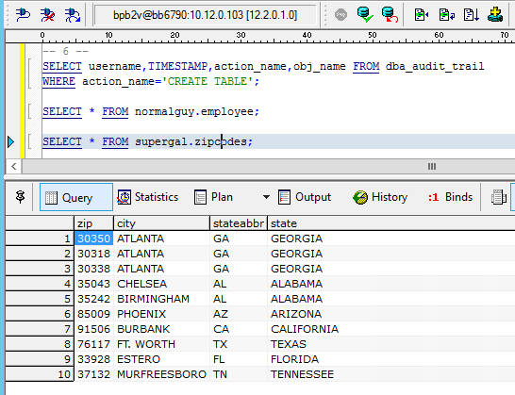  
     
     
     
     
     
     
     
   But then I was unable to do the flashback, because there was no flashback point:  
   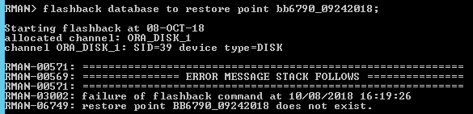  
     
   Just to make sure, I checked here:  
   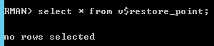  
     
   I knew I had set up flashback and set a flashback point though. From HW4:  
   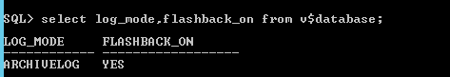  
     
     
   So, I don’t know. Perhaps I messed things up back in step #1.
6. My 15 items:
   1. In the table named DBA_DATA_FILES there is a column named AUTOEXTENSIBLE which indicates whether or not a particular data file is extensible. At the time of my query, the first row showed this value to be YES.
   2. In the table named DBA_DATA_FILES there is a column named INCREMENT_BY which indicates how many tablespace blocks to increment if the data file is set up to be automatically extensible. At the time of my query, the first row showed this value to be 1280 blocks.
   3. In the table named DBA_EXTENTS there is a column named SEGMENT_TYPE which indicates which type of segment a particular extent is. It can be either an index partition or a table partition. At the time of my query, the first row showed this value to be TABLE.
   4. In the table named DBA_TABLESPACES there is a column named MIN_EXTENTS which indicates the fewest number of extents a tablespace may have. This value may not be null. At the time of my query, the first row showed this value to be 2,147,483,645 which is close to the maximum value for a 32-bit system.
   5. In the table named DBA_SEGMENTS there is a column named SEGMENT_TYPE which indicates the type of segment a particular segment is. It can be one of the following values: index partition, table partition, table, cluster, index, rollback, deferred rollback, temporary, cache, lobsegment, or lobindex. At the time of my query, the first row showed this value to be CLUSTER.
   6. In the table named DBA_USERS there is a column named EXPIRY_DATE which indicates the date a particular account expires. At the time of my query, the first row showed this value to be 06.03.2019 10:01:56.
   7. In the table named DBA_ROLES there is a column named AUTHENTICATION_TYPE which indicates what type of authentication method would be used to connect to the database in a particular role, if any. The possible values can be: none, external, global, application, or password. At the time of my query, the first row showed this value to be NONE.
   8. In the table named V$FILESTAT there is a column named PHYRDS which indicates how many physical reads a particular file has had. At the time of my query, the first row showed this value to be 6582.
   9. In the table named V$DATAFILE there is a column named ENABLED which indicates what kind of access is allowed to a particular file from SQL. The possible values are: disabled, read only, write only, read write, or unknown. At the time of my query, the first row showed this value to be READ WRITE.
   10. In the table named V$PARAMETER there is a column named VALUE which indicates the value for a particular parameter for the current session only if it was modified in the session. Otherwise it will be the instance-wide value. At the time of my query, the first row showed this value to be <null>.
   11. In the table named V$PARAMETER there is a column named DEFAULT_VALUE which indicates the value given by the database if one is not expressly specified. At the time of my query, the first row showed this value to be NULL.
   12. In the table named V$LIBRARYCACHE there is a column named GETS which indicates how many times a lock was requested for objects in a particular namespace. At the time of my query, the first row showed this value to be 5600.
   13. In the table named V$LIBRARYCACHE there is a column named GETHITS which indicates how many times a particular namespace was found in memory. At the time of my query, the first row showed this value to be 2022.
   14. In the table named V$LOCK there is a column named ADDR which indicates the address of the item being locked. At the time of my query, the first row showed this value to be 00007FF78772BEB0.
   15. In the table named V$LOCK there is a column named KADDR which indicates the address of the lock. At the time of my query, the first row showed this value to be 00007FF78772BF30.