**Soil geochemistry – and not topography - as a major driver of canopy chemistry of African tropical montane forests**

**Research questions**

* What role do soils play as drivers of canopy chemistry in tropical montane forests? Can similar forests types (Afromontane forests) exhibit a substantial variation in canopy chemistry, driven by edaphic contrasts?
* Does topography explain more or rather less variation in canopy chemistry of tropical montane forests than soil geochemistry?
* Can soil geochemistry be used to understand large-scale ecosystems functioning in tropical montane forests?

**Research hypotheses**

1. We hypothesize that the canopy chemistry of tropical montane forests is strongly linked to the geochemical properties which soils derive from their local parent material.
2. We further hypothesize that the effects of geochemistry derived soil fertility indicators are stronger controls on canopy chemistry than the effects of local topography.

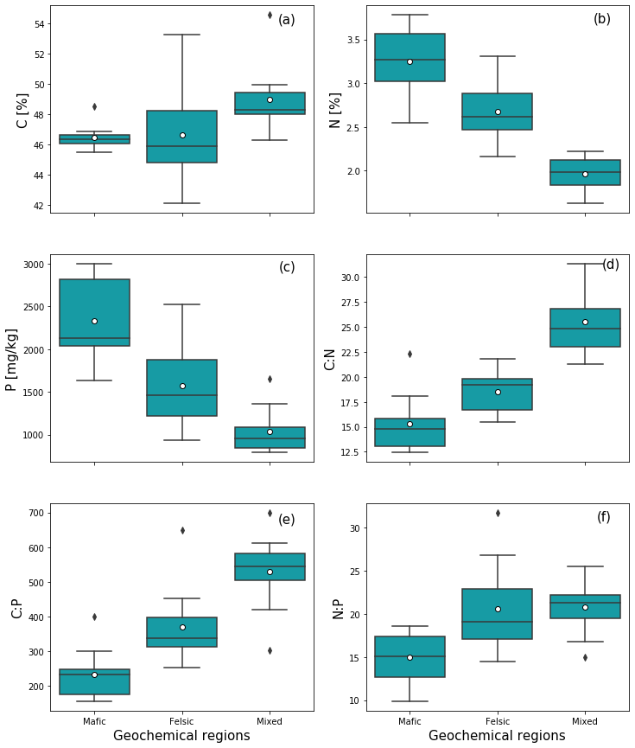

**Figure 1.** Community weighted concentration of major nutrients and their ratios in the canopy for the three investigated geochemical regions. (a) Leaf carbon content, (b) leaf nitrogen content, (c) leaf phosphorus content, (d) leaf carbon to nitrogen ratio, (e) leaf carbon to phosphorus ratio, (f) leaf nitrogen to phosphorus ratio. The white dot in the centre of the box plot represents the mean value. The weighting factor is the proportion of community basal area to the total basal area of the plot.

* The canopy chemistry differed between the three investigated geochemical regions
* The average leaf C content was higher in the mixed sediment region and lower in the mafic and felsic regions. But, there was no difference in mean leaf C content between sites in mafic and felsic regions
* There was a wider spread of leaf C content between communities in the felsic region compared to mafic and mixed sediment regions
* Leaf N and P content differed between geochemical regions with high N and P content in the mafic region followed by felsic and lower in mixed sediment regions
* CNP ratios differed between the three investigated regions, with higher canopy CN, CP, in the mixed region, followed by felsic and lower in the mafic region
* Both low uptake of N and P, as well as high CN, CP and NP, indicate a limitation of N and P in the mixed sediment region

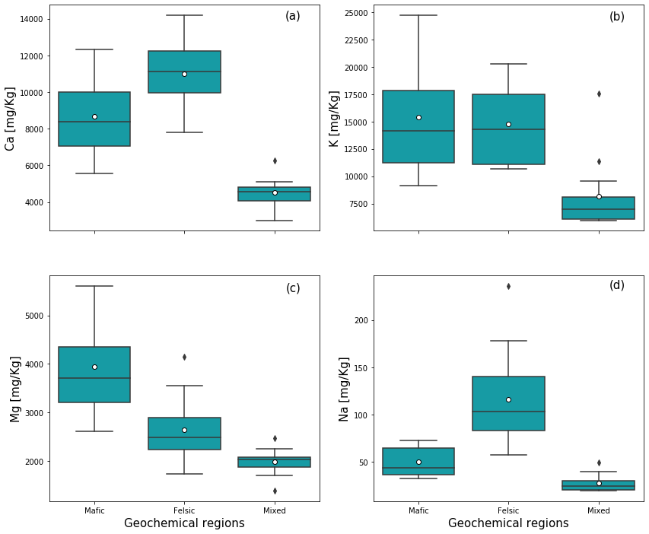

**Figure 2**. Community weighted mean concentration of base cations in the canopy for the three investigated geochemical regions. (a) leaf calcium content, (b) the leaf potassium content, (c) leaf magnesium content, (d) leaf sodium content. The white dot in the centre of the box plot represents the mean value. The weighting factor is the proportion of community basal area to the total basal area of the plot.

* Consistent with N and P, forests in the mixed sediment region uptake low amounts of rock derived nutrients (Ca, K, Mg & Na) compared to their counterpart mafic and felsic regions
* Mean leaf Ca content was higher in the felsic region, followed by mafic and lower in the mixed region
* Mean leaf K content was lower in the mixed region, but there was no difference in mean leaf K between forests in mafic and felsic regions
* Mean leaf Mg content differed between the three investigated regions with higher leaf Mg content in mafic, followed by felsic and lower in the mixed region
* Na plant uptake seemed to be important in the felsic region compared to their counterpart mafic and mixed regions. Mean leaf Na content was two-fold higher in felsic compared to the mafic region and about four times higher compared to the mixed sediment region

**3**

**Table 1.** Standardized effects size of rotated principal components (RC) as explanatory factors on leaf nitrogen, phosphorus, leaf CN, leaf CP, leaf NP, leaf calcium, leaf potassium, leaf magnesium, and leaf sodium. The estimates values indicate mean effects size, the 95% confidence intervals of the estimates, p-values, the R2 and adjusted R2 values as results of the linear regression models.

|  |  |  |  |  |  |  |
| --- | --- | --- | --- | --- | --- | --- |
|  | **Intependent variables** | **Estimates** | **CI (95%)** | **p-value** | **R2** | **R2.adj** |
| **N** | (Intercept) | 2.59 | 2.45 – 2.73 | **<0.001** | 0.62 | 60 |
|  | Soil exchangeable bases & base cation stocks | 0.02 | 0.01 – 0.03 | **<0.001** |  |  |
|  | Soil CNP & nutrient exchange | 0.05 | 0.02 – 0.09 | **0.006** |  |  |
|  | Soil texture | 0.11 | 0.05 – 0.17 | **0.001** |  |  |
| P | (Intercept) | 1605.28 | 1469.42 – 1741.13 | **<0.001** | 0.7 | 0.66 |
|  | Soil exchangeable bases & base cation stocks | 23.25 | 12.29 – 34.22 | **<0.001** |  |  |
|  | Soil CNP & nutrient exchange | 70.15 | 34.19 – 106.11 | **<0.001** |  |  |
|  | Soil texture | 126.61 | 66.34 – 186.89 | **<0.001** |  |  |
| **CN** | (Intercept) | 20.04 | 18.85 – 21.23 | **<0.001** | 0.6 | 0.55 |
|  | Soil exchangeable bases & base cation stocks | -0.2 | -0.30 – -0.11 | **<0.001** |  |  |
|  | Soil CNP & nutrient exchange | -0.45 | -0.77 – -0.14 | **0.007** |  |  |
|  | Soil texture | -0.72 | -1.24 – -0.19 | **0.01** |  |  |
| **CP** | (Intercept) | 386.32 | 351.95 – 420.69 | **<0.001** | 0.62 | 0.59 |
|  | Soil exchangeable bases & base cation stocks | -5.57 | -8.34 – -2.79 | **<0.001** |  |  |
|  | Soil CNP & nutrient exchange | -15.04 | -24.14 – -5.95 | **0.002** |  |  |
|  | Soil texture | -25 | -40.25 – -9.75 | **0.002** |  |  |
| **NP** | (Intercept) | 19.01 | 17.67 – 20.35 | **<0.001** | 0.39 | 0.31 |
|  | Soil exchangeable bases & base cation stocks | -0.06 | -0.17 – 0.05 | 0.276 |  |  |
|  | Soil CNP & nutrient exchange | -0.42 | -0.78 – -0.07 | **0.021** |  |  |
|  | Soil texture | -0.73 | -1.32 – -0.13 | **0.018** |  |  |
| **Ca** | (Intercept) | 8029.43 | 7504.70 – 8554.17 | **<0.001** | 0.81 | 0.79 |
|  | Soil exchangeable bases & base cation stocks | 230.83 | 188.49 – 273.17 | **<0.001** |  |  |
|  | Soil CNP & nutrient exchange | 10.37 | -128.54 – 149.28 | 0.88 |  |  |
|  | Soil texture | -33.7 | -266.52 – 199.12 | 0.77 |  |  |
|  | (Intercept) | 12608.1 | 11201.68 – 14014.61 | **<0.001** | 0.46 | 0.4 |
| **K** | Soil exchangeable bases & base cation stocks | 223.65 | 110.17 – 337.14 | **<0.001** |  |  |
|  | Soil CNP & nutrient exchange | 124.66 | -247.66 – 496.98 | 0.499 |  |  |
|  | Soil texture | 798.17 | 174.13 – 1422.21 | **0.014** |  |  |
| **Mg** | (Intercept) | 2796.81 | 2529.77 – 3063.85 | **<0.001** | 0.53 | 0.49 |
|  | Soil exchangeable bases & base cation stocks | 30.17 | 8.62 – 51.71 | **0.008** |  |  |
|  | Soil CNP & nutrient exchange | 73.41 | 2.72 – 144.10 | **0.042** |  |  |
|  | Soil texture | 213.99 | 95.51 – 332.48 | **0.001** |  |  |
| **Na** | (Intercept) | 65.6 | 54.77 – 76.42 | **<0.001** | 0.65 | 0.62 |
|  | Soil exchangeable bases & base cation stocks | 3.03 | 2.16 – 3.91 | **<0.001** |  |  |
|  | Soil CNP & nutrient exchange | -3.43 | -6.29 – -0.56 | **0.021** |  |  |
|  | Soil texture | -1.87 | -6.67 – 2.93 | 0.432 |  |  |

* Overall, we estimated with 95% confidence that the three RCs representing geochemical soil properties, significantly explain the variance observed in the canopy chemistry of the investigated tropical montane forests in three geochemical regions
* Depending on the elements, geochemical soil properties explained 40-81 % of the variance observed in the canopy chemistry with the highest explanatory power observed on leaf Ca content and the lowest on leaf K content
* In general, soil texture and soil exchangeable bases & base cation stocks emerged as the most important drivers of canopy chemistry.

|  |  |  |  |  |  |  |
| --- | --- | --- | --- | --- | --- | --- |
|  |  |  |  |  |  |  |
|  |  |  |  |  |  |  |
|  |  |  |  |  |  |  |
|  |  |  |  |  |  |  |
|  |  |  |  |  |  |  |
|  |  |  |  |  |  |  |
|  |  |  |  |  |  |  |
|  |  |  |  |  |  |  |
|  |  |  |  |  |  |  |
|  |  |  |  |  |  |  |
|  |  |  |  |  |  |  |
|  |  |  |  |  |  |  |
|  |  |  |  |  |  |  |
|  |  |  |  |  |  |  |
|  |  |  |  |  |  |  |
|  |  |  |  |  |  |  |
|  |  |  |  |  |  |  |
|  |  |  |  |  |  |  |
|  |  |  |  |  |  |  |
|  |  |  |  |  |  |  |
|  |  |  |  |  |  |  |
|  |  |  |  |  |  |  |
|  |  |  |  |  |  |  |
|  |  |  |  |  |  |  |
|  |  |  |  |  |  |  |
|  |  |  |  |  |  |  |
|  |  |  |  |  |  |  |
|  |  |  |  |  |  |  |
|  |  |  |  |  |  |  |
|  |  |  |  |  |  |  |
|  |  |  |  |  |  |  |
|  |  |  |  |  |  |  |
|  |  |  |  |  |  |  |
|  |  |  |  |  |  |  |
|  |  |  |  |  |  |  |
|  |  |  |  |  |  |  |
|  |  |  |  |  |  |  |
|  |  |  |  |  |  |  |
|  |  |  |  |  |  |  |
|  |  |  |  |  |  |  |
|  |  |  |  |  |  |  |
|  |  |  |  |  |  |  |
|  |  |  |  |  |  |  |
|  |  |  |  |  |  |  |
|  |  |  |  |  |  |  |
|  |  |  |  |  |  |  |
|  |  |  |  |  |  |  |
|  |  |  |  |  |  |  |
|  |  |  |  |  |  |  |
|  |  |  |  |  |  |  |
|  |  |  |  |  |  |  |
|  |  |  |  |  |  |  |
|  |  |  |  |  |  |  |
|  |  |  |  |  |  |  |
|  |  |  |  |  |  |  |
|  |  |  |  |  |  |  |
|  |  |  |  |  |  |  |
|  |  |  |  |  |  |  |
|  |  |  |  |  |  |  |
|  |  |  |  |  |  |  |
|  |  |  |  |  |  |  |
|  |  |  |  |  |  |  |
|  |  |  |  |  |  |  |



**Appendices: Figures**

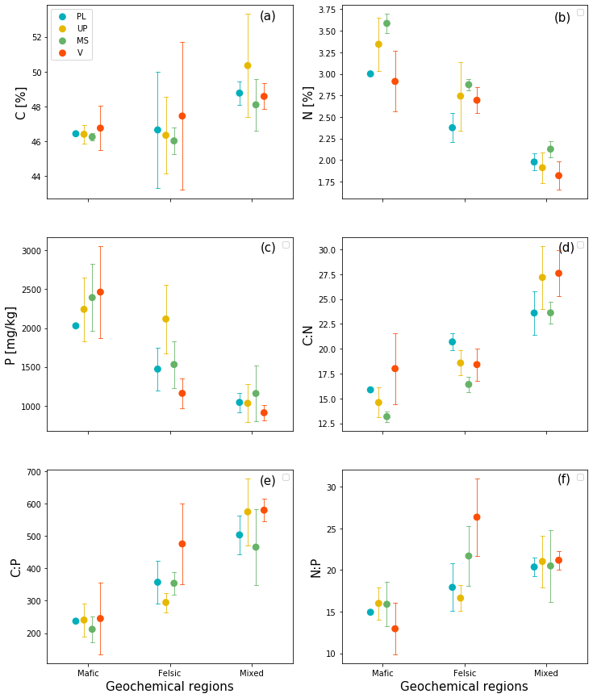

**Figure A1**. Community weighted mean concentrations of major nutrients in the canopy along topographic positions (PL: Plataue, UP: Upper slope, MS: Midslope, V: Valley) for the three investigated geochemical regions. . (a) Leaf carbon content, (b) leaf nitrogen content, (c) leaf phosphorus content, (d) leaf carbon to nitrogen ratio, (e) leaf carbon to phosphorus ratio, (f) leaf nitrogen to phosphorus ratio. The weighting factor is the proportion of community basal area to the total basal area of the plot.

* Leaf C content in mafic and felsic regions decreased with slope and then increased in the valley positions. There were no consistent patterns in leaf C content related to topographic positions in the mixed sediment region
* Leaf N content in the mafic and felsic region increased with slope and then decreased in the valleys. In contrast, leaf N content in the mixed sediment region tended to decrease with the slope, with high leaf N on midslopes
* Leaf P content increased with the slope in mafic only but not in the felsic and mixed sediment regions. Instead, P tended to decrease with the slope in the felsic and mixed sediment regions
* Leaf CN decreased with slope and then increased in the valley positions in mafic and felsic regions but not in mixed sediment region. There were no consistent patterns in leaf CN related topographic positions observed in the mixed sediment region
* There were no consistent patterns in leaf CP & NP content related topographic positions across the three investigated geochemical regions

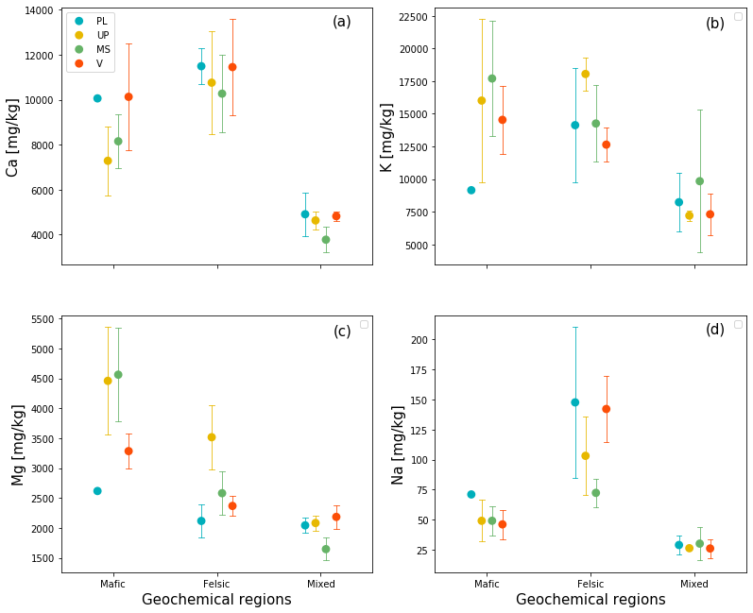

**Figure A2.** Community weighted mean concentration of base cations in the canopy along topographic positions (PL: Plataue, UP: Upper slope, MS: Midslope, V: Valley) for the three investigated geochemical regions. (a) leaf calcium content, (b) the leaf potassium content, (c) leaf magnesium content, (d) leaf sodium content. The weighting factor is the proportion of community basal area to the total basal area of the plot.

* In general, leaf Ca content was higher in valley positions compared to non-valley positions across the investigated geochemical regions and leaf Ca content tended to decrease with the slope in the felsic and mixed sediment regions but not in the mafic region
* No consistent patterns in leaf K content were detected in relation to the local topographic positions across the three investigated geochemical regions
* For Mg, there were no consistent patterns detected in relation to the local topographic positions across the investigated geochemical regions
* For Na, in the mafic region, leaf Na decreased with slope. In the felsic region, leaf Na decreased with slope but then increased in the valley position. There was no difference in mean leaf Na content between topographic positions in the mixed sediment region.

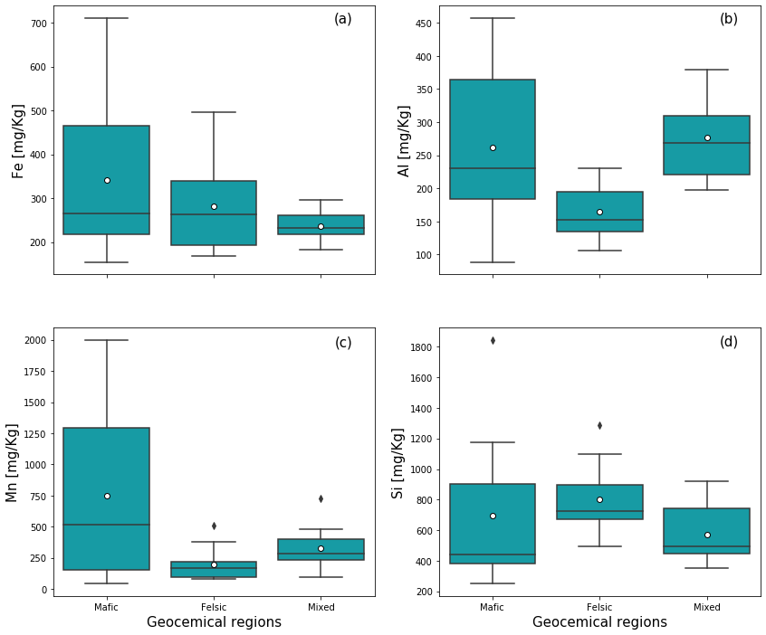

**Figure A3.** Community weighted mean concentration of micronutrients in the canopy for the three investigated geochemical regions. (a) Leaf iron content, (b) leaf aluminium content, leaf manganese content, and leaf silicon content. The white dot in the centre of the box plot represents the mean value. The weighting factor is the proportion of community basal area to the total basal area of the plot.

* Leaf Fe content differed between geochemical regions. Leaf Fe content was higher in the mafic region, followed by felsic and lower in the mixed sediment region
* Leaf Al content was lower in the felsic region but there was no difference in mean Al content between mafic and the mixed regions
* Despite the low amount of Mn in deeply weathered tropical soils, Mn plant uptake differed between regions with higher leaf Mn content observed in the mafic region. There was no difference in leaf Mn content between felsic and mixed sediment regions. Furthermore, the spread of leaf Mn between forest sites in the mafic region was wider compared to their counterpart forest sites developed on felsic and mixed sediment
* The mean Si uptake was similarly lower across all investigated regions and the spread of leaf Si content was narrow

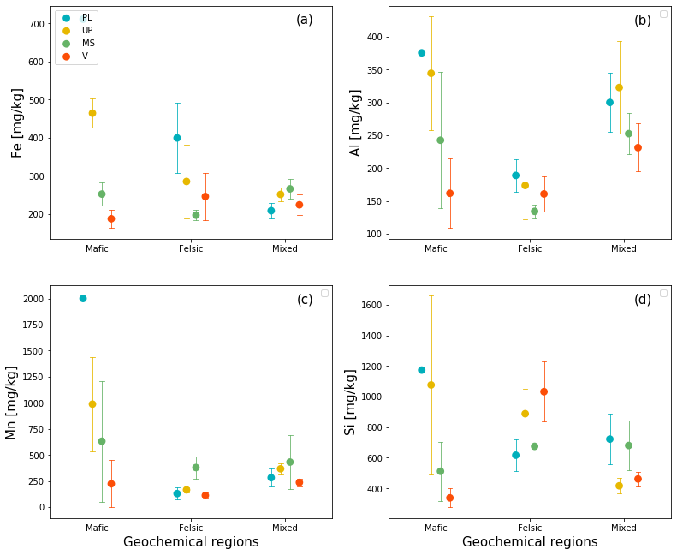

**Figure A4**: Community weighted mean concentration of micronutrients in the canopy along topographic positions (PL: Plataue, UP: Upper slope, MS: Midslope, V: Valley) for the three investigated geochemical regions. (a) Leaf iron content, (b) leaf aluminium content, leaf manganese content, and leaf silicon content. The weighting factor is the proportion of community basal area to the total basal area of the plot.

* In general, within each geochemical region, we found patterns in micronutrients related to local topographic positions
* Valley positions were depleted in leaf micronutrients
* Leaf Fe content decreased along with the slope and patterns related to the slope positions were strong in mafic compared to felsic and mixed regions. In the felsic region, leaf Fe decreased with slope but then increased in the valley positions. In contrast, in the mixed sediment region, leaf Fe increased with slope but then decreased in the valley position
* Leaf Al content decrease along with the slope across all regions except in the valley positions of the felsic region
* For Mn, in the mafic region, leaf Mn content decreased with slope but not in the felsic and mixed sediment regions. In felsic and mixed sediment regions, leaf Mn was higher on sloping positions compared to plateau and valley positions
* Leaf Si decreased along with the slope in the mafic while it increased with the slope in the felsic region. There were no consistent patterns in leaf Si related to topography in the mixed sediment region

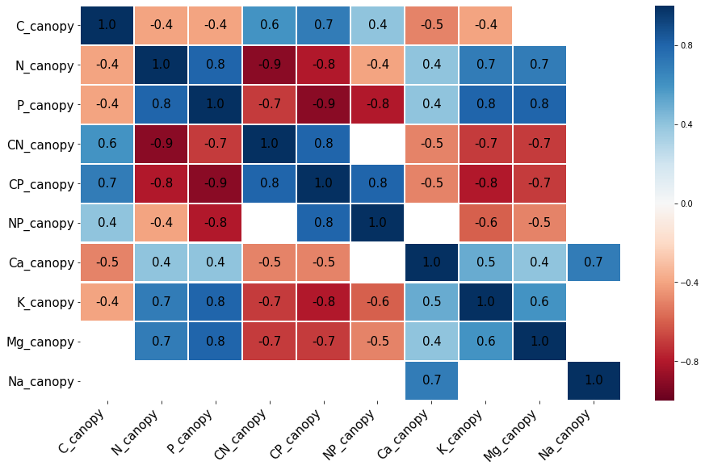

**Figure A5.** Pearson correlations between elemental composition of the canopy chemistry (leaf carbon, leaf nitrogen content, leaf phosphorus content, leaf CN ratio, leaf NP ratio, leaf CP ratio, leaf calcium content, leaf potassium, leaf magnesium content, and leaf sodium content ). Blank cells indicate non-significant correlations, p-value ≤ 0.05.

* The elemental composition of the canopy chemistry was strongly interrelated
* The uptake of major nutrients especially N and P was significantly related to the uptake of base cations K and Mg
* Leaf CN, CP and NP ratios were strongly correlated with canopy Ca, K and Mg

**Appendices: Tables**

**B**

|  |  |  |  |  |  |  |
| --- | --- | --- | --- | --- | --- | --- |
|  |  |  |  |  |  |  |
|  |  |  |  |  |  |  |
|  |  |  |  |  |  |  |
|  |  |  |  |  |  |  |
|  |  |  |  |  |  |  |
|  |  |  |  |  |  |  |
|  |  |  |  |  |  |  |
|  |  |  |  |  |  |  |
|  |  |  |  |  |  |  |
|  |  |  |  |  |  |  |
|  |  |  |  |  |  |  |
|  |  |  |  |  |  |  |
|  |  |  |  |  |  |  |
|  |  |  |  |  |  |  |
|  |  |  |  |  |  |  |
|  |  |  |  |  |  |  |
|  |  |  |  |  |  |  |
|  |  |  |  |  |  |  |
|  |  |  |  |  |  |  |
|  |  |  |  |  |  |  |
|  |  |  |  |  |  |  |
|  |  |  |  |  |  |  |
|  |  |  |  |  |  |  |
|  |  |  |  |  |  |  |
|  |  |  |  |  |  |  |
|  |  |  |  |  |  |  |
|  |  |  |  |  |  |  |
|  |  |  |  |  |  |  |
|  |  |  |  |  |  |  |
|  |  |  |  |  |  |  |
|  |  |  |  |  |  |  |
|  |  |  |  |  |  |  |
|  |  |  |  |  |  |  |
|  |  |  |  |  |  |  |
|  |  |  |  |  |  |  |
|  |  |  |  |  |  |  |
|  |  |  |  |  |  |  |
|  |  |  |  |  |  |  |
|  |  |  |  |  |  |  |
|  |  |  |  |  |  |  |
|  |  |  |  |  |  |  |
|  |  |  |  |  |  |  |
|  |  |  |  |  |  |  |
|  |  |  |  |  |  |  |
|  |  |  |  |  |  |  |
|  |  |  |  |  |  |  |
|  |  |  |  |  |  |  |
|  |  |  |  |  |  |  |
|  |  |  |  |  |  |  |
|  |  |  |  |  |  |  |
|  |  |  |  |  |  |  |
|  |  |  |  |  |  |  |
|  |  |  |  |  |  |  |
|  |  |  |  |  |  |  |
|  |  |  |  |  |  |  |
|  |  |  |  |  |  |  |
|  |  |  |  |  |  |  |
|  |  |  |  |  |  |  |
|  |  |  |  |  |  |  |
|  |  |  |  |  |  |  |
|  |  |  |  |  |  |  |
|  |  |  |  |  |  |  |
|  |  |  |  |  |  |  |

**Table B2**. Rotated principal component analysis for four principal components (RC) that were retained with Eigenvalues >1 and proportion variance ≥10 %. The upper part of the table shows eigenvalues, proportional, cumulative variance and mechanistic interpretation of specific RCs. The bottom part represents loadings. Blank cells indicate that variables are not represented by the corresponding RCs and the loadings of those variables onto the RC are near or equal to zero.

|  |  |  |  |  |
| --- | --- | --- | --- | --- |
| Rotated components |  | RC1 | RC2 | RC3 |
| Eigenvalue |  | 12.6 | 4.0 | 2.3 |
| Proportion variance (%) |  | 0.6 | 0.2 | 0.1 |
| Cumulative variance (%) |  | 0.6 | 0.8 | 0.9 |
|  |  |  |  |  |
| Mechanistic  interpretation |  | Soil exchangeable  bases & base cation stocks | Soil CNP & nutrient exchange | Soil texture |
| Independent variables | Units |  |  |  |
| TC_bulk | % | -0.5 | 0.7 |  |
| TN_bulk | % |  | 1.0 |  |
| P_avail | 0.01 me g-1 | 0.7 |  |  |
| clay | % |  |  | 0.8 |
| silt | % |  |  | -1.0 |
| sand | % | -0.4 |  | 0.4 |
| pH_KCL |  | 0.9 |  |  |
| bases_in_CEC | % | 0.9 | -0.4 |  |
| CEC | 0.01 me g-1 |  | 0.9 |  |
| bases_in_ECEC | % | 1.0 |  |  |
| ECEC | 0.01 me g-1 | 0.9 |  |  |
| exch_bases_Mg | 0.01 me g-1 | 1.0 |  |  |
| exch_bases_Ca | 0.01 me g-1 | 1.0 |  |  |
| exch_bases_K | 0.01 me g-1 | 1.0 |  |  |
| exch_base | 0.01 me g-1 | 1.0 |  |  |
| exch_acidity_Al | 0.01 me g-1 | -0.9 |  |  |
| Ca_soil | % | 1.0 |  |  |
| K_soil | % | 0.9 |  |  |
| Mg_soil | % | 0.8 | 0.6 |  |
| Na_soil | % | 0.6 |  | 0.6 |
| TRB_soil | % | 0.9 |  |  |
| P_soil | % |  | 0.8 |  |

* The rotated principal components analysis (rPCA) yielded three rotated components
* Altogether the three RCs explained 90 % of the variance observed in the independent variables
* The first RC explained 60 % of the variance observed in the independent variables, the second RC explained 20 % while the third RC explained 10 % of the variance observed in the independent variables
* We interpreted was loaded with exchangeable bases and total base cations hence, we interpreted the first RC as being related to exchangeable base cations and base cation stocks, the second was loaded with CNP and CEC, we interpreted it as being related to soil CNP and soil nutrient exchange capacity and the third RC was loaded with clay and sand content, we interpreted it as being related to soil texture