RISC-V emulator

Workflow of the CPU:
- Fetch instruction from memory
- Decode instruction
- Execute instruction
- Increase program counter
- Go back to step 1.

Important details of RISC-V 64 bits:
- 64 general-purpose register (from 0 to 31)
  - 0th register always contains a zero
  - each register has the size of 64 bits
- PC (program counter)
  - counts which instruction are we at
  - doesn’t stored in the general-purpose registers
- Instructions has the size of 32 bits

Instruction formats:
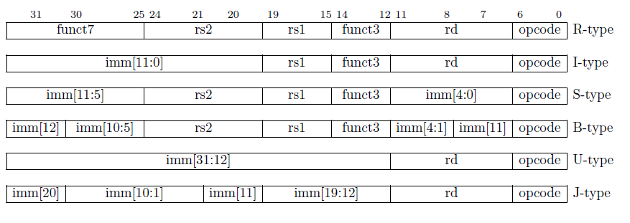
- Six basic instruction formats:
  - R-type for register-register operations
  - I-type for immediate and load operations
  - S-type for store operations
  - B-type for conditional branch operations (the full immediate must be reconstructed)
  - U-type for long immediate instructions
  - J-type for unconditional jumps
- Notations:
  - opcode: Code of the exact operation (eg: plus)
  - rd: Destination register
  - rs1/2: Source register 1/2
  - funct3/7: Sub functions of the operations defined in opcode
  - imm: immediate value (basically hard coded integers)

Instructions needed to be implemented:
- li Load Immediate (U-Type)
  - loading an integer into a register
- mulw MULtiply Word (R-Type, funct3)
  - only works on 64 bit versions
  - takes the lower 32 bits as signed of r1 and r2 and multiplies them into the rd 64 bit register
- beqz Jumps when register is zero (because it’s a more specific version of beq it is B-Type)
  - It check if r1 is zero, if yes sets the pc to the immediate value (jumps)
- add adds two register together (R-type)
- addi add immediate to register value (I-type)
- j jumps to label (what is basically an immediate) (J-type)
- jal jump and link (J-type)
  - basically like calling a function.
  - it saves to the current program counter in rd, then sets the pc to the immediate value
  - if we want to go back to where jal is called we just jump to the value stored in rd
- lw Loads 32 bit value into rd (I-Type)
- sw Stores lower 32 bit of rs2 into rd (S-Type)
- ret Return (I-Type)
  - Returns to the ra value which was saved by the jal

