The effect of marine heatwaves on Anthopleura elegantissima and its algal symbionts

by

Caitlin Bergman and Elizabeth Blanchette
A report submitted in partial fulfilment of the requirements of
Directed Studies and Applied Data Analysis

at
Bamfield Marine Sciences Centre

Instructor: Daniel Wuitchuk and Dr. Sara Wuitchuk
Teaching Assistant: Jenna Fleet

©Caitlin Bergman, 12/2021
Home University: University of Victoria

© Elizabeth Blanchette, 12/2021
Home University: University of Alberta

Abstract
Anthopleura elegantissima is a temperate sea anemone whose facultative symbiosis with photosynthetic algae is a model system for better understanding the cnidarian-algal symbioses that are foundational to many marine ecosystems. We propose two alternative hypotheses on the response of A. elegantissima and its symbionts to marine heatwaves: H1) that symbiont stress will increase at increased temperatures or H2) that anemone host stress will increase at increased temperatures. We collected anemones from 3 locations in Barkley Sound, British Columbia and randomly assigned them to control, 25°C, and 30°C treatments. To simulate marine heatwave conditions, we increased the water temperature of each of our treatments over the course of six hours, and repeated this temperature ramp for three days total. We measured photosynthetic efficiency, symbiont density, symbiont mitotic index, anemone base diameter, anemone feeding time, and anemone behavioural responses throughout the experiment. Immediately after the heatwave, symbionts showed some signs of stress in our 25°C treatment and anemones showed some signs of stress in our 30°C treatment. By the end of the recovery period however, photosynthetic efficiency and symbiont density recovered and we saw no negative impacts on anemone health. Our results suggest that A. elegantissima in tidepools are resilient to short term marine heatwaves and that symbionts may acclimatize to heat during variable temperature increases.

Keywords
Sea anemone, intertidal, climate change, PAM fluorometry, symbiosis, zooxanthellae

Introduction
More and more, we are discovering that symbiotic relationships are ubiquitous in nature and integral to ecosystems. In marine ecosystems, the obligate symbioses of many corals and photosynthetic algae are foundational to supporting biodiversity (Baker et al., 2008). These are obligate, mutual symbioses, where the coral hosts rely on sugars produced by the photosynthesizing algae to survive (Falkowski et al., 1984). Coral bleaching is used to describe when symbionts have lost photosynthetic pigments or have left their host, and can lead to reduced growth rate, reduced reproductive success, or death of the coral (Glynn, 1993). Disruptions to this host-symbiont relationship can have community-level impacts; for example, coral bleaching can lead to erosion and declines in reef fish diversity (Baker et al., 2008).

As we develop a better understanding of the benefits and costs that symbionts and hosts incur from their close association, we can better predict the responses of these organisms to environmental stressors. This is especially important in the context of climate change, which will have unexpected effects on organisms through both long-term environmental changes and a higher frequency of extreme weather events such as storms and heatwaves (Oliver et al., 2018). We know that increasing sea surface temperatures are the most common cause of coral reef bleaching (Baker et al., 2008), but less is known about the individual thermal tolerances and physiological responses of the symbiont and host to increasing temperature. By understanding the effects of environmental stress on each organism in a symbiotic relationship, as well as how these effects interact, we can better understand how symbiotic organisms will respond to these changes.

Anthopleura elegantissima (Brandt) is a temperate anemone species in the phylum Cnidaria (Class: Anthozoa), and is found in the rocky intertidal from Alaska, U.S. to Baja California, Mexico (Secord and Augustine, 2000). A. elegantissima forms mutual symbiotic relationships with two groups of endosymbiotic algae: zooxanthellae (dinoflagellate symbionts), and zoochlorellae (green algal symbionts) (Muscatine, 1971). An individual anemone may have one or both types of symbionts. Both of these symbionts translocate photosynthetic carbon to the anemone host (Peng et al., 2020). In return, the anemone provides nutrients to the algal symbionts, as well as providing a stable structure and access to sunlight (Peng et al., 2020). This is comparable to the symbiotic relationships found in corals, which also host zooxanthellae (Shaffer, 2018). However, A. elegantissima has a facultative relationship with its algal symbionts; it can live either symbiotically (high densities of photosynthetic symbionts) or aposymbiotically (without photosynthetic symbionts) (Bedgood et al., 2020). This most likely evolved because A. elegantissima lives in temperate, nutrient-rich waters, where prey is more abundant than in tropical ecosystems (Bedgood et al., 2020). This species is frequently used as a model organism for investigating cnidarian-algal symbiotic relationships, because the facultative relationship allows for changes in the symbiotic relationship to be studied without killing the host (Shaffer, 2018). This also provides a unique opportunity to distinguish between the responses of the host and symbiont to different environmental factors.

Although both the anemone host and the symbionts receive a net benefit, there are still evolutionary tradeoffs to this association. In some conditions, these tradeoffs will outweigh the benefits of the relationship, and the anemone may no longer maintain a symbiont population. A. elegantissima have been shown to lose their photosynthetic symbionts in a variety of conditions, including low light levels (Weis and Levine, 1996), high temperatures (Engebretson and Muller-Parker, 1999), and high UV exposure (Lesser, 1996). In some cases, symbiont loss occurs because environmental conditions are beyond the range of tolerance for the algal symbionts and cause the symbionts to die (Muller-Parker et al., 2007). In other cases, the algae are able to survive, but the relationship is no longer beneficial to the anemone. One of the major causes of this is the production of reactive oxygen species (ROS) by the algae (Lesser, 1996). ROS are produced as a byproduct of photosynthesis, and in high concentrations they can cause damage to cellular proteins and DNA in the anemone (Sies et al., 2017). When this occurs, the anemone will actively regulate its symbiont population by expelling excess algal cells in a bolus of mucus, or by restricting nutrients that are required for algal growth (McCloskey et al., 1996).

There are many studies focused on the thermal tolerances of zooxanthellae and zoochlorellae symbionts in A. elegantissima when exposed to moderate, long-term increases in temperature, ranging from 26 days to 6 months (Saunders and Muller-Parker, 1997; Tsuchida and Potts, 1994). A study by Secord and Augustine (2000) found that zoochlorellae have a lower temperature tolerance and are restricted to northern latitudes, while zooxanthellae can tolerate a wider temperature range and are found throughout the range of A. elegantissima. This was also observed by Saunders and Muller-Parker (1997), who found that the mitotic index and cell density of zoochlorellae decrease at 20°C, while zooxanthellae were not affected. In tropical coral species, zooxanthellae have been found to be negatively affected by temperatures of 38°C, with decreases in both cell density and photosynthetic efficiency (Kuanui et al., 2015). These effects will likely impact how these organisms respond to climate change, and could potentially limit future geographic range expansion that is predicted to occur in response to increasing water temperatures (Prather et al., 2012).

Although there are many studies focused on the responses of A. elegantissima and its symbionts to long term, moderate temperature stress, our understanding of how this relationship will respond to acute temperature stress such as marine heatwaves is limited. Marine heatwaves have increased in frequency and duration over the last few decades, with as much as a 54% increase in the number of marine heatwave days over the last century (Oliver et al., 2018). In our study, we investigate two questions regarding the responses of A. elegantissima and its algal symbionts to marine heatwaves: will symbionts leave the host as a result of a marine heatwave? Will heat stress have a negative impact on the anemone, algal symbionts, or both, or neither?

We propose two alternative hypotheses that may occur: H1) heat wave events will cause algal symbionts to be negatively impacted by heat stress as the algae are exposed to temperatures beyond their physiological tolerance, and H2) heat wave events will negatively impact A. elegantissima, causing them to expel their algal symbionts due to an increase in the production of harmful byproducts of photosynthesis. If H1 is supported, we predict a decrease in photosynthetic efficiency and cell density of the algal symbionts and no changes in anemone base diameter and feeding time. If H2 is supported, we predict a decrease in the cell density of algal symbionts and decreases in base diameter and feeding time of the anemones. Analyzing these measurements will allow us to investigate our hypotheses and contribute to broader knowledge on host-symbiont relationships and the impacts of marine heat waves.

Materials and Methods
Anemone collection and care

We collected Anthopleura elegantissima during the month of October 2021 from the intertidal zone of three sites in Barkley Sound, British Columbia. We collected from the Bamfield Marine Science Center (BMSC) (48°50’07”N 125°08’10”W) on October 21 and 22, Eagle Bay (48°50’03”N 125°08’48”W) on October 23 and 26, and Bluestone Point (48°49’03”N 125°09’57”W) on October 30 (nBluestone Point= 14, nEagle Bay = 11, nBMSC = 20, Ntotal = 45). Anemones with a base diameter of less than 2 cm were excluded due to the difficulty of collecting tentacles from these anemones.

We acclimated the anemones to lab conditions for a period of one to two weeks prior to the start of the experiment. Acclimation periods varied because anemone collection was dependent on weather conditions, and anemones at Bluestone Point could not be collected until a safe weather window on October 30. At the time of collection, we placed each anemone into a separate container to prevent interaction between individuals. Each container had at least one stone for the anemone to attach to. We placed the containers into a sea table with flowing seawater, at a salinity of approximately 35 ppt and a temperature of 12°C. We maintained a photoperiod schedule of 12L:12D to approximate summer daylight hours. Summer daylight hours were used in order to replicate summer heatwave conditions, to the best extent possible with the available equipment. The anemones were fed small fish pieces every four days.

Experimental treatments

After acclimation, we randomly assigned anemones to one of three treatment groups (12°C control, 25°C heatwave, or 30°C heatwave), with 15 individuals in each treatment. Within each treatment, there were 5 aquarium replicates, which were bins with independent water flow and air supply. Each replicate had 3 anemones to account for individual variation (Fig. 1). We carried out a simulated heatwave over a three-day period for the 25°C and 30°C treatments. These treatments were designed to mimic the effects of extreme heat conditions within a tide pool at low tide.

During each day of the heatwave, the anemones were subjected to a 6-hour heat exposure event, followed by a ‘recovery’ period that mimicked the tide returning. We turned off the water flow to the anemones to simulate low tide and the water temperature was gradually raised to the maximum heatwave temperature for each treatment. The increasing temperature ramp was achieved in approximately 3 hours, the anemones were held at the treatment heatwave temperature for 3 hours, then the water temperature was gradually ramped down to control temperatures. In the 25°C treatment, the water reached an average temperature of 24-25°C in the last 3 hours of each heat period (Fig. 2). However, in the 30°C treatment, the actual temperature that was reached varied between days, due to problems with the electrical system during the heatwave. The 30°C treatment reached a higher temperature than the 25°C treatment on all days, but only reached 30°C on the final day of the heatwave (Fig. 2). We repeated this temperature ramp for each day of the heatwave, and then the recovery of the anemones was monitored for five days under control conditions.

Photosynthetic efficiency

We quantified photosynthetic efficiency of the algal symbionts using pulse amplitude moderated (PAM) fluorometry. The anemones were removed from sea tables and covered for 20 minutes for dark acclimation, then the dark-adapted yield (F_{v}/F_{m}) was measured using a Junior-PAM fluorometer (Walz GmbH, Effeltrich, Germany). For each anemone, three measurements were taken at different points at the top of the column (the main body, not including the tentacles). If the anemone was open, it was disturbed so that it would close and the measurement could be taken. We performed PAM fluorometry measurements at the beginning and end of acclimation to monitor how photosynthetic efficiency changed due to lab conditions. Measurements were taken twice per day during heatwave treatments to compare photosynthetic efficiency before and after an acute heat wave event, and the cumulative response after the second and third days. To measure photosynthetic efficiency immediately after each heat event, water was turned on again for 30 minutes after the experiment and then anemones were dark acclimated for 20 minutes before PAM measurements. Finally, PAM measurements were taken at the beginning and end of recovery. Measurements on the second day of the heatwave (November 7) were excluded from analysis due to technical errors during data collection.

Algal cell density and mitotic index

Two to three tentacles were removed from each anemone one week before the heatwaves, on the first and last days of the three-day heatwave, and after five days of recovery. The tentacles were frozen in filtered seawater at -20°C for subsequent processing. The tentacles were then thawed, weighed, homogenized with a mortar and pestle, and diluted with 0.5 mL of seawater. The total number of cells and the number of dividing cells were counted for each symbiont species (zooxanthellae and zoochlorellae) using a hemocytometer. These cell counts were used to calculate the cell density (measured as the number of cells per gram of tentacle tissue) and the mitotic index (the ratio of dividing cells to total cells) for each species. The mitotic index was used as a proxy for population growth rate. The two symbiont types can be distinguished using a microscope; zooxanthellae are large and olive-brown in colour, while zoochlorellae are relatively small and bright green (Fig. 3). The density and mitotic index of zoochlorellae were excluded from analysis, as there were very few samples which contained zoochlorellae, and no dividing zoochlorellae found in any of the samples.

Anemone base diameter

The base diameter of each anemone was measured one week before the heatwaves, on the first and last days of the three-day heatwave, and after five days of recovery. Due to variations in the shape of the base, measurements were taken along three axes to calculate an average diameter. Anemones that were not attached to the substrate during measurements were not included in the analysis.

Anemone feeding time

We randomly selected three anemones from each treatment to record feeding time as a proxy for anemone responsiveness. Measurements were taken one week before the heatwaves, on the first and last days of the three-day heatwave, and after five days of recovery. Feeding time was measured as the time in minutes that it took for an anemone to engulf a small piece of fish placed near the tips of the tentacles. Stop time was delineated by the moment the food was no longer visible.

Behavioural responses
The behavioural responses of all anemones were recorded at intervals of one hour during each six-hour heat period. Anemones were categorized as Open, Closed, or Partially open. Anemones were classified as “Open” if their tentacles were extended past the edge of the oral disk and the oral disk was visible, as “Partially open” if tentacles were visible but partially covered by the column, and as “Closed” if tentacles were pulled completely inside of the body and were no longer visible. These measurements were repeated on each day of the three-day heatwave.

Statistical analysis

For all continuous variables (photosynthetic efficiency, symbiont density, mitotic index, and base diameter), normality of the data was assessed using a Shapiro-Wilk test (Shapiro and Wilk, 1965). Homoscedasticity was assessed using Bartlett’s test (Bartlett, 1937).

Photosynthetic efficiency measurements were divided into two separate time series for analysis. Morning (pre-heat) and afternoon (post-heat) measurements were compared on the first and last days of the three-day heatwave, and morning measurements were also compared throughout the whole study period. The data from both time series did not meet the assumption of normality, using a Shapiro-Wilk test (Shapiro and Wilk, 1965).

Both time series were then analyzed using generalized additive models for location, scale, and shape (GAMLSS; Rigby and Stasinopoulos, 2005). The distribution of the data was determined using the fitDist function from the fitdistrplus package in R (Delignette-Muller and Dutang, 2015). A Gamma Lopatatsidis-Green distribution was used for the pre-heat and post-heat comparison, and a Gumbel distribution was used for the morning measurement time series. Full models were constructed, then reduced using backwards step-wise model selection, with an initial full model including the main effects of treatment (control, 25℃, or 30℃) and measurement time, and the random effects of replicate, site, and anemone ID. The final reduced model for the pre-heat and post-heat comparison included the main effects of treatment and measurement time, and the random effects of aquarium replicate and site (Table S1). For the morning measurement time series, the reduced model included the main effects of treatment and measurement time, and the random effect of anemone ID (Table S2).

The assumption of normality was also assessed for the feeding time, base diameter, zooxanthellae density, and zooxanthellae mitotic index data using a Shapiro-Wilk test. These variables were all found to be non-normal. For all of these variables, a log transformation was used to normalize the data. The assumption of homoscedasticity was also assessed using Bartlett’s test (Bartlett, 1937). The feeding time, base diameter, and zooxanthellae cell density data all had equal variances. The zooxanthellae mitotic index data did not meet the assumption of homogeneity of variances, but we ignored this deviation as ANOVA is robust to some violations of assumptions. These variables were all analyzed using two-way analysis of variance (ANOVA; Chambers et al., 1992). The ANOVA models used for all measurements included the main effects of treatment and measurement time, and the random effect of anemone ID (Table S3).

The behavioural responses of the anemones were analyzed using a Bayesian regression analysis with weakly informative flat priors (Bürkner, 2018). The model included the main effects of treatment, date, and time interval, and the random effect of anemone ID. All of the above analyses were conducted in R (v. 4.1.1., R Core Team, 2021).

Results
Photosynthetic efficiency
When photosynthetic efficiency was compared between pre-heat and post-heat measurements during the heatwave, the 25℃ and 30℃ treatments showed different trends (Fig. 4). When averaged across all measurement times, the 30℃ treatment had a lower photosynthetic efficiency than the control (p=3.09x10⁻⁴), and the 25℃ treatment had a higher photosynthetic efficiency than the control (p=0.00963). Both the pre-heat and post-heat measurements on Day 3 showed significant increases in photosynthetic efficiency relative to the beginning of the heatwave (Table S4; p=2.17x10⁻¹⁰ and p=2.44x10⁻⁷ respectively).

In the 25℃ treatment, average photosynthetic efficiency increased by 0.035±0.0156 between Day 1 pre-heat and post-heat measurements (Fig. 4). The post-heat measurement on this day was significantly higher than the control (p=0.0296). On Day 3, the photosynthetic efficiency of the 25℃ treatment decreased by 0.029±0.0180 between pre-heat and post-heat measurements, and had a post-heat photosynthetic efficiency that was significantly lower than the control (p=2.72x10⁻⁴).

In the 30℃ treatment, average photosynthetic efficiency decreased by 0.047±0.0244 between pre-heat and post-heat measurements on the first day (Fig. 4). The Day 1 post-heat measurement for this treatment had the lowest photosynthetic efficiency observed throughout the heatwave, and was significantly lower than the control (F_{v}/F_{m}=0.419±0.0133; p=0.00877). This treatment increased to a maximum photosynthetic efficiency in the Day 3 pre-heat measurement, and was significantly higher than the control (F_{v}/F_{m}=0.545±0.0160; p=0.0421). The 30℃ treatment showed no significant change in photosynthetic efficiency in the Day 3 post-heat measurement.

When the morning photosynthetic efficiency measurements for all treatments were compared throughout the study period, there was a significant decline in photosynthetic efficiency from the beginning to end of acclimation (Fig. 5; p=8.84x10⁻⁶). At the end of acclimation, the lowest photosynthetic efficiency was observed in the 25℃ treatment, and was significantly lower than the control (Fv/Fm=0.492±0.0116; p=0.00123). All treatments increased in photosynthetic efficiency immediately after the heatwave; the last day of the heatwave (November 8; p=9.13x10⁻⁶) and first day of recovery (November 9; p=1.22x10⁻⁵) had significantly higher average values than the beginning of the acclimation period (Fig. 5, Table S5). However, there was no significant difference in photosynthetic efficiency between treatments during the heatwave or recovery periods.

Symbiont density and mitotic index

The dominant symbiont type in all anemones was found to be zooxanthellae, with a range from 1.61x10⁴ ± 3.11x10³ cells/mg to 6.73x10⁴ ± 1.77x10⁴ cells/mg (Fig. 6). A small number of zoochlorellae were also observed. However, there were not enough zoochlorellae to accurately measure cell density, and no dividing zoochlorellae were found in any samples.

Zooxanthellae cell density showed some change from the beginning of acclimation to the end of the recovery period and little difference between treatments. When taking the average of all treatments at each timepoint, there were significant decreases in zooxanthellae density between November 1 and November 9 (ANOVA, df=1, F=15.174, p=0.00619) as well as between November 1 and November 13 (ANOVA, df=1, F=15.174, p=9.09x10⁻⁴). There was only one significant interaction term in this model; in the 30℃ treatment, there was a significant decrease in zooxanthellae density between November 1 and November 9 (Fig. 6; ANOVA, df=2, F = 0.319, p=0.0273).

The mitotic index of zooxanthellae ranged from 0.00539 ± 0.00171 to 0.0279 ±
0.00643 (Fig. 6). We observed some individual samples with no dividing cells, but when the samples were averaged for each anemone, some dividing cells were observed in all anemones. There were no significant differences in mitotic index between treatments or measurement times.

Anemone base diameter

Base diameter was similar among all treatments and time points (Fig. 7). The lowest average diameter was 21.8 ± 0.983 mm and the highest was 24.2 ± 1.51 mm. There was no significant difference found for any interaction between treatment and time. However, the 30℃ treatment was significantly higher than the 25℃ treatment when averaged across all timepoints (ANOVA, df=2, F=3.331, p=0.0208).

Feeding time

Feeding time was similar among all treatments and time points (Fig. 8). Both the lowest and highest average feeding times were observed in the control (Fig. 8; 0.333 ± 0.155 minutes and 15.0 ± 11.6 minutes respectively). There were no significant interaction terms and no significant differences between treatments. However, when averaging across treatments, there was a significant increase in feeding time from November 1 to November 5 (ANOVA, df=3, F=5.165, p=0.0447), and significant decreases in feeding time from November 5 to November 13 (ANOVA, df=3, F=5.165, p=0.0255) and November 9 to November 13 (ANOVA, df=3, F=5.165, p=0.0467).

Behavioural responses

There were no mortalities at any point of the experiment. During the simulated heat wave, we observed that anemones in all treatments, including the control, were more responsive to disturbance in the water. When water was running, anemones had to be touched or removed from the water for their tentacles to retract. Conversely, when water was not running, a disturbance to the water around the anemones could cause some to retract.

Overall, the anemones showed little response to heatwave conditions (Fig. 9). The most frequent response for all treatments was Open, which was 6.8 times more frequent than the next most frequent response, Partially open (Table S6). The least frequent response was Closed with only 3 total responses and none in the 30℃ treatment (Table S6). Our Bayesian regression analysis found that when averaging across dates, we can be 27.7% certain that anemones in Treatment 25℃ were less responsive than anemones than the control. We can also be 82.3% certain that Treatment 30℃ were more responsive than the control. There were no major differences observed between the 3 days of the heatwave (17.5% confidence for November 7, and 42.8% confidence for November 8).

Our plotted values suggest an increasing trend in Partially open anemones at the later time points (Fig. 9). Our analysis suggests that anemones were more responsive at time points 2 (99.8 confidence), 4 (99.9% confidence), 5 (>99.9% confidence), and 6 (>99.9% confidence) compared to time point 0.

Discussion
Our first hypothesis was that symbiont stress will increase due to heatwave conditions. Our second, alternative hypothesis was that heat stress will negatively impact the anemone host and cause it to expel its symbionts. The results of our 25℃ treatment somewhat support our first hypothesis as zooxanthellae showed stress responses immediately after the heatwave based on a decrease in photosynthetic efficiency, while anemones showed no signs of stress, with no changes in either base diameter or feeding time. However, the photosynthetic efficiency of the zooxanthellae recovered by the end of the experiment, indicating that there were no long-term effects of the heatwave. Conversely, the results of the 30℃ treatment somewhat support our second hypothesis. Zooxanthellae did not show signs of stress at the end of the heatwave, but anemones displayed behavioural stress responses during the last day and showed evidence of symbiont expulsion immediately after the heatwave. Just as in our 25℃ treatment, both the host and symbiont recovered by the end of the experiment, indicating that there were no long-term effects of the heatwave.

In the short term, the 25℃ and 30℃ treatments had different impacts on the algal symbionts. In the 25℃ treatment, the response of the algal symbionts changed throughout the heatwave period, but the symbionts showed signs of stress on the last day of the heatwave (Fig. 4). This indicates that repeated exposures to this temperature over time had detrimental effects on the zooxanthellae in the short term. The 30℃ treatment initially caused stress to the algal symbionts, but this effect was not seen on the final day of the heatwave. These results show that the symbionts in the 30℃ treatment were more tolerant of the increase in temperature on the final day of the heatwave than initially. This indicates that the symbionts acclimatized to the increased temperature over the course of the heatwave.

Although our 30℃ treatment reached higher temperatures than the 25℃ treatment on all days of the heatwave, anemones in this treatment showed more evidence of acclimatization to heat (Fig. 2). One explanation for this is that the variability in temperature over the course of the heatwave allowed the symbionts to recover from the extreme temperatures more effectively than the moderate, consistent temperatures in the 25℃ treatment. A similar result was observed in a study by Oliver and Palumbi (2011), which found that thermal variability led to increased thermal tolerance in the coral species Acropora hyacinthus. Both the 25℃ and 30℃ treatments had thermal variation to an extent, with temperature increasing during heat periods and decreasing during recovery intervals. However, it is possible that the additional temperature variability between days in this heatwave treatment allowed the algal symbionts to acclimate to the higher temperatures, and led to an increase in the thermal tolerance of the symbionts in this treatment.

In both treatments, all measurements of algal stress had returned to pre-heatwave values by the end of the recovery period, indicating that the algal population was able to recover quickly from the stress caused by the heatwave. Similar responses have also been observed in some species of corals; a study by Rodolfo-Metalpa et al. (2006) observed reduced photosynthetic efficiency in the algal symbionts of four Mediterranean coral species after a 48 hour heatwave at 32℃, but the symbionts recovered within one day after the end of the heatwave. Overall, this provides evidence that zooxanthellae show short-term stress responses to heatwave conditions, but do not experience long-term impacts.

The heatwave simulation did not have significant impacts on any measurements of anemone health at 25℃ or 30℃. This indicates that A. elegantissima has a high tolerance for heat stress and our experiment was within its thermal tolerance. Similar results were observed in a three-day field study investigating thermal tolerances of A. elegantissima, which saw no lethal effects of temperatures ranging from 24℃ to 32℃ (Bingham et al., 2019). At these temperatures, the authors did find production of heat shock proteins which help minimize cellular damage due to heat and desiccation stress (Bingham et al., 2019). It is likely that the anemones in our heat treatments reached body temperatures within this range and used heat shock proteins to counteract negative impacts of heat. When considering behavioral responses, however, A. elegantissima showed a greater stress response in the 30℃ treatment compared to the 25℃ treatment and the control. Our findings suggest that anemones are more tolerant of tidepools up to 25℃, but their acute stress response increases at higher temperatures.

The decrease in cell density in the 30℃ treatment immediately after the heatwave supports our previous conclusion that the anemones experienced heat stress (Fig. 6). Since there was no major change in mitotic index or photosynthetic efficiency to indicate an increase in symbiont stress, this decrease in density was most likely caused by anemones actively expelling their symbionts (Fig. 5, Fig. 6). We predict that the expulsion of symbionts occurred due to an increase in the production of ROS by the algal symbionts. This is supported by Dimond et al. (2017), who observed higher ROS production by algal symbiont`s at higher temperatures. The increased behavioural stress response in the 30℃ treatment further supports that the anemones experienced short-term heat stress and would benefit from expelling symbionts to prevent damage from ROS. The rapid recovery of zooxanthellae cell density after the heatwave indicates that there is an evolutionary benefit to retaining algal symbionts despite the production of ROS.

Decrease in cell density could potentially be caused by symbiont death rather than anemone stress. However, photosynthetic efficiency did not significantly decrease in the 30℃ treatment at the end of the heatwave, which suggests that zooxanthellae were not experiencing heat stress. A possible way to investigate zooxanthellae response further would be to measure photosynthetic ability of expelled symbionts as well as that of symbionts inside the anemone. This technique was used by Muller-Parker et al. (2007) to determine if anemones were selectively expelling symbionts with low photosynthetic efficiency. It is questionable, however, whether measuring the photosynthetic ability of expelled symbionts accurately reflects the photosynthetic ability that the symbionts would have had before expulsion from the anemone.

There were several limitations that may impact the results of our experiment. One limitation was that the lights used in our experiment most likely provided less illumination than anemones experience in their natural environments. Other studies have found that illumination affects symbiont density in A. elegantissima (Weis and Levine, 1995; Saunders and Muller-Parker, 1997). Therefore, the symbiont communities that we observed during our experiment may not reflect the symbiont communities that would be present in natural populations of A. elegantissima. In addition, the 1-2 week acclimation period may not have been sufficient for the anemones to completely adjust to lab conditions. In the 25℃ treatment, photosynthetic efficiency declined significantly over the acclimation period, and it is possible that this trend continued during the heatwave. Finally, it is possible that the lack of water flow during the heat periods had impacts on symbiont and anemone health in conjunction with the heatwave. We observed an increase in photosynthetic efficiency during the heatwave in all treatments, including the control, which could have been caused by this change in water flow. Future studies could maintain a tidal cycle throughout the acclimation period to control for this variable.

Our results can be used to understand how the benefits and costs of the relationship between A. elegantissima and its algal symbionts change with short-term variations in temperature. Our experiment shows that anemones submerged in tidepools are unlikely to lose their algal symbionts in response to short-term heatwaves. However, anemones that live outside of tidepools and experience desiccation at low tide may experience more extreme impacts. In future studies, it would be interesting to investigate the combined effects of desiccation and heat stress. In addition, the resilience of the symbionts increased in variable temperature conditions, even at higher temperatures. This indicates that both the overall temperature and the variability in temperature should be considered when predicting how this symbiotic relationship will respond to heatwaves in the future.

As marine heatwaves are predicted to increase in intensity and frequency (Oliver et al., 2018), understanding how cnidarian-algal symbioses will respond to these events becomes more important. A. elegantissima has a broad range of temperature tolerances; however, this is not the case for many obligate symbiotic corals that are foundational to reef ecosystems and declines in tropical corals have already been observed in response to marine heatwaves (Genevier et al., 2019). Our findings suggest that temperature tolerances of both the host and symbiont, production of ROS, and acclimatization to increased temperatures are all important factors to consider in these symbiotic relationships. Moving forward, research should consider these nuanced aspects of cnidarian-algal symbioses when modelling population declines and range shifts and when planning habitat restoration.

Conclusion

Our results help bring clarity to how A. elegantissima will respond to marine heatwaves and develop our understanding of how cnidarian hosts balance the trade-offs of photosynthetic symbionts. A. elegantissima shows resilience to a broad range of temperatures and an ability to regulate its symbiont population to reduce stress in heatwave conditions. Their zooxanthellae symbionts, however, do show short term stress response in 25℃ and show evidence of acclimatization when exposed to variable temperature conditions before extreme heat. Despite changes in photosynthetic efficiency from their symbionts, decreasing in 25℃ and increasing in 30℃, the anemones did not bleach. As a model organism for symbiotic relationships, our study of A. elegantissima emphasizes the importance of studying both host and symbiont resilience when predicting how these organisms will respond to increasing frequency and intensity of marine heatwaves.

Acknowledgments
Thank you to our incredible instructors and TA, Dan and Sara Wuitchuk and Jenna Fleet. We would also like to thank Nootka for her unconditional support. We are grateful to our fellow students Paige Amos and Michael Chung for assistance with data collection, and to Lyubava Erko, Carys Hughes, Gena Desjardin, and Gabrielle Languedoc for taking the time to review our work and provide helpful feedback. This project was conducted on the traditional territory of the Huu-ay-aht First Nations, a Nuu-chah-nulth Nation and signatory to the Maa-nulth First Nations Final Agreement. We are so grateful for the opportunity to learn and do research on this territory; in particular we are grateful to the Huu-ay-aht First Nation for access to Bluestone Point and hope that our project shows the deep appreciation we have for the anemones we collected. Lastly, this project would not have been possible without the other half of our Anemone Supergroup, Joan Moreaux and Meredith Miller. Thank you for being such incredible and dedicated teammates!

References
Baker, A.C., Glynn, P.W., Riegl, B., 2008. Climate change and coral reef bleaching: An ecological assessment of long-term impacts, recovery trends and future outlook. Estuarine Coastal and Shelf Sci. 80 (4), 435-471. DOI: 10.1016/j.ecss.2008.09.003
Bartlett, M.S., 1937. Properties of sufficiency and statistical tests. Proc. R. Soc. London, Ser. A. 160 (901), 268-282. DOI: 10.1007/978-1-4612-0919-5_8
Bedgood, S.A., Mastroni, S.E., Bracken, M.E.S., 2020. Flexibility of nutritional strategies within a mutualism: Food availability affects algal symbiont productivity in two congeneric sea anemone species: Mutualism and nutritional flexibility. Proc. R. Soc. London, Ser. B. 287 (1940). DOI: 10.1098/rspb.2020.1860
Bingham, B.L., Freytes, I., Emery, M., Dimond, J., Muller-Parker, G., 2011. Aerial exposure and body temperature of the intertidal sea anemone Anthopleura elegantissima. Invertebr. Biol. 130 (4), 291-301. DOI: 10.1111/j.1744-7410.2011.00241.x
Bürkner, P.C., 2018. Advanced Bayesian multilevel modeling with the R package brms. R J., 10 (1), 395-411. doi:10.32614/RJ-2018-017
Chambers, J.M., Freeny, A., Heiberger, R.M., 1992. Analysis of variance; designed experiments. In: Chambers, J.M., Hastie, T.J. (Eds.), Statistical Methods in S, 1st Edition. Routeledge, Boca Raton, pp. 145-193.
Delignette-Muller, M.L., Dutang, C., 2015. fitdistrplus: An R package for fitting distributions. J. Stat. Softw. 64 (4), 1-34. DOI: 10.18637/jss.v064.i04
Dimond, J.L., Orechovesky, S., Oppenheimer, J., Rodríguez-Ramos, J., Bingham, B.L., 2017. Photophysiology and hydrogen peroxide generation of the dinoflagellate and chlorophyte symbionts of the sea anemone Anthopleura elegantissima. J. Exp. Mar. Biol. Ecol., 489, 43–47. DOI: 10.1016/j.jembe.2017.01.008
Engebretson, H.P., Muller-Parker, G., 1999. Translocation of photosynthetic carbon from two algal symbionts to the sea anemone Anthopleura elegantissima. Biol. 197(1), 72–81. DOI: 10.2307/1542998
Falkowski, P.G., Dubinsky, Z., Muscatine, L., Porter, J.W., 1984. Light and the bioenergetics of a symbiotic coral. BioScience. 34 (11), 705–709. DOI: 10.2307/1309663
Genevier, L.G.C., Jamil, T., Raitsos, D.E., Krokos, G., Hoteit, I., 2019. Marine heatwaves reveal coral reef zones susceptible to bleaching in the Red Sea. Glob Change Biol. 25. 2338– 2351. DOI: 10.1111/gcb.14652
Glynn, P.W., 1993. Coral reef bleaching: Ecological perspectives. Coral Reefs. 12 (1), 1–17. DOI: 10.1007/BF00303779
Kuanui, P., Chavanich, S., Viyakarn, V., Omori, M., Lin, C., 2015. Effects of temperature and salinity on survival rate of cultured corals and photosynthetic efficiency of zooxanthellae in coral tissues. Ocean Sci. 50 (2), 263-268. DOI: 10.1007/s12601-015-0023-3
Lesser, M.P., 1996. Elevated temperatures and ultraviolet radiation cause oxidative stress and inhibit photosynthesis in symbiotic dinoflagellates. Limnol. Oceanogr. 41 (2), 271–283. DOI: 10.4319/lo.1996.41.2.0271
McCloskey, L.R., Cove, T.G., Verde, E.A., 1996. Symbiont expulsion from the anemone Anthopleura elegantissima (Brandt) (Cnidaria; Anthozoa). J. Exp. Mar. Biol. Ecol. 195 (2), 173–186. DOI: 10.1016/0022-0981(95)00079-8
Muscatine, L., 1971. Experiments on green algae coexistent with zooxanthellae in sea anemones. Pac. Sci. 25 (1950), 13–21. URL: http://hdl.handle.net/10125/6104
Muller-Parker, G., Pierce-Cravens, J., Bingham, B.L., 2007. Broad thermal tolerance of the symbiotic dinoflagellate Symbiodinium muscatinei (Dinophyta) in the sea anemone Anthopleura elegantissima (Cnidaria) from northern latitudes. J. Phycol., 43 (1), 25-31. DOI: 10.1111/j.1529-8817.2006.00302.x
Oliver, E.C.J., Donat, M.G., Burrows, M.T., Moore, P.J., Smale, D.A., Alexander, L.V., Benthuysen, J.A., Feng, M., Sen Gupta, A., Hobday, A.J., Holbrook, N.J., Perkins-Kirkpatrick, S.E., Scannell, H.A., Straub, S.C., Wernberg, T., 2018. Longer and more frequent marine heatwaves over the past century. Nat. Commun. 9 (1), 1324. DOI: 10.1038/s41467-018-03732-9
Oliver, T.A., Palumbi, S.R., 2011. Do fluctuating temperature environments elevate coral thermal tolerance? Coral Reefs. 30 (2), 429-440. DOI: 10.1007/s00338-011-0721-y
Peng, S.E., Moret, A., Chang, C., Mayfield, A.B., Ren, Y.T., Chen, W.N.U., Giordano, M., Chen, C.S., 2020. A shift away from mutualism under food-deprived conditions in an anemone-dinoflagellate association. PeerJ, 8, e9745. DOI: 10.7717/peerj.9745
Prather, C.M., Pelini, S.L., Laws, A., Rivest, E., Woltz, M., Bloch, C.P., Del Toro, I., Ho, C.K., Kominoski, J., Newbold, T.A.S., Parsons, S., Joern, A., 2012. Invertebrates, ecosystem services and climate change. Biol. Rev. 88 (2), 327-348. DOI: 10.1111/brv.12002
R Core Team, 2021. R: A language and environment for statistical computing. R Foundation for Statistical Computing, Vienna, Austria. URL https://www.R-project.org/
Rigby, R.A., Stasinopoulos, D.M., 2005. Generalized additive models for location, scale and shape, (with discussion). Appl. Statist. 54, 507-554. DOI: 10.1111/j.1467-9876.2005.00510.x
Rodolfo-Metalpa, R., Richard, C., Allemand, D., Bianchi, C.N., Morri, C., Ferrier-Pagès, C. (2006). Response of zooxanthellae in symbiosis with the Mediterranean corals Cladocora caespitosa and Oculina patagonica to elevated temperatures. Mar. Biol. 150, 45-55. DOI: 10.1007/s00227-006-0329-x
Saunders, B.K., Muller-Parker, G., 1997. The effects of temperature and light on two algal populations in the temperate sea anemone Anthopleura elegantissima (Brandt, 1835). J. Exp. Mar. Biol. Ecol. 211(2), 213–224. DOI: 10.1016/s0022-0981(96)02723-2
Secord, D., Augustine, L., 2000. Biogeography and microhabitat variation in temperate algal-invertebrate symbioses: zooxanthellae and zoochlorellae in two Pacific intertidal sea anemones, Anthopleura elegantissima and A. xanthogrammica. Invertebr. Biol. 119(2), 139–146. DOI: 10.1111/j.1744-7410.2000.tb00002.x
Shaffer, L., 2018. Chromosome visualization in a temperate anemone, Anthopleura elegantissima. Honours College Thesis. Oregon State University.
Shapiro, S.S., Wilk, M.B., 1965. An analysis of variance test for normality (Complete samples). Biometrika, 52, 591-611. DOI: 10.2307/2333709
Sies, H., Berndt, C., Jones, D.P., 2017. Oxidative stress. Annu. Rev. Biochem. 86, 715-748. DOI: 10.1146/annurev-biochem-061516-045037
Tsuchida, C.B., Potts, D.C., 1994. The effects of illumination, food and symbionts on growth of the sea anemone Anthopleura elegantissima (Brandt, 1835). II. Clonal growth. J. Exp. Mar. Biol. Ecol. 183 (2), 243–258. DOI: 10.1016/0022-0981(94)90090-6
Weis, V.M., Levine, R.P., 1996. Differential protein profiles reflect the different lifestyles of symbiotic and aposymbiotic Anthopleura elegantissima, a sea anemone from temperate waters. J. Exp. Biol. 199 (4), 883–892. DOI: 10.1242/jeb.199.4.883

Tables and Figures
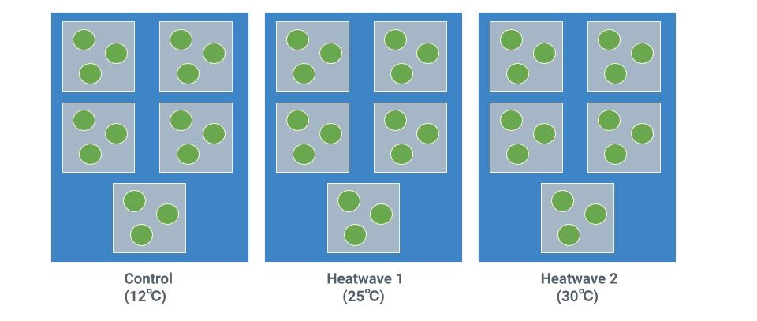
Fig. 1. Diagram of experimental setup for heatwave treatments. Grey squares represent replicates with separate water flow, and green circles represent perforated containers holding individual anemones. During each heat exposure period, water surrounding the replicates (blue) was heated to the maximum heatwave temperature over a three hour period and sustained for an additional three hours before returning to ambient conditions.

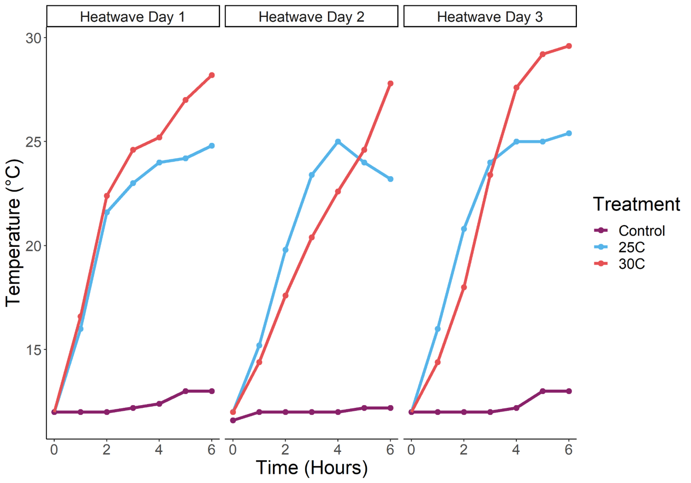
Fig. 2. Temperature ramp performed during each day of the 3-day heatwave simulation.
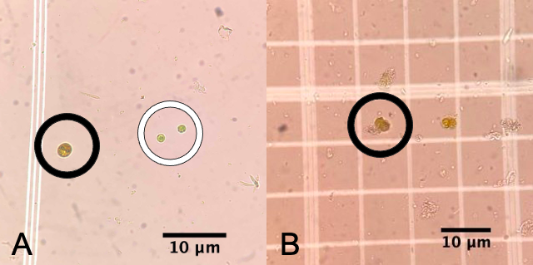
Fig. 3. Algal symbionts viewed at 40x under a compound light microscope. A) When viewed under the microscope, zooxanthellae (circled in black) are brown and relatively larger and zoochlorellae (circled in white) are green and relatively smaller. B) A dividing zooxanthella. Mitotic index was calculated by dividing the number of dividing cells by the total number of cells.

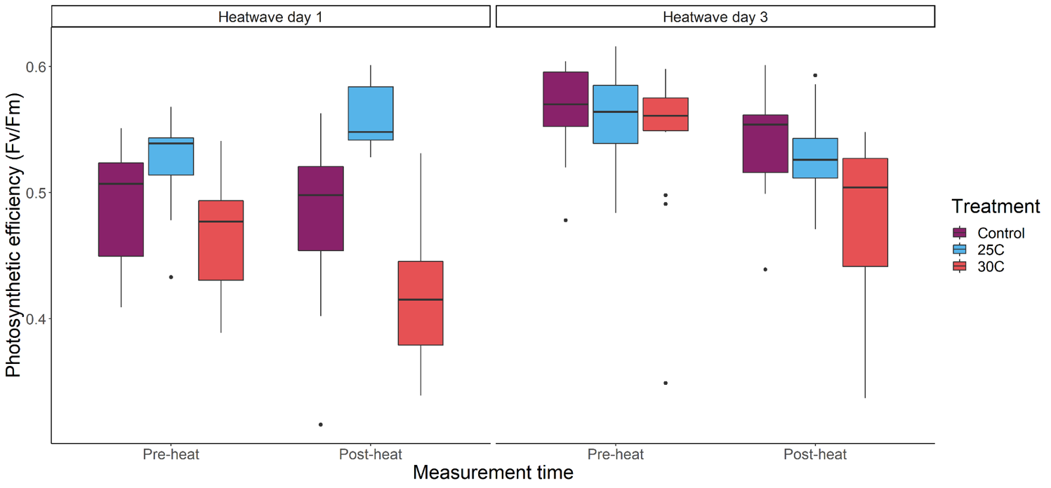
Fig. 4. Photosynthetic efficiency (F_{v}/F_{m}) of A. elegantissima measured on Heatwave Day 1 and Heatwave Day 3 of a 3-day simulated heatwave. Photosynthetic efficiency was measured before (pre-heat) and after (post-heat) a 6-hour heat stress period on each day.

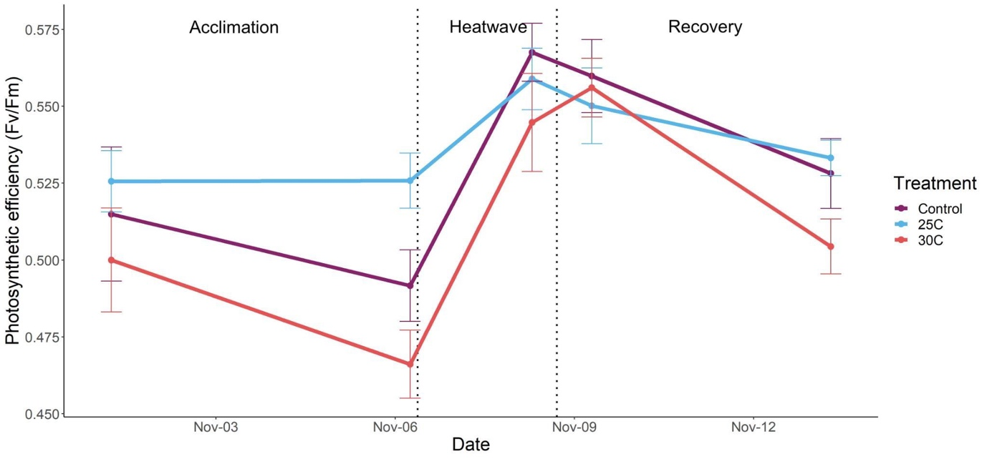
Fig. 5. Mean photosynthetic efficiency (F_{v}/F_{m}) of A. elegantissima exposed to a 3-day heatwave treatment at 25℃ and 30℃. Heatwave treatments were conducted from November 6 to November 8 (indicated by dotted lines). Error bars represent the standard error for each measurement.

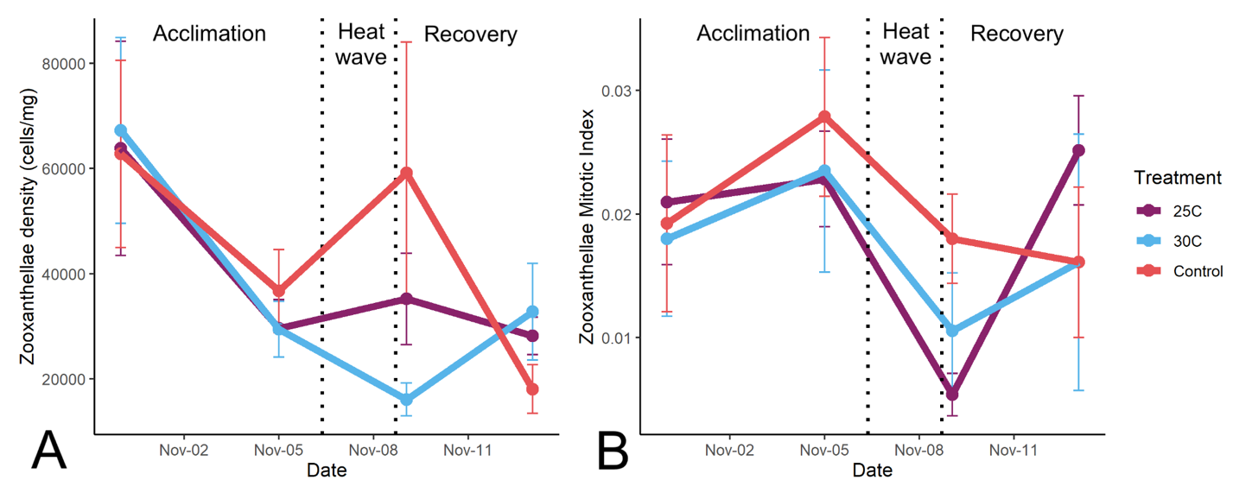
Fig. 6. A) Mean density of zooxanthellae in tentacles clipped throughout the experiment. B) Mitotic index of zooxanthellae in tentacles clipped throughout the experiment. Mitotic index is the measure of dividing cells by total cells. For both density and mitotic index, counts were taken for each day tentacles were clipped: Nov. 1 (acclimation), Nov. 5 (immediately before heatwave), Nov. 7 (immediately after heatwave), and Nov. 13 (post-recovery). Error bars represent the standard error for each measurement.

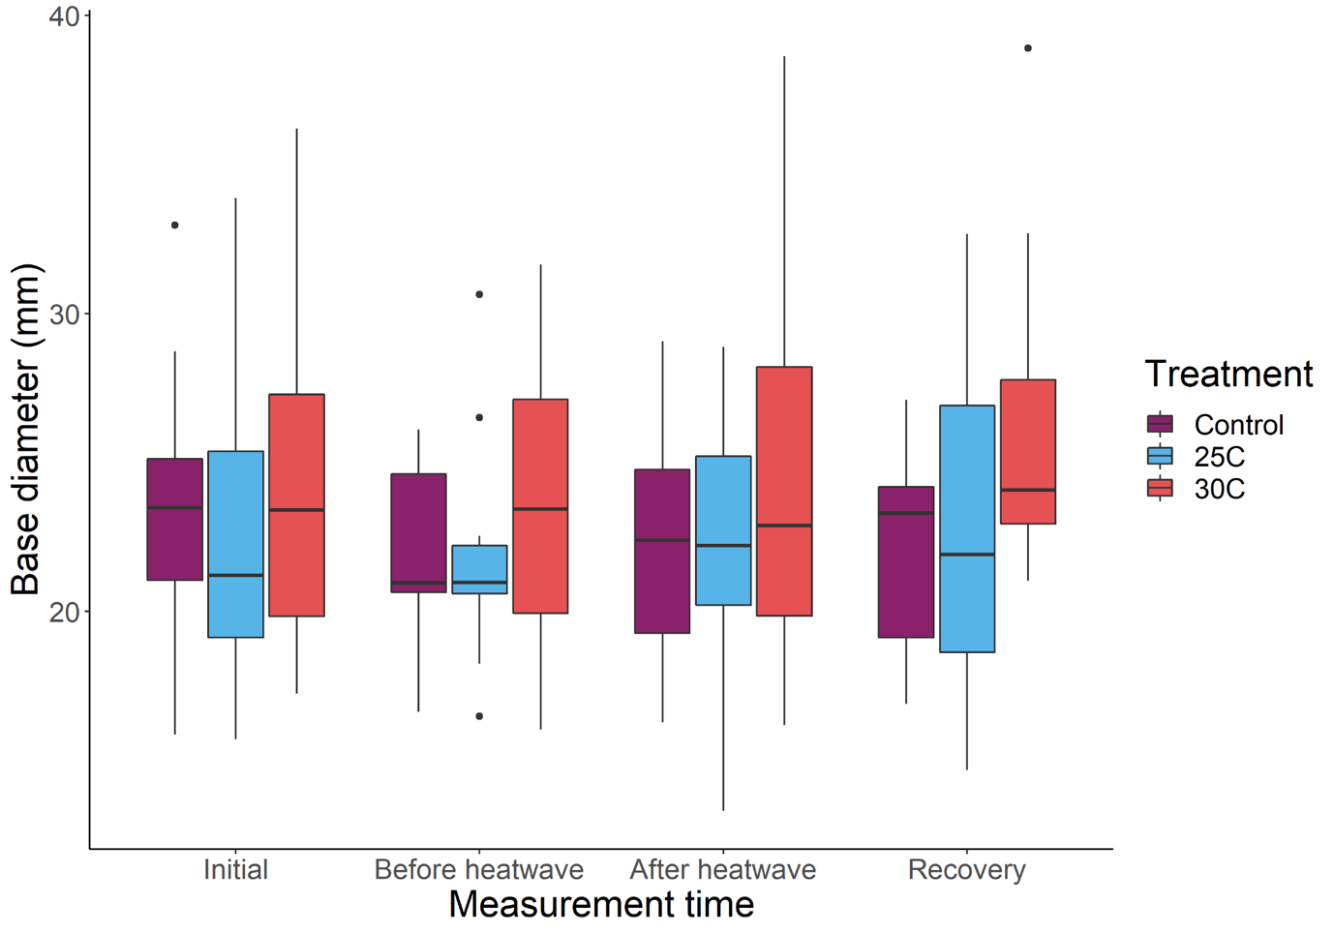
Fig 7. Base diameter measurements of A. elegantissima exposed to 3-day heatwave treatments at 25℃ and 30℃. Base diameter was measured 5 days before heatwave treatments (Initial), one day before heatwave treatments (Before heatwave), one day after treatments (After heatwave), and five days after the treatments (Recovery).
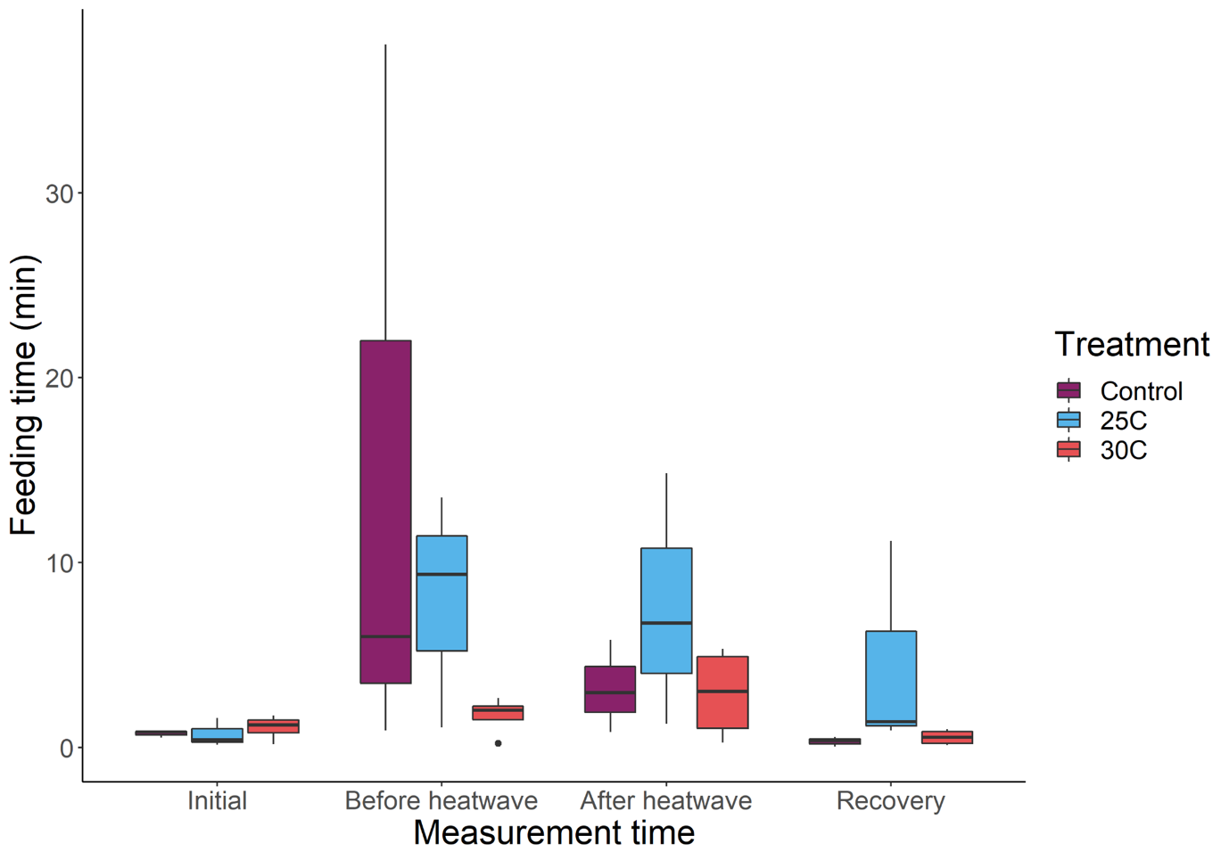
Fig. 8. Feeding time of A. elegantissima over the course of the experiment. Feeding time was measured 5 days before heatwave treatments (Initial), one day before heatwave treatments (Before heatwave), one day after treatments (After heatwave), and five days after the treatments (Recovery). Feeding time was measured as the time taken for an anemone to ingest a small piece of fish after it was placed on the tentacles.

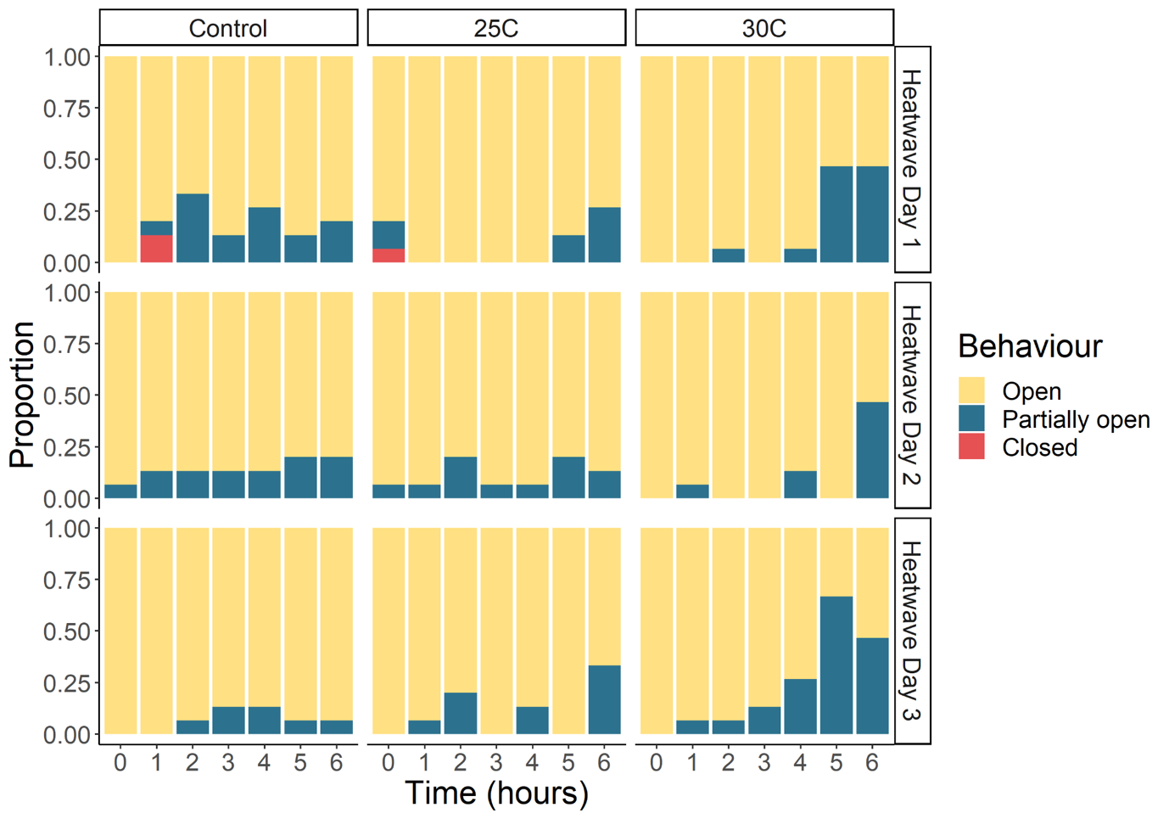
Fig. 9. Response behaviours of A. elegantissima for each treatment over the course of the heatwave. Columns represent treatments and rows represent days of the heatwave: November 6, 7 and 8. At each hour, anemones were classified as either Open, Partially open, or Closed.

Supplementary Information

Table S1. Terms and AIC values for full and reduced GAMLSS models used to analyze heatwave photosynthetic efficiency measurements. Random effects are italicized.
 | Model terms | AIC
Full model | Fv/Fm ~ Treatment + Date + Treatment*Date + Site + Replicate | -642.91
Reduced model | Fv/Fm ~ Treatment + Date + Treatment*Date + Site + Replicate | -642.91

Table S2. Terms and AIC values for full and reduced GAMLSS models used to analyze morning photosynthetic efficiency measurements. Random effects are italicized.
 | Model terms | AIC
Full model | Fv/Fm ~ Treatment + Date + Treatment*Date + Anemone ID + Site + Replicate | -884.17
Reduced model | Fv/Fm ~ Treatment + Date + Treatment*Date + Anemone ID | -887.17

Table S3. Terms and AIC values for ANOVA models used to analyze base diameter, feeding time, zooxanthellae cell density, and zooxanthellae mitotic index (MI).
Response variable | Model terms | AIC
Base diameter | log(Base Diameter) ~ Treatment + Date + Treatment*Date + Anemone ID | -60.71
Feeding time | log(Feeding Time) ~ Treatment + Date + Treatment*Date + Anemone ID | 141.14
Zooxanthellae density | log(Density) ~ Treatment + Date + Treatment*Date + Site + Replicate | 119.95
Zooxanthellae mitotic index | log(MI + 0.1) ~ Treatment + Date + Treatment*Date + Site + Replicate | -81.34

Table S4. Estimates, standard error, t-values, and p-values from GAMLSS model analyzing photosynthetic efficiency in all treatments during 3-day heatwave.

 | Estimate | Standard Error | t value | p value
Intercept | -0.67244 | 0.012799 | -52.538 | < 2x10⁻¹⁶ ***
Treatment 25℃ | 0.060676 | 0.016433 | 3.692 | 0.000309 ***
Treatment 30℃ | -0.04345 | 0.016573 | -2.622 | 0.009634 **
Day 1 post-heat | 0.007481 | 0.016762 | 0.446 | 0.656
Day 3 pre-heat | 0.112915 | 0.016587 | 6.807 | 2.17x10⁻¹⁰ ***
Day 3 post-heat | 0.088817 | 0.016426 | 5.407 | 2.44x10⁻⁷ ***
Treatment 25℃: Day 1 post-heat | 0.051082 | 0.023259 | 2.196 | 0.029595 *
Treatment 30℃: Day 1 post-heat | -0.06168 | 0.023227 | -2.655 | 0.008771 **
Treatment 25℃: Day 3 pre-heat | -0.03165 | 0.023559 | -1.343 | 0.181124
Treatment 30℃: Day 3 pre-heat | 0.0476 | 0.023216 | 2.05 | 0.042058 *
Treatment 25℃: Day 3 post-heat | -0.08655 | 0.023218 | -3.727 | 0.000272 ***
Treatment 30℃: Day 3 post-heat | -0.03851 | 0.023216 | -1.659 | 0.099247

*p<0.05, **p<0.01, ***p<0.001

Table S5. Estimates, standard error, t-values, and p-values from GAMLSS model analyzing photosynthetic efficiency in all treatments at morning measurement times.

 | Estimate | Standard Error | t value | p value
Intercept | 0.536333 | 0.005459 | 98.24 | < 2x10⁻¹⁶ ***
Treatment 25℃ | 0.001645 | 0.007697 | 0.214 | 0.83099
Treatment 30℃ | -0.01048 | 0.007699 | -1.361 | 0.17536
Heatwave day 1 | -0.03528 | 0.007697 | -4.583 | 8.84x10⁻⁶ ***
Heatwave day 3 | 0.03524 | 0.007701 | 4.576 | 9.13x10⁻⁶ ***
Recovery day 1 | 0.034688 | 0.007697 | 4.507 | 1.22x10⁻⁵ ***
Recovery day 5 | 0.000565 | 0.007698 | 0.073 | 0.94157
Treatment 25℃: Heatwave day 1 | 0.035787 | 0.010886 | 3.288 | 0.00123 **
Treatment 30℃: Heatwave day 1 | -0.01016 | 0.010886 | -0.933 | 0.35208
Treatment 25℃: Heatwave day 3 | 0.001552 | 0.010892 | 0.142 | 0.88688
Treatment 30℃: Heatwave day 3 | 0.004408 | 0.010886 | 0.405 | 0.68604
Treatment 25℃: Recovery day 1 | -0.00685 | 0.010886 | -0.629 | 0.53016
Treatment 30℃: Recovery day 1 | 0.006413 | 0.010889 | 0.589 | 0.55666
Treatment 25℃: Recovery day 5 | 0.004169 | 0.010886 | 0.383 | 0.70222
Treatment 30℃: Recovery day 5 | -0.012 | 0.010887 | -1.102 | 0.27212

*p<0.05, **p<0.01, ***p<0.001
Table S6. Summarized counts of anemones for different behavioral responses (Open, Partially open, and Closed). Behavioral response counts from all measurements are combined for each treatment.

 | Open | Partially open | Closed
Control | 274 | 39 | 2
25℃ treatment | 283 | 31 | 1
30℃ treatment | 264 | 51 | 0

