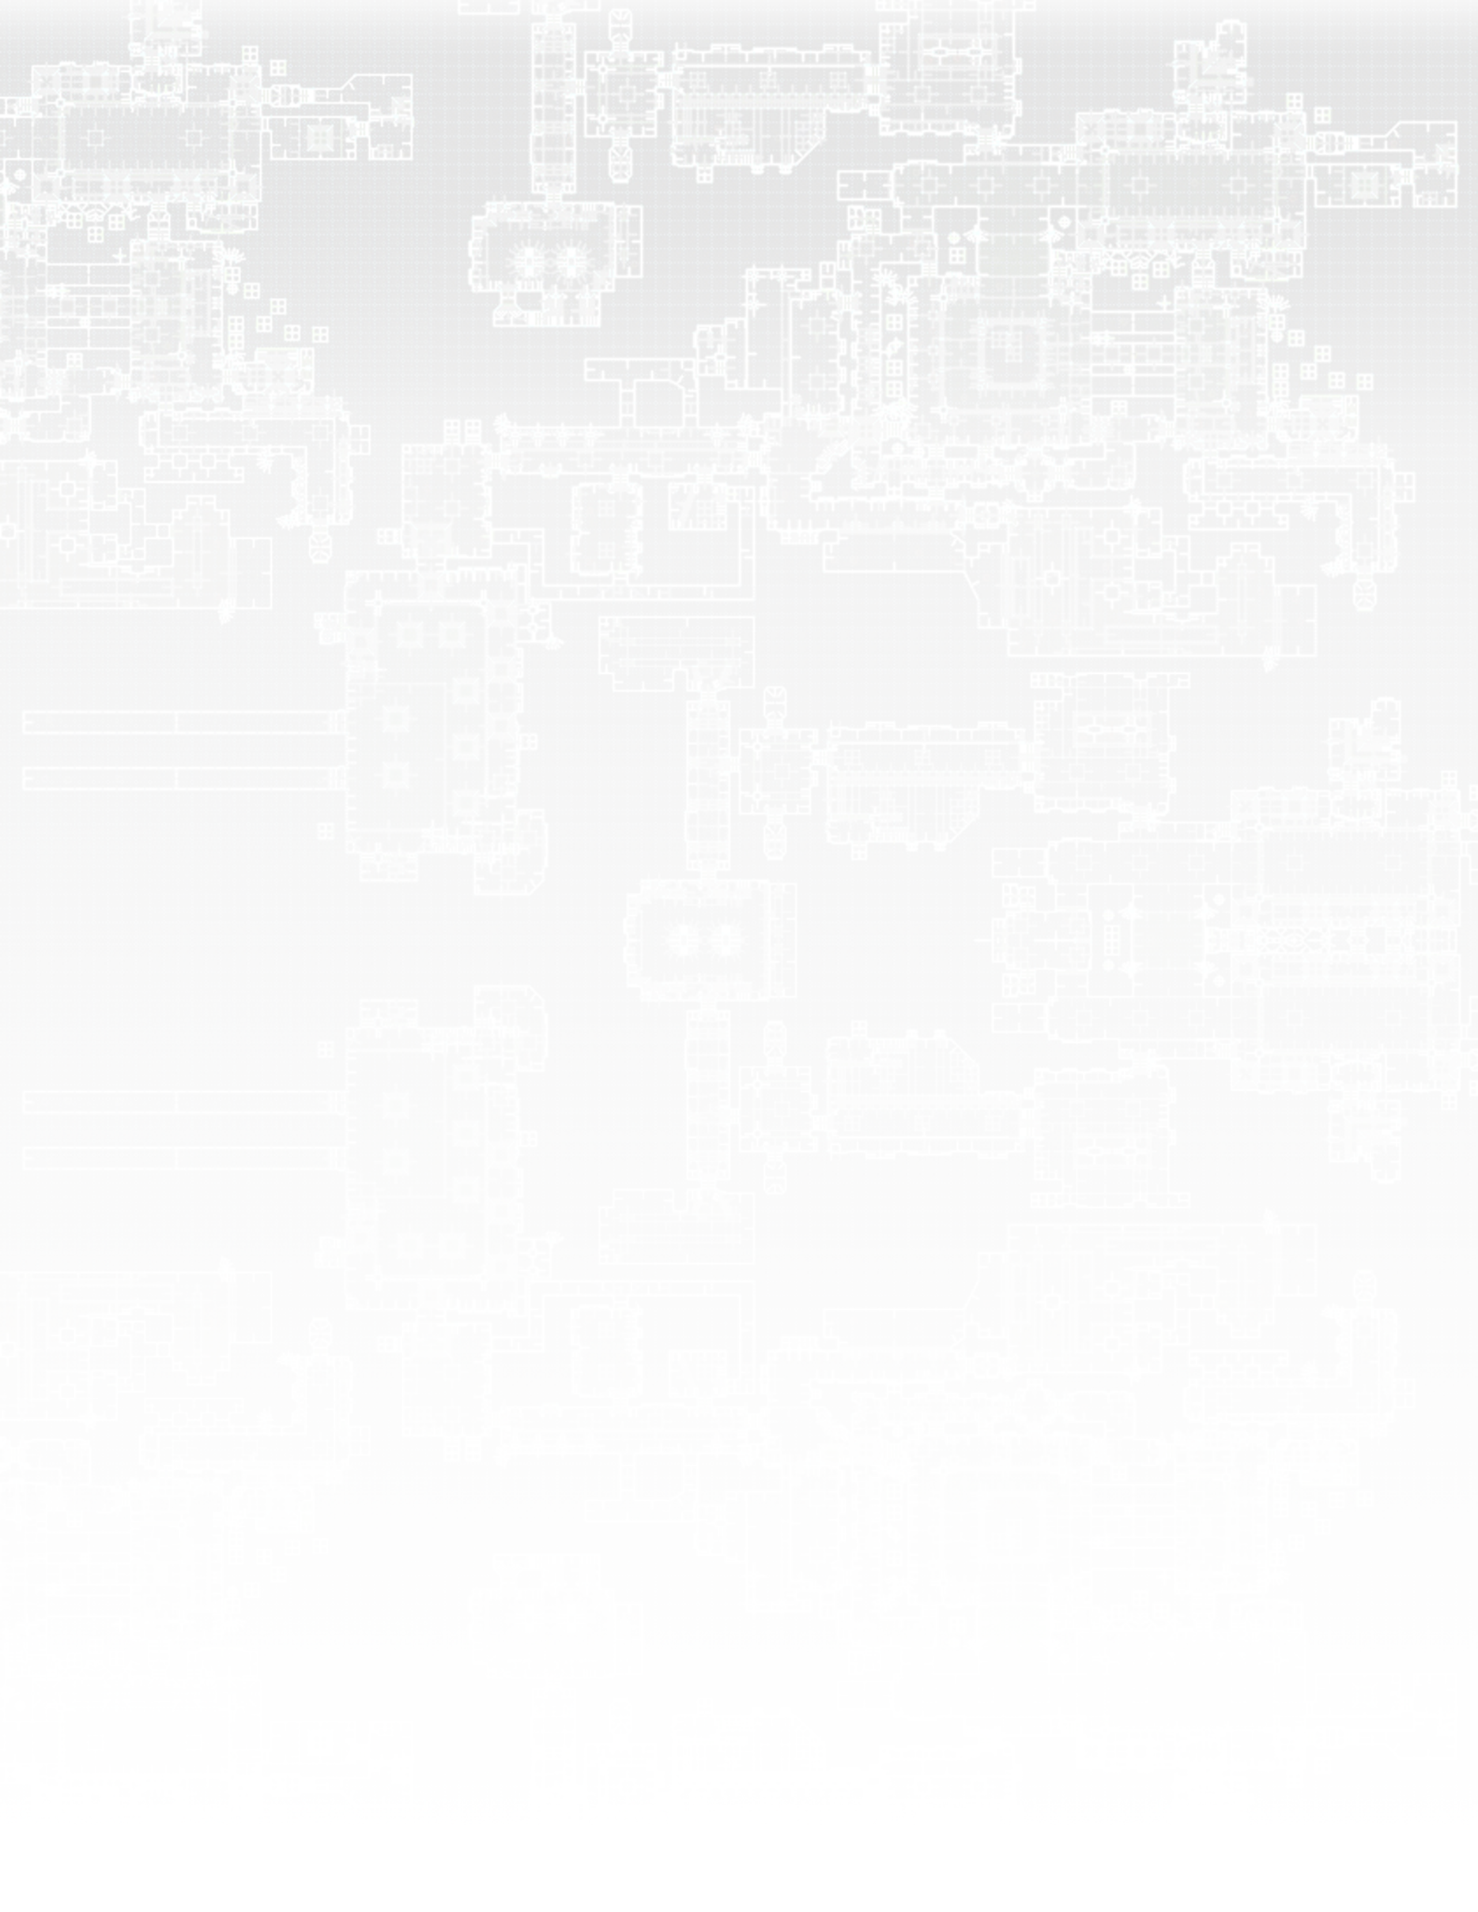

**William Bracho Blok**

**Level Designer**

**Website:** bblok.github.io

**Email:** williambrachoblok@gmail.com

**Linkedin:** [linkedin.com/in/williambrachoblok](https://www.linkedin.com/in/williambrachoblok)

**Location:** Plano TX

|  |  |
| --- | --- |
| Education | |
| **SMU Guildhall** (Fall 2017 – Spring 2019)– Master of Interactive Technology in Game Development. Specialization in Level Design  **Lone Star College** (Spring 2017 – Summer 2017) – Workforce Certificate in Web Design and Web Development  **Texas A&M University** (Fall 2013 – Fall 2016) – Bachelor of Science in Computer Science. Minor in Art | |
| Individual Projects | |
| ***Unreal Tournament 4 CTF Map****: Egocentric Empanadas* – Fall 2017   * Completed a Capture The Flag (CTF) map for Unreal Tournament 4   ***Killing Floor 2 Map***– Fall 2017   * Completed a survival map for Killing Floor 2 and published it on the Killing Floor 2 Steam Workshop   ***Unity2D - El Platanazo!***– Spring 2017   * Completed and published a 2D arcade mobile/web based game in Unity 2D * Role: game/level designer, programmer, and artist   ***Classic Doom Mod***   * Completed an introductory level with cutscenes for Doom using the Doom Builder editor | |
| Team Projects | |
| ***Smith And Dozer*** – Fall 2017   * Completed a 2D side-scroller mobile game in Unity 2D in a multidisciplinary team of 4 members using scrum (software development framework) * Role: level designer   ***Lunch Rush*** – Chillennium Game Jam Project - Fall 2016   * Created a 2D side-scroller 2-player game in Unity 2D in less than 48 hours based on a given theme * Worked in a multidisciplinary team of 4 members * Role: game designer, 2D artist * **Award winning game: Special Recognition in Programming**   ***WordChain*** – Spring 2016   * Developed a 2D game in Unity 2D * Worked in a multidisciplinary team of 4 members * Role: Lead Designer and artist, programmer | |
| Skills | |
| Level Editors/Game Engines:   * Unity Game Engine * Doom Builder Editor * Unreal Engine/Editor 4 * Killing Floor 2 SDK   Other Softwares:   * Adobe Photoshop * Microsoft Office and Google Docs * Audacity | Programming:   * C#, C++, * HTML, CSS   Other Skills:   * Sprite art and animation * Sketching/life drawing * Fluent Proficiency in Spanish |
| Other Experience | |
| ***Software Development Summer Internship at ExxonMobil –*** *Summer 2016*   * Develop a reusable and standalone software component for well schematics visualization * Written in C# and using .NET framework | |