<http://sleepdisorders.sleepfoundation.org/chapter-1-normal-sleep/stages-of-human-sleep/>

**Stages of Human Sleep** - **What are the Stages of Human Sleep?**

Following the discovery of rapid eye movement (REM) sleep in 1953, researchers learned that there are three basic states of consciousness: wakefulness, REM sleep, and non-rapid eye movement (NREM) sleep.1  (See Table 1.1.)

REM sleep is “an active period of sleep marked by intense brain activity. Brain waves are fast and desynchronized, similar to those in the waking state. Breathing becomes more rapid, irregular, and shallow; eyes move rapidly in various directions and limb muscles become temporarily paralyzed. Heart rate increases and blood pressure rises. This also is the sleep stage in which most dreams occur.” 2

REM sleep is thought to play a role in memory consolidation, the synthesis and organization of cognition, and mood regulation.3  Depriving someone of just REM sleep (by waking the subject upon when he or she enters into REM, but allowing NREM to occur) results both in the person making increasingly frequent attempts to enter REM sleep and spending increased time in REM sleep.

NREM sleep is characterized by a reduction in physiological activity. As sleep deepens, a person’s brain waves slow down and gain amplitude, both breathing and the heart rate slow down, and the individual’s blood pressure drops.

NREM sleep consists of three stages:4

* Stage 1 is a time of drowsiness or transition from being awake to falling asleep. Brain waves and muscle activity begin slowing down in this stage. People in stage 1 sleep may experience sudden muscle jerks, preceded by a falling sensation.
* Stage 2 is a period of light sleep during which eye movements stop. Brain waves become slower, with occasional bursts of rapid waves (called sleep spindles) and spontaneous periods of muscle tone mixed with periods of muscle relaxation. The heart rate slows and body temperature decreases.
* Stage 3 is called “slow wave sleep” (SWS) and is characterized by the presence of slow brain waves called “delta waves” interspersed with smaller, faster waves. Blood pressure falls, breathing slows, and temperatures drops even lower, with the body becoming immobile. Sleep is deeper, with no eye movement and decreased muscle activity, although muscles retain their ability to function. It is most difficult to be awakened during SWS, and people may feel groggy or disoriented for several minutes after they wake up from this stage. During SWS, some children experience bedwetting, night terrors, or sleepwalking.  SWS seems to be associated with bodily recovery, certain types of learning,5  and central nervous system changes.6  The amount of SWS a person gets is directly related to accumulated sleep need — the longer a person has been awake, the more SWS he or she gets when sleep occurs.

Although the role each of these states plays in overall health is uncertain, having the right balance between them is believed to be important for obtaining restful, restorative sleep and for promoting processes such as learning, memory, mood, and ability to concentrate.7

There are distinct and typical electroencephalogram (EEG) and physiologic patterns for alert and relaxed wakefulness, for REM sleep, and for each of the stages of NREM. (See Figure 1.1.) Although the sleep stages are specifically defined, in reality, they gradually merge from one to another.

**Figure 1.1: Characteristic electroencephalogram patterns of human sleep stages.8**

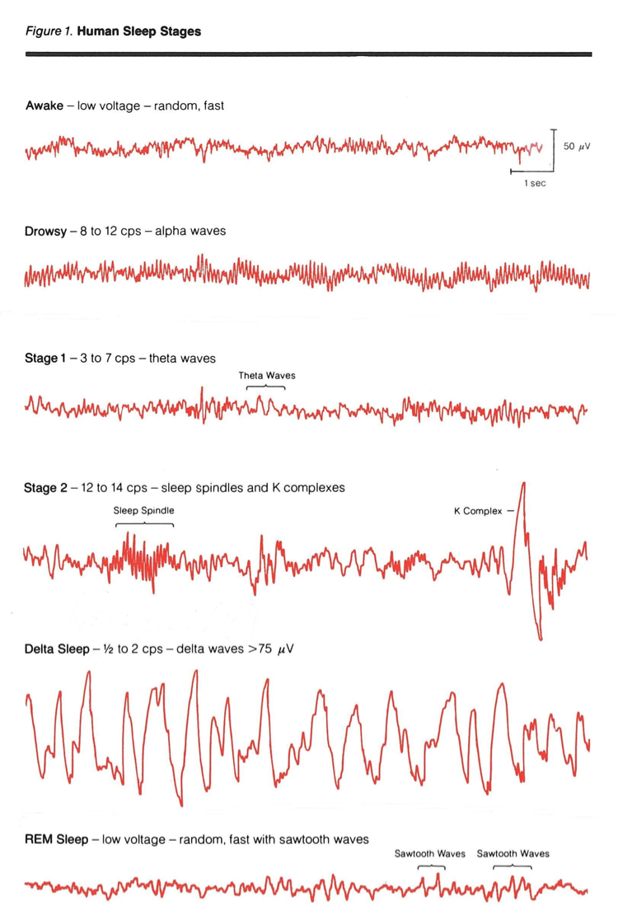

In the sleep laboratory, two or three EEG channels are typically recorded, mainly to determine whether a patient is awake and, if not, what sleep stage he or she is in. The EEG captures the four types of brain waves that occur during wakefulness and sleep, which are measured in cycles per second (cps):9

* Beta waves occur during daily wakefulness. They have the highest frequency and the lowest amplitude, compared to other waves. These patterns also show a lot of variability.
* Alpha waves occur during wakefulness and periods of relaxation (i.e., during meditation). These waves are slower, and have less amplitude and variability than beta waves.
* Theta waves occur during stages 1 and 2 and are slower in frequency and greater in amplitude than alpha waves. As a person moves from stage 1 to stage 2 sleep, theta wave activity continues; every few minutes, sleep spindles (sudden increase in wave frequency) and K-complexes (sudden increase in wave amplitude) occur.
* Delta waves occur during stage 3 sleep and are the slowest waves with the highest amplitude. Delta sleep is the deepest sleep.

**References**

1. Aserinsky E, Kleitman N. Regularly occurring periods of eye motility, and concomitant phenomena, during sleep. Science. 1953;118:273-274.
2. National Sleep Foundation, The Sleep-Wake Cycle: Its Physiology and Impact on Health, Arlington: NSF, 2006. Available at: <http://sleepfoundation.org/primary-links/how-sleep-works>
3. Bonnet MH. Acute sleep deprivation. In: Kryger MH, Roth T, Dement WC, eds. Principles and Practice of Sleep Medicine. 5th ed. Philadelphia: Elsevier Saunders; 2011:54-66.
4. National Sleep Foundation, The Sleep-Wake Cycle: Its Physiology and Impact on Health, Arlington: NSF, 2006. Available at: <http://sleepfoundation.org/primary-links/how-sleep-works>
5. Tononi G, Cirelli C. Sleep function and synaptic homeostasis. Sleep Med Rev. 2006;10:49-62.
6. Huber R, Esser SK, Ferrarelli F, et al. TMS-Induced cortical potentiation during wakefulness locally increases slow wave activity during sleep. PLoS ONE 2(3):e276. doi:10.1371/journal.pone.0000276.
7. National Sleep Foundation, The Sleep-Wake Cycle: Its Physiology and Impact on Health, Arlington: NSF, 2006. Available at: <http://sleepfoundation.org/primary-links/how-sleep-works>
8. Hauri P. Current Concepts: The Sleep Disorders, 2nd Edition, Kalamazoo, MI: Upjohn Company; 1982.
9. Missouri University of Science, Psychology World website, Sleep Stages, no date. Available online at: [http://web.mst.edu/~psyworld/sleep_stages.htm](http://web.mst.edu/%7Epsyworld/sleep_stages.htm).
10. Rechtschaffen A, Kales A, eds. A manual of standardized terminology, techniques, and scoring system for sleep stages in human subjects. Los Angeles: Brain Information Service/Brain Research Institute, UCLA; 1968.

**Table 1.1: Sleep stage characteristics10**

|  | **Brain Waves** | | |  |  |
| --- | --- | --- | --- | --- | --- |
| **Sleep Stage** | **Defining EEG Frequency [cps]** | **Type** | **Characteristics** | **First Appearance** | **Additional Comments** |
| Alert wakefulness | Fast, with many waves >13 | Beta | Low voltage, random pattern, with few rhythmic components |  |  |
| Relaxed wakefulness | 8-13 | Alpha | Low voltage, rhythmic alpha, with occasional bursts of the alertness pattern | The person is relaxed or drowsy, with eyes closed. |  |
| NREM Stage 1 | 3-7 | Theta | Theta waves interspersed with brief periods of alpha waves | As soon as alpha waves are < 50% of a 30-second epoch | Reactivity to outside stimuli diminished, while subjectively the sleeper may still feel awake. |
| NREM Stage 2 | 12-14 lasting >0.5 seconds Isolated slow/high amplitude waves | Theta with sleep spindles and K-complexes | At least 1 sleep spindle or K-complex per 30 seconds on a stage 1 background | When the first sleep spindle or K-complex appears | The most prominent sleep stage, deeper than stage 1, lighter than SWS |
| NREM Stage 3 – slow wave sleep (SWS) | <4 | Delta | High amplitude, low waves | Occurs within 15-45 minutes after sleep onset | Deepest sleep; duration of SWS depends on age (less in the elderly) |
| REM sleep | Stage 1 pattern with “saw tooth waves” | Low voltage, random, fast | Eyes move; the autonomic system is activated (eg, respiratory and cardiac irregularities). | First REM period occurs after ~85 minutes of NREM sleep. | A unique state, during which dreams usually occur. The brain is awake; the body is paralyzed (REM-related atonia). |