**Táblák létrehozása:**

mysql> CREATE TABLE TULAJDONOS(TKOD INT PRIMARY KEY,NEV VARCHAR(20) NOT NULL, VAROS VARCHAR(20));

Query OK, 0 rows affected (0.24 sec)

mysql> CREATE TABLE AUTO(RENDSZAM CHAR(7) PRIMARY KEY, TIPUS VARCHAR(25) NOT NULL, SZIN VARCHAR(15), KOR INT(2), AR INT(8), TULAJ INT(3), FOREIGN KEY(TULAJ) REFERENCES TULAJDONOS(TKOD));

Query OK, 0 rows affected (0.28 sec)

mysql> DESCRIBE TULAJDONOS;

+-------+-------------+------+-----+---------+-------+

| Field | Type | Null | Key | Default | Extra |

+-------+-------------+------+-----+---------+-------+

| TKOD | int(11) | NO | PRI | NULL | |

| NEV | varchar(20) | NO | | NULL | |

| VAROS | varchar(20) | YES | | NULL | |

+-------+-------------+------+-----+---------+-------+

3 rows in set (0.00 sec)

mysql> DESCRIBE AUTO;

+----------+-------------+------+-----+---------+-------+

| Field | Type | Null | Key | Default | Extra |

+----------+-------------+------+-----+---------+-------+

| RENDSZAM | char(7) | NO | PRI | NULL | |

| TIPUS | varchar(25) | NO | | NULL | |

| SZIN | varchar(15) | YES | | NULL | |

| KOR | int(2) | YES | | NULL | |

| AR | int(8) | YES | | NULL | |

| TULAJ | int(3) | YES | MUL | NULL | |

+----------+-------------+------+-----+---------+-------+

6 rows in set (0.00 sec)

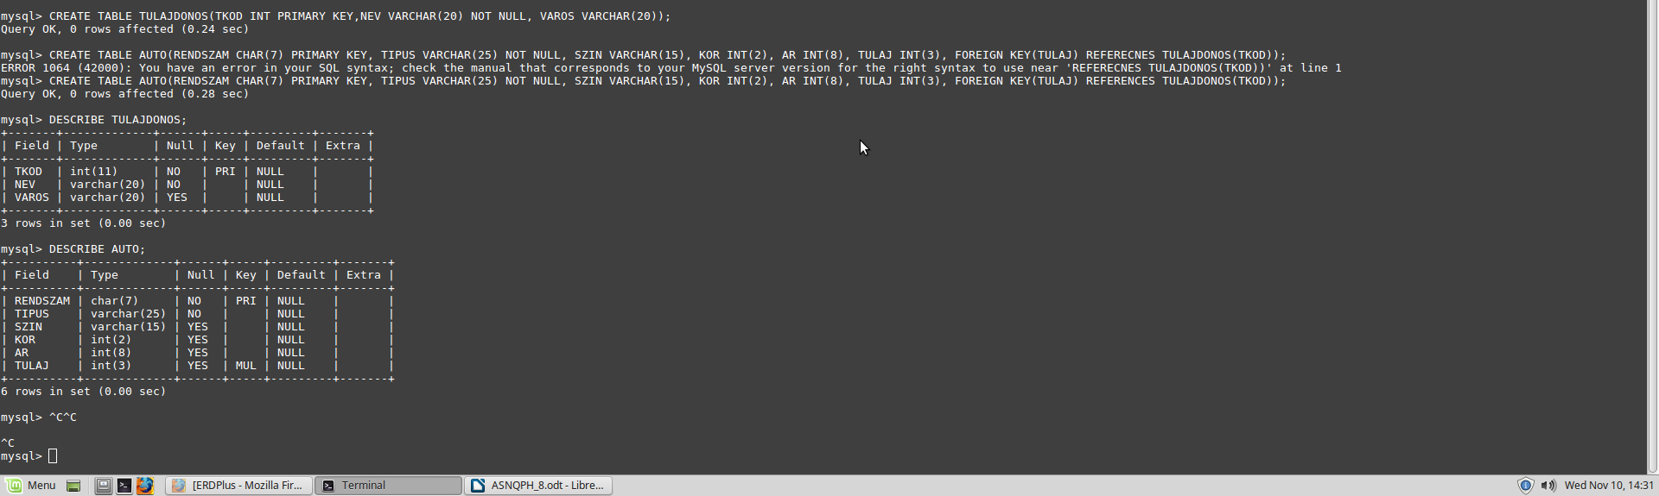

**Táblák feltöltése:**

mysql> SELECT * FROM TULAJDONOS;

+------+----------------+----------+

| TKOD | NEV | VAROS |

+------+----------------+----------+

| 101 | KIS JÁNOS | MISKOLC |

| 102 | KIS ÉVA | SZERENCS |

| 103 | RETEK ÖDÖN | MISKOLC |

| 104 | VIRÁG ZOLTÁN | NYÉK |

| 105 | NAGY ESZTER | NYÉK |

| 106 | KOVÁCS MAGOR | SZERENCS |

| 107 | ASZTAL ANTAL | MISKOLC |

+------+----------------+----------+

7 rows in set (0.00 sec)

mysql> SELECT * FROM AUTO;

+----------+----------------+---------+------+------+-------+

| RENDSZAM | TIPUS | SZIN | KOR | AR | TULAJ |

+----------+----------------+---------+------+------+-------+

| FER-831 | OPEL CORSA | PIROS | 18 | 390 | 101 |

| GDF-525 | RENAULT TWINGO | FEKETE | 16 | 208 | NULL |

| HUB-936 | SUZUKI SWIFT | FEKETE | 16 | 500 | NULL |

| JAH-425 | SKODA FABIA | PIROS | 13 | 620 | 102 |

| JDC-443 | OPEL ASTRA | FEHÉR | 12 | 990 | 107 |

| KAP-290 | BMW 316 | FEKETE | 6 | 3250 | 102 |

| KFT-204 | OPEL ASTRA | SZÜRKE | 7 | 1250 | 106 |

| MLM-211 | TOYOTA YARIS | FEHÉR | 3 | 1850 | 105 |

| TXJ-239 | SUZUKI SWIFT | ZOLD | 15 | 450 | 105 |

+----------+----------------+---------+------+------+-------+

9 rows in set (0.00 sec)

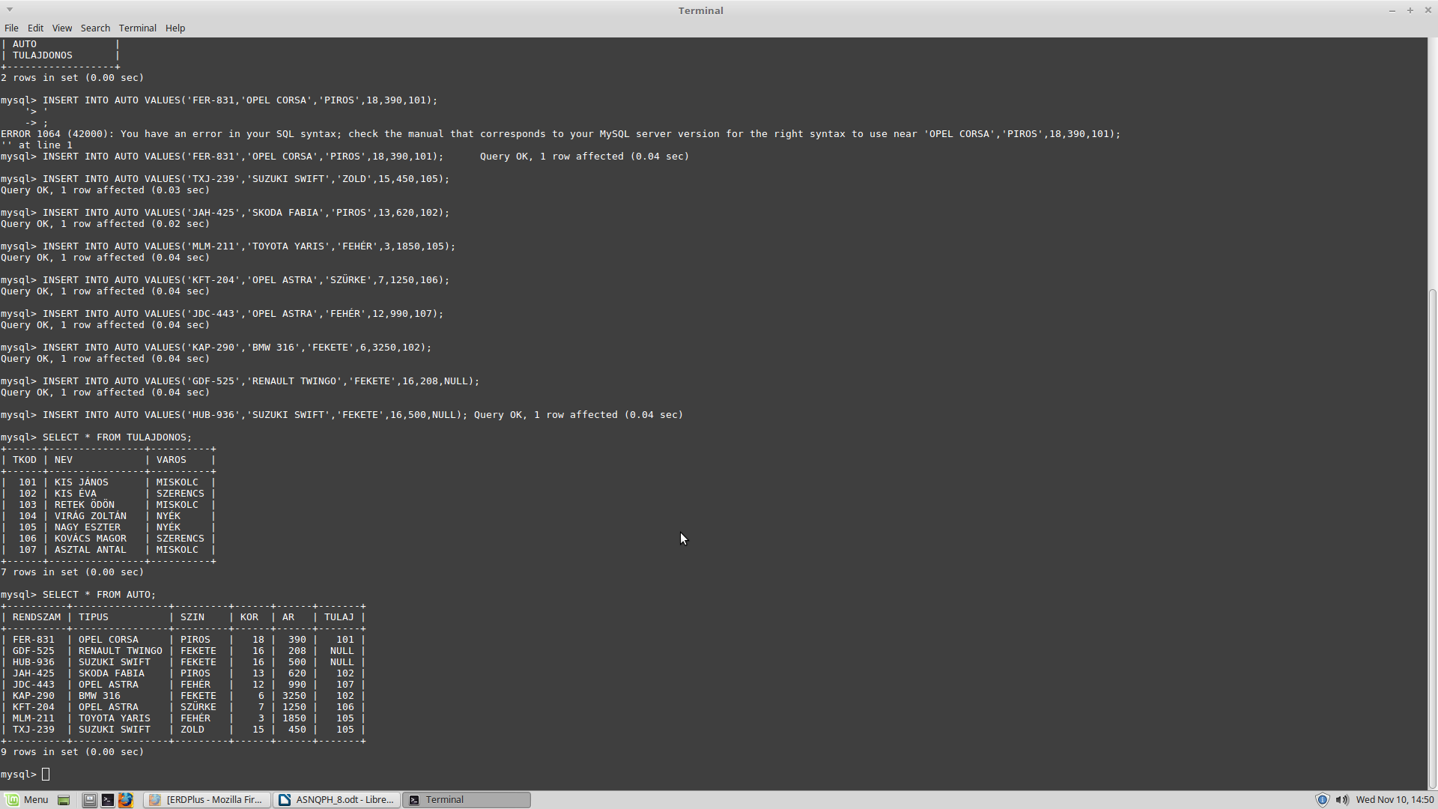

**Lekérdezések:**

**1.**

mysql> SELECT RENDSZAM,NEV FROM AUTO INNER JOIN TULAJDONOS ON TULAJ=TKOD;

+----------+---------------+

| RENDSZAM | NEV |

+----------+---------------+

| FER-831 | KIS JÁNOS |

| JAH-425 | KIS ÉVA |

| KAP-290 | KIS ÉVA |

| MLM-211 | NAGY ESZTER |

| TXJ-239 | NAGY ESZTER |

| KFT-204 | KOVÁCS MAGOR |

| JDC-443 | ASZTAL ANTAL |

+----------+---------------+

7 rows in set (0.01 sec)

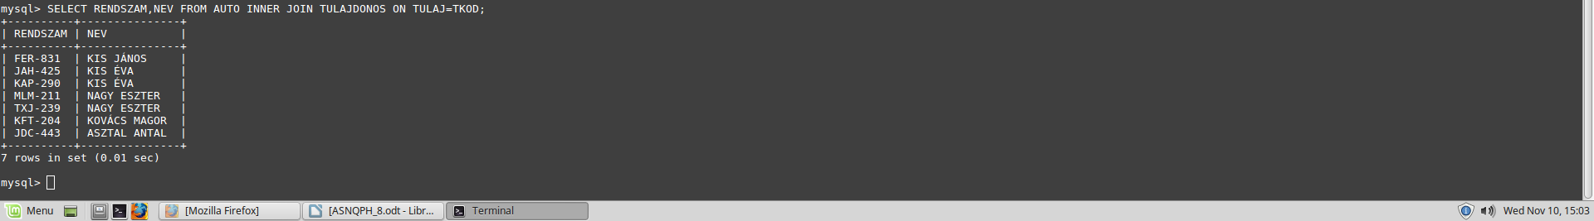

**2.**

mysql> SELECT AUTO.* FROM AUTO INNER JOIN TULAJDONOS ON TULAJ=TKOD WHERE VAROS ='MISKOLC';

+----------+------------+--------+------+------+-------+

| RENDSZAM | TIPUS | SZIN | KOR | AR | TULAJ |

+----------+------------+--------+------+------+-------+

| FER-831 | OPEL CORSA | PIROS | 18 | 390 | 101 |

| JDC-443 | OPEL ASTRA | FEHÉR | 12 | 990 | 107 |

+----------+------------+--------+------+------+-------+

2 rows in set (0.00 sec)



**3.**

mysql> SELECT TIPUS, AR FROM AUTO;

+----------------+------+

| TIPUS | AR |

+----------------+------+

| OPEL CORSA | 390 |

| RENAULT TWINGO | 208 |

| SUZUKI SWIFT | 500 |

| SKODA FABIA | 620 |

| OPEL ASTRA | 990 |

| BMW 316 | 3250 |

| OPEL ASTRA | 1250 |

| TOYOTA YARIS | 1850 |

| SUZUKI SWIFT | 450 |

+----------------+------+

9 rows in set (0.00 sec)

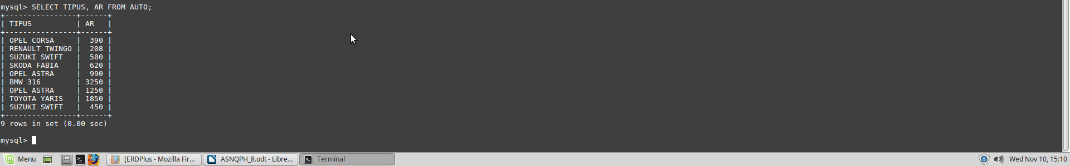

**4.**

mysql> SELECT TULAJDONOS.*, AUTO.RENDSZAM FROM TULAJDONOS LEFT JOIN AUTO ON TULAJDONOS.TKOD=AUTO.TULAJ;

+------+----------------+----------+----------+

| TKOD | NEV | VAROS | RENDSZAM |

+------+----------------+----------+----------+

| 101 | KIS JÁNOS | MISKOLC | FER-831 |

| 102 | KIS ÉVA | SZERENCS | JAH-425 |

| 102 | KIS ÉVA | SZERENCS | KAP-290 |

| 103 | RETEK ÖDÖN | MISKOLC | NULL |

| 104 | VIRÁG ZOLTÁN | NYÉK | NULL |

| 105 | NAGY ESZTER | NYÉK | MLM-211 |

| 105 | NAGY ESZTER | NYÉK | TXJ-239 |

| 106 | KOVÁCS MAGOR | SZERENCS | KFT-204 |

| 107 | ASZTAL ANTAL | MISKOLC | JDC-443 |

+------+----------------+----------+----------+

9 rows in set (0.00 sec)

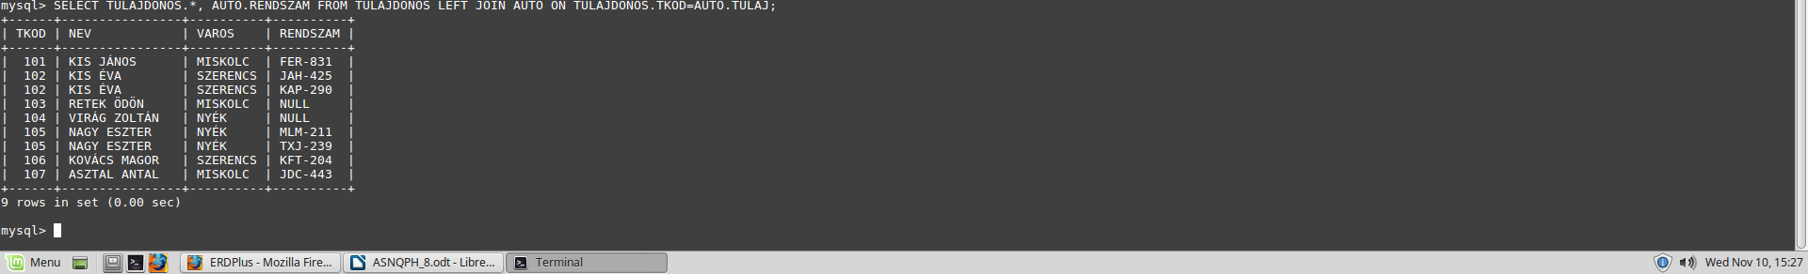

**5.**

MariaDB [GYAK8]> SELECT RENDSZAM, NEV FROM AUTO LEFT JOIN TULAJDONOS ON TKOD = TULAJ;

+----------+--------------+

| RENDSZAM | NEV |

+----------+--------------+

| GDF-525 | NULL |

| HUB-936 | NULL |

| FER-831 | Kis János |

| JAH-425 | Kis Éva |

| KAP-290 | Kis Éva |

| IXJ-239 | Nagy Eszter |

| MLM-211 | Nagy Eszter |

| KFT-204 | Kovács Magor |

| JCD-443 | Asztal Antal |

+----------+--------------+

9 rows in set (0.009 sec)

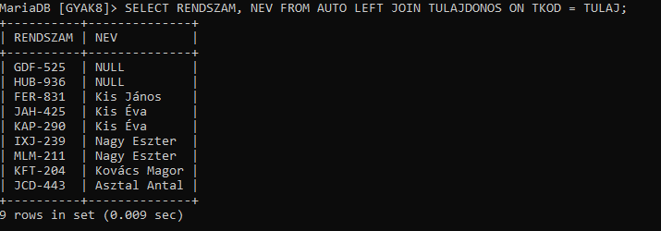

**6.**

MariaDB [GYAK8]> SELECT RENDSZAM FROM AUTO INNER JOIN TULAJDONOS ON TKOD = TULAJ WHERE AR > (SELECT AVG(AR) FROM AUTO INNER JOIN TULAJDONOS ON TKOD = TULAJ WHERE VAROS = 'Miskolc') AND VAROS != 'Miskolc';

+----------+

| RENDSZAM |

+----------+

| KAP-290 |

| KFT-204 |

| MLM-211 |

+----------+

3 rows in set (0.012 sec)



**7.**

MariaDB [GYAK8]> SELECT NEV, COUNT(TULAJ) FROM TULAJDONOS INNER JOIN AUTO ON TKOD = TULAJ GROUP BY TULAJ HAVING COUNT(TULAJ) > 1;

+-------------+--------------+

| NEV | COUNT(TULAJ) |

+-------------+--------------+

| Kis Éva | 2 |

| Nagy Eszter | 2 |

+-------------+--------------+

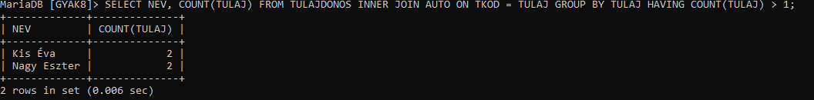2 rows in set (0.006 sec)

**8.**

MariaDB [GYAK8]> SELECT A.RENDSZAM AS RENDSZAM1, A.TIPUS, A.KOR, A.AR FROM AUTO A, AUTO B WHERE A.RENDSZAM <> B.RENDSZAM AND A.TIPUS = B.TIPUS AND A.KOR > B.KOR AND A.AR > B.AR ORDER BY A.TIPUS;

+-----------+--------------+------+------+

| RENDSZAM1 | TIPUS | KOR | AR |

+-----------+--------------+------+------+

| HUB-936 | Suzuki Swift | 16 | 500 |

+-----------+--------------+------+------+

1 row in set (0.007 sec)



**9.**

MariaDB [GYAK8]> SELECT * FROM AUTO WHERE (SELECT AR FROM AUTO WHERE SZIN = 'Piros' ORDER BY AR DESC LIMIT 1) > AR;

+----------+----------------+--------+------+------+-------+

| RENDSZAM | TIPUS | SZIN | KOR | AR | TULAJ |

+----------+----------------+--------+------+------+-------+

| FER-831 | Opel Corsa | Piros | 18 | 390 | 101 |

| GDF-525 | Renault Twingo | Fekete | 16 | 280 | NULL |

| HUB-936 | Suzuki Swift | Fekete | 16 | 500 | NULL |

| IXJ-239 | Suzuki Swift | Zöld | 15 | 450 | 105 |

+----------+----------------+--------+------+------+-------+

4 rows in set (0.000 sec)

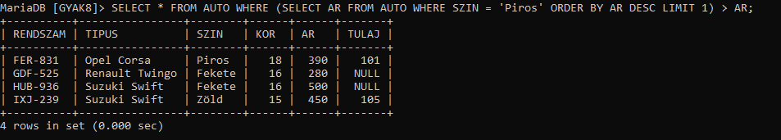

**10.**

MariaDB [GYAK8]> SELECT * FROM AUTO WHERE (SELECT AR FROM AUTO WHERE SZIN = 'Piros' ORDER BY AR ASC LIMIT 1) > AR;

+----------+----------------+--------+------+------+-------+

| RENDSZAM | TIPUS | SZIN | KOR | AR | TULAJ |

+----------+----------------+--------+------+------+-------+

| GDF-525 | Renault Twingo | Fekete | 16 | 280 | NULL |

+----------+----------------+--------+------+------+-------+

1 row in set (0.000 sec)

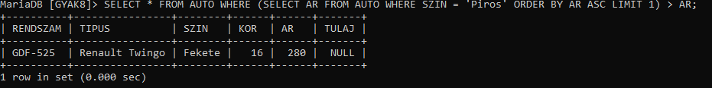

**11.**

MariaDB [GYAK8]> SELECT DISTINCT NEV FROM TULAJDONOS INNER JOIN AUTO ON TKOD = TULAJ WHERE TULAJ IS NOT NULL;

+--------------+

| nev |

+--------------+

| Kis János |

| Kis Éva |

| Nagy Eszter |

| Kovács Magor |

| Asztal Antal |

+--------------+

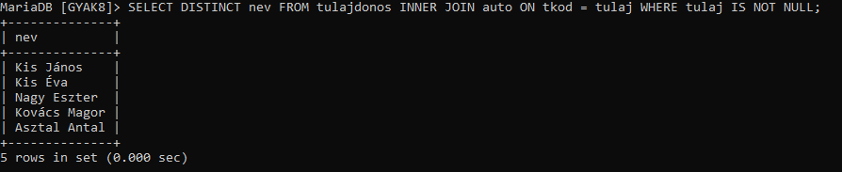5 rows in set (0.000 sec)

**12.**

MariaDB [GYAK8]> SELECT NEV FROM TULAJDONOS WHERE NOT EXISTS (SELECT 1 FROM AUTO WHERE AUTO.TULAJ = TULAJDONOS.TKOD);

+--------------+

| NEV |

+--------------+

| Retek Ödön |

| Virág Zoltán |

+--------------+

2 rows in set (0.008 sec)

