Táblák létrehozása:

mysql> CREATE TABLE TULAJDONOS(TKOD INT PRIMARY KEY,NEV VARCHAR(20) NOT NULL, VAROS VARCHAR(20));
Query OK, 0 rows affected (0.24 sec)

mysql> CREATE TABLE AUTO(RENDSZAM CHAR(7) PRIMARY KEY, TIPUS VARCHAR(25) NOT NULL, SZIN VARCHAR(15), KOR INT(2), AR INT(8), TULAJ INT(3), FOREIGN KEY(TULAJ) REFERENCES TULAJDONOS(TKOD));
Query OK, 0 rows affected (0.28 sec)

mysql> DESCRIBE TULAJDONOS;
+-------+-------------+------+-----+---------+-------+
| Field | Type | Null | Key | Default | Extra |
+-------+-------------+------+-----+---------+-------+
| TKOD | int(11) | NO | PRI | NULL | |
| NEV | varchar(20) | NO | | NULL | |
| VAROS | varchar(20) | YES | | NULL | |
+-------+-------------+------+-----+---------+-------+
3 rows in set (0.00 sec)

mysql> DESCRIBE AUTO;
+----------+-------------+------+-----+---------+-------+
| Field | Type | Null | Key | Default | Extra |
+----------+-------------+------+-----+---------+-------+
| RENDSZAM | char(7) | NO | PRI | NULL | |
| TIPUS | varchar(25) | NO | | NULL | |
| SZIN | varchar(15) | YES | | NULL | |
| KOR | int(2) | YES | | NULL | |
| AR | int(8) | YES | | NULL | |
| TULAJ | int(3) | YES | MUL | NULL | |
+----------+-------------+------+-----+---------+-------+
6 rows in set (0.00 sec)
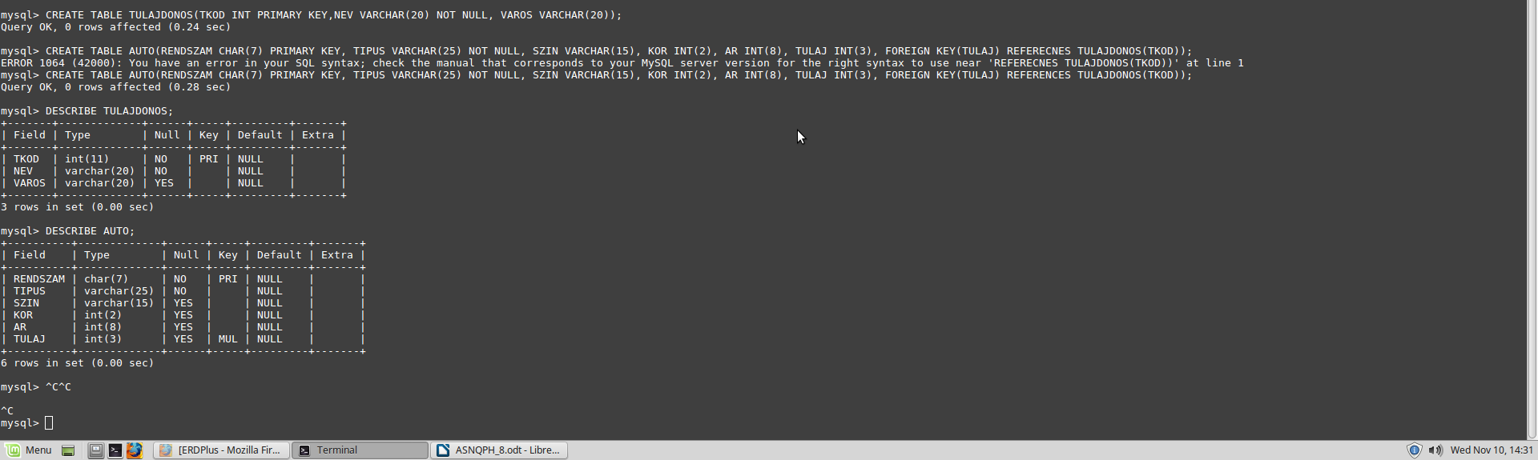

Táblák feltöltése:

mysql> SELECT * FROM TULAJDONOS;
+------+----------------+----------+
| TKOD | NEV | VAROS |
+------+----------------+----------+
| 101 | KIS JÁNOS | MISKOLC |
| 102 | KIS ÉVA | SZERENCS |
| 103 | RETEK ÖDÖN | MISKOLC |
| 104 | VIRÁG ZOLTÁN | NYÉK |
| 105 | NAGY ESZTER | NYÉK |
| 106 | KOVÁCS MAGOR | SZERENCS |
| 107 | ASZTAL ANTAL | MISKOLC |
+------+----------------+----------+
7 rows in set (0.00 sec)

mysql> SELECT * FROM AUTO;
+----------+----------------+---------+------+------+-------+
| RENDSZAM | TIPUS | SZIN | KOR | AR | TULAJ |
+----------+----------------+---------+------+------+-------+
| FER-831 | OPEL CORSA | PIROS | 18 | 390 | 101 |
| GDF-525 | RENAULT TWINGO | FEKETE | 16 | 208 | NULL |
| HUB-936 | SUZUKI SWIFT | FEKETE | 16 | 500 | NULL |
| JAH-425 | SKODA FABIA | PIROS | 13 | 620 | 102 |
| JDC-443 | OPEL ASTRA | FEHÉR | 12 | 990 | 107 |
| KAP-290 | BMW 316 | FEKETE | 6 | 3250 | 102 |
| KFT-204 | OPEL ASTRA | SZÜRKE | 7 | 1250 | 106 |
| MLM-211 | TOYOTA YARIS | FEHÉR | 3 | 1850 | 105 |
| TXJ-239 | SUZUKI SWIFT | ZOLD | 15 | 450 | 105 |
+----------+----------------+---------+------+------+-------+
9 rows in set (0.00 sec)

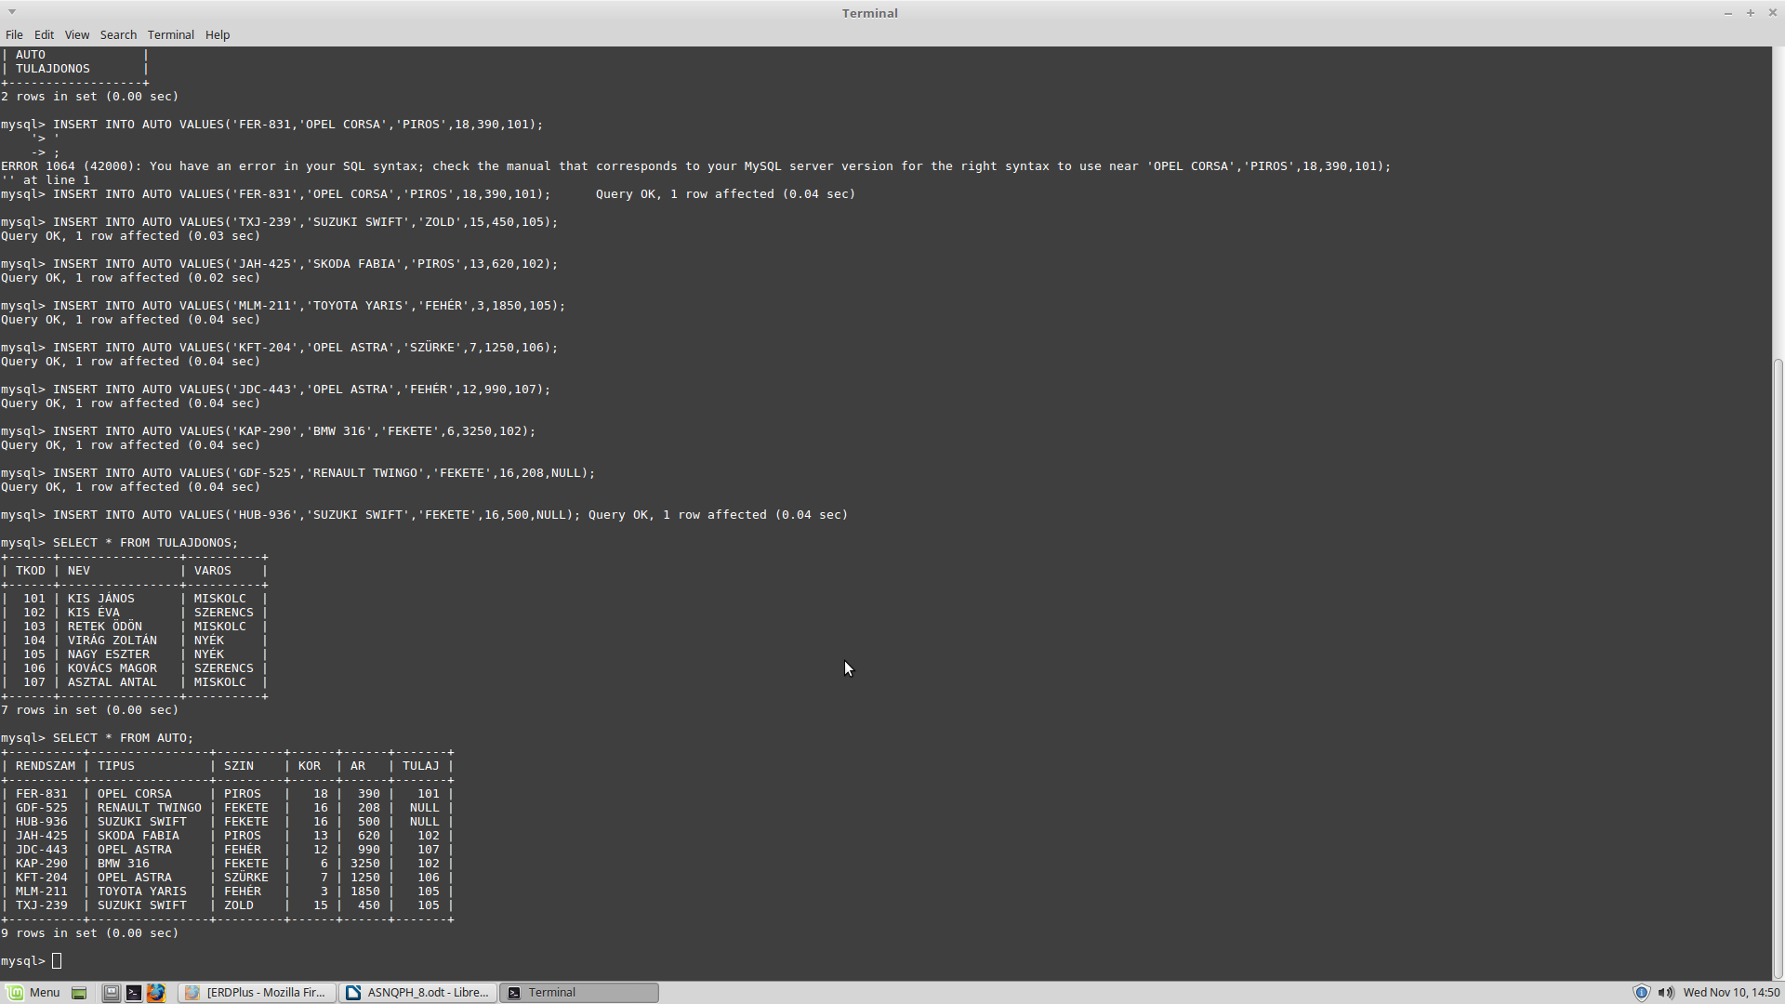
Lekérdezések:

1.

mysql> SELECT RENDSZAM,NEV FROM AUTO INNER JOIN TULAJDONOS ON TULAJ=TKOD;

+----------+---------------+
| RENDSZAM | NEV |
+----------+---------------+
| FER-831 | KIS JÁNOS |
| JAH-425 | KIS ÉVA |
| KAP-290 | KIS ÉVA |
| MLM-211 | NAGY ESZTER |
| TXJ-239 | NAGY ESZTER |
| KFT-204 | KOVÁCS MAGOR |
| JDC-443 | ASZTAL ANTAL |
+----------+---------------+
7 rows in set (0.01 sec)

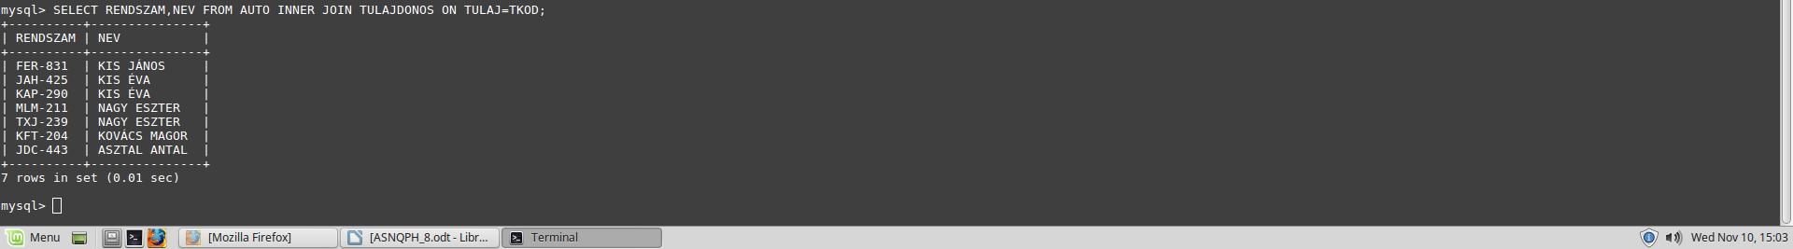

2.

mysql> SELECT AUTO.* FROM AUTO INNER JOIN TULAJDONOS ON TULAJ=TKOD WHERE VAROS ='MISKOLC';

+----------+------------+--------+------+------+-------+
| RENDSZAM | TIPUS | SZIN | KOR | AR | TULAJ |
+----------+------------+--------+------+------+-------+
| FER-831 | OPEL CORSA | PIROS | 18 | 390 | 101 |
| JDC-443 | OPEL ASTRA | FEHÉR | 12 | 990 | 107 |
+----------+------------+--------+------+------+-------+
2 rows in set (0.00 sec)

3.

mysql> SELECT TIPUS, AR FROM AUTO;

+----------------+------+
| TIPUS | AR |
+----------------+------+
| OPEL CORSA | 390 |
| RENAULT TWINGO | 208 |
| SUZUKI SWIFT | 500 |
| SKODA FABIA | 620 |
| OPEL ASTRA | 990 |
| BMW 316 | 3250 |
| OPEL ASTRA | 1250 |
| TOYOTA YARIS | 1850 |
| SUZUKI SWIFT | 450 |
+----------------+------+
9 rows in set (0.00 sec)
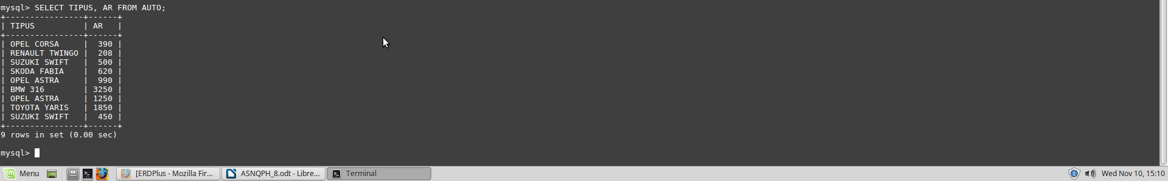
4.

mysql> SELECT TULAJDONOS.*, AUTO.RENDSZAM FROM TULAJDONOS LEFT JOIN AUTO ON TULAJDONOS.TKOD=AUTO.TULAJ;

+------+----------------+----------+----------+
| TKOD | NEV | VAROS | RENDSZAM |
+------+----------------+----------+----------+
| 101 | KIS JÁNOS | MISKOLC | FER-831 |
| 102 | KIS ÉVA | SZERENCS | JAH-425 |
| 102 | KIS ÉVA | SZERENCS | KAP-290 |
| 103 | RETEK ÖDÖN | MISKOLC | NULL |
| 104 | VIRÁG ZOLTÁN | NYÉK | NULL |
| 105 | NAGY ESZTER | NYÉK | MLM-211 |
| 105 | NAGY ESZTER | NYÉK | TXJ-239 |
| 106 | KOVÁCS MAGOR | SZERENCS | KFT-204 |
| 107 | ASZTAL ANTAL | MISKOLC | JDC-443 |
+------+----------------+----------+----------+
9 rows in set (0.00 sec)
