Proposal Form

*Amplify Promotions*

Ben Brogan – Ciaran Kilkenny – Michael Barry

*Contents*

Introduction………………………………………………………………………..2

Software……………………………………………………………………………..3

Clients Brief…………………………………………………………………………4

Logo Creation………………………………………………………………………5

Mindmap…………………………………………………………………………….7

Content Flowchart……………………………………………………………….8

Wireframe……………………………………………………………………………9

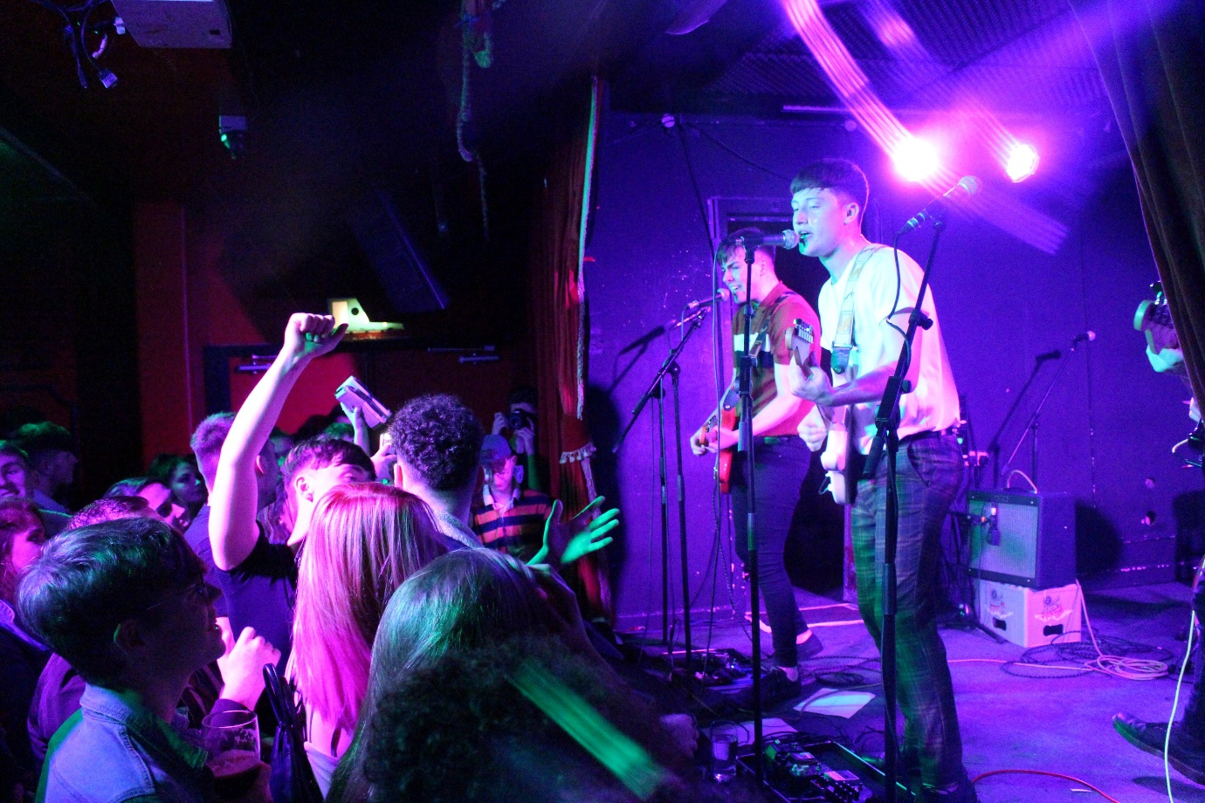

*Introduction*

As part of the Digital Media Group Project, my colleagues Ciaran Kilkenny, Michael Barry and I, Ben Brogan, have decided to create a website for a music promotional company based in Dublin called *Amplify Promotions*.

I had been in contact with this company before the Christmas Holidays in relation to creating a website, but I felt I did not have the acquired skillset to go through with it. Seeing as we now had a whole module based around this topic for the second semester, I was delighted to agree to make the company’s website especially now that I have a team with me and the additional help of in-class lecturers.

We were also eager to accept this company for our project because it is an exciting and interesting industry that we are all interested in. Our goal is to create a fully functional website in-line with the client’s brief and give it an inviting, youthful design to attract its target audience (hence the colour scheme used within this proposal document).

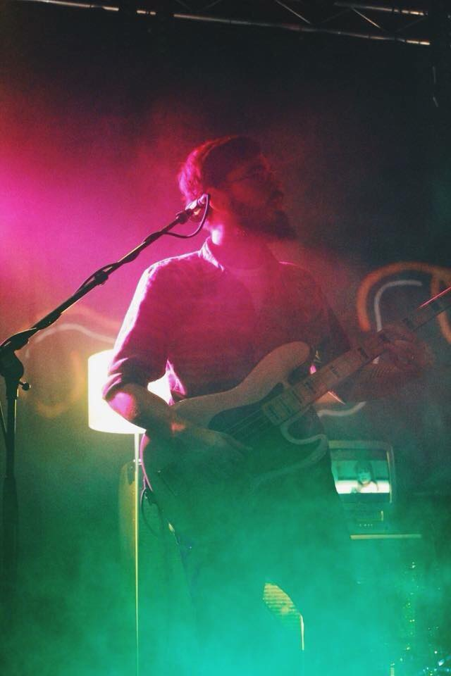

*Software*

*Hypertext Markup Language (HTML)*

HTML is the standard markup language for creating web pages and web applications. Web browsers receive HTML documents from a web server or from local storage and render the documents into multimedia web pages. HTML describes the structure of a web page semantically and originally included cues for the appearance of the document.

*Cascading Style Sheets (CSS)*

CSS is a style sheet language used for describing the presentation of a document written in a markup language like HTML. CSS is designed to enable the separation of presentation and content, including layout, colours, and fonts.

*JavaScript (JS)*

JS is a high-level, interpreted programming language that conforms to the ECMAScript specification. It is a language that is also characterized as dynamic, weakly typed, prototype-based and multi-paradigm.

*Bootstrap*

Bootstrap is a free and open-source front-end framework for developing websites and web applications. It contains HTML and CSS-based design templates for typography, forms, buttons, navigation and other interface components, as well as optional JavaScript extensions. Unlike many earlier web frameworks, it concerns itself with front-end development only.

*Adobe Illustrator, Adobe Photoshop, MS Paint*

*Client’s Brief*

Our client wants simplicity and a summer, youthful feel to the website. The design used will give this vibe to customers and be somewhat “Bubble gum” in colour scheme.

They want the website to consist of 5 pages. These will be *Events, Gallery, Our Artists, About, Home.*

|  |  |  |  |  |
| --- | --- | --- | --- | --- |
| **Home** | **Events** | **Gallery** | **Our Artists** | **About** |
| Brief description of what they do.  Hyperlinks to social medias.  Newest Event.  “why work with us” | List of upcoming events.  List of previous events.  Tickets for sale | Images of gigs and bands. | Bands they have previously or currently work with.  Each band’s social media and Spotify/Soundcloud links. | Information on the company in more detail.  Contact Details |

*Logo Creation*

I was contacted to also create a logo for the company. This is my favourite area to work in so I was happy to help. I sketched out initial ideas, showed them to the client and let them decide which they preferred and what they’d like to see different. Below are some examples:

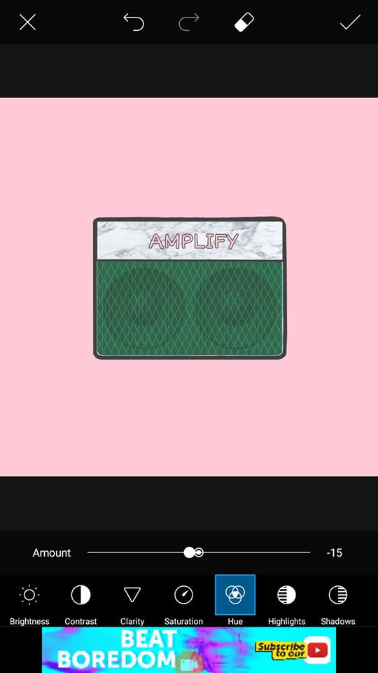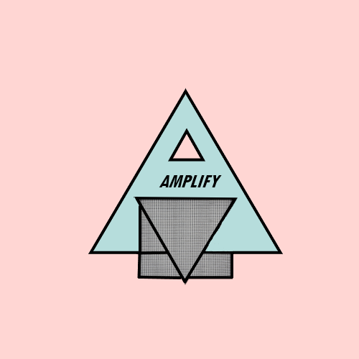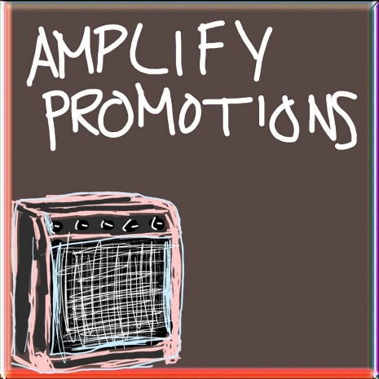

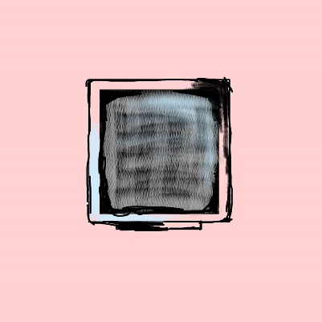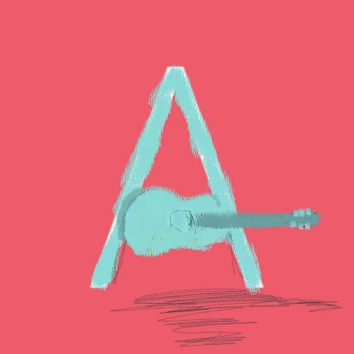

These sketches were made on MS Paint and Adobe Illustrator. We agreed on something similar to the bottom right image, but in a more professional style using Adobe Photoshop and Adobe Illustrator. I used Illustrator to create the text: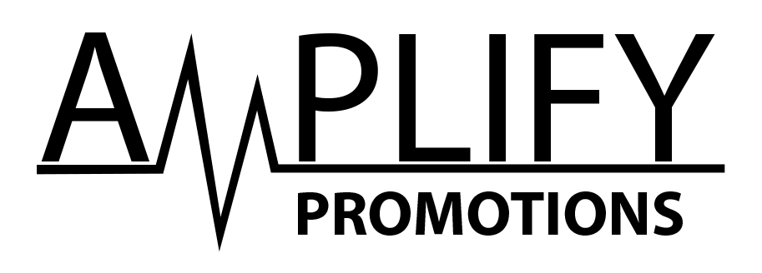

The “M” was made in the shape of a soundwave to relate to music and give the text a unique style. I then googled for an image of an “Orange” amplifier. When I found one I liked, I brought it into Illustrator and edited it using layer masking and minimising its colours to make it bolder and slightly cartoonish in style. It also gave the image a softer look.

I transferred this image over to Photoshop and began to remove the orange font logo using the clone tool and spot healing brush. Then I used colour picker masking to change the orange to a bubble gum pink, then brushing in a soft light blue in the corner to give contrast.

Once I was happy with the colours, I dragged over the font I made in illustrator and reshaped it. Then I removed the background and replaced it with another soft pink, I could then change the background colour to whatever the client wanted.

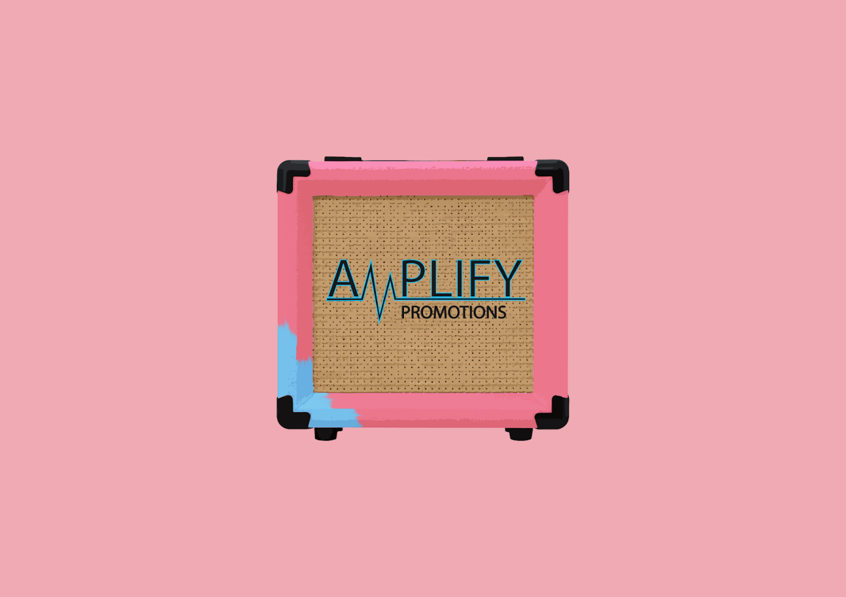

This is the final product.

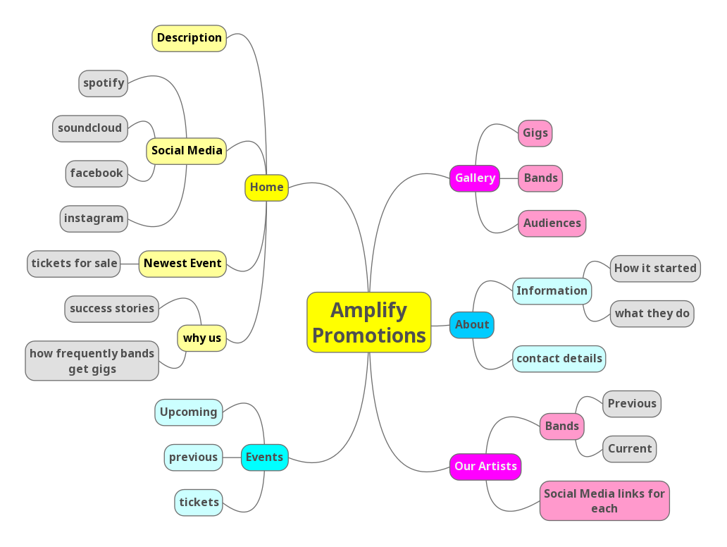*Mindmap*

*Flow Chart*

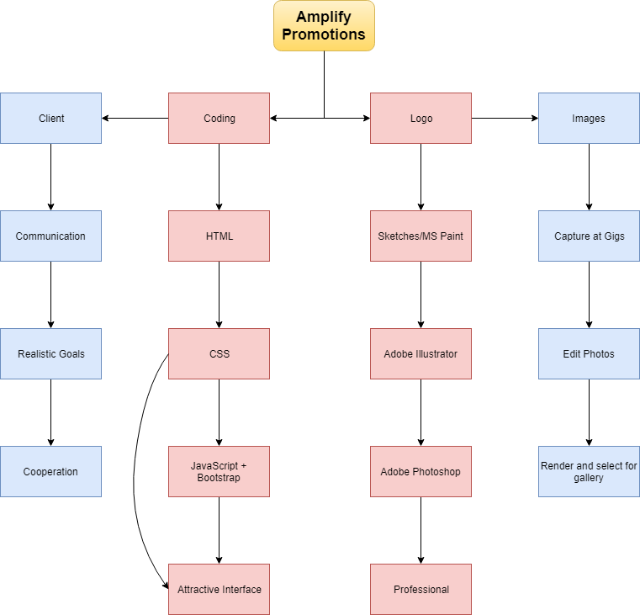

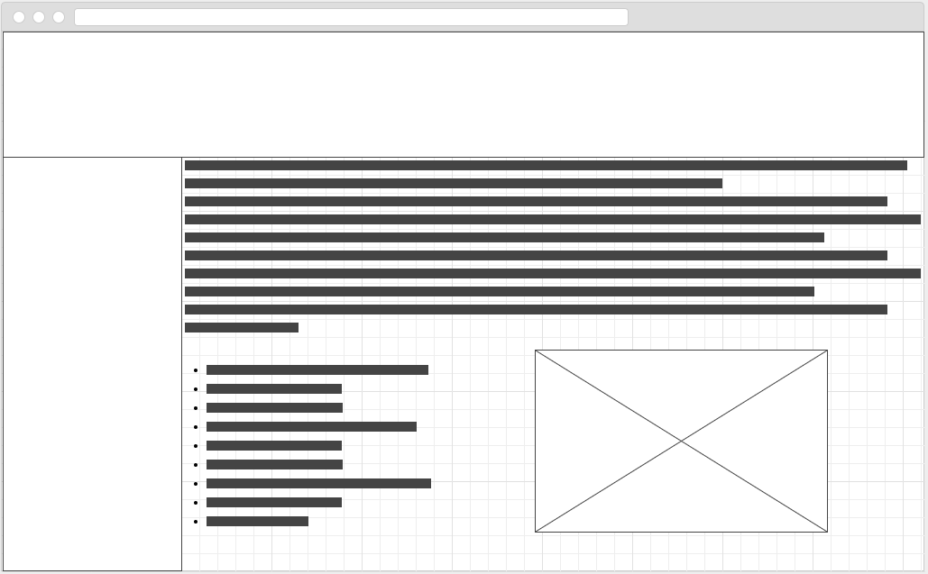*Wireframes*

