Team: 2 Many Cooks

# Project Name: In The Kitchen

## By: Anis Medini, Beau Crumley, Nirmal Lodhi , Noureldin Kamel

## Team Lead: Beau Crumley

Date: 4/1/2021

# Overview

## Project Description

Cookbooks and recipe guides are all over the place. Everybody uses them. Everybody has struggled with them. Our goal is to provide a product that takes the hassle out of following a new recipe. No longer will people need to check, double-check and triple-check their recipes before moving on to the next step. Instead we will provide a streamlined, step-by-step, easy-to-use guide that will provide would-be chefs all the information they need to prepare the perfect dish. Each step will be presented in an easy-to-read format and supply feedback to show exactly where they should be at at a given stage.

We also want users to be able to share their feedback and experiences. Users will be able to give recipes a rating and leave comments for other users to see. We also want to make finding recipes easy. Users will be able to search for recipes by name or browse by tags to always find what they're looking for.

We also feel that this product would be easily marketable to online and retail grocers. All it would take is connecting the application to an existing e-commerce platform and users would be able to purchase all of the ingredients they need for a certain recipe directly from a local store. All at the click of a button from within the application.

## Minimum Viable Product

* 1. Account creation/login.
  2. Search for recipes.
  3. Step-by-step guide on preparing recipes.
  4. Recipes can be rated and commented on.

### 3rd Party API

An API for getting different Recipes and different food information: <https://rapidapi.com/blog/recipe-apis/>

## User Stories

* 1. Users shall be able to login and register
  2. Users shall be able to search for recipes by name
  3. Users shall be able to view information about a recipe
  4. Users shall be able to follow a step by step guide on how to cook the recipe
  5. Users shall be able to leave the website and then resume the guide at the same step on opening the website again
  6. Users shall be able to save a recipe in their favorites list for later reference
  7. Users shall be able to review the recipe and rate it

## Stretch Goals

* 1. Users shall be able to sort search results by popularity
  2. Users shall be able to add recipe requests to be added
  3. Admin users shall be able to delete reviews and add recipes

## UI Models

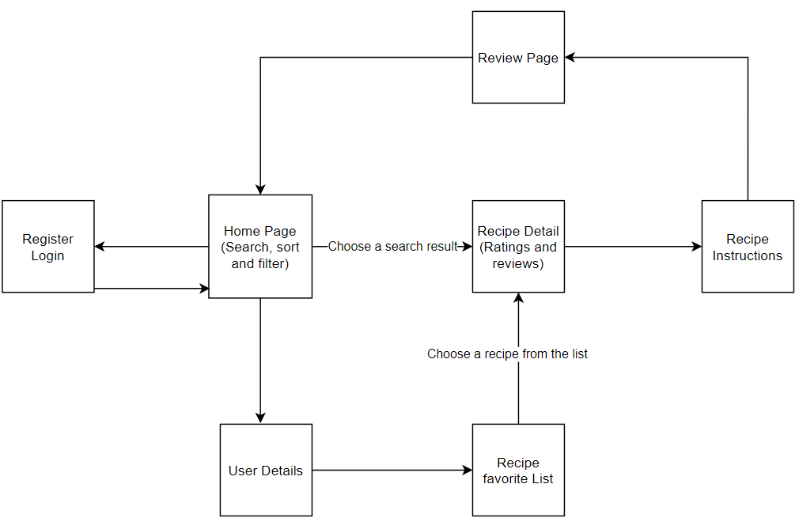

## DB Model

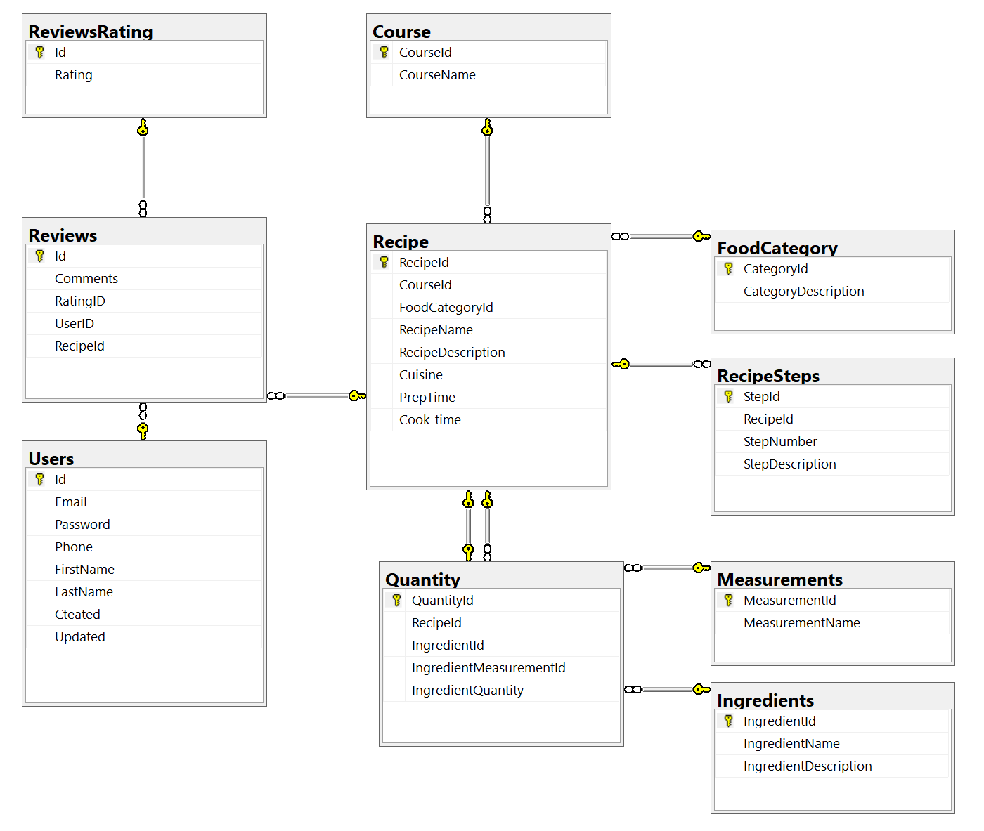

## Kanban board

<https://trello.com/b/WjKzLyF3/agile-sprint-board>

## Github Repository

<https://github.com/BC12807/P2_2ManyCooks>