Richard Saint-Fleur  
CISC 4900 Independent and Group Projects I

Professor Gerald Weiss  
Supervisor: Camille Eddy, Bloc Engineer

4900 Project Log:

Task: CISC 4900 Orientation Meeting

Date: August 26, 2020

Time Dedicated: 1 hour

* Professor introduction
* Explanation of goals and expectations of course
* General Q&A

Task: Project Procurement

Date: August 27, 2020

Time Dedicated: 30 minutes

* Applied to Bloc internship. The Bloc is a career service management platform
* Emailed and inquired Professor Titley about a project. Set up meeting to discuss on August 28th

Task: Project Suggestion Meeting With Professor Titley

Date: August 28, 2020

Time Dedicated: 1 hour

* Discussed the idea of continuing topics from CISC3810 Database Management Systems

Task: Project Procurement – Project Found!

Date: September 1, 2020

Time Dedicated: n/a

* Officially accepted to intern for Bloc
* Details on training materials, roles, job assignments, and teams to be distributed on September 15th
* Program begins October 1st

Task: 4900 Project Proposal Due

Date: September 9, 2020

Time Dedicated: 30 minutes

* Completed Project Proposal Form
* Proposal form emailed to Professor Weiss’ Dropbox without Project Details Form
* Bloc program begins October 1st
* Students with internships with late start times must resubmit both the Proposal and Details Forms with more information is acquired.

Task: Bloc Update

Date: September 15, 2020

Time Dedicated: n/a

* Assigned to “Team Turtle” – Product Pathway
* Product Pathway – Collect more information from unemployed job seekers about what digital resources and tool they need;
* Group must reflect on the following:
* What is your favorite education tool?
* What do you like/dislike about creating a resume for application?
* What would you improve about the process.
* Assigned Supervisor: Camille Eddy, Bloc Engineer
* Internship still scheduled to begin October 1st

Task: Bloc Internship Orientation via Zoom

Date: October 1, 2020

Time Dedicated: 1 hour, 30 minutes

* Introduction of Bloc and its company leaders.
* Program track outlined.
* Group Assign – Training Module tasked via Bloc website.
* Attendees split off into their assigned groups to make acquaintances and discuss our assignment.
* Team consists of fellow CISC4900 students Mehmet Karadayi, Faisal Ibrahim, Muhammad Arif, and Myself.
* Discord server created for communication.
* Meeting with Bloc occur every Thursday at 12pm via Zoom.

Task: Team Turtle Meeting via Discord

Date: October 5, 2020

Time Dedicated: 1 hour, 30 minutes

* Discussed and completed the module.
* The module consisted of questions of questions revolved around the job searching experience:
* What resources would you like to have while searching for internships for 4900 or other times in your life?

Task: Bloc Internship Update

Date: October 7, 2020

Time Dedicated: n/a

* Bloc Internship tasked fully detailed
* During our five weeks with Bloc, each team will research, design, and deploy a new Job Board or Technology Tool Plug-in for the Bloc platform.
* Project Description 🡪 <https://www.notion.so/Internship-Project-Web-App-Bloc-Plug-in-with-Job-Board-Integration-RESTful-API-d328c31cfd4d413bb7ad14d7a7565af8>

Task: Bloc Meeting

Date: October 8, 2020

Time Dedicated: 1 hour, 25 minutes

* Discussed the project, API integration, and Web scrappers with our supervisor.
* Our group is to decide on the stack we will be utilizing, from where we will be sourcing the information, and the app’s specialization as it pertains to job searching.
* Completed a Product Spec sheet for our application via [www.notion.so](http://www.notion.so)

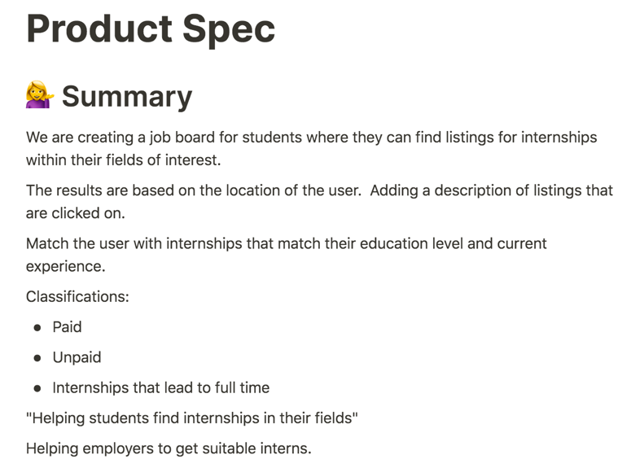

Task: Researching APIs And Integrating with Java

Date: October 9, 2020

Time Dedicated: 2 hours

* Youtube videos on the topic
* Looking into Java servers like Tomcat and Spring
* Looking into GET and POST
* RESTful API

Task: Project Proposal and Details Resubmitted

Date: October 11, 2020

Time Dedicated: n/a

Task: Team Turtle Meeting Discord

Date: October 12, 2020

Time Dedicated: 1 hour, 45 minutes

* Discussed what we found individually on API integration
* Stacks
* Completed Product Spec sheet that is due October 15th

Task: Proposal Accepted!

Date: October 13, 2020

Time Dedicated: n/a

* 4900 project officially given the green light.

Task: Research on Linking DB and Java

Date: October 13, 2020

Time Dedicated: 2 hours

Task: Team Turtle Meeting via Discord

Date: October 14, 2020

Time Dedicated: 1 hour, 15 minutes

* Added more detail to our Product Spec sheet
* Discussed and planned what we will be presenting during our meeting with our supervisor
* Discussed possible technical questions for our supervisor as it pertains to the our Webapp