REVIVE - A PRE-LOVED FASHION MARKETPLACE

A Project Report

Submitted in partial fulfillment of the requirement for the award of Degree of
Bachelor of Computer Applications

Submitted to
310-CIMAGE PROFESIONAL COLLEGE, Patna

Submitted By
<Prince Raj>
Registration No.: <23303310004>
BCA - 3rd Year
Session: 2023-2026

Under Joint Guidance of
Prof. Niraj Kumar Singh and Prof. Anjesh Kumar
Assistant Professor
Department of Computer Science & Applications

CERTIFICATE

This is to certify that the work embodied in this project entitled "Revive - A Pre-loved Fashion Marketplace", being submitted by <Your Name> (<Your Registration Number>) in partial fulfillment of the requirement for the award of Bachelor of Computer Applications to Patliputra University, Patna during the academic year 2023-2026, is a record of bonafide work carried out by him/her under our supervision and guidance in the Department of Computer Science & Applications, SSSAPTM, Patna.

Date: <21/06/2026>

Director: ____________________
Dean Academics: ____________________
Principal: ____________________

APPROVAL CERTIFICATE

The project report entitled "Revive - A Pre-loved Fashion Marketplace", being submitted by <Your Name> (<Your Registration Number>) has been examined by us and is hereby approved for the award of degree Bachelor of Computer Applications, for which it has been submitted. It is understood that by this approval the undersigned do not necessarily endorse or approve any statement made, opinion expressed, or conclusion drawn therein, but approve the project only for the purpose for which it has been submitted.

Internal Examiner: ____________________
External Examiner: ____________________
Date: <Date>

DECLARATION

I, <Your Name>, hereby declare that the work presented in the project report entitled "Revive - A Pre-loved Fashion Marketplace", submitted in partial fulfillment of the requirements for the award of degree of Bachelor of Computer Applications in the Department of Computer Science & Applications, Cimage professional college, is an authentic record of my own work carried out under the joint guidance of Prof. Niraj Kumar Singh and Prof. Anjesh Kumar.
I have not submitted the matter embodied in this report for the award of any other degree.

<Your Name>
Registration No.: <Your Registration Number>
BCA 3rd Year
Session: 2023-2026

ACKNOWLEDGEMENT

I would like to express my sincere gratitude to Prof. Niraj Kumar Singh and Prof. Anjesh Kumar for providing regular guidance, valuable suggestions, and continuous support throughout the development of this project.
I also extend my thanks to the respected Director, Dean Academics, Principal, faculty members, and staff of the Department of Computer Science & Applications for providing the necessary facilities and academic environment to complete this project successfully.
I am also thankful to my friends for their cooperation and encouragement during the development work. Lastly, I express my heartfelt thanks to my parents and family members for their constant moral support, motivation, and encouragement.

<Your Name>
Registration No.: <Your Registration Number>
BCA 3rd Year
Session: 2023-2026

CONTENTS

1. Introduction
2. Objective
3. Project Category
4. Advantages of Web-Based E-Commerce Application
5. Tools/Platform Required
6. Hardware & Software Requirements
7. Problem Definition
8. Requirement Specifications
9. Project Planning & Scheduling
10. Gantt Chart
11. PERT Chart
12. System Analysis
13. Identification of Need
14. Feasibility Study
15. Analysis
16. Data Flow Diagram
17. Module Description
18. Data Structure
19. List of Reports
20. Scope and Future Enhancement
21. Implementation Methodology
22. Testing
23. Limitations and Further Enhancements
24. Security Mechanism
25. Snapshots
26. Bibliography
27. References

INTRODUCTION

In the rapidly evolving landscape of digital commerce and sustainable lifestyle choices, "Revive - A Pre-loved Fashion Marketplace" emerges as a practical web-based application for buying and selling second-hand fashion products. The platform is designed to connect people who want to sell unused fashion items with buyers who are looking for affordable, quality, and sustainable fashion options.
The system supports a peer-to-peer marketplace model. A normal user can work both as a buyer and a seller. Buyers can browse products, search and filter listings, add products to cart or wishlist, place orders, track purchases, chat with sellers, and submit reviews after successful purchases. Sellers can upload products, manage listings, view orders, update delivery status, and communicate directly with buyers.
Revive also includes an admin panel for monitoring and managing users, products, orders, reports, disputes, contact messages, and platform statistics. The project promotes sustainable fashion by encouraging reuse of clothes, footwear, accessories, luxury items, vintage fashion, and streetwear.
The frontend of the project is developed using HTML, CSS, JavaScript, and Tailwind CSS. The backend is developed using PHP, and MySQL is used for database management. The project is designed to run in a local XAMPP/Apache server environment.

OBJECTIVE

The primary objective of Revive is to provide a secure, user-friendly, and responsive online marketplace where users can buy and sell pre-loved fashion products.
â€¢ To allow users to register, log in, verify accounts through OTP, and manage profiles securely.
â€¢ To allow sellers to upload fashion products with descriptions, prices, images, brand, size, and condition.
â€¢ To allow buyers to search, filter, wishlist, add to cart, and purchase products.
â€¢ To provide checkout, payment flow, order tracking, invoice generation, and order history.
â€¢ To enable buyer-seller communication through a chat module.
â€¢ To provide an admin dashboard for managing users, products, orders, reports, and platform records.
â€¢ To encourage sustainable shopping and reduce textile waste through reuse of wearable products.

PROJECT CATEGORY

This project belongs to the category of Web-Based E-Commerce Application. It is also a Peer-to-Peer Marketplace System because users can directly sell their products to other users through the platform.
The project includes concepts of online shopping, user authentication, product catalog management, cart and wishlist management, checkout, order processing, notification handling, buyer-seller communication, reviews, reports, and admin control.
â€¢ Application Type: Web Application
â€¢ Domain: E-commerce and Sustainable Fashion
â€¢ Architecture: Client-Server Architecture
â€¢ Frontend: Browser-based user interface
â€¢ Backend: PHP server-side scripting
â€¢ Database: MySQL relational database
ADVANTAGES OF WEB-BASED E-COMMERCE APPLICATION

â€¢ Easy accessibility through a web browser without special installation.
â€¢ Centralized database management for users, products, orders, and reports.
â€¢ Responsive interface for desktop and mobile users.
â€¢ Better product discovery using search and filter options.
â€¢ Secure role-based access for buyers, sellers, and administrators.
â€¢ Supports sustainable shopping by extending the life of fashion products.

TOOLS/PLATFORM REQUIRED

â€¢ Operating System: Windows
â€¢ Server: Apache using XAMPP
â€¢ Database Server: MySQL
â€¢ Backend Language: PHP
â€¢ Frontend Technologies: HTML, CSS, JavaScript
â€¢ CSS Framework: Tailwind CSS CDN
â€¢ Editor: Visual Studio Code or any suitable code editor
â€¢ Browser: Google Chrome, Microsoft Edge, or Mozilla Firefox
HARDWARE & SOFTWARE REQUIREMENTS

Hardware Requirements
â€¢ Processor: Intel Core i3 or higher
â€¢ RAM: 4 GB minimum
â€¢ Hard Disk: 500 MB free space for project files and database
â€¢ Monitor, keyboard, and mouse
â€¢ Internet connection for CDN resources and email configuration
Software Requirements
â€¢ Windows operating system
â€¢ XAMPP server package
â€¢ Apache web server
â€¢ MySQL database
â€¢ PHP
â€¢ Web browser and code editor

PROBLEM DEFINITION

Many people own clothes, footwear, accessories, and other fashion items that are still in good condition but are no longer used. These items often remain unused or are discarded, which contributes to textile waste. At the same time, many buyers want affordable fashion products but do not have a trusted local platform for finding quality second-hand fashion items.
The problem is to design and develop a secure web-based marketplace where users can list, browse, communicate, purchase, and manage pre-loved fashion products. The system must support different user roles, maintain product and order records, and provide a simple interface for buyers, sellers, and administrators.
REQUIREMENT SPECIFICATIONS

Functional Requirements
â€¢ The system shall allow users to register and log in.
â€¢ The system shall support OTP verification and password reset.
â€¢ The system shall allow sellers to add product details and images.
â€¢ The system shall display products with search and filter options.
â€¢ The system shall allow buyers to use cart and wishlist features.
â€¢ The system shall allow buyers to place orders and generate invoices.
â€¢ The system shall allow sellers to update order status and tracking details.
â€¢ The system shall allow buyers and sellers to chat.
â€¢ The system shall provide admin features for managing users, products, orders, and reports.
Non-Functional Requirements
â€¢ The system should be responsive and easy to use.
â€¢ The system should protect user passwords and sessions.
â€¢ The system should validate important inputs and prevent unauthorized access.
â€¢ The system should maintain database consistency and handle common errors gracefully.

PROJECT PLANNING & SCHEDULING

Project planning was done by dividing the application into smaller modules. Each module was designed, implemented, and tested separately before integration.
1. Requirement collection and study
2. Database design
3. User interface design
4. Authentication module development
5. Product catalog module development
6. Cart, wishlist, and checkout development
7. Seller dashboard development
8. Admin dashboard development
9. Chat, review, and notification module development
10. Testing and final documentation
GANTT CHART

Task | Week 1 | Week 2 | Week 3 | Week 4 | Week 5 | Week 6
Requirement Analysis | Yes
Database Design | Yes | Yes
UI Design |  | Yes | Yes
Authentication Module |  | Yes | Yes
Product Module |  |  | Yes | Yes
Cart and Checkout |  |  |  | Yes | Yes
Seller and Admin Module |  |  |  | Yes | Yes
Testing and Documentation |  |  |  |  | Yes | Yes

PERT CHART

Start -> Requirement Analysis -> Database Design -> UI Design -> Module Development -> Integration -> Testing -> Documentation -> Final Submission
Module development includes authentication, product management, cart, wishlist, checkout, seller dashboard, admin dashboard, chat, notifications, and reviews.

SYSTEM ANALYSIS

System analysis was performed to understand the needs of buyers, sellers, and administrators. The system must manage users, products, images, orders, reviews, cart items, wishlists, chats, notifications, contact messages, subscribers, OTP records, and disputes.
The application uses a centralized MySQL database. PHP files handle server-side logic, while JavaScript and Fetch API are used for dynamic operations such as cart updates, wishlist updates, search suggestions, and notifications.
IDENTIFICATION OF NEED

The need for this system arises from the increasing demand for affordable and sustainable fashion. Users require a platform where they can sell unused fashion products and buy second-hand items safely.
â€¢ Reduce wastage of usable fashion products.
â€¢ Provide affordable fashion options.
â€¢ Connect buyers and sellers directly.
â€¢ Maintain digital records of products and orders.
â€¢ Provide admin monitoring and control.
â€¢ Encourage sustainable shopping behavior.
FEASIBILITY STUDY

Technical Feasibility
The project is technically feasible because it uses commonly available technologies such as PHP, MySQL, HTML, CSS, JavaScript, and XAMPP.
Economical Feasibility
The project is economically feasible because all major technologies used are open-source or freely available.
Operational Feasibility
The system is operationally feasible because it provides a user-friendly interface for buyers, sellers, and administrators.

ANALYSIS

The system is divided into three main user areas: Buyer area, Seller area, and Admin area.
â€¢ Buyer operations include searching products, adding to cart or wishlist, placing orders, chatting with sellers, and reviewing purchases.
â€¢ Seller operations include adding products, managing products, viewing orders, and updating delivery status.
â€¢ Admin operations include managing users, products, reports, and platform data.
DATA FLOW DIAGRAM

Level 0 DFD
Buyer -> Revive System -> Products, Cart, Orders, Chats, Reviews
Seller -> Revive System -> Products, Orders, Chats
Admin -> Revive System -> Users, Products, Orders, Reports
Level 1 DFD
1. User Authentication: registration, login, OTP, password reset, and verified user session.
2. Product Management: product details, images, listing, and product records.
3. Shopping Process: cart, wishlist, checkout, payment, order confirmation, and invoice.
4. Communication Process: buyer-seller messages and stored chat records.
5. Admin Management: admin actions and updated user, product, order, and report data.

MODULE DESCRIPTION

Authentication Module
Handles registration, login, logout, OTP verification, and password reset. Important files include register.php, login.php, logout.php, verify_otp.php, forgot_password.php, reset_password.php, and actions/auth_action.php.
Product Catalog Module
Displays products and product details. Users can search and filter products using category, size, brand, condition, and price.
Cart and Wishlist Module
Allows buyers to add products to cart and wishlist. Data is stored in the database.
Checkout and Order Module
Manages order placement, payment flow, invoices, order tracking, and cancellations.
Seller Module
Allows sellers to add products, manage listings, update order status, and manage seller profile.
Chat Module
Allows buyers and sellers to communicate about products.
Review Module
Allows buyers to submit reviews only for completed purchases.
Admin Module
Allows administrators to manage users, products, orders, statistics, and reports.

DATA STRUCTURE

The database used in the project is revive_db. It uses primary keys, foreign keys, and cascading delete rules to maintain relationships and consistency.
Table | Description
users | Stores user account details, role, status, profile image, and verification data.
otp_requests | Stores OTP data for registration and password reset.
categories | Stores product categories.
products | Stores product details uploaded by sellers.
product_images | Stores multiple product image paths.
orders | Stores order details, buyer, product, amount, status, and tracking data.
cart | Stores products added to user cart.
wishlist | Stores wishlist products.
chats | Stores buyer-seller messages.
reviews | Stores product ratings and comments.
notifications | Stores user notifications.
messages | Stores contact form messages.
subscribers | Stores newsletter subscribers.
disputes | Stores order dispute details.

LIST OF REPORTS

â€¢ User list report
â€¢ Product list report
â€¢ Order report
â€¢ Financial report
â€¢ Seller order report
â€¢ Buyer purchase history
â€¢ Invoice report
â€¢ Contact message records
â€¢ Dispute records
â€¢ Admin dashboard statistics
SCOPE AND FUTURE ENHANCEMENT

The scope of Revive includes user account management, product listing, product browsing, cart and wishlist, order processing, seller dashboard, admin dashboard, chat, reviews, notifications, invoices, and reporting.
â€¢ Real payment gateway integration.
â€¢ Advanced seller verification.
â€¢ Product approval workflow with moderation history.
â€¢ Return and refund automation.
â€¢ Seller analytics dashboard.
â€¢ AI-based product recommendations.
â€¢ Mobile application support.
â€¢ REST API development.
â€¢ Automated testing and cloud deployment.

IMPLEMENTATION METHODOLOGY

The project follows a modular implementation approach. Each module was developed separately and then integrated into the complete system.
1. Database schema was created using MySQL.
2. Common database connection was configured in config/db.php.
3. Header, footer, and reusable layout files were created.
4. Authentication pages and action files were implemented.
5. Product listing and product detail pages were developed.
6. Cart, wishlist, checkout, and payment flow were implemented.
7. Seller dashboard and admin dashboard were added.
8. Chat, notification, review, and reporting features were implemented.
9. The project was tested through browser-based execution in XAMPP.
TESTING

Unit Testing
Individual modules such as login, registration, product upload, cart, wishlist, and order placement were tested separately.
Integration Testing
Multiple modules were tested together. Checkout was tested with cart, product status, orders, invoices, and notifications.
Functional Testing
â€¢ User registration and login
â€¢ OTP verification
â€¢ Product browsing
â€¢ Product upload
â€¢ Add to cart
â€¢ Add to wishlist
â€¢ Checkout
â€¢ Order tracking
â€¢ Seller order update
â€¢ Admin management
â€¢ Chat
â€¢ Review submission
User Interface Testing
The interface was tested on desktop and mobile screen sizes to verify layout, navigation, forms, product cards, dashboard pages, and notifications.

LIMITATIONS AND FURTHER ENHANCEMENTS

Limitations
â€¢ The project currently runs mainly in a local XAMPP environment.
â€¢ Real payment gateway integration is not fully production-ready.
â€¢ Email OTP requires correct mail configuration.
â€¢ Automated testing is limited.
â€¢ Advanced fraud detection is not included.
â€¢ Product moderation can be further improved.
Further Enhancements
â€¢ Deploy the application on a live server.
â€¢ Add secure online payment gateway.
â€¢ Add automated product verification.
â€¢ Add advanced admin analytics.
â€¢ Add better shipment integration.
â€¢ Add automated test cases.
â€¢ Improve performance for large product catalogs.
SECURITY MECHANISM

â€¢ Password hashing for user passwords.
â€¢ Session-based login management.
â€¢ CSRF token generation for form security.
â€¢ OTP verification for registration and password reset.
â€¢ User ban status check during active sessions.
â€¢ Product availability check before order placement.
â€¢ Review restriction to completed purchases.
â€¢ Foreign key constraints for database consistency.
â€¢ Input validation in important forms.
â€¢ Role-based access for admin and normal users.

SNAPSHOTS

Snapshot 1: Home Page
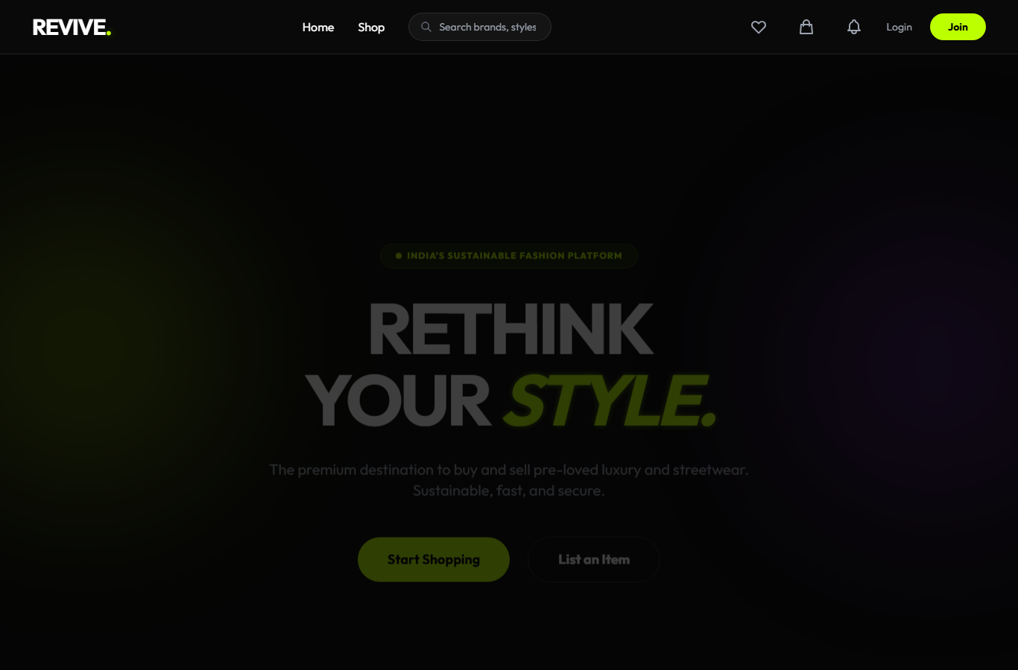
Related Coding
File: index.php
1 <?php
2 require_once 'config/db.php';
3 include 'includes/header.php';
4
5 // Stats for banner
6 $total_products = $conn->query("SELECT COUNT(*) as c FROM products WHERE status = 'available'")->fetch_assoc()['c'] ?? 0;
7 $total_sellers = $conn->query("SELECT COUNT(DISTINCT seller_id) as c FROM products")->fetch_assoc()['c'] ?? 0;
8 $total_sold = $conn->query("SELECT COUNT(*) as c FROM products WHERE status = 'sold'")->fetch_assoc()['c'] ?? 0;
9 $waste_saved = round($total_sold * 1.5, 1);
10 ?>
11
12 <?php if(isset($_GET['success']) && $_GET['success'] === 'logged_in'): ?>
13 <div id="login-toast" class="fixed top-20 right-6 z-[999] bg-[#bcff00] text-black px-6 py-4 rounded-2xl font-bold shadow-2xl shadow-[#bcff00]/20 flex items-center space-x-3 transition-all duration-500">
14 <svg xmlns="http://www.w3.org/2000/svg" class="h-5 w-5" fill="none" viewBox="0 0 24 24" stroke="currentColor">
15 <path stroke-linecap="round" stroke-linejoin="round" stroke-width="2" d="M9 12l2 2 4-4m6 2a9 9 0 11-18 0 9 9 0 0118 0z"/>
16 </svg>
17 <span>Welcome back to Revive! ðŸ‘‹</span>
18 </div>
19 <script>
20 setTimeout(() => {
21 const toast = document.getElementById('login-toast');
22 if (toast) { toast.style.opacity = '0'; toast.style.transform = 'translateY(-20px)'; setTimeout(() => toast.remove(), 500); }
23 }, 3000);
24 </script>
25 <?php endif; ?>
26
27 <!-- Hero Section -->
28 <section class="relative min-h-[90vh] flex items-center justify-center overflow-hidden px-6">
29 <!-- Abstract Background Elements -->
30 <div class="absolute top-1/4 -left-20 w-96 h-96 bg-[#bcff00]/10 rounded-full blur-[120px]"></div>
31 <div class="absolute bottom-1/4 -right-20 w-96 h-96 bg-purple-600/10 rounded-full blur-[120px]"></div>
32
33 <div class="max-w-5xl mx-auto text-center relative z-10" data-aos="fade-up">
34 <div class="inline-flex items-center space-x-2 bg-[#bcff00]/10 border border-[#bcff00]/20 text-[#bcff00] text-xs font-bold uppercase tracking-widest px-5 py-2 rounded-full mb-8">
35 <span class="w-2 h-2 bg-[#bcff00] rounded-full animate-pulse"></span>
36 <span>India's Sustainable Fashion Platform</span>
37 </div>
38 <h1 class="text-6xl md:text-8xl font-bold tracking-tighter leading-none mb-8">
39 RETHINK<br>
40 YOUR <span class="neon-text italic">STYLE.</span>
41 </h1>
42 <p class="text-xl text-gray-400 max-w-2xl mx-auto mb-12">
43 The premium destination to buy and sell pre-loved luxury and streetwear.
44 Sustainable, fast, and secure.
45 </p>
46 <div class="flex flex-col md:flex-row items-center justify-center gap-6">
47 <a href="shop.php?view=products" class="neon-btn text-lg font-bold px-10 py-4 rounded-full w-full md:w-auto text-center">
48 Start Shopping
49 </a>
50 <a href="<?php echo isset($_SESSION['user_id']) ? 'add_product.php' : 'login.php'; ?>" class="text-lg font-bold border border-white/20 px-10 py-4 rounded-full hover:bg-white/5 transition w-full md:w-auto text-center">
51 List an Item
52 </a>
53 </div>
54 </div>
55 </section>
56
57 <!-- Stats Banner -->
58 <section class="py-6 px-6 max-w-7xl mx-auto" data-aos="fade-up">
59 <div class="bg-white/5 border border-white/10 rounded-[2rem] px-8 py-6 grid grid-cols-2 md:grid-cols-4 gap-6 text-center">
60 <div>
61 <p class="text-3xl md:text-4xl font-black text-[#bcff00] italic"><?php echo number_format($total_products); ?>+</p>
62 <p class="text-gray-500 text-xs font-bold uppercase tracking-widest mt-1">Live Listings</p>
63 </div>
64 <div>
65 <p class="text-3xl md:text-4xl font-black text-white italic"><?php echo number_format($total_sellers); ?>+</p>
66 <p class="text-gray-500 text-xs font-bold uppercase tracking-widest mt-1">Active Sellers</p>
67 </div>
68 <div>
69 <p class="text-3xl md:text-4xl font-black text-purple-400 italic"><?php echo number_format($total_sold); ?>+</p>
70 <p class="text-gray-500 text-xs font-bold uppercase tracking-widest mt-1">Items Sold</p>
71 </div>
72 <div>
73 <p class="text-3xl md:text-4xl font-black text-emerald-400 italic"><?php echo $waste_saved; ?>kg</p>
74 <p class="text-gray-500 text-xs font-bold uppercase tracking-widest mt-1">Textile Waste Saved</p>
75 </div>
76 </div>
77 </section>
78
79 <!-- Latest Drops Section -->
80 <section class="py-24 px-6 max-w-7xl mx-auto">
81 <div class="flex justify-between items-end mb-12">
82 <div data-aos="fade-right">
83 <h2 class="text-4xl font-bold tracking-tight mb-2">Latest Drops</h2>
84 <p class="text-gray-400">Recently added pieces from our community.</p>
85 </div>
86 <a href="shop.php?view=products" class="text-[#bcff00] font-semibold hover:underline flex items-center space-x-1 group">
87 <span>View all</span>
88 <span class="group-hover:translate-x-1 transition">&rarr;</span>
89 </a>
90 </div>
.... [Code continues in the project source file.]

Snapshot 2: Product Listing Page
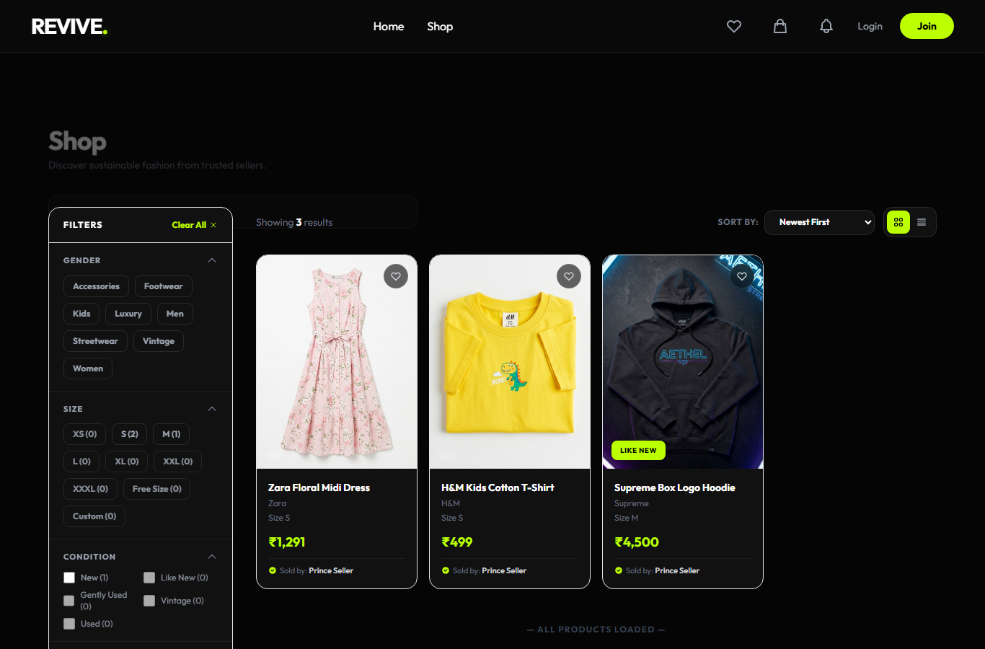
Related Coding
File: shop.php
1 <?php
2 require_once 'config/db.php';
3
4 // Check if it is an AJAX filter request
5 if (isset($_GET['ajax'])) {
6 $category_filters = isset($_GET['categories']) ? array_map('intval', $_GET['categories']) : [];
7 $search_query = isset($_GET['search']) ? trim($_GET['search']) : '';
8 $selected_sizes = isset($_GET['sizes']) ? $_GET['sizes'] : [];
9 $selected_brands = isset($_GET['brands']) ? $_GET['brands'] : [];
10 $selected_conditions = isset($_GET['conditions']) ? $_GET['conditions'] : [];
11 $min_price = isset($_GET['min_price']) ? (float)$_GET['min_price'] : 0;
12 $max_price = isset($_GET['max_price']) ? (float)$_GET['max_price'] : 999999;
13 $sort = $_GET['sort'] ?? 'newest';
14 $limit = 12;
15 $offset = isset($_GET['offset']) ? max(0, (int)$_GET['offset']) : 0;
16
17 $user_id = $_SESSION['user_id'] ?? 0;
18
19 // Build WHERE conditions with a closure to allow exclusions for dynamic filter counting
20 $buildWhere = function($exclude) use ($conn, $category_filters, $selected_sizes, $selected_brands, $selected_conditions, $min_price, $max_price, $search_query) {
21 $w = "WHERE p.status = 'available'";
22 if (!empty($category_filters)) $w .= " AND p.category_id IN (" . implode(',', $category_filters) . ")";
23 if ($exclude !== 'sizes' && !empty($selected_sizes)) {
24 $escaped = array_map(fn($s) => "'" . mysqli_real_escape_string($conn, $s) . "'", $selected_sizes);
25 $w .= " AND p.size IN (" . implode(',', $escaped) . ")";
26 }
27 if ($exclude !== 'brands' && !empty($selected_brands)) {
28 $escaped = array_map(fn($b) => "'" . mysqli_real_escape_string($conn, $b) . "'", $selected_brands);
29 $w .= " AND p.brand IN (" . implode(',', $escaped) . ")";
30 }
31 if ($exclude !== 'conditions' && !empty($selected_conditions)) {
32 $escaped = array_map(fn($c) => "'" . mysqli_real_escape_string($conn, $c) . "'", $selected_conditions);
33 $w .= " AND p.product_condition IN (" . implode(',', $escaped) . ")";
34 }
35 if ($min_price >= 0) $w .= " AND p.price >= $min_price";
36 if ($max_price > 0) $w .= " AND p.price <= $max_price";
37 if ($search_query) {
38 $keywords = explode(' ', $search_query);
39 $search_conditions = [];
40 foreach ($keywords as $word) {
41 $word = mysqli_real_escape_string($conn, $word);
42 $search_conditions[] = "(p.title LIKE '%$word%' OR p.brand LIKE '%$word%' OR p.description LIKE '%$word%')";
43 }
44 $w .= " AND (" . implode(' AND ', $search_conditions) . ")";
45 }
46 return $w;
47 };
48
49 $where = $buildWhere('none');
50
51 // Dynamic Counts Calculations
52 $size_counts = [];
53 $cond_counts = [];
54 $brand_counts = [];
55
56 $sc_query = $conn->query("SELECT p.size, COUNT(p.id) as c FROM products p JOIN categories c ON p.category_id = c.id JOIN users u ON p.seller_id = u.id " . $buildWhere('sizes') . " GROUP BY p.size");
57 if($sc_query) while($row = $sc_query->fetch_assoc()) $size_counts[$row['size']] = (int)$row['c'];
58
59 $cc_query = $conn->query("SELECT p.product_condition, COUNT(p.id) as c FROM products p JOIN categories c ON p.category_id = c.id JOIN users u ON p.seller_id = u.id " . $buildWhere('conditions') . " GROUP BY p.product_condition");
60 if($cc_query) while($row = $cc_query->fetch_assoc()) $cond_counts[$row['product_condition']] = (int)$row['c'];
61
62 $bc_query = $conn->query("SELECT p.brand, COUNT(p.id) as c FROM products p JOIN categories c ON p.category_id = c.id JOIN users u ON p.seller_id = u.id " . $buildWhere('brands') . " GROUP BY p.brand");
63 if($bc_query) while($row = $bc_query->fetch_assoc()) $brand_counts[$row['brand']] = (int)$row['c'];
64
65 $sort_sql = match($sort) {
66 'price_low' => "p.price ASC",
67 'price_high' => "p.price DESC",
68 default => "p.created_at DESC"
69 };
70
71 // Count query (no subquery conflict)
72 $count_sql = "SELECT COUNT(*) as total
73 FROM products p
74 JOIN categories c ON p.category_id = c.id
75 JOIN users u ON p.seller_id = u.id
76 $where";
77 $total_count = $conn->query($count_sql)->fetch_assoc()['total'] ?? 0;
78 $has_more = ($offset + $limit) < $total_count;
79
80 // Main products query
81 $sql = "SELECT p.*, c.name as category_name, u.name as seller_name,
82 (SELECT id FROM wishlist WHERE user_id = $user_id AND product_id = p.id) as is_wishlisted
83 FROM products p
84 JOIN categories c ON p.category_id = c.id
85 JOIN users u ON p.seller_id = u.id
86 $where
87 ORDER BY $sort_sql LIMIT $limit OFFSET $offset";
88
89 $products = $conn->query($sql);
90
91 // Render new-design cards
92 if ($products->num_rows > 0) {
93 while ($product = $products->fetch_assoc()) {
94 $cond = $product['product_condition'];
95 $badge = match($cond) {
96 'New' => ['label' => 'Like New', 'class' => 'bg-[#bcff00] text-black'],
97 'Like New' => ['label' => 'Like New', 'class' => 'bg-[#bcff00] text-black'],
98 'Gently Used'=> ['label' => 'Gently Used', 'class' => 'bg-orange-400/90 text-black'],
99 'Used' => ['label' => 'Gently Used', 'class' => 'bg-orange-400/90 text-black'],
100 'Vintage' => ['label' => 'Vintage', 'class' => 'bg-purple-500/90 text-white'],
101 default => ['label' => htmlspecialchars($cond), 'class' => 'bg-white/20 text-white'],
102 };
103 ?>
104 <a href="product_details.php?id=<?php echo $product['id']; ?>" class="group block bg-[#111] border border-white/8 rounded-2xl overflow-hidden hover:border-white/20 hover:shadow-xl hover:shadow-black/40 transition-all duration-300">
105 <!-- Product Image -->
106 <div class="relative aspect-[3/4] overflow-hidden bg-[#1a1a1a]">
107 <img src="assets/img/products/<?php echo htmlspecialchars($product['images']); ?>"
108 onerror="this.style.display='none'"
109 class="w-full h-full object-cover group-hover:scale-105 transition duration-500">
110 <!-- Condition Badge -->
.... [Code continues in the project source file.]

Snapshot 3: Product Details Page
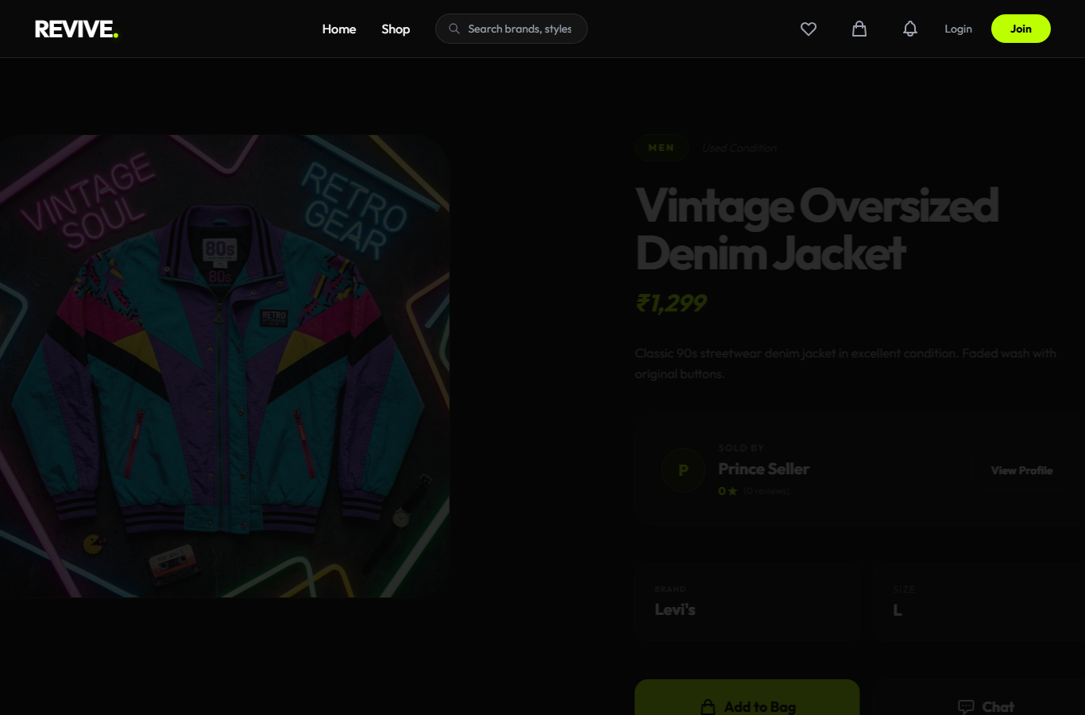
Related Coding
File: product_details.php
1 <?php
2 require_once 'config/db.php';
3 include 'includes/header.php';
4
5 $id = isset($_GET['id']) ? (int)$_GET['id'] : 0;
6 $result = $conn->query("SELECT p.*, c.name as category_name, u.name as seller_name FROM products p JOIN categories c ON p.category_id = c.id JOIN users u ON p.seller_id = u.id WHERE p.id = $id");
7
8 if($result->num_rows === 0) {
9 echo "<section class='py-40 text-center'><h1 class='text-4xl font-bold'>Product not found.</h1><a href='shop.php' class='text-[#bcff00] mt-4 block'>Back to Shop</a></section>";
10 include 'includes/footer.php';
11 exit();
12 }
13
14 $product = $result->fetch_assoc();
15 ?>
16
17 <section class="py-24 px-6 max-w-7xl mx-auto">
18 <div class="grid grid-cols-1 lg:grid-cols-2 gap-16 items-start">
19 <!-- Product Gallery -->
20 <div data-aos="fade-right">
21 <?php
22 $images_res = $conn->query("SELECT * FROM product_images WHERE product_id = $id ORDER BY is_primary DESC");
23 $images = [];
24 while($img = $images_res->fetch_assoc()) $images[] = $img['image_path'];
25
26 $primary_image = !empty($images) ? $images[0] : $product['images'];
27 if(empty($images)) $images[] = $product['images'];
28 ?>
29 <div class="relative aspect-square rounded-[3rem] overflow-hidden bg-white/5 border border-white/10 mb-6 group">
30 <img id="main-product-image" src="assets/img/products/<?php echo $primary_image; ?>"
31 class="absolute inset-0 w-full h-full object-cover transition duration-700">
32
33 <!-- Zoom Overlay Icon -->
34 <div class="absolute inset-0 bg-black/20 opacity-0 group-hover:opacity-100 transition flex items-center justify-center pointer-events-none">
35 <svg xmlns="http://www.w3.org/2000/svg" class="h-10 w-10 text-white" fill="none" viewBox="0 0 24 24" stroke="currentColor">
36 <path stroke-linecap="round" stroke-linejoin="round" stroke-width="2" d="M21 21l-6-6m2-5a7 7 0 11-14 0 7 7 0 0114 0z" />
37 </svg>
38 </div>
39 </div>
40
41 <?php if(count($images) > 1): ?>
42 <div class="flex space-x-4 overflow-x-auto pb-4 scrollbar-hide">
43 <?php foreach($images as $img_path): ?>
44 <button onclick="document.getElementById('main-product-image').src='assets/img/products/<?php echo $img_path; ?>'"
45 class="w-24 h-24 rounded-2xl overflow-hidden flex-shrink-0 border-2 border-transparent hover:border-[#bcff00] transition active:scale-95">
46 <img src="assets/img/products/<?php echo $img_path; ?>" class="w-full h-full object-cover">
47 </button>
48 <?php endforeach; ?>
49 </div>
50 <?php endif; ?>
51 </div>
52
53 <!-- Product Info -->
54 <div data-aos="fade-left">
55 <div class="mb-8">
56 <div class="flex items-center space-x-4 mb-6">
57 <span class="bg-[#bcff00]/10 text-[#bcff00] text-xs font-bold uppercase tracking-[0.2em] px-4 py-2 rounded-full border border-[#bcff00]/20">
58 <?php echo htmlspecialchars($product['category_name']); ?>
59 </span>
60 <span class="text-gray-500 text-sm italic"><?php echo htmlspecialchars($product['product_condition']); ?> Condition</span>
61 </div>
62
63 <h1 class="text-5xl md:text-6xl font-bold tracking-tighter mb-4"><?php echo htmlspecialchars($product['title']); ?></h1>
64 <p class="text-3xl font-bold text-[#bcff00] italic mb-8">â‚¹<?php echo number_format($product['price'], 0); ?></p>
65
66 <p class="text-gray-400 leading-relaxed mb-10">
67 <?php echo nl2br(htmlspecialchars($product['description'])); ?>
68 </p>
69
70 <!-- Seller Info Card -->
71 <?php
72 $seller_id = $product['seller_id'];
73 $seller_stats = $conn->query("SELECT
74 u.name, u.created_at,
75 (SELECT AVG(rating) FROM reviews r JOIN products p2 ON r.product_id = p2.id WHERE p2.seller_id = $seller_id) as avg_rating,
76 (SELECT COUNT(*) FROM reviews r JOIN products p2 ON r.product_id = p2.id WHERE p2.seller_id = $seller_id) as total_reviews
77 FROM users u WHERE u.id = $seller_id")->fetch_assoc();
78 ?>
79 <div class="bg-white/5 border border-white/10 rounded-3xl p-8 mb-12 group hover:border-[#bcff00]/50 transition duration-500">
80 <div class="flex items-center justify-between">
81 <div class="flex items-center space-x-4">
82 <div class="w-14 h-14 rounded-full bg-[#bcff00]/10 flex items-center justify-center text-[#bcff00] font-bold text-xl border border-[#bcff00]/20">
83 <?php echo strtoupper(substr($seller_stats['name'], 0, 1)); ?>
84 </div>
85 <div>
86 <p class="text-xs text-gray-500 uppercase tracking-widest font-bold mb-1">Sold By</p>
87 <h4 class="text-xl font-bold"><?php echo $seller_stats['name']; ?></h4>
88 <div class="flex items-center mt-1 text-[#bcff00]">
89 <?php
90 $rating = round($seller_stats['avg_rating'] ?: 0, 1);
91 echo "<span class='text-sm font-bold mr-2'>$rating â˜…</span>";
92 echo "<span class='text-gray-500 text-xs font-normal'>(" . $seller_stats['total_reviews'] . " reviews)</span>";
93 ?>
94 </div>
95 </div>
96 </div>
97 <a href="seller_profile.php?id=<?php echo $seller_id; ?>" class="px-6 py-3 rounded-xl border border-white/10 text-sm font-bold hover:bg-white/5 transition">
98 View Profile
99 </a>
100 </div>
101 </div>
102
103 <div class="grid grid-cols-2 gap-4 mb-12">
104 <div class="bg-white/5 border border-white/10 p-6 rounded-2xl">
105 <p class="text-gray-500 uppercase tracking-widest text-[10px] font-bold mb-1">Brand</p>
.... [Code continues in the project source file.]

Snapshot 4: Login Page
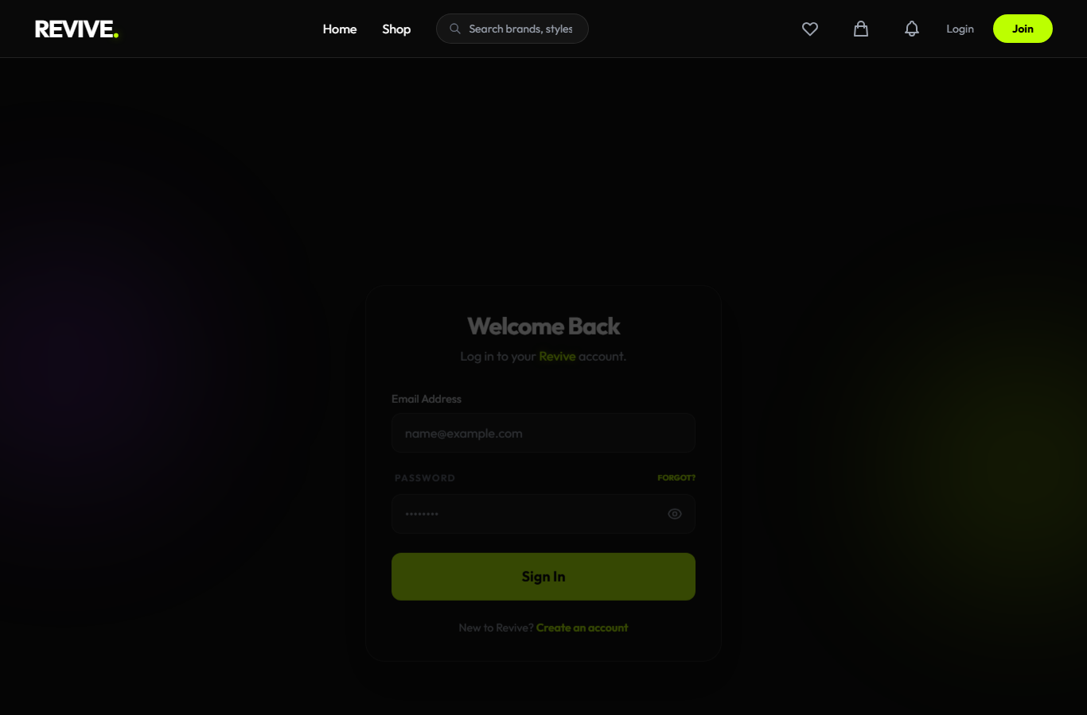
Related Coding
File: login.php
1 <?php
2 include 'includes/header.php';
3
4 if(isset($_SESSION['user_id'])) {
5 echo "<script>window.location.href='index.php';</script>";
6 exit();
7 }
8 ?>
9
10 <section class="min-h-screen flex items-center justify-center px-6 py-20 relative overflow-hidden">
11 <!-- Background Blurs -->
12 <div class="absolute top-1/4 -left-20 w-80 h-80 bg-purple-600/10 rounded-full blur-[100px]"></div>
13 <div class="absolute bottom-1/4 -right-20 w-80 h-80 bg-[#bcff00]/10 rounded-full blur-[100px]"></div>
14
15 <div class="w-full max-w-md relative z-10" data-aos="fade-up">
16 <div class="glass-nav p-8 rounded-3xl border border-white/10 shadow-2xl">
17 <div class="text-center mb-8">
18 <h2 class="text-3xl font-bold tracking-tight mb-2">Welcome Back</h2>
19 <p class="text-gray-400">Log in to your <span class="neon-text">Revive</span> account.</p>
20 </div>
21
22 <?php if(isset($_GET['error'])): ?>
23 <div class="mb-6 bg-red-500/10 border border-red-500/20 text-red-400 p-4 rounded-xl text-sm font-bold text-center">
24 <?php
25 $wait = (int)($_GET['wait'] ?? 15);
26 $errors = [
27 'invalid_credentials' => 'Incorrect email or password.',
28 'user_not_found' => 'No account was found with that email.',
29 'email_not_verified' => 'Verify your email before signing in.',
30 'banned' => 'This account has been suspended.',
31 'security_mismatch' => 'Security verification failed. Please try again.',
32 'too_many_attempts' => "Too many failed attempts. Please wait {$wait} minute(s) before trying again.",
33 ];
34 echo htmlspecialchars($errors[$_GET['error']] ?? 'Unable to sign in.');
35 ?>
36 </div>
37 <?php elseif(($_GET['success'] ?? '') === 'password_reset'): ?>
38 <div class="mb-6 bg-[#bcff00]/10 border border-[#bcff00]/20 text-[#bcff00] p-4 rounded-xl text-sm font-bold text-center">
39 Password updated successfully. You can now sign in.
40 </div>
41 <?php endif; ?>
42
43 <form action="actions/auth_action.php" method="POST" class="space-y-6">
44 <input type="hidden" name="action" value="login">
45 <?php echo csrf_field(); ?>
46
47 <div>
48 <label class="block text-sm font-medium mb-2 text-gray-300">Email Address</label>
49 <input type="email" name="email" required
50 class="w-full bg-white/5 border border-white/10 rounded-xl px-4 py-3 focus:outline-none focus:border-[#bcff00] transition text-white"
51 placeholder="name@example.com">
52 </div>
53
54 <div>
55 <div class="flex justify-between items-center mb-3">
56 <label class="block text-xs font-bold uppercase tracking-widest text-gray-500 ml-1">Password</label>
57 <a href="forgot_password.php" class="text-[10px] uppercase font-bold text-[#bcff00] hover:underline">Forgot?</a>
58 </div>
59 <div class="relative">
60 <input type="password" name="password" id="login-password" required
61 class="w-full bg-white/5 border border-white/10 rounded-xl px-4 py-3 pr-12 focus:outline-none focus:border-[#bcff00] transition text-white"
62 placeholder="â€¢â€¢â€¢â€¢â€¢â€¢â€¢â€¢">
63 <button type="button" onclick="togglePasswordVisibility('login-password', this)" class="absolute right-4 top-1/2 -translate-y-1/2 text-gray-400 hover:text-white transition">
64 <svg class="w-5 h-5 eye-icon" xmlns="http://www.w3.org/2000/svg" fill="none" viewBox="0 0 24 24" stroke="currentColor"><path stroke-linecap="round" stroke-linejoin="round" stroke-width="2" d="M15 12a3 3 0 11-6 0 3 3 0 016 0z" /><path stroke-linecap="round" stroke-linejoin="round" stroke-width="2" d="M2.458 12C3.732 7.943 7.523 5 12 5c4.478 0 8.268 2.943 9.542 7-1.274 4.057-5.064 7-9.542 7-4.477 0-8.268-2.943-9.542-7z" /></svg>
65 <svg class="w-5 h-5 eye-off-icon hidden" xmlns="http://www.w3.org/2000/svg" fill="none" viewBox="0 0 24 24" stroke="currentColor"><path stroke-linecap="round" stroke-linejoin="round" stroke-width="2" d="M13.875 18.825A10.05 10.05 0 0112 19c-4.478 0-8.268-2.943-9.543-7a9.97 9.97 0 011.563-3.029m5.858.908a3 3 0 114.243 4.243M9.878 9.878l4.242 4.242M9.88 9.88l-3.29-3.29m7.532 7.532l3.29 3.29M3 3l3.59 3.59m0 0A9.953 9.953 0 0112 5c4.478 0 8.268 2.943 9.543 7a10.025 10.025 0 01-4.132 5.411m0 0L21 21" /></svg>
66 </button>
67 </div>
68 </div>
69
70 <button type="submit"
71 class="neon-btn w-full font-bold py-4 rounded-xl text-lg mt-4">
72 Sign In
73 </button>
74
75 <p class="text-center text-gray-400 text-sm mt-6">
.... [Code continues in the project source file.]
File: actions\auth_action.php
60 elseif ($action === 'login' || $action === 'admin_login') {
61 // Rate Limiting: max 5 failed attempts per IP per 15 minutes
62 $ip = $_SERVER['REMOTE_ADDR'];
63 $rate_key = 'login_attempts_' . md5($ip);
64 $time_key = 'login_attempt_time_' . md5($ip);
65
66 if (!isset($_SESSION[$rate_key])) $_SESSION[$rate_key] = 0;
67 if (!isset($_SESSION[$time_key])) $_SESSION[$time_key] = time();
68
69 // Reset counter after 15 minutes
70 if (time() - $_SESSION[$time_key] > 900) {
71 $_SESSION[$rate_key] = 0;
72 $_SESSION[$time_key] = time();
73 }
74
75 if ($_SESSION[$rate_key] >= 5) {
76 $wait = ceil((900 - (time() - $_SESSION[$time_key])) / 60);
77 $loc = ($action === 'admin_login') ? "../admin_login.php" : "../login.php";
78 header("Location: $loc?error=too_many_attempts&wait=$wait");
79 exit();
80 }
81
82 $email = mysqli_real_escape_string($conn, $_POST['email']);
83 $password = $_POST['password'];
84
85 $result = $conn->query("SELECT * FROM users WHERE email = '$email'");
86 if ($result->num_rows === 1) {
87 $user = $result->fetch_assoc();
88 if (password_verify($password, $user['password'])) {
89 // Reset rate limit on successful login
90 $_SESSION[$rate_key] = 0;
91
92 if (isset($user['email_verified']) && !$user['email_verified']) {
93 header("Location: ../login.php?error=email_not_verified");
94 exit();
95 }
96 if($user['status'] === 'banned') {
97 $loc = ($action === 'admin_login') ? "../admin_login.php" : "../login.php";
98 header("Location: $loc?error=banned");
99 exit();
100 }
101
102 // If it's an admin login, check the role BEFORE session
103 if ($action === 'admin_login') {
104 if ($user['role'] !== 'admin') {
105 header("Location: ../admin_login.php?error=unauthorized");
106 exit();
107 }
108 // âœ… Admin credentials valid â€” now send OTP (2-Step)
109 $_SESSION[$rate_key] = 0;
110 $otp_result = create_and_send_otp($conn, $user['email'], 'admin_login', ['user_id' => $user['id'], 'name' => $user['name']]);
111 if ($otp_result === 'sent' || $otp_result === 'wait') {
112 header("Location: ../admin_verify_otp.php" . ($otp_result === 'wait' ? '?error=resend_wait' : ''));
113 } else {
114 header("Location: ../admin_login.php?error=otp_send_failed");
115 }
116 exit();
117 }
118
119 // Regular user login â€” set session directly
120 $_SESSION[$rate_key] = 0;
121 $_SESSION['user_id'] = $user['id'];
122 $_SESSION['user_name'] = $user['name'];
123 $_SESSION['user_role'] = $user['role'];
124
125 $redirect = ($user['role'] === 'admin') ? "../admin_dashboard.php" : "../index.php?success=logged_in";
126 header("Location: $redirect");
127 } else {
128 // Increment failed attempt counter
129 $_SESSION[$rate_key]++;
.... [Code continues in the project source file.]

Snapshot 5: Registration Page
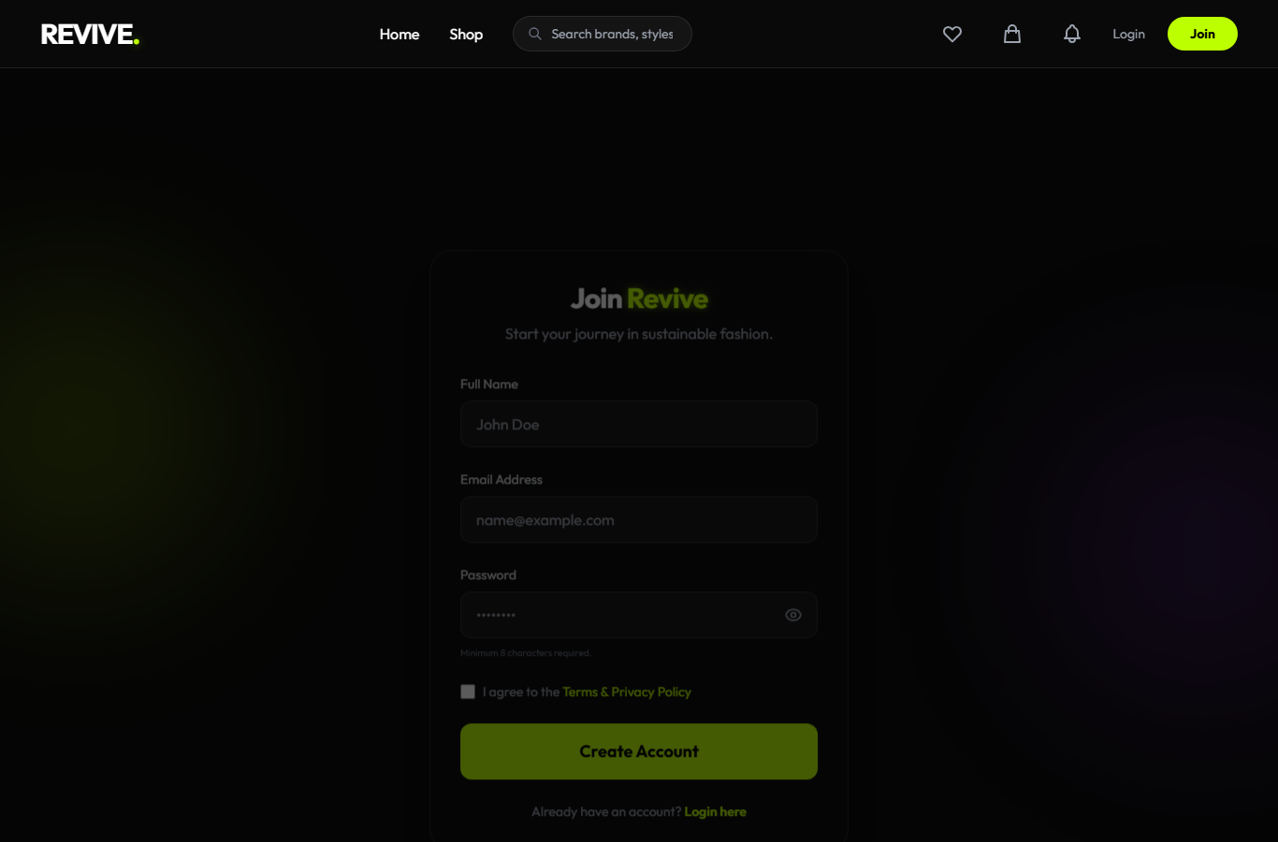
Related Coding
File: register.php
1 <?php
2 include 'includes/header.php';
3
4 if(isset($_SESSION['user_id'])) {
5 echo "<script>window.location.href='index.php';</script>";
6 exit();
7 }
8 ?>
9
10 <section class="min-h-screen flex items-center justify-center px-6 py-20 relative overflow-hidden">
11 <!-- Background Blurs -->
12 <div class="absolute top-1/4 -left-20 w-80 h-80 bg-[#bcff00]/10 rounded-full blur-[100px]"></div>
13 <div class="absolute bottom-1/4 -right-20 w-80 h-80 bg-purple-600/10 rounded-full blur-[100px]"></div>
14
15 <div class="w-full max-w-md relative z-10" data-aos="fade-up">
16 <div class="glass-nav p-8 rounded-3xl border border-white/10 shadow-2xl">
17 <div class="text-center mb-8">
18 <h2 class="text-3xl font-bold tracking-tight mb-2">Join <span class="neon-text">Revive</span></h2>
19 <p class="text-gray-400">Start your journey in sustainable fashion.</p>
20 </div>
21
22 <?php if(isset($_GET['error'])): ?>
23 <div class="mb-6 bg-red-500/10 border border-red-500/20 text-red-500 p-4 rounded-xl text-sm font-bold text-center">
24 <?php
25 $err = $_GET['error'];
26 if($err == 'email_exists') echo 'This email is already registered.';
27 elseif($err == 'invalid_name') echo 'Name cannot contain numbers or unsupported characters.';
28 elseif($err == 'invalid_email') echo 'Please enter a valid email format.';
29 elseif($err == 'weak_password') echo 'Password must be at least 8 characters long.';
30 elseif($err == 'otp_send_failed') echo 'The verification OTP could not be sent. Check the SMTP configuration.';
31 elseif($err == 'registration_expired') echo 'Your registration verification expired. Please register again.';
32 else echo htmlspecialchars($err);
33 ?>
34 </div>
35 <?php endif; ?>
36
37 <form action="actions/auth_action.php" method="POST" class="space-y-6">
38 <input type="hidden" name="action" value="register">
39 <?php echo csrf_field(); ?>
40
41 <div>
42 <label class="block text-sm font-medium mb-2 text-gray-300">Full Name</label>
43 <input type="text" name="name" required maxlength="100" pattern="[A-Za-z .'-]+" title="Name can only contain letters, spaces, apostrophes, periods, and hyphens" oninput="this.value=this.value.replace(/[0-9]/g,'')"
44 class="w-full bg-white/5 border border-white/10 rounded-xl px-4 py-3 focus:outline-none focus:border-[#bcff00] transition text-white"
45 placeholder="John Doe">
46 </div>
47
48 <div>
49 <label class="block text-sm font-medium mb-2 text-gray-300">Email Address</label>
50 <input type="email" name="email" required maxlength="100"
51 class="w-full bg-white/5 border border-white/10 rounded-xl px-4 py-3 focus:outline-none focus:border-[#bcff00] transition text-white"
52 placeholder="name@example.com">
53 </div>
54
55 <div>
56 <label class="block text-sm font-medium mb-2 text-gray-300">Password</label>
57 <div class="relative">
58 <input type="password" name="password" id="register-password" required minlength="8"
59 class="w-full bg-white/5 border border-white/10 rounded-xl px-4 py-3 pr-12 focus:outline-none focus:border-[#bcff00] transition text-white"
60 placeholder="â€¢â€¢â€¢â€¢â€¢â€¢â€¢â€¢">
61 <button type="button" onclick="togglePasswordVisibility('register-password', this)" class="absolute right-4 top-1/2 -translate-y-1/2 text-gray-400 hover:text-white transition">
62 <svg class="w-5 h-5 eye-icon" xmlns="http://www.w3.org/2000/svg" fill="none" viewBox="0 0 24 24" stroke="currentColor"><path stroke-linecap="round" stroke-linejoin="round" stroke-width="2" d="M15 12a3 3 0 11-6 0 3 3 0 016 0z" /><path stroke-linecap="round" stroke-linejoin="round" stroke-width="2" d="M2.458 12C3.732 7.943 7.523 5 12 5c4.478 0 8.268 2.943 9.542 7-1.274 4.057-5.064 7-9.542 7-4.477 0-8.268-2.943-9.542-7z" /></svg>
63 <svg class="w-5 h-5 eye-off-icon hidden" xmlns="http://www.w3.org/2000/svg" fill="none" viewBox="0 0 24 24" stroke="currentColor"><path stroke-linecap="round" stroke-linejoin="round" stroke-width="2" d="M13.875 18.825A10.05 10.05 0 0112 19c-4.478 0-8.268-2.943-9.543-7a9.97 9.97 0 011.563-3.029m5.858.908a3 3 0 114.243 4.243M9.878 9.878l4.242 4.242M9.88 9.88l-3.29-3.29m7.532 7.532l3.29 3.29M3 3l3.59 3.59m0 0A9.953 9.953 0 0112 5c4.478 0 8.268 2.943 9.543 7a10.025 10.025 0 01-4.132 5.411m0 0L21 21" /></svg>
64 </button>
65 </div>
66 <p class="text-[10px] text-gray-500 mt-2">Minimum 8 characters required.</p>
67 </div>
68
69 <div class="flex items-center">
70 <input type="checkbox" required class="w-4 h-4 rounded border-gray-300 text-[#bcff00] focus:ring-[#bcff00] bg-white/5">
71 <label class="ml-2 text-sm text-gray-400">
72 I agree to the <a href="#" class="text-[#bcff00] hover:underline">Terms & Privacy Policy</a>
73 </label>
74 </div>
75
76 <button type="submit"
77 class="neon-btn w-full font-bold py-4 rounded-xl text-lg mt-4">
78 Create Account
79 </button>
80
81 <p class="text-center text-gray-400 text-sm mt-6">
82 Already have an account? <a href="login.php" class="text-[#bcff00] hover:underline font-semibold">Login here</a>
83 </p>
84 </form>
85 </div>
.... [Code continues in the project source file.]
File: actions\auth_action.php
15 if ($action === 'register') {
16 $name_input = trim($_POST['name']);
17 $email_input = trim($_POST['email']);
18 $password_input = $_POST['password'];
19
20 // Validation 1: Person names cannot contain numbers or unsupported symbols.
21 if ($name_input === '' || !preg_match("/^[\p{L}][\p{L}\s.'-]*$/u", $name_input)) {
22 header("Location: ../register.php?error=invalid_name");
23 exit();
24 }
25
26 // Validation 2: Email Format
27 if (!filter_var($email_input, FILTER_VALIDATE_EMAIL)) {
28 header("Location: ../register.php?error=invalid_email");
29 exit();
30 }
31
32 // Validation 3: Password Length/Strength
33 if (strlen($password_input) < 8) {
34 header("Location: ../register.php?error=weak_password");
35 exit();
36 }
37
38 $email_input = strtolower($email_input);
39 $email = mysqli_real_escape_string($conn, $email_input);
40 $password = password_hash($password_input, PASSWORD_DEFAULT);
41
42 // Check if email already exists
43 $check = $conn->query("SELECT id FROM users WHERE email = '$email'");
44 if ($check->num_rows > 0) {
45 header("Location: ../register.php?error=email_exists");
46 exit();
47 }
48
49 $payload = ['name' => $name_input, 'password' => $password];
50 $otp_result = create_and_send_otp($conn, $email_input, 'register', $payload);
51 if ($otp_result === 'sent') {
52 header("Location: ../verify_otp.php?purpose=register");
53 } elseif ($otp_result === 'wait') {
54 header("Location: ../verify_otp.php?purpose=register&error=resend_wait");
55 } else {
56 header("Location: ../register.php?error=otp_send_failed");
57 }
58 }
59
.... [Code continues in the project source file.]

Snapshot 6: Checkout Login Protection

Related Coding
File: checkout.php
1 <?php
2 require_once 'config/db.php';
3
4 // Auth check BEFORE any HTML output
5 if(!isset($_SESSION['user_id'])) {
6 header("Location: login.php");
7 exit();
8 }
9
10 include 'includes/header.php';
11
12 $user_id = $_SESSION['user_id'];
13 $cart_items = $conn->query("SELECT c.quantity, p.title, p.price FROM cart c JOIN products p ON c.product_id = p.id WHERE c.user_id = $user_id");
14
15 $total = 0;
16 $items = [];
17 while($row = $cart_items->fetch_assoc()) {
18 $items[] = $row;
19 $total += $row['price'] * $row['quantity'];
20 }
21
22 if(count($items) === 0) {
23 echo "<section class='py-40 text-center'><h1 class='text-4xl font-bold'>Your bag is empty.</h1><a href='shop.php' class='text-[#bcff00] mt-4 block'>Back to Shop</a></section>";
24 include 'includes/footer.php';
25 exit();
26 }
27 ?>
28
29 <section class="py-24 px-6 max-w-5xl mx-auto">
30 <div class="mb-16" data-aos="fade-right">
31 <h1 class="text-5xl font-bold tracking-tight mb-4">Final <span class="neon-text">Step</span></h1>
32 <p class="text-gray-400 text-lg">Complete your order and get your pieces.</p>
33 </div>
34
35 <form id="checkout-form">
36 <?php echo csrf_field(); ?>
37 <div class="grid grid-cols-1 lg:grid-cols-3 gap-16">
38 <!-- Shipping Form -->
39 <div class="lg:col-span-2 space-y-12" data-aos="fade-up">
40 <div class="bg-white/5 border border-white/10 p-10 rounded-[2.5rem]">
41 <h3 class="text-2xl font-bold mb-8">Shipping Address</h3>
42 <div class="space-y-6">
43 <div class="grid grid-cols-2 gap-6">
44 <div>
45 <label class="block text-xs font-bold uppercase tracking-widest text-gray-500 mb-2">Full Name</label>
46 <input type="text" value="<?php echo htmlspecialchars($_SESSION['user_name']); ?>" required readonly class="w-full bg-white/5 border border-white/10 rounded-xl px-5 py-3 focus:outline-none focus:border-[#bcff00] transition text-white">
47 </div>
48 <div>
49 <label class="block text-xs font-bold uppercase tracking-widest text-gray-500 mb-2">Phone Number</label>
50 <input type="tel" name="phone" required inputmode="numeric" maxlength="10" pattern="[0-9]{10}" title="Please enter a 10-digit mobile number" oninput="this.value=this.value.replace(/[^0-9]/g,'').slice(0,10)" placeholder="10-digit mobile number" class="w-full bg-white/5 border border-white/10 rounded-xl px-5 py-3 focus:outline-none focus:border-[#bcff00] transition text-white">
51 </div>
52 </div>
53 <div>
54 <label class="block text-xs font-bold uppercase tracking-widest text-gray-500 mb-2">Street Address</label>
55 <textarea name="address" rows="3" required maxlength="500" placeholder="Apartment, house number, area, city, pincode..." class="w-full bg-white/5 border border-white/10 rounded-xl px-5 py-3 focus:outline-none focus:border-[#bcff00] transition text-white"></textarea>
56 </div>
57 </div>
58 </div>
59
60 <div class="bg-white/5 border border-white/10 p-10 rounded-[2.5rem]">
61 <h3 class="text-2xl font-bold mb-8">Payment Method</h3>
62 <div class="space-y-4">
63 <label class="flex items-center p-6 bg-white/5 border border-[#bcff00]/50 rounded-2xl cursor-pointer">
64 <input type="radio" name="payment_method" value="cod" checked class="w-5 h-5 accent-[#bcff00]">
65 <div class="ml-4">
66 <p class="font-bold">Cash on Delivery (COD)</p>
67 <p class="text-xs text-gray-500">Pay when you receive your package.</p>
68 </div>
69 </label>
70 <label class="flex items-center p-6 bg-white/5 border border-white/10 rounded-2xl cursor-pointer hover:border-[#bcff00]/50 transition">
71 <input type="radio" name="payment_method" value="online" class="w-5 h-5 accent-[#bcff00]">
72 <div class="ml-4">
73 <p class="font-bold">Online Payment</p>
74 <p class="text-xs text-gray-500">Pay securely with Credit Card / UPI.</p>
75 </div>
76 </label>
77 </div>
78 </div>
79 </div>
80
81 <!-- Order Summary -->
82 <div class="lg:col-span-1" data-aos="fade-left">
83 <div class="bg-[#bcff00]/5 border border-[#bcff00]/20 p-10 rounded-[2.5rem] sticky top-32">
84 <h3 class="text-2xl font-bold mb-8 text-[#bcff00]">Order Summary</h3>
85 <div class="space-y-4 mb-8">
86 <?php foreach($items as $item): ?>
87 <div class="flex justify-between text-sm">
88 <span class="text-gray-400"><?php echo $item['title']; ?> <span class="text-xs">x<?php echo $item['quantity']; ?></span></span>
89 <span class="font-bold text-white">â‚¹<?php echo number_format($item['price'] * $item['quantity'], 0); ?></span>
90 </div>
91 <?php endforeach; ?>
92 </div>
93
94 <div class="border-t border-[#bcff00]/20 pt-6 space-y-4">
95 <div class="flex justify-between text-gray-400 text-sm">
.... [Code continues in the project source file.]
File: actions\order_action.php
1 <?php
2 session_start();
3 require_once '../config/db.php';
4
5 // Enable error reporting for debugging
6 mysqli_report(MYSQLI_REPORT_ERROR | MYSQLI_REPORT_STRICT);
7
8 if(!isset($_SESSION['user_id'])) exit(json_encode(['error' => 'Unauthorized']));
9
10 $user_id = $_SESSION['user_id'];
11
12 if ($_SERVER['REQUEST_METHOD'] === 'POST') {
13 // CSRF Protection
14 if (!isset($_POST['csrf_token']) || $_POST['csrf_token'] !== $_SESSION['csrf_token']) {
15 echo json_encode(['error' => 'Security token mismatch']);
16 exit();
17 }
18
19 $address = mysqli_real_escape_string($conn, trim($_POST['address'] ?? ''));
20 $phone_input = trim($_POST['phone'] ?? '');
21
22 if (!preg_match('/^[0-9]{10}$/', $phone_input)) {
23 echo json_encode(['error' => 'Please enter a valid 10-digit mobile number']);
24 exit();
25 }
26
27 $phone = mysqli_real_escape_string($conn, $phone_input);
28
29 // Get all items in cart and verify availability
30 $cart_items = $conn->query("SELECT c.product_id, p.price, p.status FROM cart c JOIN products p ON c.product_id = p.id WHERE c.user_id = $user_id");
31
32 $cart_items_list = [];
33 if ($cart_items->num_rows > 0) {
34 while ($item = $cart_items->fetch_assoc()) {
35 if ($item['status'] !== 'available') {
36 echo json_encode(['error' => 'Product is no longer available']);
37 exit();
38 }
39 $cart_items_list[] = $item;
40 }
41 } else {
42 echo json_encode(['error' => 'Cart is empty']);
43 exit();
44 }
45
46 $conn->begin_transaction();
47 try {
48 $payment_method = $_POST['payment_method'] ?? 'cod';
49 // Both COD and online start as 'pending' â€” seller must ship first
50 $order_status = 'pending';
51 $order_ids = [];
52
53 $num_items = count($cart_items_list);
54
55 for ($i = 0; $i < $num_items; $i++) {
56 $item = $cart_items_list[$i];
57 $pid = $item['product_id'];
58 $amount = $item['price'];
59
60 // Create Order
61 $stmt_order = $conn->prepare("INSERT INTO orders (buyer_id, product_id, amount, shipping_address, phone, status) VALUES (?, ?, ?, ?, ?, ?)");
62 $stmt_order->bind_param("iidsss", $user_id, $pid, $amount, $address, $phone, $order_status);
63 $stmt_order->execute();
64
65 $order_ids[] = $conn->insert_id;
66
67 // Mark product as SOLD immediately ONLY for COD
68 // For online payment, product stays available until payment is confirmed
69 if ($payment_method === 'cod') {
70 $conn->query("UPDATE products SET status = 'sold' WHERE id = $pid");
71 }
72
73 // For ALL orders (COD + Online), notify both parties about new order
74 $prod_info = $conn->query("SELECT seller_id, title FROM products WHERE id = $pid")->fetch_assoc();
75 $seller_id = $prod_info['seller_id'];
76 $prod_name = $prod_info['title'];
77
78 // Notify Seller about new order
79 $seller_msg = "ðŸ›ï¸ New order received for '$prod_name'! Please prepare and ship it. Check your dashboard.";
80 $seller_msg_escaped = mysqli_real_escape_string($conn, $seller_msg);
81 $conn->query("INSERT INTO notifications (user_id, message, type) VALUES ($seller_id, '$seller_msg_escaped', 'order')");
82
83 // Notify Buyer about order confirmation
84 $buyer_msg = "âœ… Order confirmed! Your order for '$prod_name' has been placed. The seller will ship it soon.";
85 $buyer_msg_escaped = mysqli_real_escape_string($conn, $buyer_msg);
86 $conn->query("INSERT INTO notifications (user_id, message, type) VALUES ($user_id, '$buyer_msg_escaped', 'success')");
87 }
88
89
90
91 // Clear Cart
92 $conn->query("DELETE FROM cart WHERE user_id = $user_id");
93
94 $conn->commit();
95
96 if ($payment_method === 'online') {
97 $ids_str = implode(',', $order_ids);
98 echo json_encode(['redirect' => "payment.php?order_ids=$ids_str"]);
99 } else {
100 echo json_encode(['success' => true]);
101 }
102 } catch (Exception $e) {
103 $conn->rollback();
104 echo json_encode(['error' => 'Order failed: ' . $e->getMessage()]);
105 }
106 } else {
107 echo json_encode(['error' => 'Invalid request method']);
108 }
109 ?>

CONCLUSION

Revive is a complete web-based marketplace project developed using PHP and MySQL. It provides a practical solution for buying and selling pre-loved fashion products. The system includes buyer, seller, and admin workflows along with product listing, search, filters, cart, wishlist, checkout, orders, invoices, chat, reviews, notifications, and reports.
The project promotes sustainable fashion by encouraging users to reuse and resell clothing and accessories. It also demonstrates important web development concepts such as database design, server-side programming, session management, user authentication, AJAX-based interaction, admin control, and responsive user interface development.
With further improvements such as live deployment, real payment gateway integration, automated testing, and advanced moderation, Revive can be extended into a production-ready sustainable fashion marketplace.
BIBLIOGRAPHY

â€¢ PHP official documentation
â€¢ MySQL documentation
â€¢ Tailwind CSS documentation
â€¢ XAMPP documentation
â€¢ Project source code and database schema
REFERENCES

â€¢ https://www.php.net/
â€¢ https://dev.mysql.com/doc/
â€¢ https://tailwindcss.com/docs
â€¢ https://www.apachefriends.org/

