
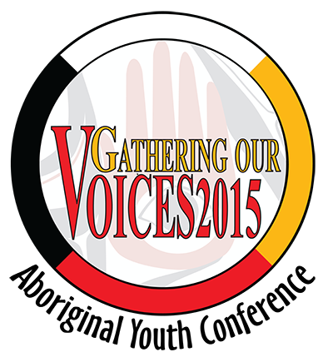


BC Association of
Aboriginal Friendship
Centres
Prince George Native Friendship Centre

Gathering Our Voices
Aboriginal Youth Conference
Prince George, British Columbia
March 17-20, 2015
Career and Education Fair Exhibitor Information
Conference Overview:
The Gathering Our Voices Aboriginal Youth Conference is hosted by the BC Association of Aboriginal Friendship Centres (BCAAFC) and their Provincial Aboriginal Youth Council (BCAAFC - PAYC). The Conference will be held from March 17-20, 2015 in Prince George, BC on the traditional territory of the Lheidli T’enneh at the Prince George Civic Centre and other venues around the city. Up to 1000 youth (14-24years) as well as chaperones, presenters and guests will network and learn new techniques and skills in workshops, share knowledge through cultural activities, witness performances by talented individuals, explore career and education possibilities and participate in sports and recreational activities. The conference will also feature a social enterprise “Dragon’s Den.”

This is a unique opportunity to share information with up to 1000 youth conference delegates. Aboriginal youth who attend come from across BC and across the country and reside both on and off reserve. While in the Career and Education Fair, Aboriginal youth and their chaperones can hear presentations, gather information and network with various educational institutions, organizations, public agencies and departments, industry, and arts and craft vendors.
General Exhibit Information:
- Exhibitor Registration Fees:
  - 1 day - $200 per table
  - 2 days - $400 per table
  - 2.5 days - $500 per table
- Each booth will be provided with one 6’ skirted table and two chairs.
- All exhibitors are responsible for their own meals, refreshments and shipping their own materials.
- Spaces for the Career and Education Fair fill up very quickly. Potential Exhibitors are encouraged to send their completed forms as soon as possible to ensure a spot at the conference.

To submit a completed application or for further information please contact:

Kathryn Lacerte, Interim Youth Conference Coordinator
BC Association of Aboriginal Friendship Centres
551 Chatham Street, Victoria, BC V8T 1E1
Phone: 250-388-5522 or 1-800-990-2432 Fax: 250-388-5502 E-mail: govcoordinator@bcaafc.com

2015 Career and Education Fair Application
Due: January 30, 2015 by 5:00 P.M. PST
Attention: Kathryn Lacerte, Interim Youth Conference Coordinator, BCAAFC
Fax: 250-388-5502 E-mail: govcoordinator@bcaafc.com Mail: 551 Chatham Street, Victoria, BC V8T 1E1

NAME
ORGANIZATION
ADDRESS
CITY / PROV.
POSTAL CODE
TELEPHONE | ( ) |  | FAX |  |  | ( )
E-MAIL
PLEASE NAME/LIST EXHIBITOR REPRESENTATIVES | - ________________________________4. _____________________________
PLEASE NAME/LIST EXHIBITOR REPRESENTATIVES | - ________________________________5. _____________________________
PLEASE NAME/LIST EXHIBITOR REPRESENTATIVES | - ________________________________6. _____________________________
EXHIBITOR TYPE  (can ✓ more than one) |  | Post-Secondary Education/Program |  |  | Trades & Technical Training
EXHIBITOR TYPE  (can ✓ more than one) |  | Health Organization/Agency |  |  | Provincial Agency/Department
EXHIBITOR TYPE  (can ✓ more than one) |  | Federal Agency/Department |  |  | Industry
EXHIBITOR TYPE  (can ✓ more than one) |  | Justice Organization/Agency |  |  | Media / Communications
EXHIBITOR TYPE  (can ✓ more than one) |  | Community Service Agency/Org. |  |  | Company / Business
EXHIBITOR TYPE  (can ✓ more than one) |  | Arts & Crafts Business |  |  | Volunteer / Community Raffle
EXHIBITOR TYPE  (can ✓ more than one) |  | Youth Group/Organization |  |  | Other __________________________
DO YOU PROVIDE? |  | Give away items |  |  | Raffled item
DO YOU PROVIDE? |  | Print information |  |  | Electronic information (i.e. CD’s)
DO YOU PROVIDE? |  | Membership information |  |  | Other _____________________
Do you require an electrical outlet for your booth? YES □ No □
Would you like to have an item in the delegate bags? YES □ No □
Payment Information
Exhibitor Registration Fee □ $200 for 1 day □ $400.00 for 2 days □ $500 for 2.5 days
Payment Method □ Cheque □ Money Order □ Credit Card*
* We encourage payment by cheque or money order. For payment by Credit Card (Visa or Mastercard only) or PayPal please call Kathryn Lacerte, Interim Youth Conference Coordinator at 1-800-990-2432.
** Fee must accompany this completed form in order to reserve a table**
A receipt will be issued and provided to exhibitors upon request

Make Payable to BCAAFC
Mail Payment to Attention: Kathryn Lacerte, Interim Youth Conference Coordinator
BC Association of Aboriginal Friendship Centres
551 Chatham Street, Victoria, BC V8T 1E1

