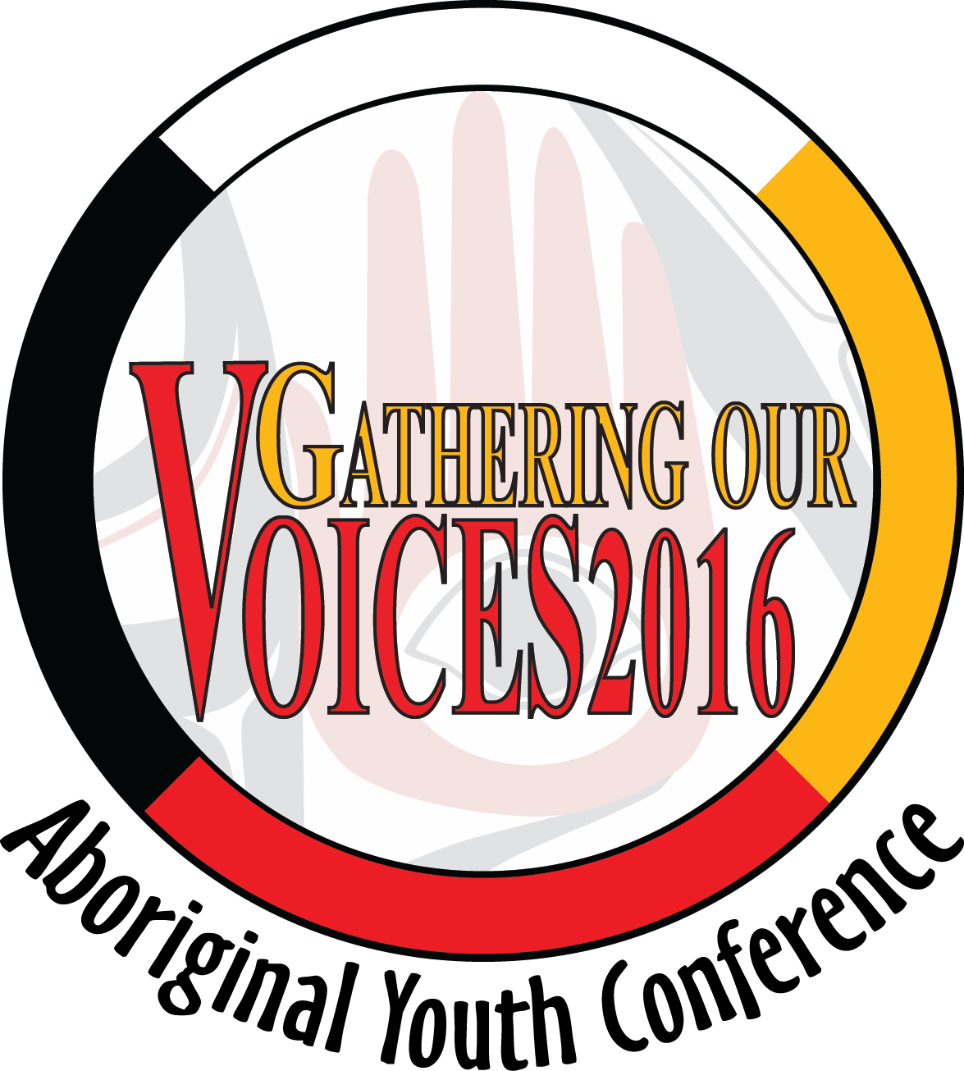
Gathering Our Voices
National Aboriginal Youth Conference

Honour an Aboriginal Youth Champion
In Your Community
The BC Association of Aboriginal Friendship Centres and their Provincial Aboriginal Youth Council (BCAAFC-PAYC) would like to recognize Aboriginal Youth Champions. If you know an Aboriginal youth (ages 14-24) who has made an outstanding commitment or achievement in their community, please nominate them to receive an Aboriginal Youth Champion award. We want to recognize young leaders and young role models who motivate others and show excellence in their chosen pursuits.
Please complete the following information and include a maximum 250 word submission outlining the nominated youth’s achievements and how they have been an Aboriginal Youth Champion in their community.
NAME OF YOUTH BEING NOMINATED*
Group Affiliation
NOMINATOR CONTACT INFORMATION

NAME OF NOMINATOR
ADDRESS
CITY |  | PROVINCE |  |  |  | POSTAL CODE
PHONE |  | ALTERNATE PHONE
FAX |  | E-MAIL
SIGNATURE OF NOMINATOR
* Youth are allowed to nominate themselves for this award*

Note: In order to receive this award, submissions must be received by March 4, 2016 and youth must be a Gathering Our Voices 2015 conference delegate and be present at the conference.
To submit completed applications or for further information please contact:

Della Preston, Youth Conference Coordinator
BC Association of Aboriginal Friendship Centres
551 Chatham Street, Victoria, BC V8T 1E1
Phone: 250-388-5522 or 1-800-990-2432 Fax: 250-388-5502 E-mail: govassistant@bcaafc.com

