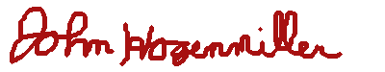
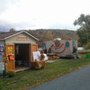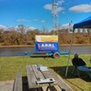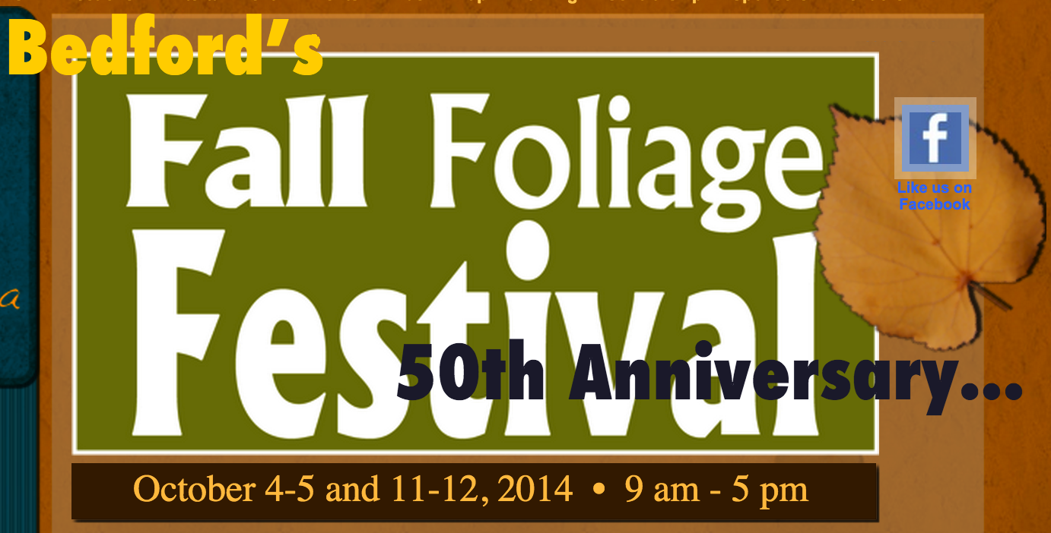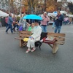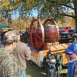

AMATEUR RADIO
SPECIAL EVENT STATION
K3NQT

IN COMMEMORIATION OF BEDFORD’S FALL FOLIAGE FESTIVAL 50TH ANNIVERSARY.
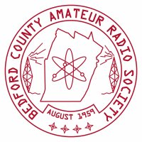
THIS CERTIFICATE CONFIRMS THAT ON Saturday, October 11, 2014, AMATEUR RADIO STATION

K2HVE

DID HAVE A TWO WAY QSO WITH SPECIAL EVENT AMATEUR RADIO STATION K3NQT ON 7.16 MHZ. SPECIAL EVENT STATION K3NQT WAS OPERATED IN BEDFORD COUNTY, PA BY THE BEDFORD COUNTY AMATEUR RADIO SOCIETY.

JOHN HOGENMILLER, KB3DFZ
PRESIDENT, BCARS
www.bcars.org
