**TERM WORK**

**I**

**BUS RESERVATION**

**DATABASE**

**Consider Following BUS RESERVATION DATABASE:**

Bus: Bus(BusNo :String ,Source : String, Destination: String, Coach Type: String)

Passenger (Pid: String, BusNo :string, Name: String, Mobno: Number, Age: integer, Gender: character, Address: String)

Ticket (TicketNo: string, Pid: String, SeatNo : Integer, DOJ: date, Source: String, Destination: String)

Reservation(RNo: String,Pid: String,TicketNo: string,NOS(no_of_seats): integer , DOJ: Date,Mobno: number,Address: String)

Cancellation (TicketNo: string, DOJ: Date, Mobno: number, Status: String)

1. Draw ER & Schema Diagrams for Database.
2. Create the above tables by properly specifying the primary keys and foreign keys.
3. Enter at least five tuples for each relation.
4. UPDATE BUS RELATION with source as Secundrabad for bus no: ka22a1234.
5. Display all the names of male passengers.
6. Find number of tickets booked for each reservation number using GROUP BYCLAUSE
7. Display the ticket numbers and names of all the passengers.
8. Find the names of Passengers whose age is between 30 and 45.

**1. Draw ER-Diagram for Database.**

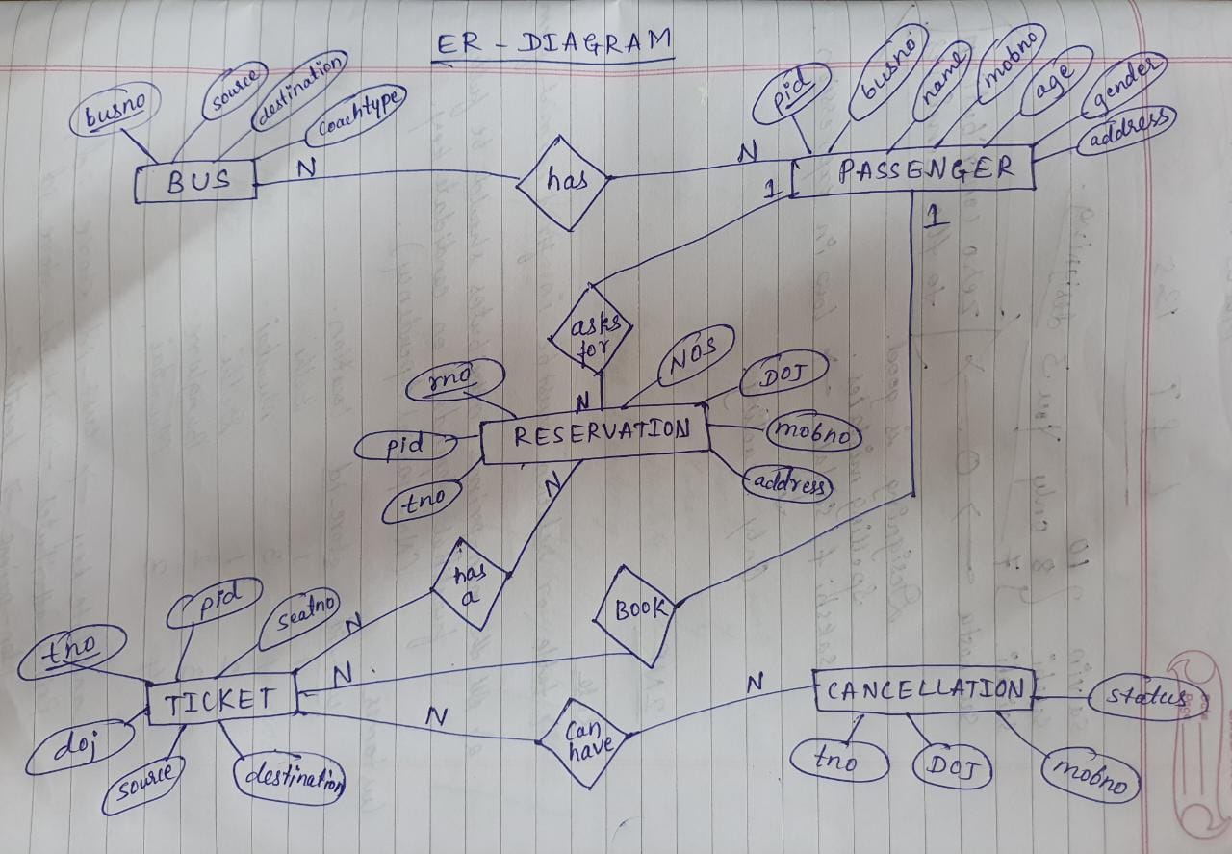

**Draw Schema for Database.**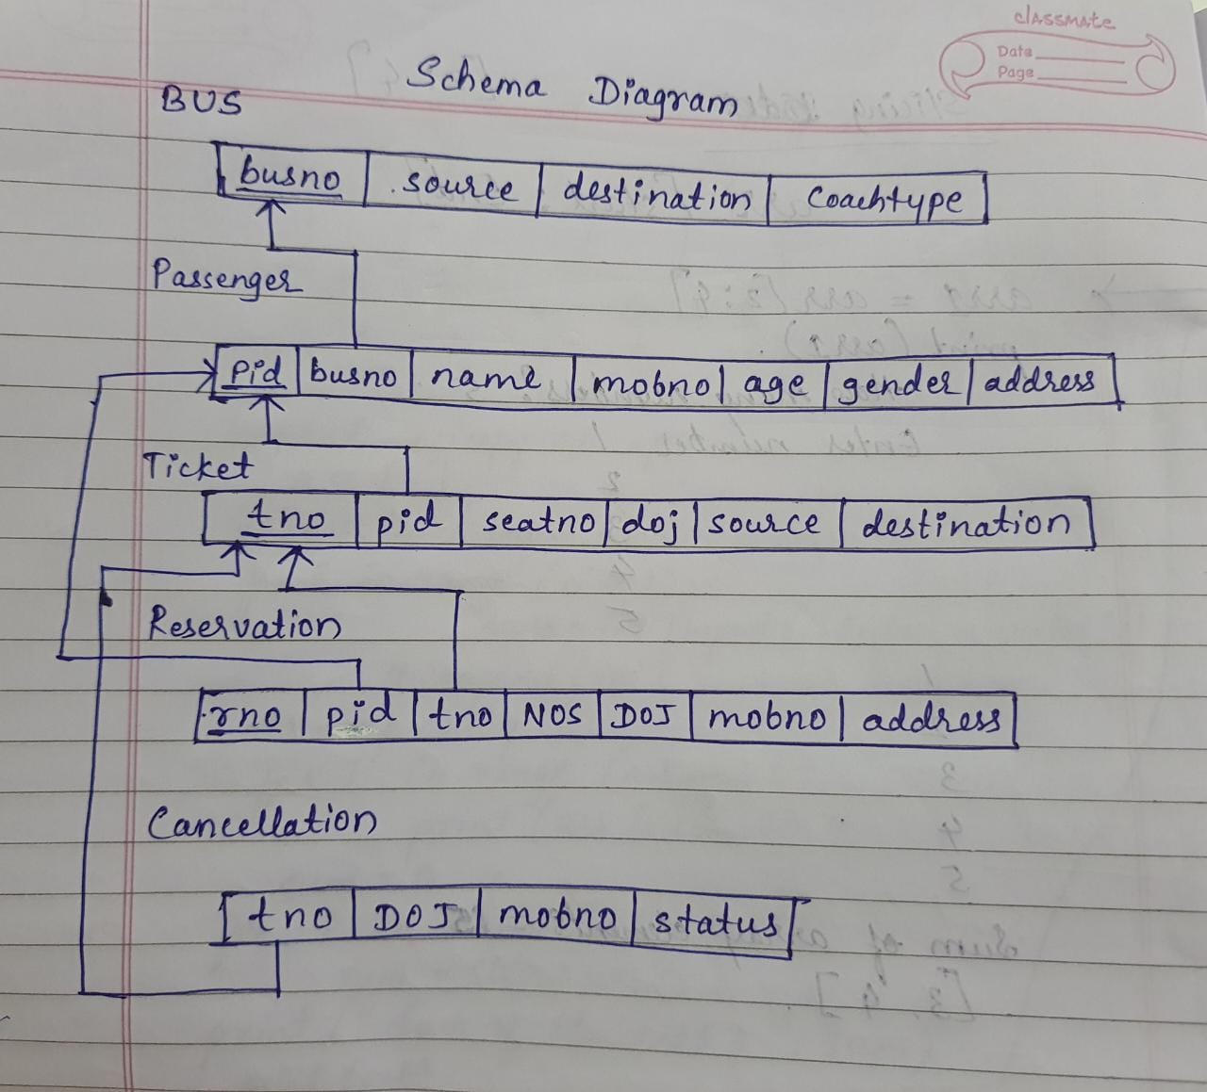

**2. Create the above tables by properly specifying the primary keys and foreign keys.**

create table bus (

busno varchar(10) primary key,

source varchar(20),

destination varchar(20),

coachtype varchar(10)

);

desc bus;

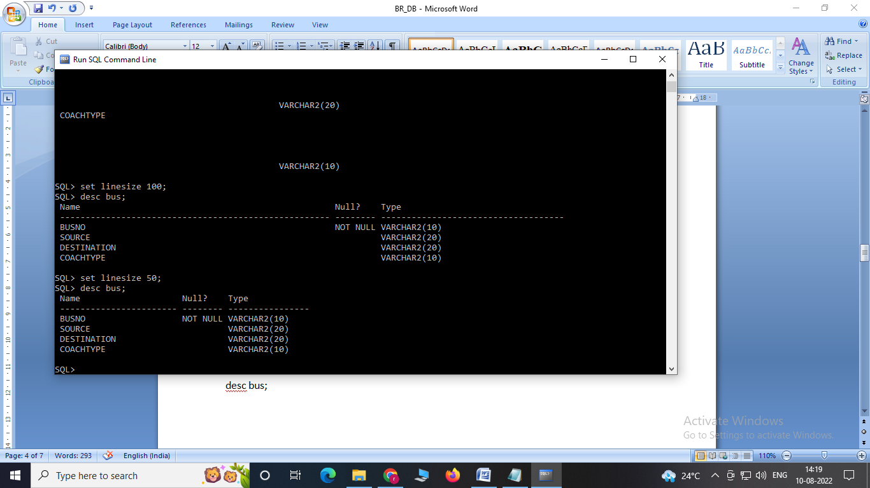

create table passenger(

pid varchar(5) primary key,

busno varchar(10) references bus(busno),

name varchar(15),

mobno number(10),

age integer,

gender char(2),

address varchar(20)

);

desc passenger;

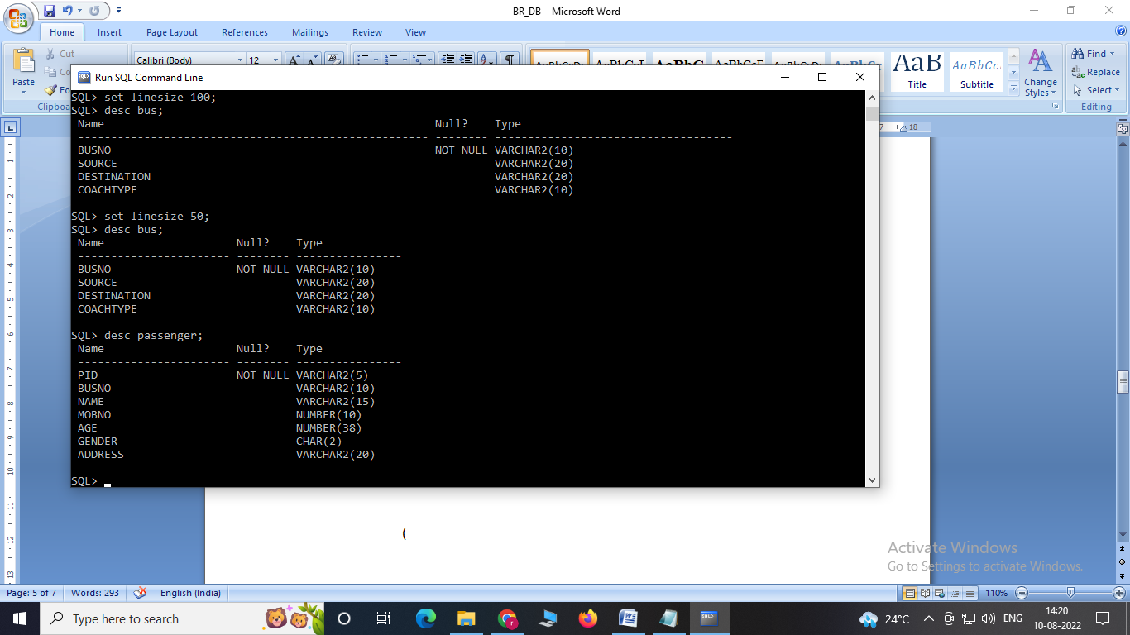

create table ticket

(

tno varchar(10) primary key,

pid varchar(5) references passenger(pid),

seatno int unique,

doj date,

source varchar(10),

destination varchar(10)

);

desc ticket;

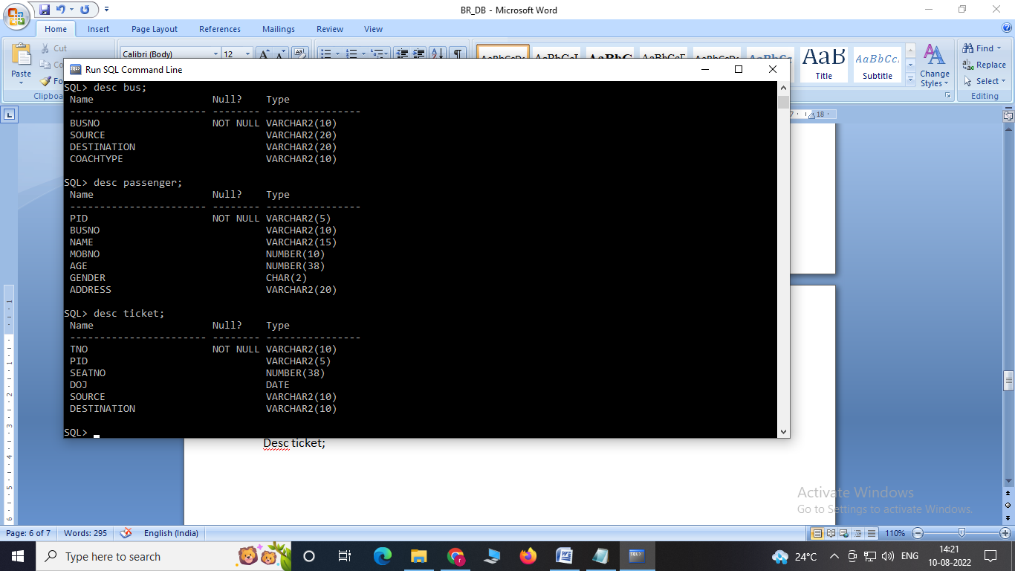

create table reservation

(

rno varchar(10) primary key,

pid varchar(5) references passenger(pid),

tno varchar(10) references ticket(tno),

NOS integer,

DOJ date,

mobno number(10),

address varchar(20)

);

desc reservation;

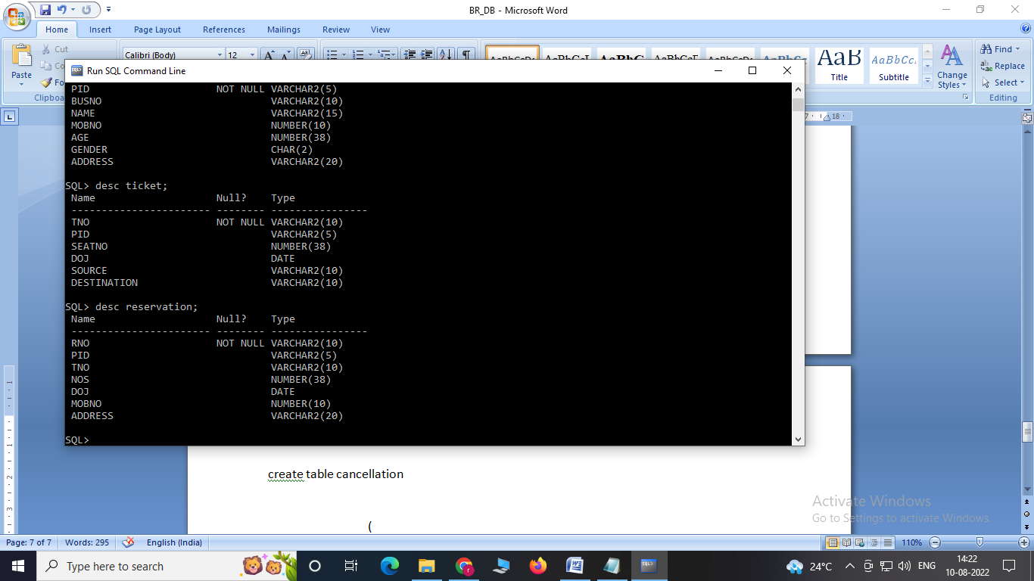

create table cancellation

(

tno varchar(10) references ticket(tno),

DOJ date,

mobno number(10),

status varchar(10)

);

desc cancellation;

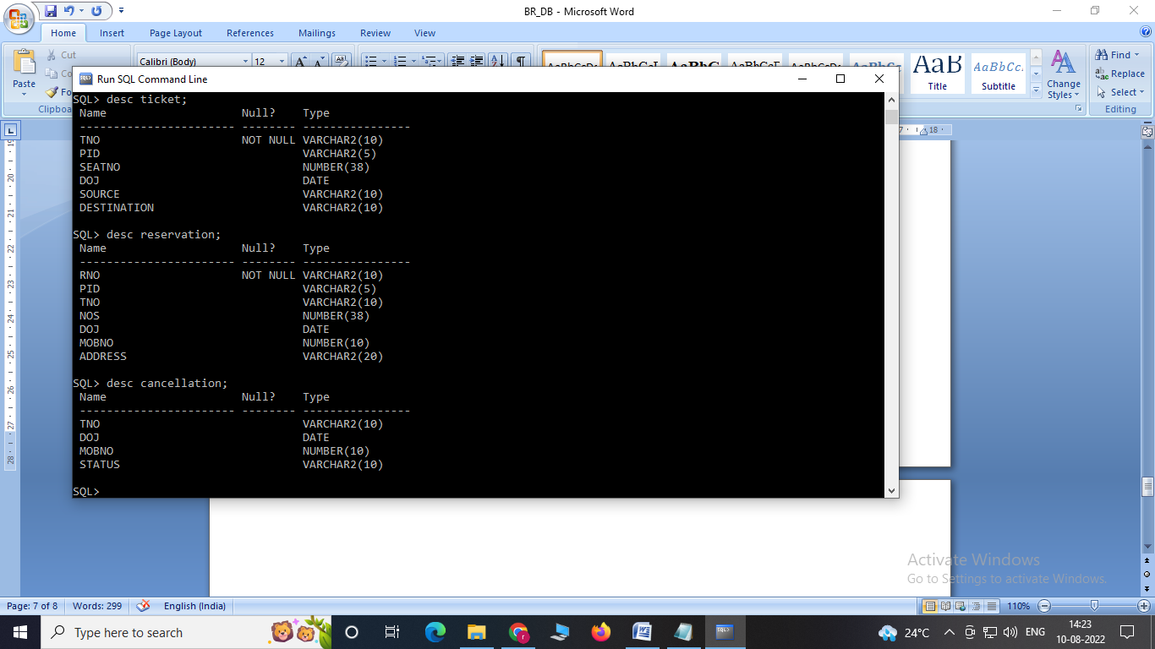

**3. Enter at least five tuples for each relation.**

insert into bus values('ka22a1234','Hyderabad','Tirupathi','airavat');

insert into bus values('ka23hm1424','Mumbai','Banglore','indra');

insert into bus values('ka24jg0506','Pune','Kolkata','garuda');

insert into bus values('ka25cb4530','Tirupathi','Banglore','saptagiri');

insert into bus values('ka26mb9852','Hyderabad','Chennai','minibus');

**select * from bus;**

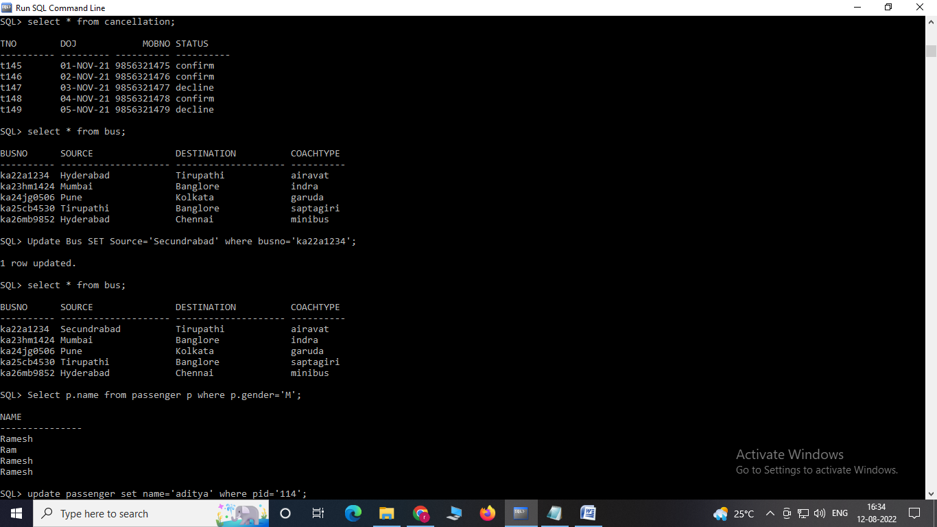

insert into passenger values('p111','ka22a1234','Ramesh',9856321475,45,'M','Bijapur');

insert into passenger values('p112','ka23hm1424','Geeta',9856322475,35,'F','Dharwad');

insert into passenger values('p113','ka24jg0506','Ram',9856323475,32,'M','Belagavi');

insert into passenger values('p114','ka25cb4530','aditya',9856321475,46,'M','Bijapur');

insert into passenger values('p115','ka26mb9852','advika',9856321475,45,'f','Bijapur');

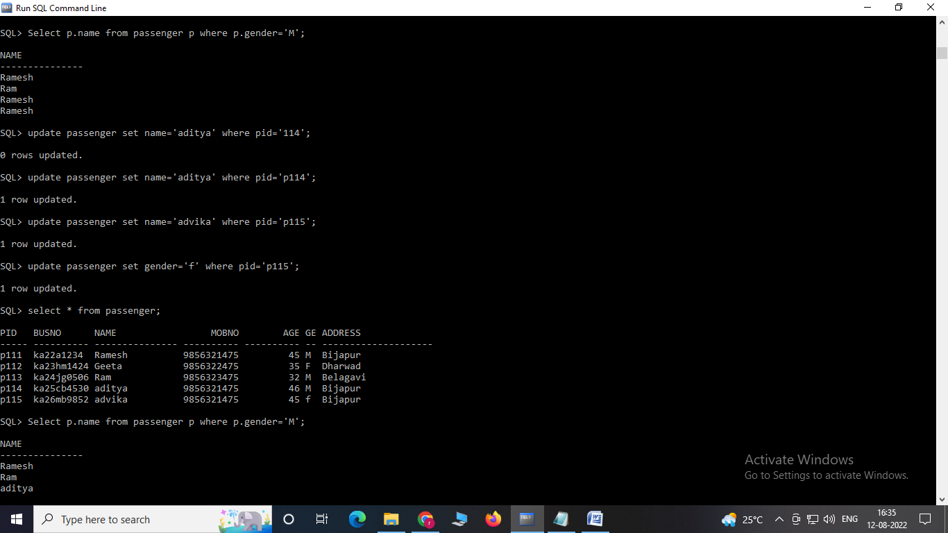

insert into ticket values('t145','p111',1,'1-nov-2021','Hyderabad','Bangalore');

insert into ticket values('t146','p112',2,'2-nov-2021','Bangalore','Tirupathi');

insert into ticket values('t147','p113',3,'3-nov-2021','Hyderabad','Chennai');

insert into ticket values('t148','p114',4,'2-nov-2021','Bangalore','Hubballi');

insert into ticket values('t149','p115',5,'4-nov-2021','Pune','Belagavi');

**select * from ticket;**

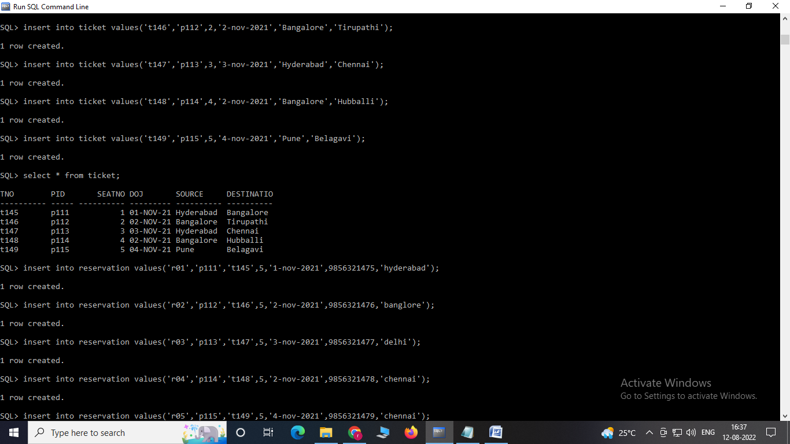

insert into reservation values('r01','p111','t145',5,'1-nov-2021',9856321475,'hyderabad');

insert into reservation values('r02','p112','t146',5,'2-nov-2021',9856321476,'banglore');

insert into reservation values('r03','p113','t147',5,'3-nov-2021',9856321477,'delhi');

insert into reservation values('r04','p114','t148',5,'2-nov-2021',9856321478,'chennai');

insert into reservation values('r05','p115','t149',5,'4-nov-2021',9856321479,'chennai');

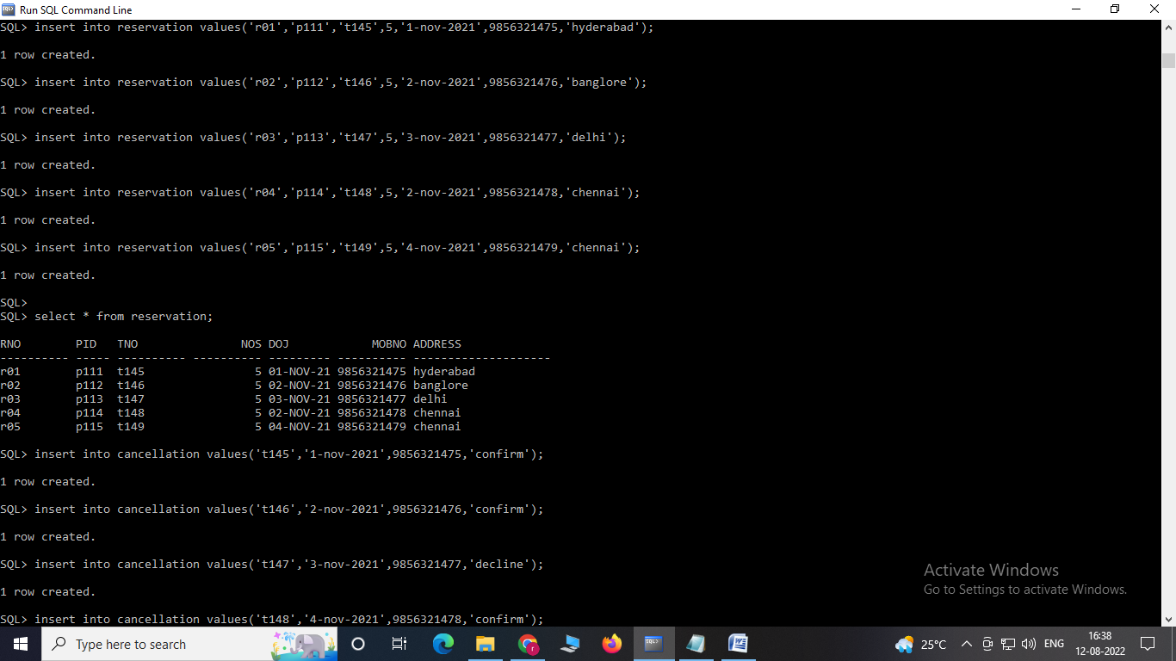

insert into cancellation values('t145','1-nov-2021',9856321475,'confirm');

insert into cancellation values('t146','2-nov-2021',9856321476,'confirm');

insert into cancellation values('t147','3-nov-2021',9856321477,'decline');

insert into cancellation values('t148','4-nov-2021',9856321478,'confirm');

insert into cancellation values('t149','5-nov-2021',9856321479,'decline');

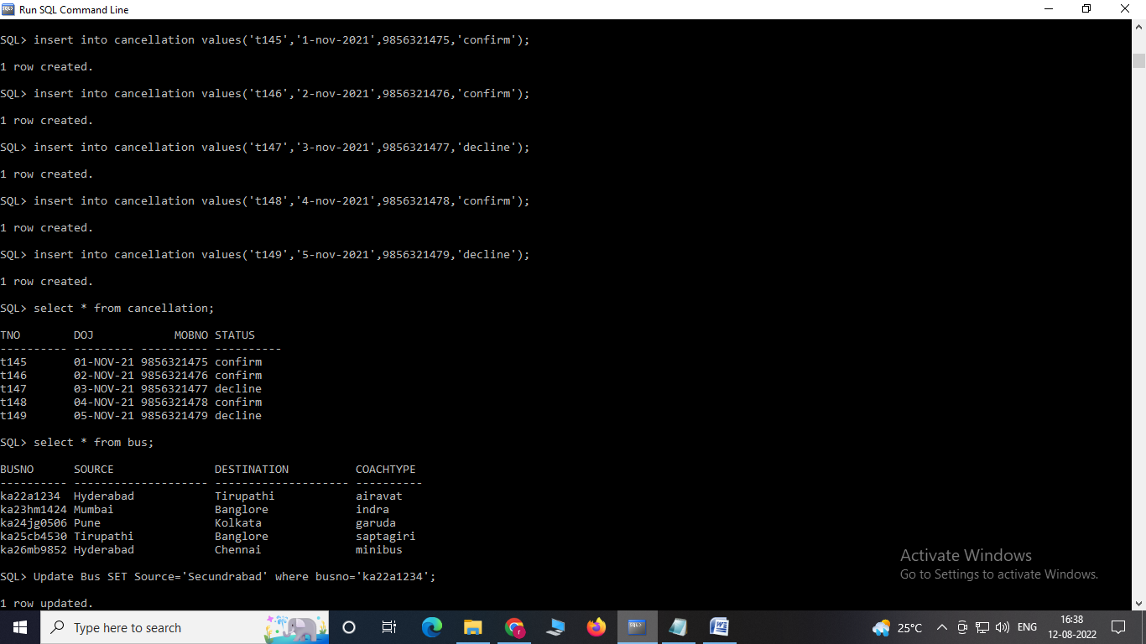

**MAIN QUERIES**

**4. UPDATE BUS RELATION with source as Secundrabad for bus no: ka22a1234.**

select * from bus;



Update Bus SET Source='Secundrabad' where busno='ka22a1234';

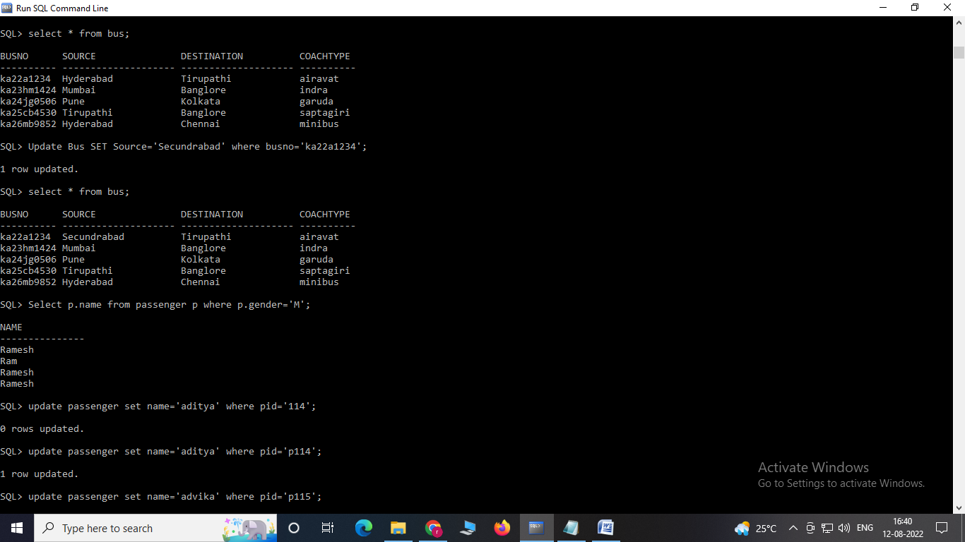

**5. Display all the names of male passengers.**

Select p.name from passenger p where p.gender='M';

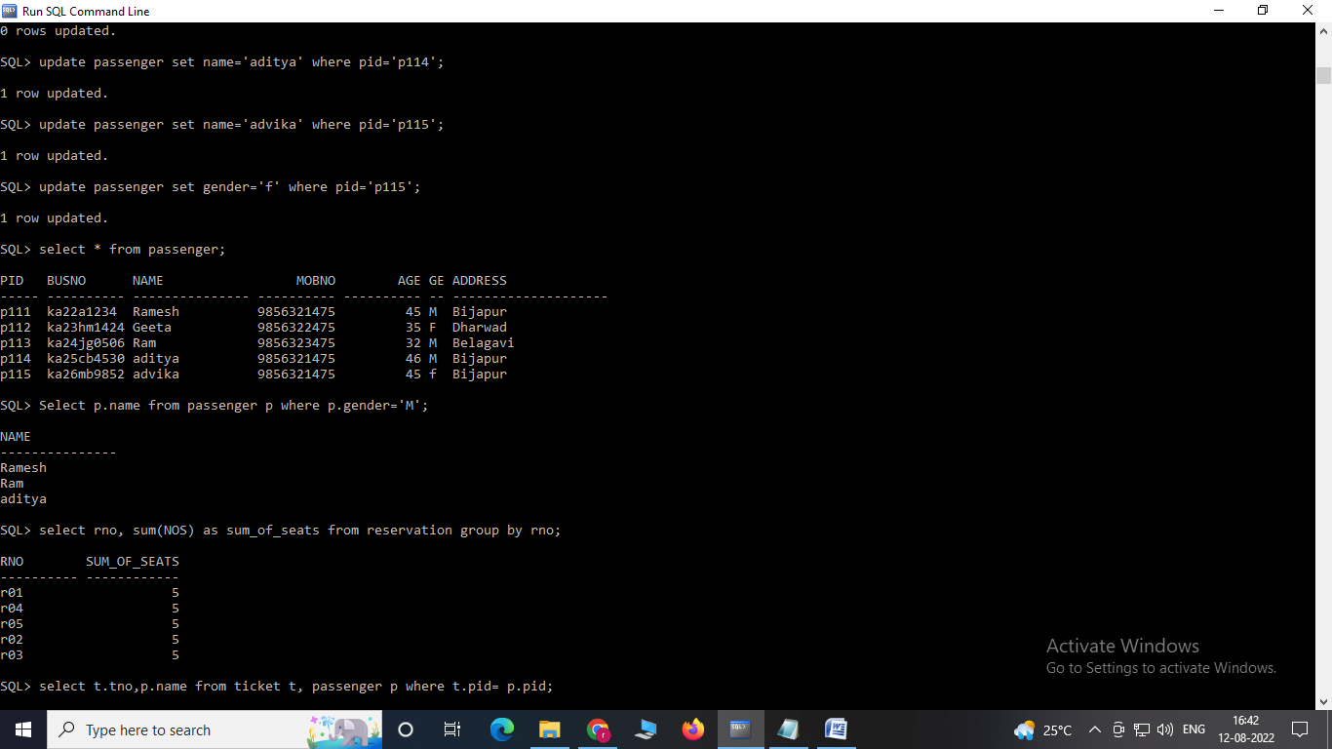

**6. Find number of tickets booked for each reservation number using GROUP BY CLAUSE.**

select rno, sum(NOS) as sum_of_seats from reservation group by rno;

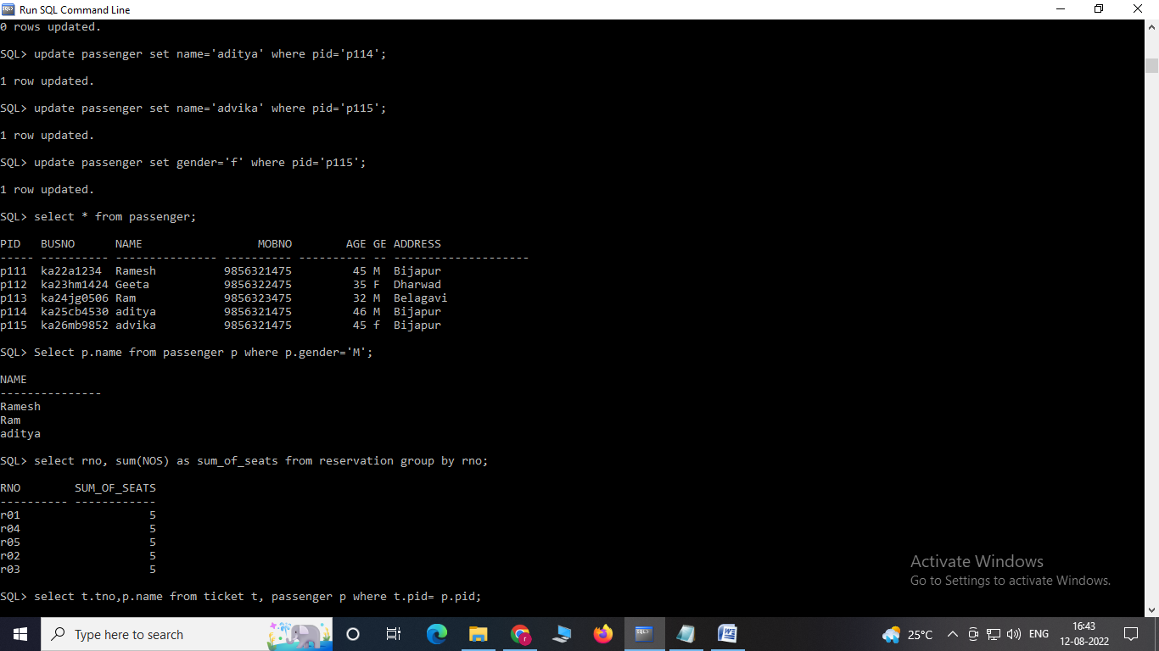

**7. Display the ticket numbers and names of all the passengers.**

select t.tno,p.name from ticket t, passenger p where t.pid= p.pid;

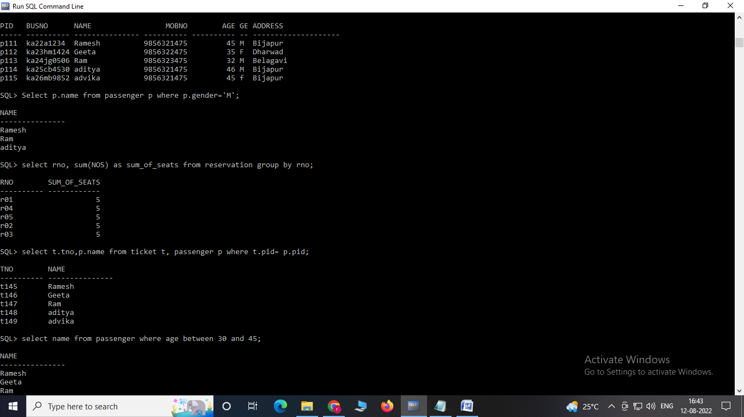

**8. Find the names of Passengers whose age is between 30 and 45.**

select name from passenger where age between 30 and 45;

