**TERM WORK**

**II**

**CRICKET DATABASE**

**2. Design an ER-diagram for the following scenario, Convert the same into a relational model and then solve the following queries.**

Consider a Cricket Tournament “ABC CUP” organized by an organization. In the tournament there are many teams are contesting each having a **Teamid,Team_Name, City, a coach.** Each team is uniquely identified by using **Teamid. A team can have many Players and a captain. Each player is uniquely identified by Playerid**, having **a Name, and multiple phone numbers,age. A player represents only one team. There are many Stadiums to conduct matches.** Each stadium is identified using **Stadiumid, having a stadium_name,Address (involves city,area_name,pincode).**A team can play many matches. Each match played between the two teams in the scheduled date and time in the predefined Stadium. **Each match is identified uniquely by using Matchid. Each match won by any of the one team that also wants to record in the database. For each match man_of_the match award given to a player.**

**Queries:**

1. Draw ER & Schema Diagram.
2. Create tables by specifying proper primary ad foreign keys.
3. Insertion of values to all the tables.
4. Display the youngest player (in terms of age) name, team name, age in which he belongs of the tournament.
5. List the details of the stadium where the maximum number of matches were played.
6. Create a view of all player details.
7. Create a view of all players whose age is less than 30.
8. Display match_id and Winning Team ID played between ‘1-jan-18’ to ‘1-sep-18’?

**1. Draw ER & Schema Diagram.**

**ER-Diagram**

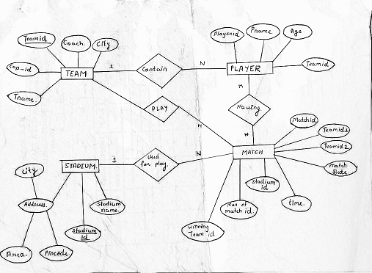

1

**SCHEMA DIAGRAM**

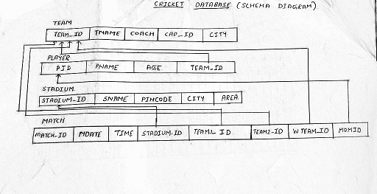

**2. Create tables by specifying proper primary ad foreign keys.**

create table team

(

tid int primary key,

tname varchar(10),

coach varchar(10),

cap_id int,

city varchar(10)

);

Table created.

desc team;

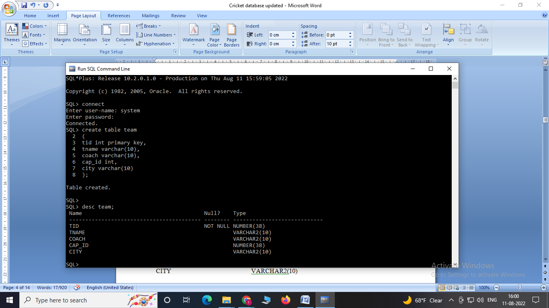

create table player

(

pid int primary key,

pname varchar(20),

age int,

tid int references team(tid)

);

Table created.

desc player;

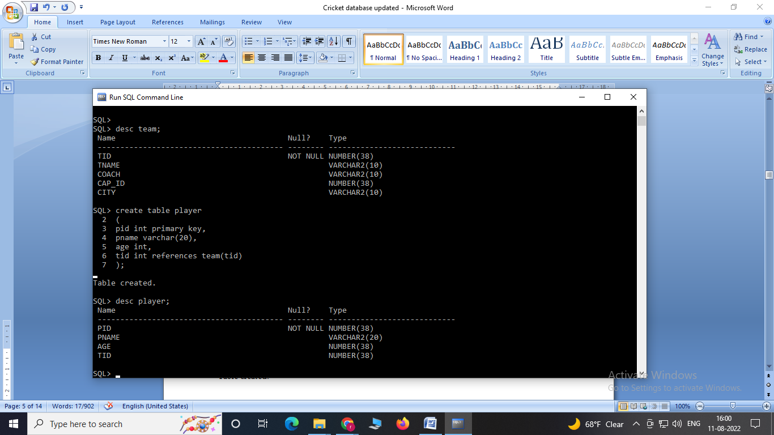

create table stadium

(

sid int primary key,

sname varchar(20),

pincode number(8),

city varchar(20),

area varchar(20)

);

Table created.

desc stadium;

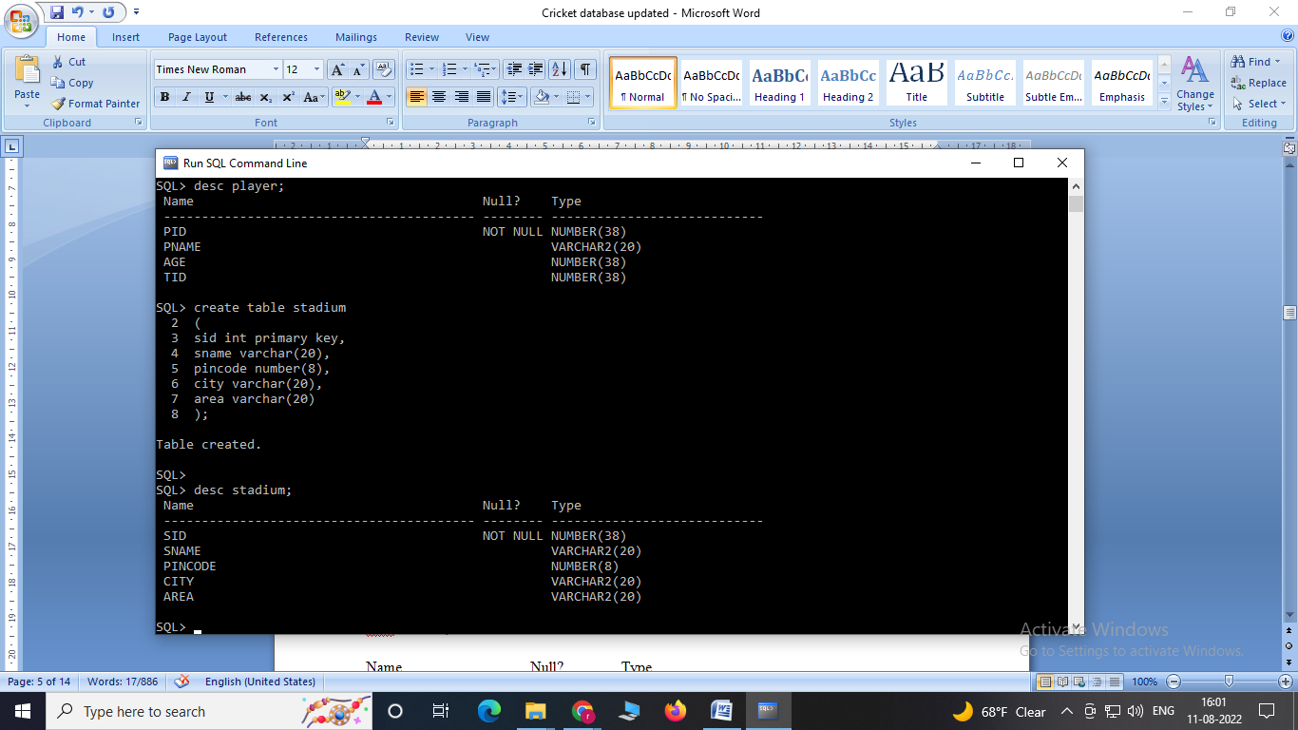

create table match(

mid int primary key,

mdate date,

time varchar(6),

sid int references stadium(sid),

team1_id int references team(tid),

team2_id references team(tid),

win_tid int references team(tid),

man_of_match int references player(pid));

Table created.

desc match;

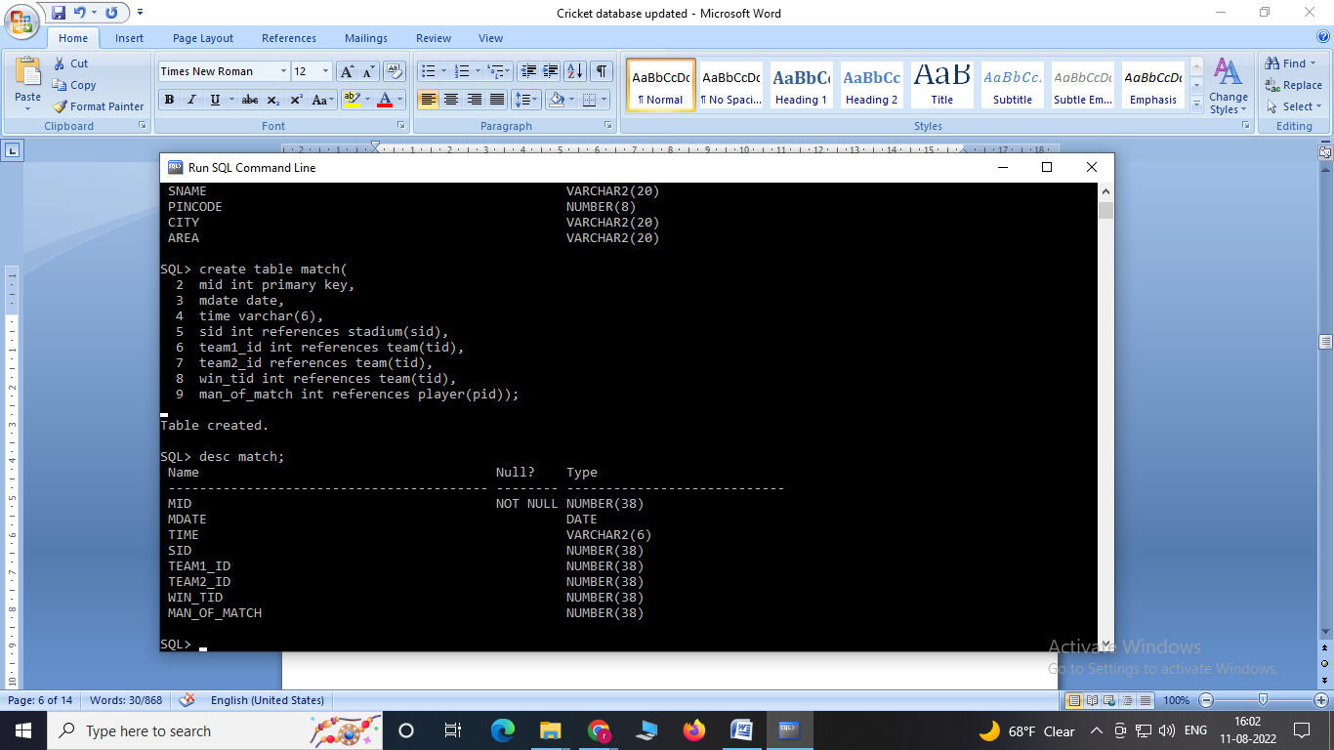

**3. Insertion of values to all the tables.**

**INSERTION IN TABLES:**

insert into team values('123','rcb','sunil','1','banglore');

insert into team values('124','csk','laxman','3','chennai');

insert into team values('125','royals','singh','4','rajastan');

insert into team values('126','daredevils','sehwag','2','dehli');

insert into team values('127’,'SHD','Rohit','5','Bangalore');

select * from team;

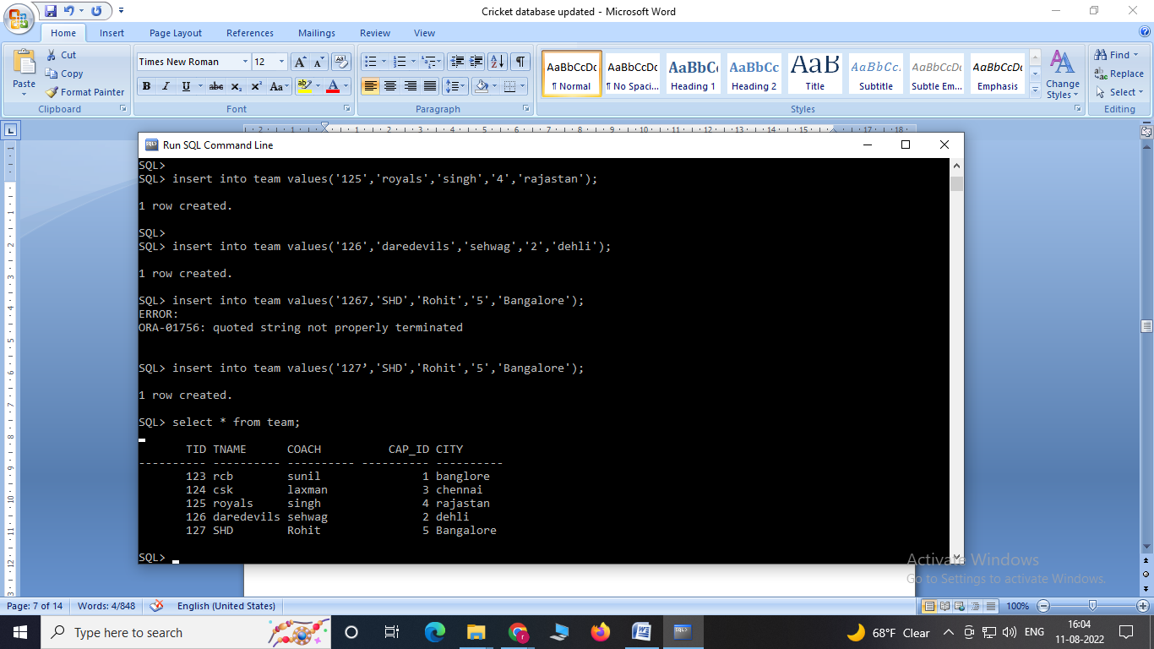

insert into player values(1,'sa','33','123');

insert into player values('2','dr','32','124');

insert into player values('3','dh','30','124');

insert into player values('4','raina','30','125');

insert into player values('5','kh','23','126');

select * from player;

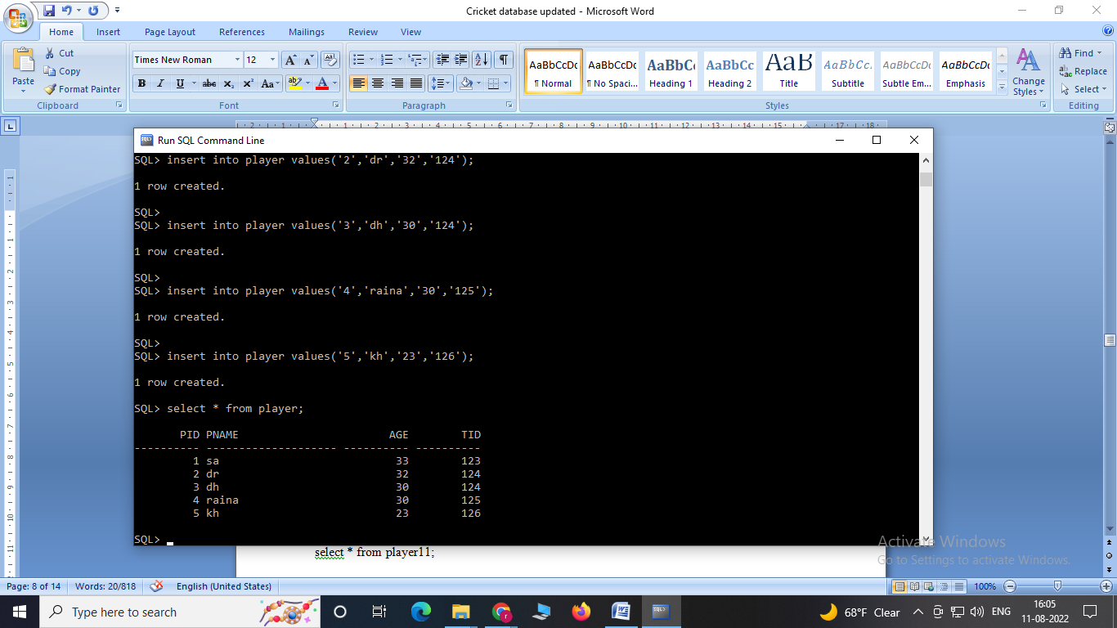

insert into stadium values('111','chinnaswami','56001','banglore','mg road');

insert into stadium values('222','kotla','460009','dehli','highway');

insert into stadium values('333','international','38883','chennai','tr nagar');

insert into stadium values('444','ksca','560098','banglore','peenya');

insert into stadium values('555','csca','567772','cochin','beach road');

select * from stadium;

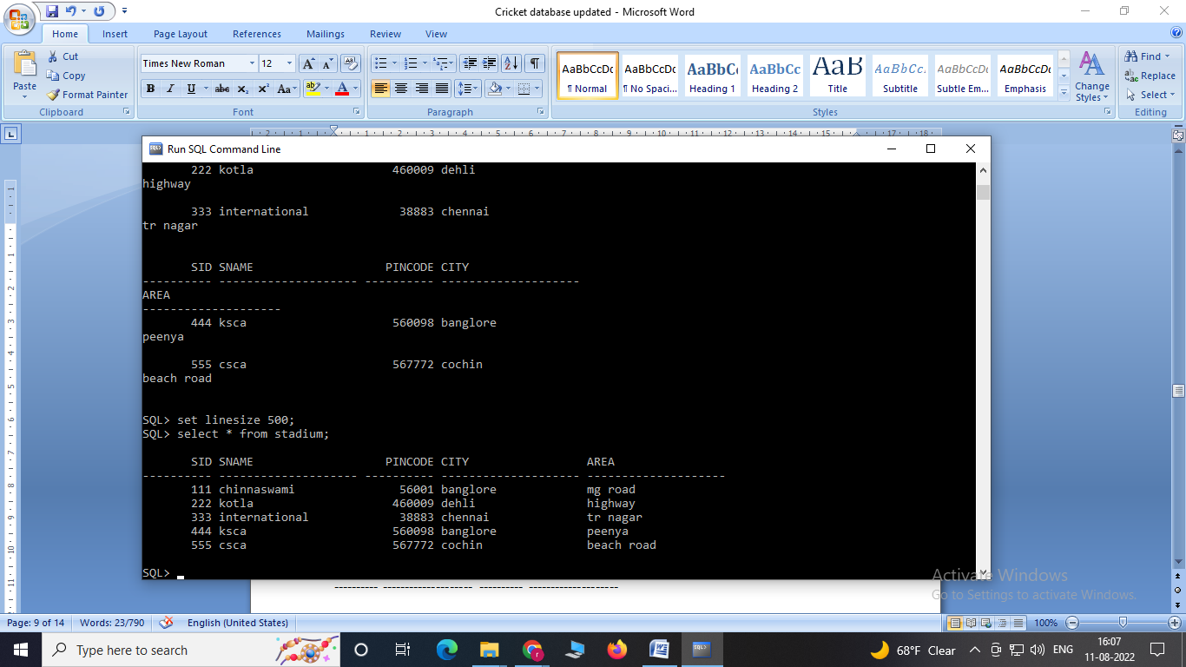

insert into match values('101','1-jan-18' ,'10am','111','123','124','123','1');

insert into match values('102','11-feb-18','11am','222','124','126','126','5');

insert into match values('103','12-jun-18','11am','111','125','126','126','5');

insert into match values('104','1-sep-18','10am','111','125','124','124','1');

select * from match;

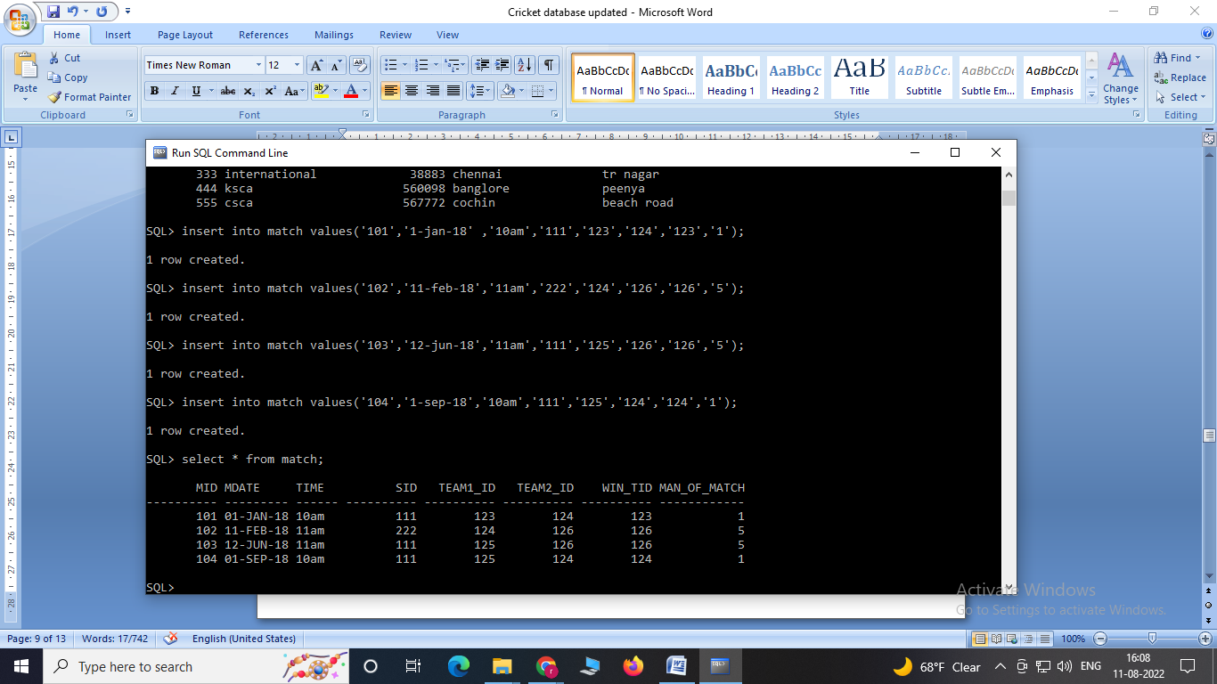

**Main Queries:**

**4. Display the youngest player (in terms of age) name, team name, age in which he belongs of the tournament.**

select pname, tname, age from player p, team t

where p.tid=t.tid and

age=(select min(age) from **player);**

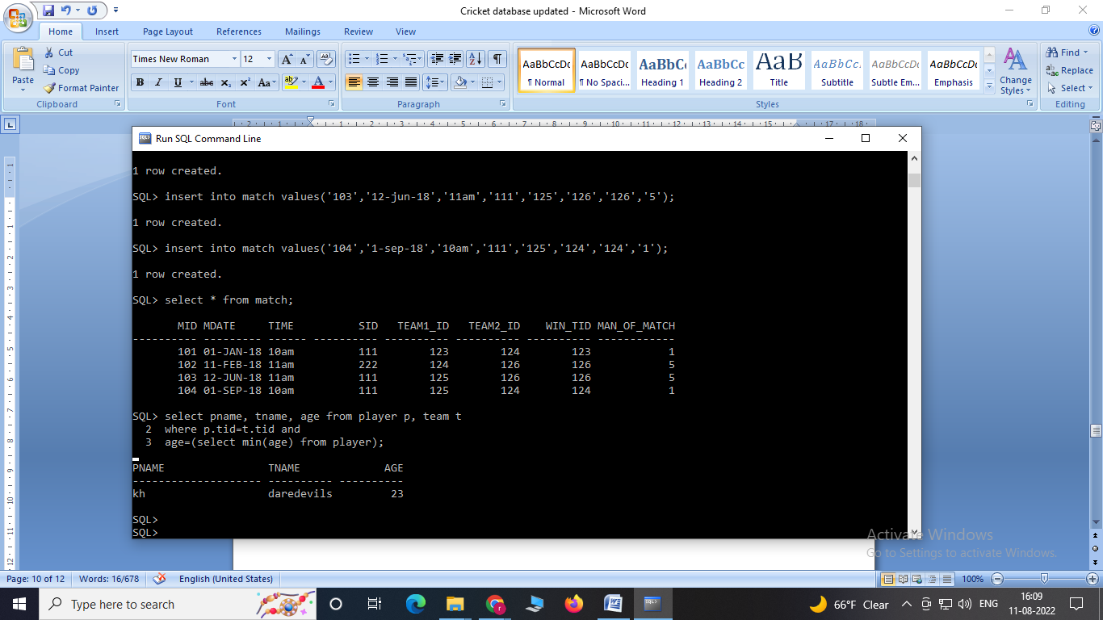

**5. List the details of the stadium where the maximum number of matches were played.**

select **\*** from stadium where sid ***in***

(select sid from match group by sid having count(sid)=(select max(count(sid))

from ***match*** group by sid));

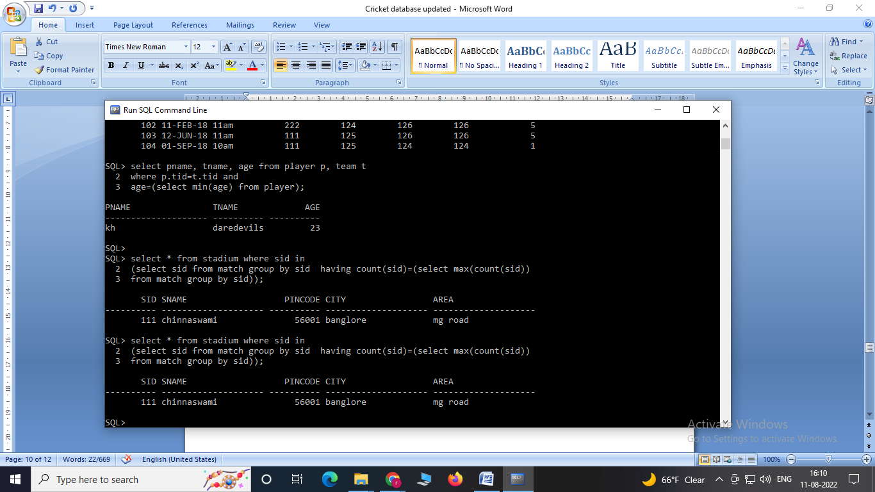

**6. Create a view of all player details.**

CREATE VIEW PlayerView11 AS

SELECT player.pname, player.pid, team.tname

FROM player, team

WHERE team.tid = player.tid;

View created.

**Select * from PlayerView11;**

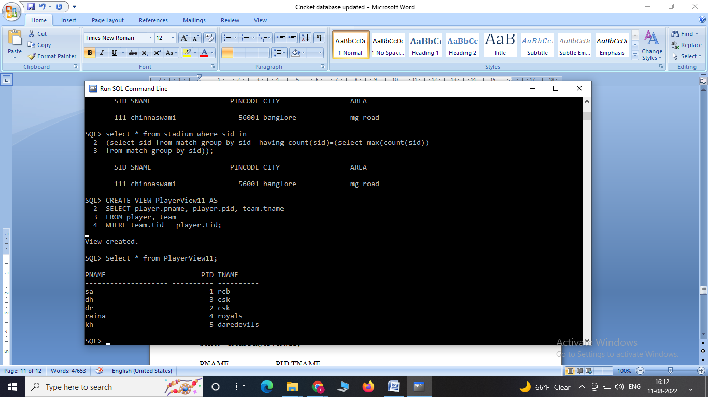

**7. Create a view of all players whose age is less than 30.**

CREATE VIEW DetailsView11 AS

SELECT pname,tid

FROM player

WHERE age < 30;

View created.

SELECT * FROM DetailsView11;

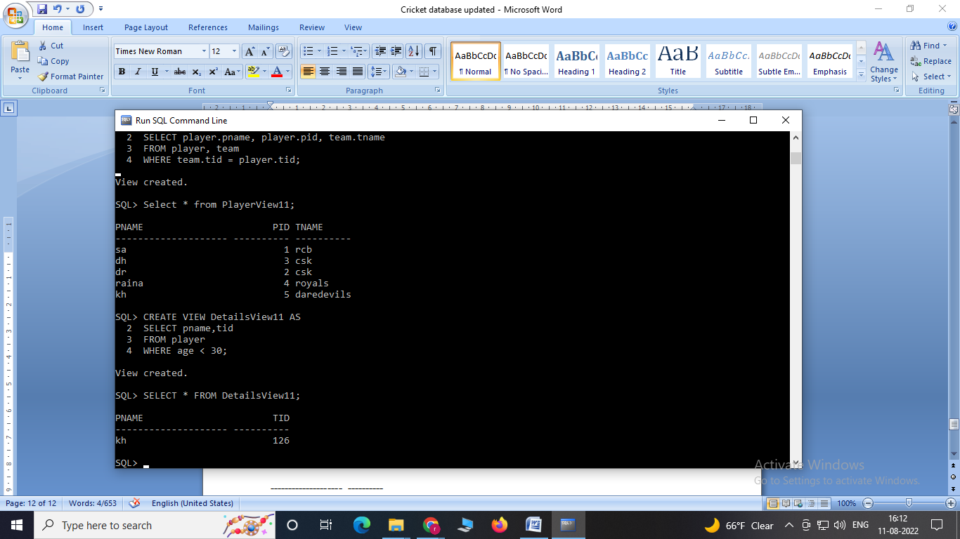

**8. Display match_id and Winning Team ID played between**

**‘1-jan-18’ to ‘1-sep-18’?**

select mid,win_tid from match

where mdate between '1-jan-18' and '1-sep-18' and time> '10am';

