Traceable Medical Image De-identification Pipeline for AI Applications

Final Report

Prepared by: | TMI Group 2
Authors: | Brian Zhou  Josh Cooper  Iwan Levin  Raouf Tiliouine
Client: | Dr. Rasika Rajapakshe  BC Cancer
Date: | April 8, 2022

Table of Contents

- Appendix A pg. 4
- Introduction pg. 5
  - Purpose pg. 5
  - Intended Audience - User groups pg. 5
  - Intended Use pg. 6
  - Scope pg. 6
    - Anonymization pg. 6
    - Storage pg. 6
    - Crosswalk Table pg. 7
    - PHI Mismatch Detection pg. 7
- System Features and Requirements pg. 8
  - Functional Requirements pg. 8
  - Non-Functional Requirements pg. 8
    - Overview pg. 8
    - Environmental Constraint pg. 8
  - Level 0 Data Flow Diagram pg. 9
  - Level 1 Data Flow Diagram pg. 9
  - Dependencies pg. 9
  - System Requirements pg. 11
- Setup Procedure pg. 11
  - Deployment A - Medical Research Manager pg. 11
    - Dependencies pg. 11
    - Building and Installing pg. 12
  - Deployment B - Using Docker and Docker Compose pg. 12
- Project Handover Instructions pg. 14
- Testing Procedures pg. 14
  - Unit Testing pg. 14
  - Manual Testing pg. 15
  - Continuous Integration pg. 15
  - Testing Results pg. 16
- Issues and Bugs pg. 17
- Appendix B: JSON Configuration pg. 17
  - Plugin Configuration pg. 18
  - Hardlinks pg. 18
    - Hash Bins pg. 18
  - Date Truncation pg. 18
    - Formating pg. 19
    - Default Configuration pg. 19
    - Truncating Different Dates Differently pg. 19
  - Filters - Removing DICOM Elements pg. 20
    - Blacklist pg. 20
    - Whitelist pg. 20

0. Appendix A

Medical modalities
Medical instruments such as CT Scanners and X-ray machines.

DICOM Protocol & File
DICOM is short for Digital Imaging and Communications in Medicine. It is the standard for the communication and management of medical imaging information and related data. The DICOM standard defined both a network protocol for communication between medical modalities and a file structure for storing medical imaging and sensitive patient health information. In this report, we will refer to the network protocol standard as DICOM protocol and the file structure standard as DICOM file.

PACS
PACS is short for Picture Archiving and Communication System. It provides storage and access to medical images from multiple medical modalities in a convenient way.

Orthanc
Orthanc is an open-source, lightweight DICOM PACS server for healthcare and medical research. It simplifies a large amount of the complexity of the DICOM protocol and DICOM file format and allows its users to focus on the content of the DICOM files. It also contains a plugin system that allows developers to create and develop plugins to extend its functionality, which we will be using extensively.

PHI
Patient Health Information. Sensitive data that relates to the past, present, or future health of an individual.

1. Introduction
Data is valuable and important, especially when it comes to conducting medical studies. Protecting sensitive patient health information while retaining the integrity of the data for medical research is crucial. In order to protect sensitive patient health information, DICOM files must be anonymized before being used to train AI models. Currently this anonymization in the BC Cancer foundation is performed by Dr. Rasika Rajapakshe. The process is that of manually editing the patient information out.

1.1 Purpose
The purpose of this software is to create a plugin for a DICOM server capable of receiving DICOM images from medical modalities from around the province. The plugin will supplant Dr Rasika in his role as anonymizer of these DICOM images containing patient information. Additionally it will create a table to lookup patient information for a given file so PHI can be retrieved as needed.

1.2 Intended Audience - User groups

Medical Research Managers
They are expected to be the main user group for this plugin and pipeline. The anonymized DICOM files can be used by researchers to train future Artificial Intelligence models, and the patient information can be used to verify the accuracy of the AI models.

Medical IT Staff
They will also be interacting with our pipeline. They are expected to maintain and manage the pipeline. IT Staff will have the knowledge to query the database system to retrieve information needed by researchers.

Developers
Future developers and development teams that might continue working on the project. They can be expected to expand the feature set and fix bugs that arise from long term testing and use of the plugin.

1.3 Intended Use

Medical Research Managers
They will interact with people who use the end result of the pipeline implemented in the plugin. They will define the config parameters to the IT staff based on their requirements.

Medical IT Staff
They will set up and maintain the server hosting the Orthanc instance. Their main interaction with the pipeline will be making sure that the dependencies are installed correctly and working as well as updating the configs according to the medical research manager’s specifications.

Developers
Will add on to our existing features or develop more as need arises. The main indicated feature that will be improved or added to is a more advanced version of the PHI mismatch feature.

1.4 Scope
The software is designed to improve the lives of medical professionals who create and manage anonymized datasets of DICOM images. As they can with this plugin configure an automated system wherein DICOM files income from modalities around the province and are automatically anonymized according to particular configuration settings. Alternatively they could use this plugin to manually anonymize images in large batches, having the Orthanc server do the hard part.

1.4.1 Anonymization
The plugin registers a callback allowing us to process DICOM images as they are first received. From here we perform the anonymization, calculate md5 checksums, and stash the anonymized DICOM file for later. The anonymization takes a configuration specified by the user inside the Orthanc.json and uses this to realize how the user wants data anonymized. The users can control how dates are treated telling the anonymizer to truncate them by overwriting specific digits using a configurable mask. Additionally the users can redact entire data fields from the DICOM file.

1.4.2 Storage
The plugin registers callback functions which define the procedures for writing, reading, and deleting files from disk. This is the “for later” that we stashed away the anonymized DICOM files, which we can lookup from inside the storage area’s write function. With the anonymized file in hand, we write it to disk. The storage code then uses the hardlink configuration to create hardlinks of this file in locations specified by the user using data desired by the user.

1.4.3 Crosswalk Table
The plugin registers what Orthanc calls an “on stored callback” which we use to update Orthanc’s database tables with correct md5 values. Additionally we insert PHI data from the DICOM file into our crosswalk table for use in PHI mismatch detection and cross references.

1.4.4 PHI Mismatch Detection
The plugin performs PHI mismatch detections via PostgreSQL triggers. These triggers are fired when new data is inserted into the crosswalk table. These triggers execute a PostgreSQL procedure for performing the mismatch detection. The detection procedure then uses SQL queries to retrieve potential PHI mismatch information and insert them into the phi_mismatch table. The detection criterias are:
- Patient ID matches (Patients share the same original patient ID)
  - Case 4: Same Full name - Different DOB
  - Case 7: Same First name, Last name, DOB - Different Middle name
  - Case 3: Same First name, DOB - Different Last name
  - Case 2: Same Last name, DOB - Different First name
- Patient DOB matches (same DOB and different patientID)
  - Case 5: Same DOB and Full name
  - Case 6: Same DOB and Last name
If any of the above criterias are met, we consider that a PHI mismatch occurred.

2. System Features and Requirements
This project software is intended to run on a server running Orthanc.

2.1. Functional Requirements
- Receive DICOM files from medical modalities via DICOM protocol.
- Store incoming DICOM files with anonymized PHI.
- Store retrievable PHI using the anonymized DICOM file’s UUID, Patient ID, and more.
Extras
- Identify 6 cases of potential PHI mismatches.
- Organize DICOM files in the file system.
- Read PHI from the database via SQL commands.
- Filter PHI from the database via SQL commands.

2.2. Non-Functional Requirements

2.2.1 Overview
Security: | PHI must be securely stored and protected from unauthorized access.
Reliability: | Must be able to reliably receive and process DICOM files with minimal downtime.
Maintainability: | IT admins need to be able to manage and maintain the pipeline without needing to modify code. So there should be adequate documentation for building, installing, and configuring the pipeline.
Usability: | The pipeline should be user-friendly and accessible.

2.2.2 Environmental Constraint
To comply with HIPAA (Health Insurance Portability and Accountability Act), all components of the pipeline must be within BC Cancer’s security network. This limits our options for our system architecture as we won’t be able to use established cloud services like AWS and Azure to handle computing, database, and storage. In addition, due to limited funding, the server infrastructure that we’ll be working with won’t be as powerful as we would like. We’ll have to optimize our pipeline to be as efficient as possible to handle the large amount of data (125GiB/day) that we need to process.

2.3 Level 0 Data Flow Diagram
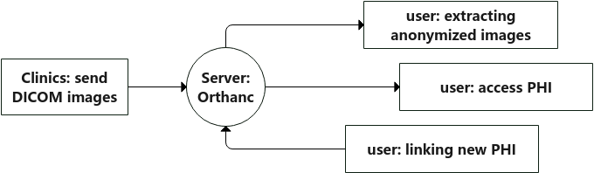

2.4 Level 1 Data Flow Diagram

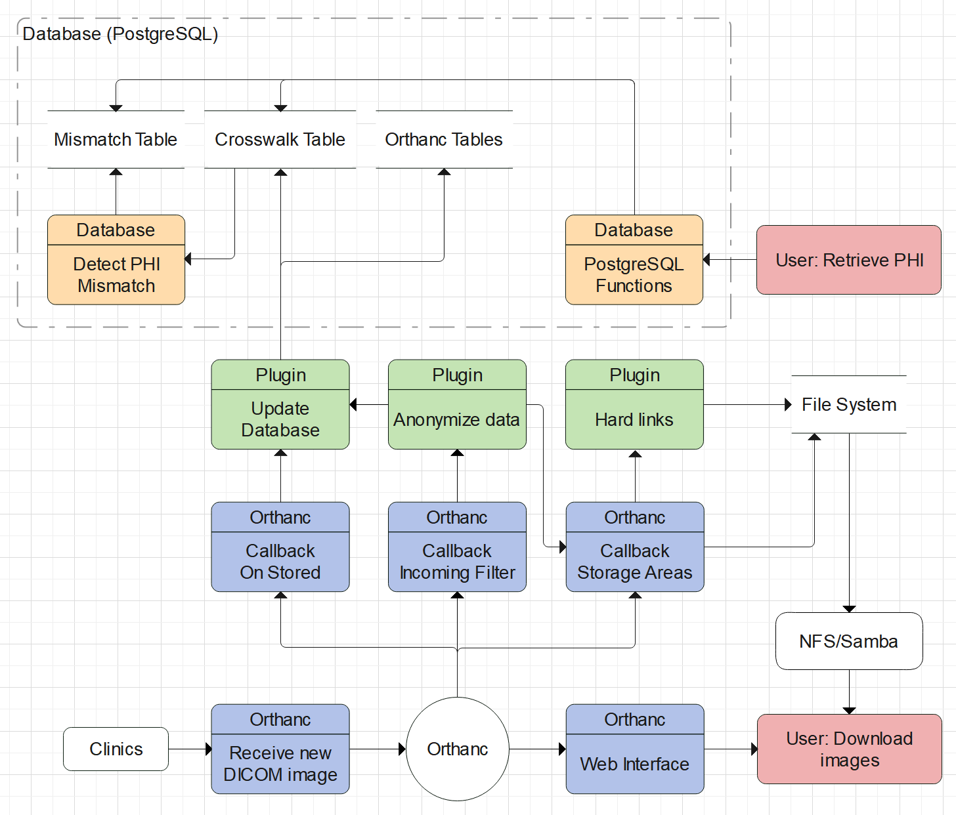

2.5 Dependencies
The dependencies change slightly depending on the user group.

Dependency | Users Groups | Purpose
C++ Compiler:  gcc, clang, etc. | Developers  Medical IT Staff | To compile the source files: for development testing or installation
CMake compatible build system:  Ninja, Visual Studio, etc. | Developers  Medical IT Staff | To tell the compiler/linker how to compile and link the source files together
CMake 3.20 | Developers  Medical IT Staff | To configure the build/install process, cmake supports generation for many different build systems
libpq | Developers  Medical IT Staff | Required to provide an API for interfacing with a PostgreSQL database
libpqxx 7.6+ | Developers  Medical IT Staff | Required by the plugin to provide a wrapper to the libpq API
googletest | Developers  Medical IT Staff (maybe) | Required for unit tests, and may be necessary for the build process when installing though it should always be present regardless of need due to the cloning process
Docker | Developers  Medical IT Staff (potentially) | Required for local testing during development, also required for deployment if a docker deployment is chosen
GitHub Actions | Developers | Required for remote continuous integration. This ensures the source code builds successfully
IDE:  CLion, Visual Studio | Developers | Highly recommended (over notepad) for editing the source and building

2.6 System Requirements
The system requirements needed to run this software are fuzzy, the better the specs the better the outcomes will be. The processing performed isn’t terribly intense, but the server could be in a situation where it has many threads of execution handling dozens of incoming files or possibly hundreds. So the more threads the better, and the more memory the better. It’ll run on a potato though.

3. Setup Procedure

3.0 Cloning the repository
No matter what you’ll be doing, you’ll need to obtain the source files because we haven’t provided pre-built binaries for deployment on various platforms. So using Git, clone the repository from https://github.com/BCCF-UBCO-AD/Orthanc-TMI, which you can do with:

$ git clone https://github.com/BCCF-UBCO-AD/Orthanc-TMI.git
$ git submodule init
$ git submodule update

Alternatively, you can also download the source directly from GitHub to your local machine.

3.1 Deployment A - Medical Research Managers
This deployment is intended for deploying the plugin to a server for production use. Deployment will require administrator rights in order to install the software and dependencies.

3.1.1 Dependencies
The primary dependencies for building the plugin are libpq and libpqxx, below are commands to install these dependencies on different distributions. Note: only the archlinux command has been tested and verified, and libpqxx must be version 7.6 or later. If your package manager does not provide a new enough build of libpqxx you will need to build and install from source.

Archlinux

$ pacman -Sy postgresql-libs libpqxx

Fedora

$ dnf install libpq libpqxx

OpenSUSE

$ zypper install libpq5 libpqxx

3.1.2 Building and Installing
From the command line you’ll need to navigate to where you cloned the repository, and then from it’s root directory run these commands:

$ mkdir build
$ cd build

For this part, use whichever build system you prefer. Ninja is recommended, but Make works just fine. Also verify the install location of Orthanc plugins [it may be different on your system] and change the install prefix path as necessary.

$ cmake .. -G Ninja -DCMAKE_INSTALL_PREFIX=/usr/share/Orthanc/plugins
$ sudo ninja install

3.2 Deployment B - Using Docker and Docker compose
The simplest way to deploy the pipeline is with Docker Compose. Utilizing Docker and Docker Compose, the pipeline can be run on any system that supports virtualization. Our pre-configure Docker images allow launching both PostgreSQL, Orthanc, as well as Adminer with a single command. You’ll also have access to the configuration files if you require to change any settings.

Step 0: Install dependencies
For installing Docker, please follow the official guide: https://docs.docker.com/get-docker/
After installing Docker, install Docker Compose: https://docs.docker.com/compose/install/
It is also recommended to install Git in order to clone the project.

Step 1: Build Docker Images
We now need to build the images for our Docker containers. Depending on your environment, this can take ~10 minutes to build everything.

First we navigate to the cloned repository by doing:
$ cd ./Orthanc-TMI

Then, we build the images by executing:
$ docker-compose build

Wait for the build process to finish and proceed to the next step.

Step 2: Installing the data-anonymize plugin
Download the pre-built plugin from https://github.com/BCCF-UBCO-AD/Orthanc-TMI/releases/ and place it in:
Orthanc-TMI/docker/Orthanc/plugins

Alternatively, follow the instruction #placeholder to build the plugin from source.

Step 3: Launching the pipeline
After the plugin is installed, we can launch the pipeline. Navigate to the root directory of the project, then execute:
$ docker-compose up

This will start the pipeline. After a few seconds, you can navigate to http://localhost:8042 and access Orthanc’s control panel. You can also access PostgreSQL’s control panel by navigating to http://localhost:8080.

Step 4: Configuration
There are three main configuration file you can modify to change the behaviour of the pipeline:
- docker-compose.yml
  - Located at: ./Orthanc-TMI/docker-compose.yml
  - Controls Docker’s behaviour. You can disable unneeded containers suchs as Adminer and Orthanc-Client to save on resources.
  - You can also change the launch parameter of the containers. This includes the credentials for PostgreSQL.
  - For more information, visit https://docs.docker.com/compose/
- postgresql.conf
  - Located at: ./Orthanc-TMI/docker/postgres/data/postgresql.conf
  - Controls Postgres’ behaviour.
  - For more info, visit: https://www.postgresql.org/docs/9.3/config-setting.html
- Orthanc.json
  - Located at: ./Orthanc-TMI/docker/Orthanc/Orthanc.json
  - Controls both Orthanc and the data-anonymize plugin’s behaviour.
  - For more information on Orthanc’s config, see Orthanc-commented.json
  - For more information on the plugin’s config, go to the configuration section.

4. Project Handover Instructions

Go to https://github.com/BCCF-UBCO-AD/Orthanc-TMI.git and fork the project on github to continue contributing or to take the project in a new direction. The client can also request admin rights to the original repo by emailing either Brian or Josh.

5. Testing Procedures

5.1 Unit Testing
- tests-jobqueue.cpp
  - This tests the functionality of the JobQueue class implemented for our Orthanc plugin. By queueing up a job on a thread and checking whether or not it completes. (DEFUNCT)
- tests-libraries.cpp
  - This test case only checks if the libraries are working as expected since a failure during the building of the binaries would be the first indication of the libraries not working as expected or that they are missing.
  - Checks libpqxx library can connect to database.
  - Checks json code works.
- test-postgrsql.cpp
  - This test runs a few SQL queries using the pqxx librarie to test the functionality of the database used by Orthanc. There are three basic sql commands testing the database's ability to handle SQL queries like: Create Table, Insert, Update, Drop Table and Select Queries.
- 1-tests-parse.cpp
  - Checks that the DicomFile class can successfully parse multiple dicom files by loading and parsing a set of sample dicom files. Uses the DicomElementView class to read dicom element sizes to find the end of the file thereby allowing us to detect an incorrect parse by not finding the correct end of file.
- 2-tests-anon.cpp
  - This tests the anonymization function of the plugin by anonomizing a set of sample files. It is configured with a hardcoded sample json to pass through PluginConfigurer to set up DicomAnonymizer. This relies on the functionality of the PluginConfigurator, DicomAnonymizer, and DicomFile classes.
- tests-date-truncation.cpp
  - This file tests the function TruncateDate and is tested by passing variations of the date config json text to the function allowing us to test common config variations that the function could receive. It also uses the same initial value as a constant across all test cases.
- tests-hex.cpp
  - Validates outputs of hex conversion functions for given inputs. These functions are crucial to numerous procedures, but most importantly to the parsing of dicom files. More generally it is critical to correctly reading and interpreting the tag values of dicom elements and groups in various places such as the json config.

5.2 Manual Testing
We use manual testing to test our plugin’s integration with Orthanc. Due to our project being a plugin for Orthanc, not all tests can be automated using unit testing. This is because we do not have the ability to test Orthanc related functions with unit tests, unless we also compile Orthanc from source.

To perform the manual test, we first compile our plugin into a binary and place it in the plugins directory. Then, we use docker-compose to launch two Orthanc clients, along with PostgreSQL and Adminer. For the two Orthanc clients we load the plugin into only one of the two and use the other as a remote modality. We then access the remote modality Orthanc’s web interface and upload DICOM images then we send them to the Orthanc client containing the plugin. Afterwards, we observe Orthanc’s console output to see if the file has been received successfully and anonymized, and if any error has been generated. Using Adminer, we can check if the patient's PHI has been correctly written to the PostgreSQL database and if the mismatch detection worked, if that’s what we wanted to test by checking the tables related to it. Furthermore, we can use softwares such as MicroDICOM to explore the anonymized file to check if all PHI has been removed and if our own information such as instance UUID has been inserted.

5.3 Continuous Integration
We use github actions to build a version of the plugin and run our suite of unit tests in a docker environment every time a commit is made to a pull request to the develop or master branches. This helps us continuously test the plugin as we add features and implement them on the develop branch. Using the github actions implementation of continuous testing has helped us identify bugs during development of the plugin and reduce the number of issues we encountered in the manual testing of the plugin later in development.

The github actions environment works through a series of tasks triggered by the commit to a select list of branches. It then clones and builds a version of the plugin containing what would be the end result of the completed pull request and starts a docker environment based on the given docker-compose config file specific to the github actions workflow. After the initial setup we currently have it set to run all the unit tests we’ve written using the google test framework for the plugin which prints to a log we can review on github later if we need to. This continuous automatic testing is our main method of testing during development and how we identified most of our encountered issues and bugs.

5.4 Testing Results

Feature | Unit Tests | Testing Strategy | Results
Receive DICOM files from medical modalities via DICOM protocol. | N/A | Tested by using a second Orthanc instance to act as a simulated modality that sent dicom images to the Orthanc instance containing the plugin and checking the updated info on the web interface for that | Successfully received all images sent.
Store incoming DICOM files with anonymized PHI. | 1-tests-parse.cpp  2-tests-anon.cpp | Runs through a batch of test files to check that the methods associated with anonymization and storage of anonymized files are working correctly | Passed all unit tests
Store retrievable PHI using the anonymized DICOM file’s UUID, Patient ID, and more. | N/A | Tested alongside PHI mismatch as the data/references are stored in the crosswalk used by PHI mismatch. | All original PHI was still accessible for the mismatch test files from the PHI mismatch test runs
Read PHI from the database via SQL commands. | tests-libraries.cpp  test-postgrsql.cpp | N/A | Passed all unit tests
Filter PHI from the database via SQL commands. | tests-libraries.cpp  test-postgrsql.cpp | N/A | Passed all unit tests
Identify 6 cases of potential PHI mismatches. | N/A | Manually uploaded duplicate files and checked the resulting tables in the database using adminer | Was able to successfully mismatch 3 different pairs of mismatching dicom files.
Organize DICOM files in the file system. | N/A | Manually tested by uploading files and then checking that it is stored correctly according to the specifications in the config. | Stored all uploaded files correctly according to the specified tags and format in the config after anonymization.

6. Issues and Bugs

No known issues or bugs in the current release (v1.0) on the master branch of the repository.

7. Appendix B: JSON Config

7.1 Plugin Configuration
To configure this plugin you'll need to add a section to your json file with the key "DataAnon" : {} under this section different parts of the plugin can be configured. Here is an empty configuration showing the different sections. These are the parts of the configuration that must be present. If missing Orthanc will fail to start.
"DataAnon": {
"HardlinksUseHashBins" : true,
"Hardlinks": { },
"DateTruncation": {
"default": "YYYYMMDD"
},
"Filter": {
"blacklist": [ ],
"whitelist": [ ]
}
}
note: changing the configuration does not (currently) affect existing DICOM files that have already been received and processed by the server.

7.2 Hard Links
Hard links are a special type of file on a filesystem that allow you to alias another file such that even if you rename the underlying file the hard link will still point to that file. In fact you could delete the underlying file and the hard link will take its place so to speak, which is to say the data is not lost because there is still a file referencing that spot on the storage medium. note: not all filesystem types support hard links (eg. FAT32)
For users of this data anonymization plugin, hard links allow us to provide a way to conveniently customize how data is organized on the filesystem. Hard links can be configured in the json using a "/folder-name/" : "group,element" pair.
For example: Say you want to organize your DICOM files according to the patients' date of births. You would add "/by-dob/": "0010,0030" to the “Hardlinks”: {} section like so

"Hardlinks" : {
"/by-dob/": "0010,0030"
}
This will create a directory named by-dob in which dicom files will be grouped according to their date of birth. For a patient who's date of birth is recorded in an incoming DICOM file as 19880404 the relative path to that file from Orthanc's storage directory will be by-dob/19880404/.
You can add multiple hardlinks by separating them by commas. The directory you use can be anything, the plugin will ensure the directory is created if it does not exist, and you can find them under the Orthanc storage directory seen in the Orthanc configuration json under "StorageDirectory'' this too can be customized.

7.2.1 Hash Bins
You may have more files than your file system is willing to manage under a particular group (eg. by-dob/19880404/) and so you can enable the use of hash bins which will use the first two characters of the DICOM file's name as part of the path. eg. by-dob/19880404/4A/; the file names are uuid.DCM where uuid is the file's rather long uuid. To enable or disable this feature you would set the "HardlinksUseHashBins" field accordingly (ie. true or false).

7.3 Date Truncation

You may want to keep dates, but also anonymize them to a certain degree which you can accomplish via the date truncation feature. You can configure different dates to be truncated differently even. The date truncation code will take the configuration and simply mask the date with it. For example:
date: 19880404
config: YYYY0101
result: 19880101

So in practice you could configure the date truncater to give you weird results by using a config such as 99YYM1DD. This would result in the example date turning into 99880104 or 19881212 becoming 99881112. Probably not what you'd want, so just be sure you set it correctly.

7.3.1 Formatting
Dates in DICOM files should be in the format YYYYMMDD and our plugin uses this same format to configure date truncation.

7.3.2 Default configuration
The date truncation requires a default truncation otherwise the plugin will not load. You can configure the truncation to do nothing by simply using YYYYMMDD (technically you could use any non-digits, but might as well make sense). To configure this you would just add “default” : “YYMMDD” to the “DateTruncation”: {} section. The example at the top shows what this would look like.

7.3.3 Truncating Different Dates Differently
Say you want all dates to be truncated by month, except date of birth which you want truncated by year. That is to say you only care about what year they were born, and everything else you care up to the month but not the day. To achieve this you would add an entry to the “DateTruncation”: {} section using the DOB's group,element which would be “0010,0030” along with the truncation mask.. in the end you'd have the following.
"DateTruncation": {
"default": "YYYYMM01",
"0010,0030": "YYYY0101"
}
- note: you can add a different mask for each and every type of date you can find in a DICOM file just add the appropriate tag (group,element) and the mask you want for each.
- note: specific dates configured for truncation will be automatically be added to the Filter whitelist (inside the plugin, not the json).

7.4 Filter - Removing Dicom Elements

If you want to completely remove data, you can use the “Filter” : {“blacklist” : []} section to achieve it.

7.4.1 Blacklist
The blacklist can be configured in two ways, you can either remove an entire group of DICOM elements, or specific elements. To remove an entire group you simply use the group tag eg. "0010" and for a specific element it would be something like "00FF,0010"

7.4.2 Whitelist
The whitelist can only be configured for specific DICOM elements because it is intended to counter-act blacklisting an entire group. note: dates specified under the “DateTruncation”: {} section will automatically be added to the whitelist.

