Bootstrap Assessment of Age-Associated Enrichment

Derek Chiu, Steven McKinney

October 23, 2017

# Introduction

To assess age-associated enrichment for intClust groups, we conducted a bootstrap analysis. We chose 50, 75, 100, 150, 200, and 300 bootstrap samples from each of the 10 intClust groups, and repeated this process 20 times. Each iteration repeat fitted a set of linear models predicting each gene target (48803 total) from age at diagnosis. An FDR of 0.01 was used for BH-adjusted p-values.

# Tests of Independence

Because of a mix of small and large expected counts in several of the tables, we obtained p-values for Fisher's exact test using Monte Carlo simulation with B = 100000 replicates. For each NiBoot size, we obtained 20 p-values, one for each bootstrap replicate. The contingency tables are cross-tabulations between intClust group (1-10) and probes exhibiting age dependent status (yes/no).

## Pearson Chi-Squared Tests

The distribution of p-values from Pearson's chi-square test for independence is shown below each bootstrap size table for the 20 replicates.

## Fisher's Exact Tests

The distribution of p-values from Fisher's exact test for independence is shown below for the 20 replicates. Because the p-values were obtained using simulation with B = 100000 replicates, the minimum p-value will be 0.0000100

## iClust group sizes

intClust number of cases

|  |  |  |  |  |  |  |  |  |  |
| --- | --- | --- | --- | --- | --- | --- | --- | --- | --- |
| 1 | 2 | 3 | 4 | 5 | 6 | 7 | 8 | 9 | 10 |
| 140 | 72 | 294 | 344 | 191 | 86 | 193 | 300 | 146 | 226 |

## Raw data iClust enrichment test

intClust number of cases

|  |  |  |  |  |  |  |  |  |  |
| --- | --- | --- | --- | --- | --- | --- | --- | --- | --- |
| 1 | 2 | 3 | 4 | 5 | 6 | 7 | 8 | 9 | 10 |
| 140 | 72 | 294 | 344 | 191 | 86 | 193 | 300 | 146 | 226 |

# NB 50 Results

## Table means

Average trend counts across bootstrap replications for each intClust group of size 50

|  |  |  |
| --- | --- | --- |
| group | mean_trend | mean_no_trend |
| 1 | 10.2 | 48793 |
| 2 | 349 | 48454 |
| 3 | 1.8 | 48801 |
| 4 | 0.15 | 48803 |
| 5 | 4.55 | 48798 |
| 6 | 174.2 | 48629 |
| 7 | 3.2 | 48800 |
| 8 | 1.5 | 48802 |
| 9 | 10.05 | 48793 |
| 10 | 0.25 | 48803 |
| mean | 55.49 | 48748 |

## Table Medians

Median trend counts across bootstrap replications for each intClust group of size 50

|  |  |  |
| --- | --- | --- |
| group | median_trend | median_no_trend |
| 1 | 1.5 | 48802 |
| 2 | 57.5 | 48746 |
| 3 | 0 | 48803 |
| 4 | 0 | 48803 |
| 5 | 1 | 48802 |
| 6 | 12.5 | 48790 |
| 7 | 0.5 | 48802 |
| 8 | 0 | 48803 |
| 9 | 1 | 48802 |
| 10 | 0 | 48803 |
| median | 0.75 | 48802 |

## Top Probe Counts

### FC = 1.25

Number of Probes chosen in 10, 15, 19, 20 times out of 20 bootstrap replicates of size 50 for FC 1.25

|  |  |  |  |  |
| --- | --- | --- | --- | --- |
| group | 10 | 15 | 19 | 20 |
| 1 | 0 | 0 | 0 | 0 |
| 2 | 0 | 0 | 0 | 0 |
| 3 | 0 | 0 | 0 | 0 |
| 4 | 0 | 0 | 0 | 0 |
| 5 | 0 | 0 | 0 | 0 |
| 6 | 0 | 0 | 0 | 0 |
| 7 | 0 | 0 | 0 | 0 |
| 8 | 0 | 0 | 0 | 0 |
| 9 | 0 | 0 | 0 | 0 |
| 10 | 0 | 0 | 0 | 0 |

### FC = 2

Number of Probes chosen in 10, 15, 19, 20 times out of 20 bootstrap replicates of size 50 for FC 2

|  |  |  |  |  |
| --- | --- | --- | --- | --- |
| group | 10 | 15 | 19 | 20 |
| 1 | 0 | 0 | 0 | 0 |
| 2 | 0 | 0 | 0 | 0 |
| 3 | 0 | 0 | 0 | 0 |
| 4 | 0 | 0 | 0 | 0 |
| 5 | 0 | 0 | 0 | 0 |
| 6 | 0 | 0 | 0 | 0 |
| 7 | 0 | 0 | 0 | 0 |
| 8 | 0 | 0 | 0 | 0 |
| 9 | 0 | 0 | 0 | 0 |
| 10 | 0 | 0 | 0 | 0 |

### FC = 4

Number of Probes chosen in 10, 15, 19, 20 times out of 20 bootstrap replicates of size 50 for FC 4

|  |  |  |  |  |
| --- | --- | --- | --- | --- |
| group | 10 | 15 | 19 | 20 |
| 1 | 0 | 0 | 0 | 0 |
| 2 | 0 | 0 | 0 | 0 |
| 3 | 0 | 0 | 0 | 0 |
| 4 | 0 | 0 | 0 | 0 |
| 5 | 0 | 0 | 0 | 0 |
| 6 | 0 | 0 | 0 | 0 |
| 7 | 0 | 0 | 0 | 0 |
| 8 | 0 | 0 | 0 | 0 |
| 9 | 0 | 0 | 0 | 0 |
| 10 | 0 | 0 | 0 | 0 |

## Pearson Chi-Square Tests

## pvalue  
## 0 6.15e-140 5.99e-102 7.43e-91 4.59e-63 1.19e-49 1.48e-45   
## 9 1 1 1 1 1 1   
## 3.51e-41 8.98e-36 1.09e-15 2.99e-15 5e-04   
## 1 1 1 1 1

## Fisher's Exact Tests

## pvalue  
## 1e-05 0.00095   
## 19 1

# NB 75 Results

## Table Means

Average trend counts across bootstrap replications for each intClust group of size 75

|  |  |  |
| --- | --- | --- |
| group | mean_trend | mean_no_trend |
| 1 | 158.9 | 48644 |
| 2 | 885.5 | 47918 |
| 3 | 19.9 | 48783 |
| 4 | 6.5 | 48796 |
| 5 | 44.9 | 48758 |
| 6 | 636.9 | 48166 |
| 7 | 4.6 | 48798 |
| 8 | 49.2 | 48754 |
| 9 | 120.7 | 48682 |
| 10 | 23.85 | 48779 |
| mean | 195.1 | 48608 |

## Table Medians

Median trend counts across bootstrap replications for each intClust group of size 75

|  |  |  |
| --- | --- | --- |
| group | median_trend | median_no_trend |
| 1 | 77.5 | 48726 |
| 2 | 727 | 48076 |
| 3 | 2 | 48801 |
| 4 | 0 | 48803 |
| 5 | 3.5 | 48800 |
| 6 | 619 | 48184 |
| 7 | 1.5 | 48802 |
| 8 | 19 | 48784 |
| 9 | 2.5 | 48800 |
| 10 | 0 | 48803 |
| median | 3 | 48800 |

## Top Probe Counts

### FC = 1.25

Number of Probes chosen in 10, 15, 19, 20 times out of 20 bootstrap replicates of size 75 for FC 1.25

|  |  |  |  |  |
| --- | --- | --- | --- | --- |
| group | 10 | 15 | 19 | 20 |
| 1 | 0 | 0 | 0 | 0 |
| 2 | 25 | 1 | 0 | 0 |
| 3 | 0 | 0 | 0 | 0 |
| 4 | 0 | 0 | 0 | 0 |
| 5 | 0 | 0 | 0 | 0 |
| 6 | 30 | 1 | 0 | 0 |
| 7 | 0 | 0 | 0 | 0 |
| 8 | 0 | 0 | 0 | 0 |
| 9 | 0 | 0 | 0 | 0 |
| 10 | 0 | 0 | 0 | 0 |

### FC = 2

Number of Probes chosen in 10, 15, 19, 20 times out of 20 bootstrap replicates of size 75 for FC 2

|  |  |  |  |  |
| --- | --- | --- | --- | --- |
| group | 10 | 15 | 19 | 20 |
| 1 | 0 | 0 | 0 | 0 |
| 2 | 11 | 1 | 0 | 0 |
| 3 | 0 | 0 | 0 | 0 |
| 4 | 0 | 0 | 0 | 0 |
| 5 | 0 | 0 | 0 | 0 |
| 6 | 21 | 1 | 0 | 0 |
| 7 | 0 | 0 | 0 | 0 |
| 8 | 0 | 0 | 0 | 0 |
| 9 | 0 | 0 | 0 | 0 |
| 10 | 0 | 0 | 0 | 0 |

### FC = 4

Number of Probes chosen in 10, 15, 19, 20 times out of 20 bootstrap replicates of size 75 for FC 4

|  |  |  |  |  |
| --- | --- | --- | --- | --- |
| group | 10 | 15 | 19 | 20 |
| 1 | 0 | 0 | 0 | 0 |
| 2 | 6 | 0 | 0 | 0 |
| 3 | 0 | 0 | 0 | 0 |
| 4 | 0 | 0 | 0 | 0 |
| 5 | 0 | 0 | 0 | 0 |
| 6 | 3 | 1 | 0 | 0 |
| 7 | 0 | 0 | 0 | 0 |
| 8 | 0 | 0 | 0 | 0 |
| 9 | 0 | 0 | 0 | 0 |
| 10 | 0 | 0 | 0 | 0 |

## Pearson Chi-Square Tests

## pvalue  
## 0 2.03e-278 5.14e-125   
## 18 1 1

## Fisher's Exact Tests

## pvalue  
## 1e-05   
## 20

# NB 100 Results

## Table Means

Average trend counts across bootstrap replications for each intClust group of size 100

|  |  |  |
| --- | --- | --- |
| group | mean_trend | mean_no_trend |
| 1 | 486.1 | 48317 |
| 2 | 2308 | 46495 |
| 3 | 106.8 | 48696 |
| 4 | 11.25 | 48792 |
| 5 | 100.7 | 48702 |
| 6 | 1212 | 47590 |
| 7 | 219.2 | 48584 |
| 8 | 63.6 | 48739 |
| 9 | 232.3 | 48571 |
| 10 | 7 | 48796 |
| mean | 474.8 | 48328 |

## Table Medians

Median trend counts across bootstrap replications for each intClust group of size 100

|  |  |  |
| --- | --- | --- |
| group | median_trend | median_no_trend |
| 1 | 282 | 48521 |
| 2 | 1898 | 46905 |
| 3 | 27.5 | 48776 |
| 4 | 1.5 | 48802 |
| 5 | 16 | 48787 |
| 6 | 1254 | 47549 |
| 7 | 80 | 48723 |
| 8 | 40.5 | 48762 |
| 9 | 31 | 48772 |
| 10 | 3 | 48800 |
| median | 35.75 | 48767 |

## Top Probe Counts

### FC = 1.25

Number of Probes chosen in 10, 15, 19, 20 times out of 20 bootstrap replicates of size 100 for FC 1.25

|  |  |  |  |  |
| --- | --- | --- | --- | --- |
| group | 10 | 15 | 19 | 20 |
| 1 | 20 | 0 | 0 | 0 |
| 2 | 477 | 91 | 17 | 6 |
| 3 | 2 | 1 | 0 | 0 |
| 4 | 0 | 0 | 0 | 0 |
| 5 | 0 | 0 | 0 | 0 |
| 6 | 155 | 16 | 2 | 0 |
| 7 | 0 | 0 | 0 | 0 |
| 8 | 5 | 0 | 0 | 0 |
| 9 | 0 | 0 | 0 | 0 |
| 10 | 0 | 0 | 0 | 0 |

### FC = 2

Number of Probes chosen in 10, 15, 19, 20 times out of 20 bootstrap replicates of size 100 for FC 2

|  |  |  |  |  |
| --- | --- | --- | --- | --- |
| group | 10 | 15 | 19 | 20 |
| 1 | 13 | 0 | 0 | 0 |
| 2 | 201 | 41 | 14 | 5 |
| 3 | 2 | 1 | 0 | 0 |
| 4 | 0 | 0 | 0 | 0 |
| 5 | 0 | 0 | 0 | 0 |
| 6 | 79 | 6 | 0 | 0 |
| 7 | 0 | 0 | 0 | 0 |
| 8 | 4 | 0 | 0 | 0 |
| 9 | 0 | 0 | 0 | 0 |
| 10 | 0 | 0 | 0 | 0 |

### FC = 4

Number of Probes chosen in 10, 15, 19, 20 times out of 20 bootstrap replicates of size 100 for FC 4

|  |  |  |  |  |
| --- | --- | --- | --- | --- |
| group | 10 | 15 | 19 | 20 |
| 1 | 3 | 0 | 0 | 0 |
| 2 | 57 | 16 | 4 | 0 |
| 3 | 1 | 1 | 0 | 0 |
| 4 | 0 | 0 | 0 | 0 |
| 5 | 0 | 0 | 0 | 0 |
| 6 | 7 | 1 | 0 | 0 |
| 7 | 0 | 0 | 0 | 0 |
| 8 | 2 | 0 | 0 | 0 |
| 9 | 0 | 0 | 0 | 0 |
| 10 | 0 | 0 | 0 | 0 |

## Pearson Chi-Square Tests

## pvalue  
## 0   
## 20

## Fisher's Exact Tests

## pvalue  
## 1e-05   
## 20

# NB 150 Results

## Table Means

Average trend counts across bootstrap replications for each intClust group of size 150

|  |  |  |
| --- | --- | --- |
| group | mean_trend | mean_no_trend |
| 1 | 1210 | 47593 |
| 2 | 5652 | 43151 |
| 3 | 502 | 48301 |
| 4 | 320.4 | 48483 |
| 5 | 358.5 | 48444 |
| 6 | 3255 | 45548 |
| 7 | 373.4 | 48430 |
| 8 | 266.4 | 48537 |
| 9 | 657 | 48146 |
| 10 | 132.8 | 48670 |
| mean | 1273 | 47530 |

## Table Medians

Median trend counts across bootstrap replications for each intClust group of size 150

|  |  |  |
| --- | --- | --- |
| group | median_trend | median_no_trend |
| 1 | 1080 | 47722 |
| 2 | 5804 | 42999 |
| 3 | 452 | 48351 |
| 4 | 155 | 48648 |
| 5 | 355.5 | 48448 |
| 6 | 3327 | 45476 |
| 7 | 282.5 | 48520 |
| 8 | 193.5 | 48610 |
| 9 | 361.5 | 48442 |
| 10 | 55.5 | 48748 |
| median | 358.5 | 48444 |

## Top Probe Counts

### FC = 1.25

Number of Probes chosen in 10, 15, 19, 20 times out of 20 bootstrap replicates of size 150 for FC 1.25

|  |  |  |  |  |
| --- | --- | --- | --- | --- |
| group | 10 | 15 | 19 | 20 |
| 1 | 393 | 101 | 16 | 6 |
| 2 | 3327 | 1199 | 321 | 173 |
| 3 | 139 | 30 | 8 | 5 |
| 4 | 14 | 1 | 0 | 0 |
| 5 | 14 | 1 | 0 | 0 |
| 6 | 1348 | 396 | 81 | 40 |
| 7 | 39 | 2 | 1 | 0 |
| 8 | 63 | 20 | 6 | 1 |
| 9 | 12 | 1 | 0 | 0 |
| 10 | 0 | 0 | 0 | 0 |

### FC = 2

Number of Probes chosen in 10, 15, 19, 20 times out of 20 bootstrap replicates of size 150 for FC 2

|  |  |  |  |  |
| --- | --- | --- | --- | --- |
| group | 10 | 15 | 19 | 20 |
| 1 | 176 | 56 | 11 | 5 |
| 2 | 1000 | 391 | 109 | 61 |
| 3 | 74 | 18 | 6 | 5 |
| 4 | 12 | 1 | 0 | 0 |
| 5 | 5 | 1 | 0 | 0 |
| 6 | 423 | 128 | 27 | 10 |
| 7 | 21 | 2 | 1 | 0 |
| 8 | 44 | 15 | 4 | 1 |
| 9 | 2 | 0 | 0 | 0 |
| 10 | 0 | 0 | 0 | 0 |

### FC = 4

Number of Probes chosen in 10, 15, 19, 20 times out of 20 bootstrap replicates of size 150 for FC 4

|  |  |  |  |  |
| --- | --- | --- | --- | --- |
| group | 10 | 15 | 19 | 20 |
| 1 | 19 | 5 | 2 | 1 |
| 2 | 188 | 77 | 18 | 12 |
| 3 | 8 | 3 | 0 | 0 |
| 4 | 5 | 0 | 0 | 0 |
| 5 | 1 | 1 | 0 | 0 |
| 6 | 46 | 14 | 4 | 0 |
| 7 | 3 | 0 | 0 | 0 |
| 8 | 14 | 6 | 2 | 1 |
| 9 | 0 | 0 | 0 | 0 |
| 10 | 0 | 0 | 0 | 0 |

## Pearson Chi-Square Tests

## pvalue  
## 0   
## 20

## Fisher's Exact Tests

## pvalue  
## 1e-05   
## 20

# NB 200 Results

## Table Means

Average trend counts across bootstrap replications for each intClust group of size 200

|  |  |  |
| --- | --- | --- |
| group | mean_trend | mean_no_trend |
| 1 | 2211 | 46592 |
| 2 | 8462 | 40341 |
| 3 | 1051 | 47752 |
| 4 | 569.3 | 48234 |
| 5 | 765.3 | 48038 |
| 6 | 4538 | 44265 |
| 7 | 1037 | 47766 |
| 8 | 688.5 | 48114 |
| 9 | 2162 | 46641 |
| 10 | 352.1 | 48451 |
| mean | 2184 | 46619 |

## Table Medians

Median trend counts across bootstrap replications for each intClust group of size 200

|  |  |  |
| --- | --- | --- |
| group | median_trend | median_no_trend |
| 1 | 2145 | 46658 |
| 2 | 8521 | 40282 |
| 3 | 913 | 47890 |
| 4 | 444.5 | 48358 |
| 5 | 687 | 48116 |
| 6 | 4568 | 44236 |
| 7 | 724.5 | 48078 |
| 8 | 640.5 | 48162 |
| 9 | 1320 | 47483 |
| 10 | 129 | 48674 |
| median | 818.8 | 47984 |

## Top Probe Counts

### FC = 1.25

Number of Probes chosen in 10, 15, 19, 20 times out of 20 bootstrap replicates of size 200 for FC 1.25

|  |  |  |  |  |
| --- | --- | --- | --- | --- |
| group | 10 | 15 | 19 | 20 |
| 1 | 1249 | 462 | 131 | 59 |
| 2 | 6665 | 3209 | 1174 | 632 |
| 3 | 484 | 185 | 49 | 23 |
| 4 | 146 | 16 | 0 | 0 |
| 5 | 106 | 15 | 2 | 0 |
| 6 | 3401 | 1655 | 583 | 338 |
| 7 | 218 | 59 | 14 | 5 |
| 8 | 264 | 97 | 30 | 16 |
| 9 | 418 | 75 | 5 | 1 |
| 10 | 3 | 0 | 0 | 0 |

### FC = 2

Number of Probes chosen in 10, 15, 19, 20 times out of 20 bootstrap replicates of size 200 for FC 2

|  |  |  |  |  |
| --- | --- | --- | --- | --- |
| group | 10 | 15 | 19 | 20 |
| 1 | 362 | 153 | 48 | 26 |
| 2 | 1693 | 832 | 305 | 177 |
| 3 | 174 | 72 | 18 | 9 |
| 4 | 80 | 10 | 0 | 0 |
| 5 | 28 | 5 | 1 | 0 |
| 6 | 812 | 391 | 149 | 94 |
| 7 | 95 | 27 | 8 | 4 |
| 8 | 139 | 49 | 17 | 10 |
| 9 | 114 | 18 | 2 | 0 |
| 10 | 1 | 0 | 0 | 0 |

### FC = 4

Number of Probes chosen in 10, 15, 19, 20 times out of 20 bootstrap replicates of size 200 for FC 4

|  |  |  |  |  |
| --- | --- | --- | --- | --- |
| group | 10 | 15 | 19 | 20 |
| 1 | 27 | 15 | 5 | 3 |
| 2 | 284 | 126 | 42 | 23 |
| 3 | 18 | 10 | 4 | 0 |
| 4 | 15 | 1 | 0 | 0 |
| 5 | 2 | 1 | 1 | 0 |
| 6 | 78 | 38 | 9 | 5 |
| 7 | 19 | 3 | 0 | 0 |
| 8 | 26 | 14 | 7 | 5 |
| 9 | 19 | 1 | 0 | 0 |
| 10 | 1 | 0 | 0 | 0 |

## Pearson Chi-Square Tests

## pvalue  
## 0   
## 20

## Fisher's Exact Tests

## pvalue  
## 1e-05   
## 20

# NB 300 Results

## Table Means

Average trend counts across bootstrap replications for each intClust group of size 300

|  |  |  |
| --- | --- | --- |
| group | mean_trend | mean_no_trend |
| 1 | 4615 | 44188 |
| 2 | 11910 | 36893 |
| 3 | 1943 | 46860 |
| 4 | 1218 | 47585 |
| 5 | 2620 | 46182 |
| 6 | 7937 | 40866 |
| 7 | 2238 | 46565 |
| 8 | 1892 | 46911 |
| 9 | 3611 | 45192 |
| 10 | 1349 | 47454 |
| mean | 3933 | 44870 |

## Table Medians

Median trend counts across bootstrap replications for each intClust group of size 300

|  |  |  |
| --- | --- | --- |
| group | median_trend | median_no_trend |
| 1 | 4669 | 44134 |
| 2 | 12014 | 36789 |
| 3 | 1826 | 46976 |
| 4 | 1186 | 47617 |
| 5 | 2518 | 46286 |
| 6 | 7808 | 40996 |
| 7 | 2255 | 46548 |
| 8 | 1694 | 47108 |
| 9 | 3380 | 45423 |
| 10 | 1224 | 47579 |
| median | 2386 | 46417 |

## Top Probe Counts

### FC = 1.25

Number of Probes chosen in 10, 15, 19, 20 times out of 20 bootstrap replicates of size 300 for FC 1.25

|  |  |  |  |  |
| --- | --- | --- | --- | --- |
| group | 10 | 15 | 19 | 20 |
| 1 | 3707 | 1927 | 806 | 518 |
| 2 | 11186 | 7299 | 3904 | 2692 |
| 3 | 1128 | 549 | 204 | 107 |
| 4 | 557 | 144 | 13 | 6 |
| 5 | 1244 | 389 | 75 | 37 |
| 6 | 7446 | 4549 | 2077 | 1389 |
| 7 | 1126 | 403 | 123 | 62 |
| 8 | 1140 | 560 | 208 | 141 |
| 9 | 2133 | 812 | 202 | 92 |
| 10 | 319 | 49 | 7 | 0 |

### FC = 2

Number of Probes chosen in 10, 15, 19, 20 times out of 20 bootstrap replicates of size 300 for FC 2

|  |  |  |  |  |
| --- | --- | --- | --- | --- |
| group | 10 | 15 | 19 | 20 |
| 1 | 665 | 352 | 168 | 112 |
| 2 | 2392 | 1518 | 803 | 533 |
| 3 | 242 | 118 | 46 | 24 |
| 4 | 174 | 48 | 7 | 1 |
| 5 | 160 | 66 | 11 | 6 |
| 6 | 1202 | 685 | 283 | 190 |
| 7 | 240 | 104 | 38 | 22 |
| 8 | 308 | 173 | 78 | 50 |
| 9 | 435 | 145 | 36 | 14 |
| 10 | 37 | 4 | 0 | 0 |

### FC = 4

Number of Probes chosen in 10, 15, 19, 20 times out of 20 bootstrap replicates of size 300 for FC 4

|  |  |  |  |  |
| --- | --- | --- | --- | --- |
| group | 10 | 15 | 19 | 20 |
| 1 | 50 | 28 | 11 | 7 |
| 2 | 369 | 228 | 111 | 77 |
| 3 | 24 | 13 | 4 | 2 |
| 4 | 16 | 6 | 1 | 0 |
| 5 | 12 | 4 | 1 | 1 |
| 6 | 89 | 43 | 20 | 9 |
| 7 | 29 | 8 | 3 | 2 |
| 8 | 51 | 26 | 13 | 8 |
| 9 | 60 | 17 | 4 | 2 |
| 10 | 2 | 1 | 0 | 0 |

## Pearson Chi-Square Tests

## pvalue  
## 0   
## 20

## Fisher's Exact Tests

## pvalue  
## 1e-05   
## 20

# Boxplots

We can also visualize the results using boxplots. Each of the following boxplots shows the distribution of the proportion of age-associated gene targets within each intClust group across the 20 replicates. There is a figure for each of the NiBoot sizes chosen.

## NiBoot = 50

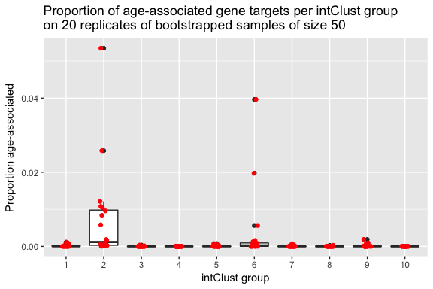

## NiBoot = 75

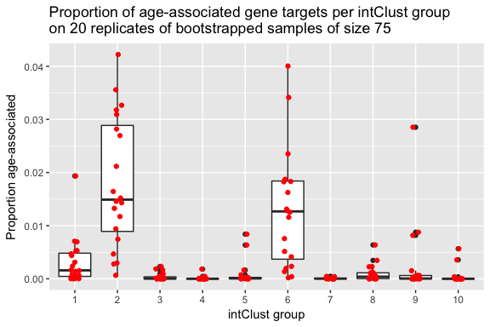

## NiBoot = 100

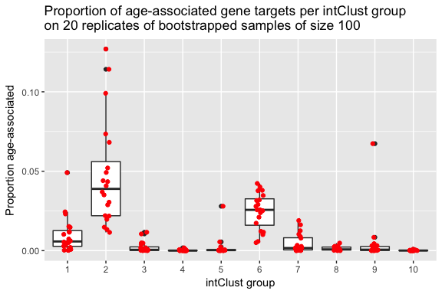

## NiBoot = 150

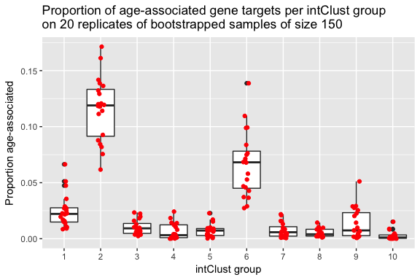

## NiBoot = 200

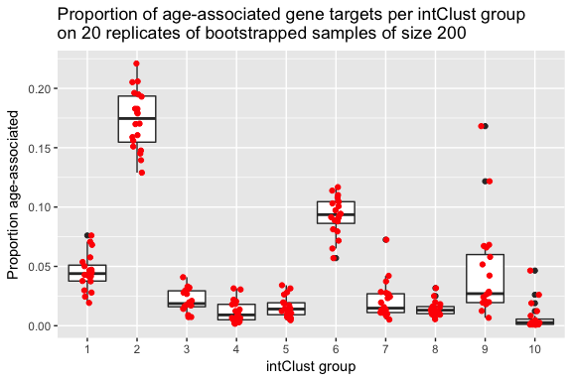

## NiBoot = 300

