Genefu applied to TCGA data



Fig 1: Initial results for genefu classification of TCGA BRCA cases

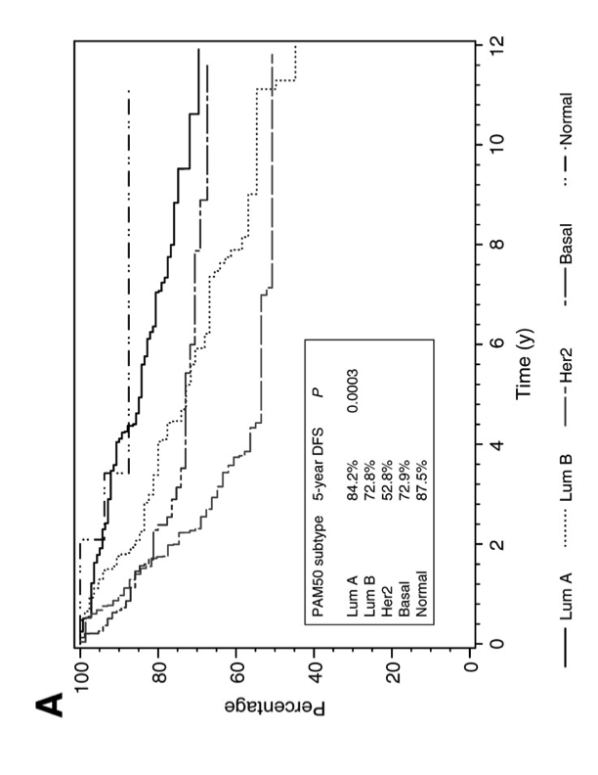

Fig 2: Figure A from Chia et al (2012)

Initial classification of TCGA BRCA cases into PAM50 subtypes using the R package "genefu" yields survival curves (Fig 1 above) quite dissimilar from PAM50 survival curves shown in Chia et al (2012) (Fig 2 above).

Obtaining more satisfactory PAM50 classifications will require additional effort, no doubt several weeks of effort, to implement a schema as discussed by Curtis et al. in the METABRIC paper.

4.2 PAM50 classification

Samples were classified into the five intrinsic subtypes [9,10] based on PAM50 [11]. As we have previously

noted probe annotation to be an important consideration in sample classification using microarray data [12],

the PAM50 gene-list was refined so that only genes for which a corresponding probe with perfect annotation

on the Illumina HT-12 v3 BeadChip [7] were used for classification. As a result, BAG1 and TMEM45B

were not included in the classification. For genes with more than one probe, probes were selected on the

basis of their annotation. For example, probes containing a SNP were avoided as were those which target

introns, have secondary targets or mismatches, lie in repeat-masked regions, or target the wrong genomic

strand. As previously recommended [13], all probes were median centred prior to classification. Due to the

imbalance in ER status, we defined 100 random reference distributions consisting of all ER-negative samples

and randomly selected ER-positive samples during the median centring step. This resulted in 100 different

classifications and the final subtype calls were derived by taking a consensus across all 100 trials. Samples

were then assigned to one of the five intrinsic subtypes using the Spearman correlation to the published

centroids and the transformed intensities, where samples with correlations < 0.1 for all subtypes were not

classified (NC) (0 samples in the discovery set, 6 samples in the validation set).