Example of a Functional Response Model (FRM) using linear regression

Q. Is there evidence of a shift in first flowering date (FFD) related to changing climate conditions?

**Inputs:**

User

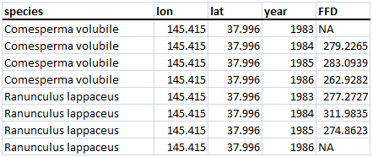

BOM

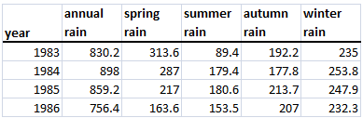

**Modeling:**

1. Is there a change in first flowering date (FFD) through time?
2. Fit **Linear Regression** to each species

**lm(**FFD ~ year)

1. Calculate the statistics in Table 1 (Keatley and Hudson 2012)
2. Is there a change in environment conditions (e.g., temperature or rainfall) through time?
   1. Fit **Linear Regression** to each environmental variable

**lm(**environmental_variable ~ year)

* 1. Calculate the statistics in Table 1 (Keatley and Hudson 2007)

1. Which environmental variables are correlated with the change in flowering?
   1. Fit **Multiple Linear Regression** for each species with multiple environmental variables

**lm**(FFD ~ July_rain + May_mintemp + autumn_mintemp + annual.maxtemp +

July_maxtemp + Sept_maxtemp + Dec_maxtemp)

Note: Only the environmental variables that show a change through time (indicated by p-values less than 0.05 in step 2b) are included in the model to reduce the number of parameters

**Outputs:**

1a. Figure showing data and fitted linear regression line for each species

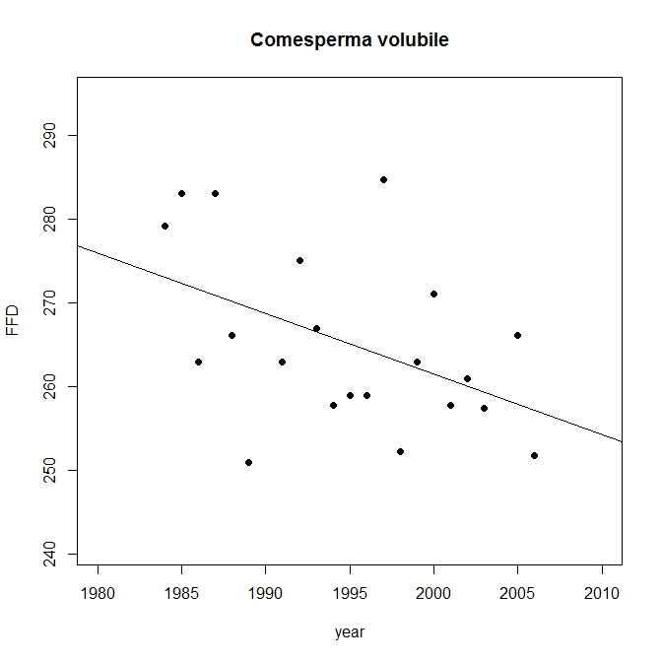

1b. Table showing summary statistics

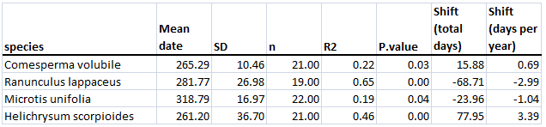

// A p-value less than 0.05 suggests there has been a change in flowering date

2a. Figure showing data and fitted linear regression line for each environmental variable

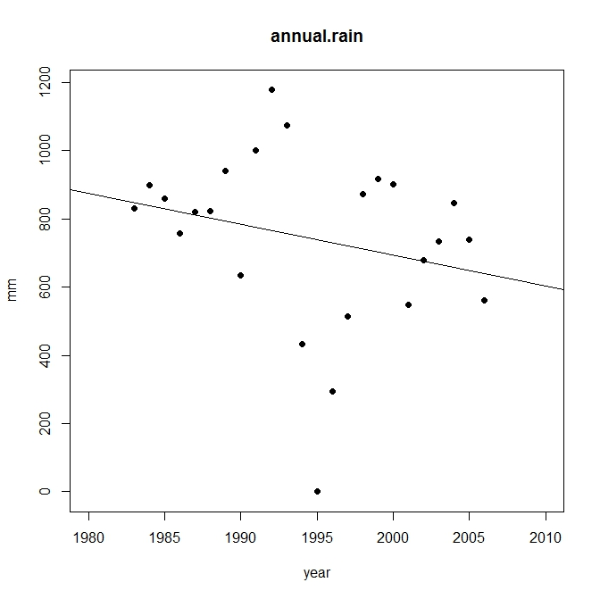

2b. Table showing statistics

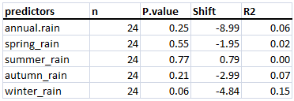

// A p-value less than 0.05 suggests there has been a change in the environmental variable

3. Table showing model fits

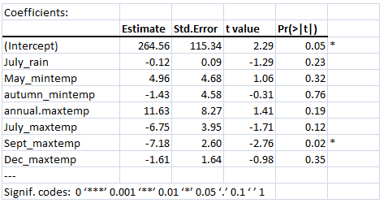

//A p-value less than 0.05 indicates there is a correlation between the environmental variable and the first flowering date (FFD)

**Appendix A** Model Formulae

The structure of the model is specified in the model formula like this:

response variable ~ predictor (aka explanatory) variable(s)

where the ~ symbol reads “is modeled as a function of”

The right hand side of the model shows the number of explanatory variables, the interactions between the explanatory variables (if any) and non-linear terms in the explanatory variables.

You can use ‘*paste*’ to create series of variable names and ‘*collapse*’ to join the variable names together by symbols:

Example for a multiple regression:

mlm.formula <- as.formula(*paste*("sp.data$FFD ~", *paste*(colnames(mlm.data[-1]),

*collapse*="+")))

* sp.data$FFD ~ July_rain + May_mintemp + autumn_mintemp + annual.maxtemp + July_maxtemp + Sept_maxtemp + Dec_maxtemp)

Also see<http://stat.ethz.ch/R-manual/R-patched/library/stats/html/formula.html> for help with model formula.