Example of a Functional Response Model (FRM) using a generalized linear model (GLM)

Q. What are the environmental variables associated with the distribution and occupancy of tapoles (Simpkins et al 2013)?

**Inputs:**

User

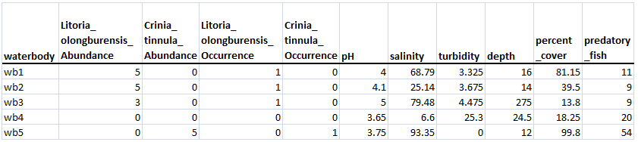

**Modeling:**

1. Assess the importance of environmental variables on the relative abundance of tadpoles
2. Fit multiple **General** **Linear Regressions** to each species

**glm(**abundance ~ explanatory(s), family=poisson)

"salinity",

"salinity + turbidity",

"salinity + turbidity + depth",

"salinity + turbidity + depth + percent_cover",

"salinity + turbidity + depth + percent_cover + predatory_fish",

"turbidity",

"turbidity + depth",

"turbidity + depth + percent_cover",

"turbidity + depth + percent_cover + predatory_fish",

"depth",

"depth + percent_cover",

"depth + percent_cover + predatory_fish",

"percent_cover",

"percent_cover + predatory_fish",

"predatory_fish"

1. Calculate the AICc to select “best” model (Table 2 Simpkins et al 2013)
2. Assess the importance of environmental variables on the occupancy of tadpoles
   1. Fit **General** **Linear Regression** to each environmental variable

**glm(**occurrence ~ explanatory(s), family=binomial)

//see 1a above for examples of model formulae

* 1. Calculate the AICc to select “best” model (Table 2 Simpkins et al 2013)

**Outputs:**

1. Model selection table for species abundance

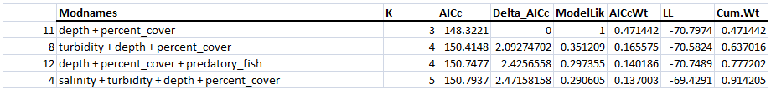

Notes from Simpkins et al 2013:

* The best model is the model with the lowest AICc value
* If a model has Delta_AICc <=2, then there is considerable support for the model
* If a model has Delta_AICc 2-4, then there is moderate support for the model
* Akaike Weights (AICcWt) are used to determine the ‘probability that the model is the best model, given the candidate set of models’. The closer the weight is to 1, the closer the model for the data

Table with parameter estimates for the best model

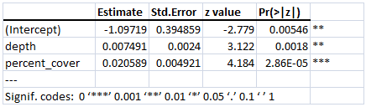

1. Model selection table for species occurrence

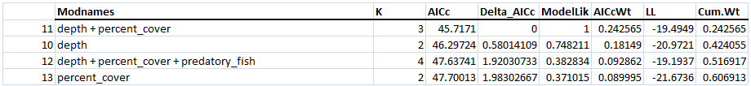

Table with parameter estimates for the best model

