How to Install Handle GUI Client

The Handle GUI Client is a Java application so it will run in any environment with a JVM. These instructions assume a Windows installation.

* Copy handle client from source directory from \\dennis2\DigiTool Projects\handleClient
* Handle client is in hs directory – this can be copied anywhere on your local PC, but must be named hs.
* To run the client, use the following from either a command line, or via a shortcut.

C:\dev\hs\bin\handle.jar net.handle.apps.gui.hadmin.HandleTool

Where C:\dev\hs is location of hs directory on your PC. Shortcut properties follow:

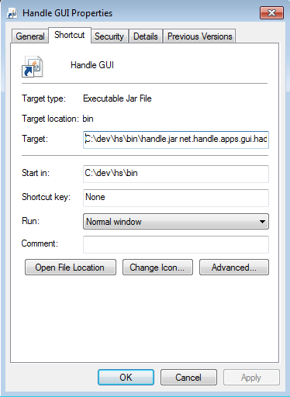

* Launch Handle client. You should see the following:

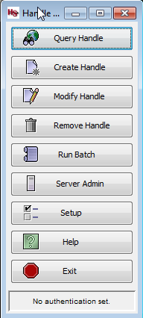

* Select Run Batch. And then Add. Browse to your batch file and click Ok.

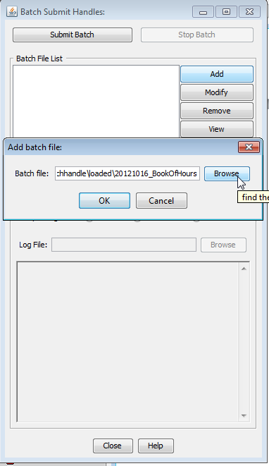

* Click Submit.
* If this is the initial use of the Client, you will need to update the ID Handle: field with the following value 0.NA/2345. The Private Key File field will need to point to your local copy of admpriv.bin.

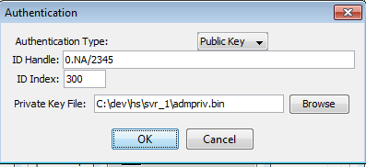

* Click Ok. You will be prompted for the secret passphrase. See BrianM for phrase.
* Verify that handles are successfully published. Troubleshooting questions can be directed to BrianM.