**General Resources for Maps and GIS data for Humanists:**

* GIS Libguide (MIT) <https://libguides.mit.edu/gis/>
* MIT maps guide: <https://libguides.mit.edu/maps>
* MIT GeoWeb: <https://arrowsmith.mit.edu>
* British Library Maps: <https://www.bl.uk/subjects/maps>
* David Rumsey map collection <https://www.davidrumsey.com/>
* Europeana map colection: <https://www.europeana.eu/portal/en/collections/maps>
* DPLA (+ refine your search by Subject Search >  Maps): <https://dp.la/>
* Ancient Places via Pleiades (downloads available at <https://pleiades.stoa.org/downloads>)
* Social Explorer: [http://www.socialexplorer.com/](http://pid.emory.edu/crm90)
* Hathi Trust (Advanced search> Format: “Map”): <https://babel.hathitrust.org/cgi/ls?a=page;page=advanced>
* [Classical Atlas Project](http://awmc.unc.edu/wordpress/free-maps/) (University of North Carolina)
* [Digital Atlas of Roman and Medieval Civilizations](https://darmc.harvard.edu/) (Harvard University)
* [Digital Map Collection](http://www.lib.berkeley.edu/EART/browse.html) (University of California, Berkeley)
* [Discovery and Exploration](http://lcweb2.loc.gov/ammem/gmdhtml/dsxphome.html) (Library of Congress)
* [Historic USGS Maps of New England and New York](http://docs.unh.edu/nhtopos/nhtopos.htm) (University of New Hampshire)
* [Map History/History of Cartography](http://www.maphistory.info/) (Website maintained by former map librarian at the British Library)
* [Old Maps Online](http://www.oldmapsonline.org/#bbox=-71.562195,42.159332,-70.562439,42.55915&q=&datefrom=1000&dateto=2010) (University of Portsmouth)
* [Perry-Castaneda Library Map Collection](http://www.lib.utexas.edu/maps/historical/index.html) (University of Texas-Austin)
* [UPenn Historical Maps LibGuide](https://guides.library.upenn.edu/historical_maps/mapoverlays)

You found your map but if it is not georeferenced what do you do? You could use these consult the [UPenn Historical Maps LibGuide](https://guides.library.upenn.edu/historical_maps/mapoverlays) if your tool does not give you the option to georeference your map.

**Georeferencing Your Data Table in Carto**

Sign up for a free student account Carto at: <https://carto.com/get-started/>

Georeferencing is the process of adding real coordinates –latitude and longitude information--to a data table (for example, an .excel or a .csv table) or raster data (anything with pixels, which includes images). ***If you have a raster map you will first need to georeference it outside of Carto.*** In the “**If you want to add your own custom map as Basemap”** section below,we explain this process.

1.      Make sure you are in the Map View by bringing the slider to on position at the bottom right corner of your screen.  Then click on the back button next to the file name in the upper left corner of your screen.

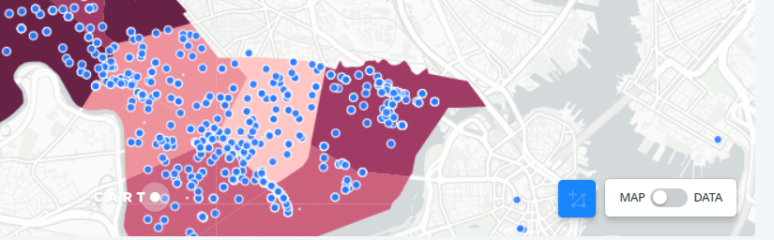

2.      If your data table has latitude/longitude, street addresses, etc. click the ADD ANALYSIS under the file name.  Click on the Geocode analysis, and then the blue ADD ANALYSIS button on the bottom right corner of the screen.

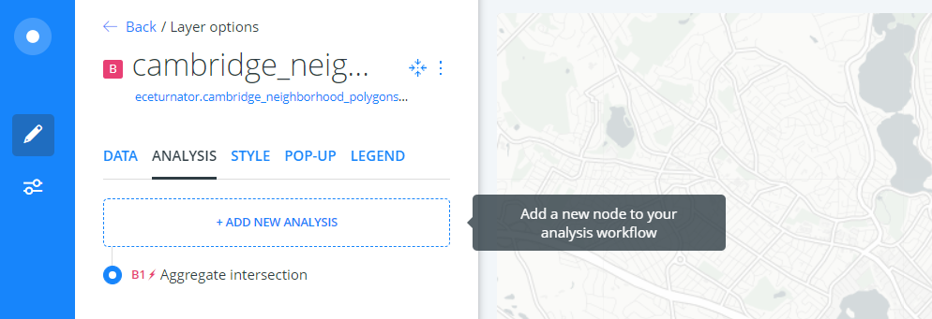

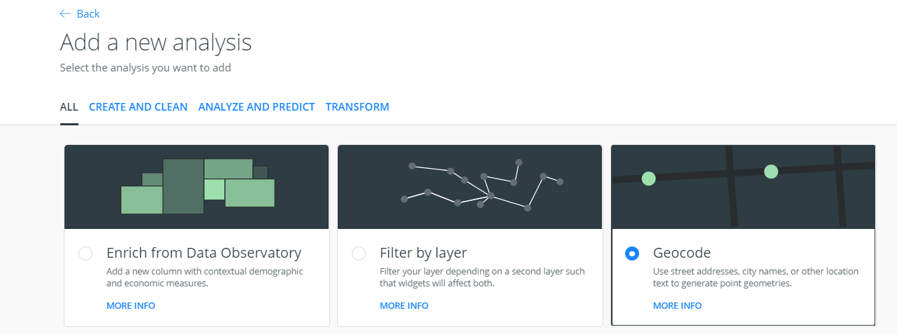

3.      Select the type of geographic data and the appropriate columns in your data table that contain it.

More help:<https://carto.com/learn/guides/analysis/georeference>

**Geometry**:

If in a single column, order by longitude first, latitude second separated by a comma.

**If you want to add your own custom map into Carto as Basemap:**

* You can add 1 basemap at a time. You can programmatically sequence or switch basemaps in MapBox/Leaflet

*All the other layers are data layers. So, 1 basemap, multiple layers is the basic premise.

1) If you are starting fresh click on the New Map icon on top right column

2) Click on the basemap at bottom of layer options (Voyager, basemap in image below)

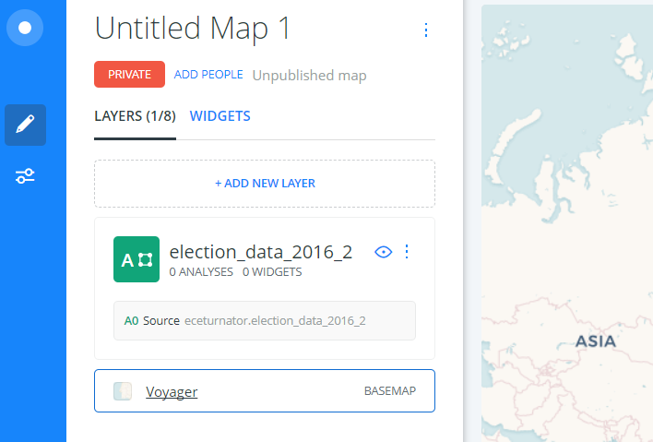

3) Under Source, select the Custom or any other option to its right by scrolling right and under Style select “+”

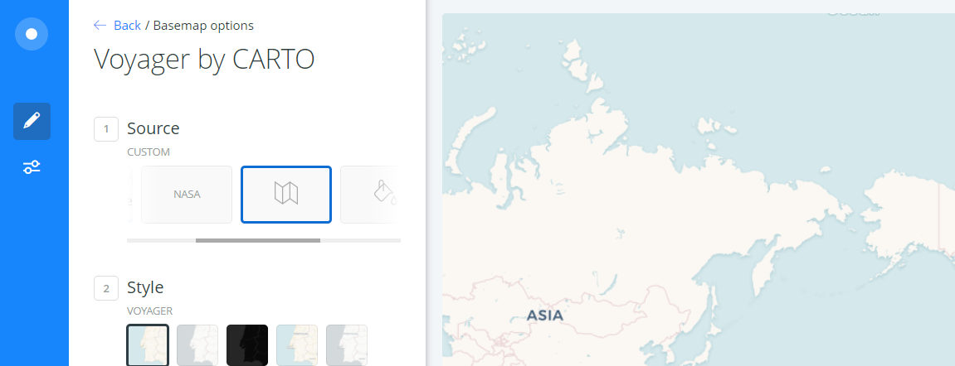

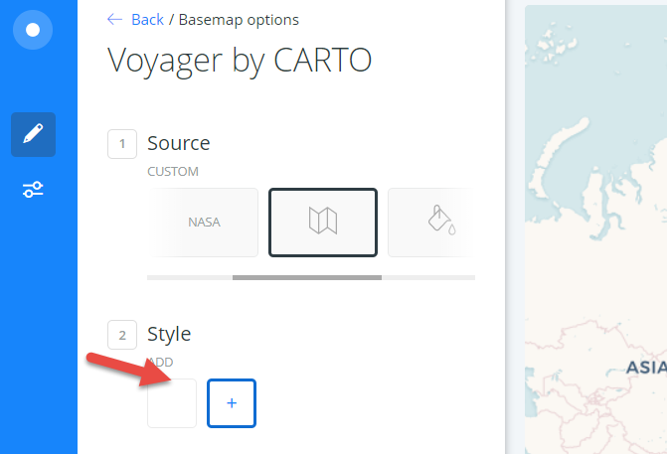

4) Select the appropriate option and add the link (example given below) to the search box

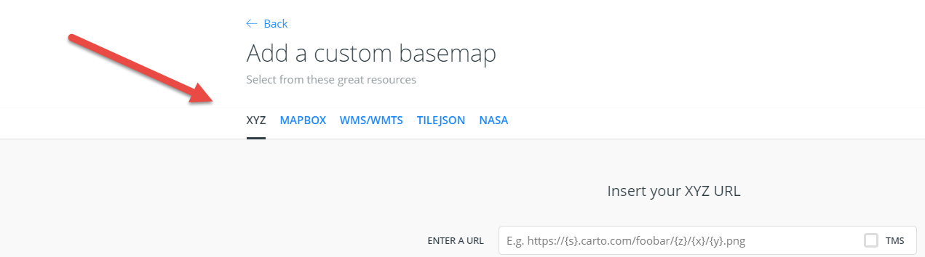

**You can get an WMS/WMTS map from any of these services below (please note that other/better services may be available on the Web):**

<http://directory.spatineo.com/>

<https://catalog.data.gov/dataset/usgs-historical-topographic-map-collection>

**You can get an XYZ base map from:**

Search the NYPL Map Warper site for a rectified/georeferenced map:

[http://maps.nypl.org/warper/](http://mapwarper.net/maps)

For keyword, as an example, use “Massachusetts” - to select a rectified/georeferenced map to add to CARTO as a custom basemap using the XYZ URL

Under the “Export” tab select the “Tiles” URL that looks like so:

[http://maps.nypl.org/warper/maps/tile/30872/{z}/{x}/{y}.png](http://maps.nypl.org/warper/maps/tile/30872/%7Bz%7D/%7Bx%7D/%7By%7D.png)

**If you don’t have a georeferenced custom basemap, you need to georeference it first.**

Use MapWarper <http://mapwarper.net/> to upload your raster map and then “rectify” (or georeference) it.

**Other georeferencing tools (please note that other/better services may be available on the Web):**

David Rumsey Georeferencer:<https://www.davidrumsey.com/view/georeferencer>

(does not allow an export option in one of the Carto formats).

[Maptiler](https://www.maptiler.com/how-to/georeferencing/) also has a free georeferencing tool.

More info: [UPenn Historical Maps LibGuide](https://guides.library.upenn.edu/historical_maps/mapoverlays)