Used MYSQL server and client on Windows Operating system.

Show Databases

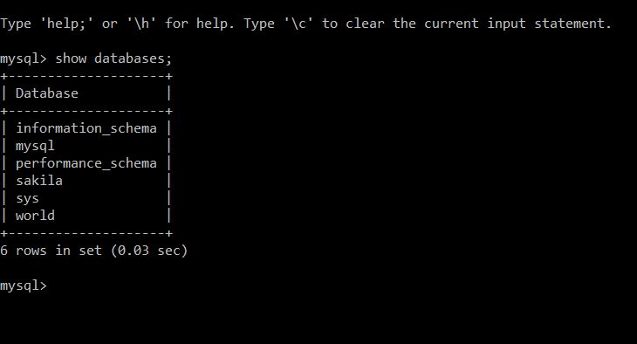

Selecting one database and looking at tables in it

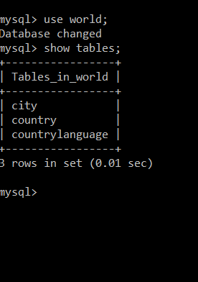

Creating a new database and selecting the created database and looking into it for tables

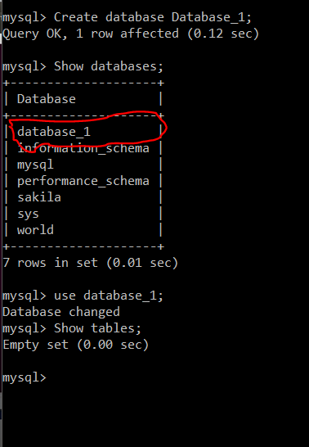

Creating a new table and inserting values into the table

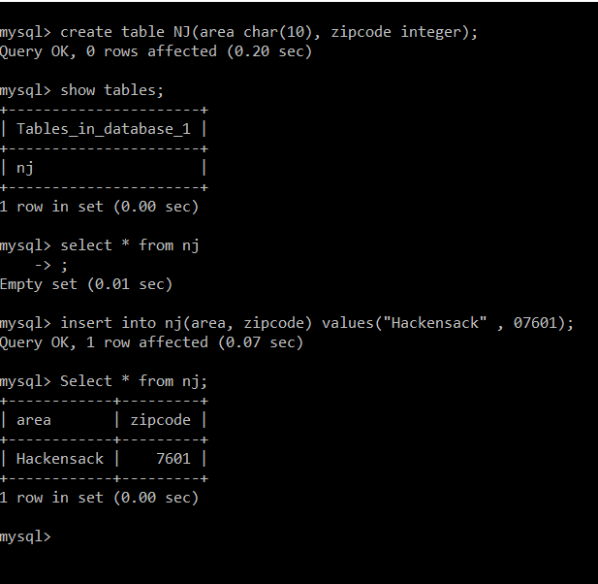

Inserting multiple rows of data into the database and counting the total number of rows.

