# Foreign Disclosure Analysis Tool for BCH Researchers

This tool analyzes PubMed publications for Boston Children's Hospital (BCH) researchers to identify foreign affiliations and collaborations, with a particular focus on Russia, North Korea, Iran, and China. The analysis results are output to a CSV file with specific fields.

## Overview

The solution uses the Azure OpenAI API and the Clinical Research MCP Server to analyze PubMed publications for foreign disclosure requirements. It processes a list of BCH researchers from a CSV file, queries PubMed for their publications, analyzes the publications for foreign affiliations, and outputs the results to a CSV file.

## System Architecture

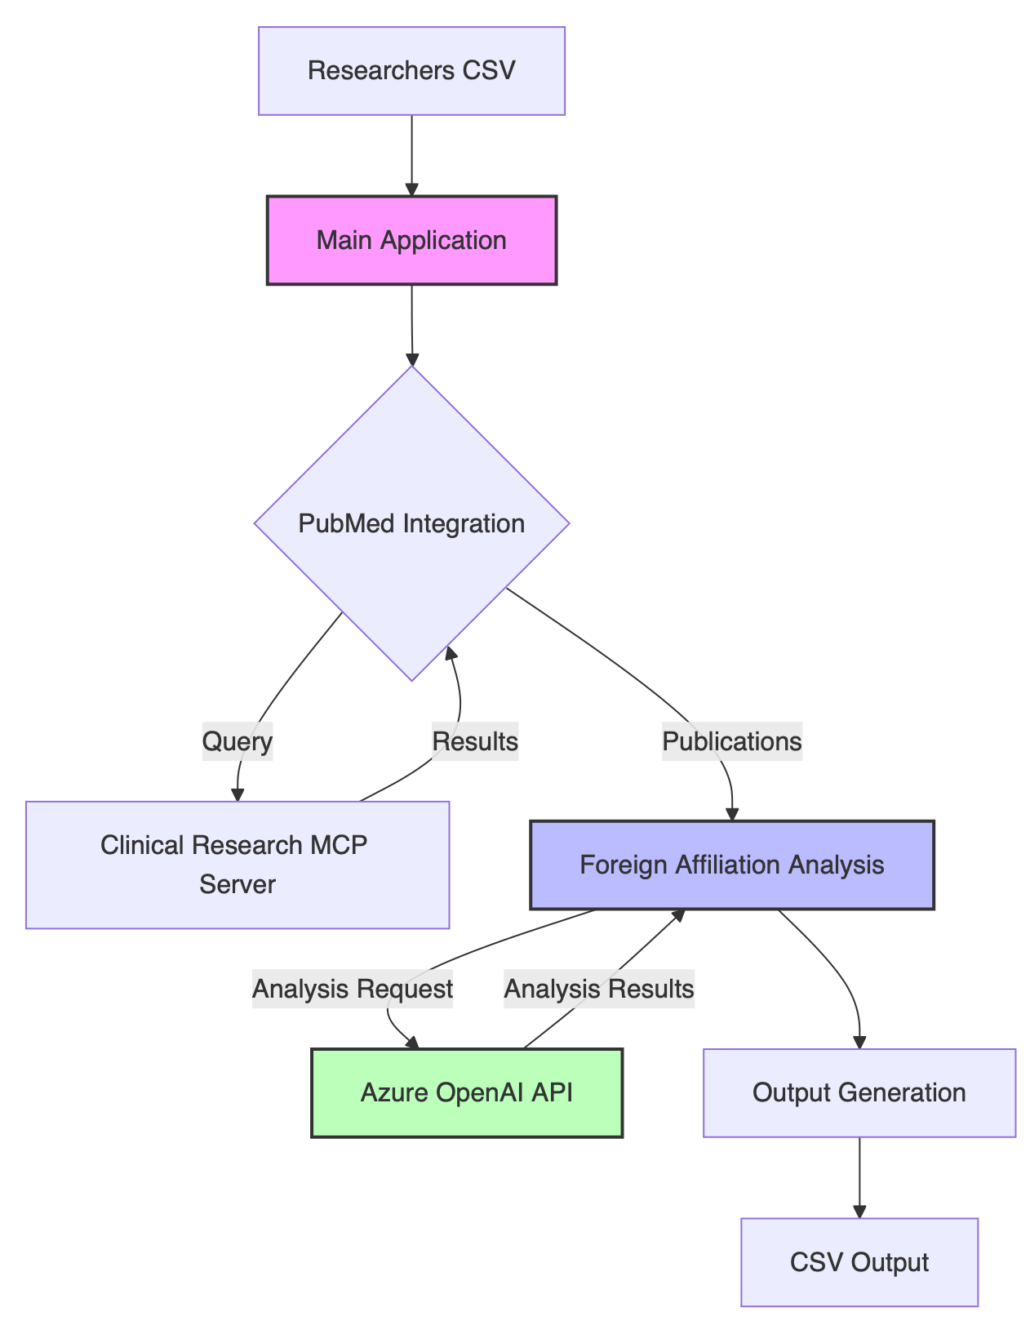

## Data Flow

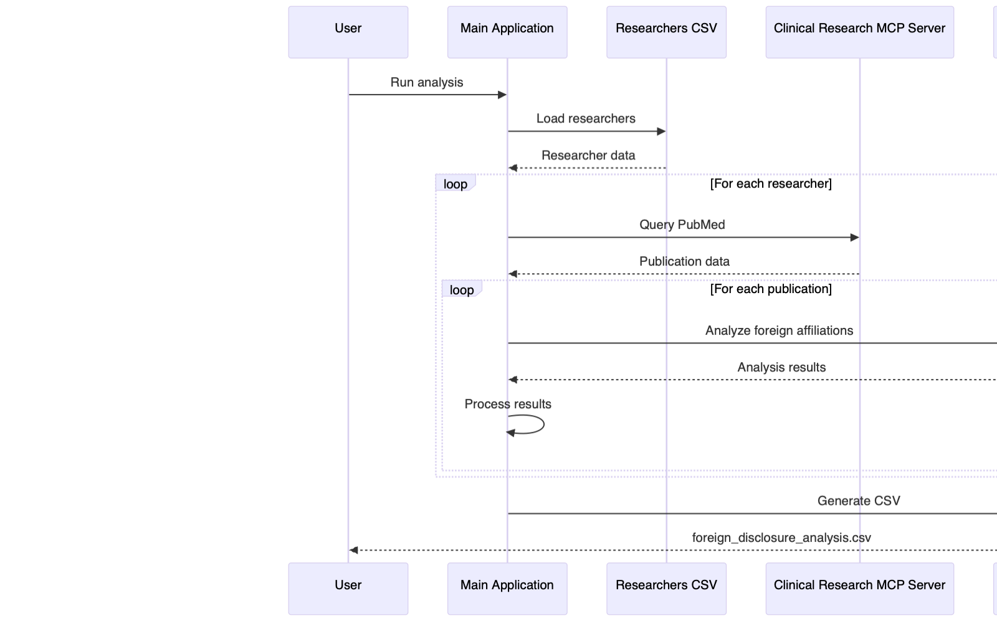

## Features

* Dynamic loading of researcher data from CSV
* PubMed integration via Clinical Research MCP Server
* Foreign affiliation analysis using Azure OpenAI API
* Special flagging for countries of concern (Russia, North Korea, Iran, China)
* Confidence scoring for foreign involvement
* CSV output with detailed information

## Requirements

* Python 3.9+
* Azure OpenAI API access
* Clinical Research MCP Server access

## Installation

1. Clone the repository:

* git clone https://github.com/BCH-IDHA/foreign-disclosure-analysis.git  
  cd foreign-disclosure-analysis

1. Install the required dependencies:

* pip install -r requirements.txt

1. Configure the .env file with your Azure OpenAI API credentials:

* AZURE_OPENAI_API_ENDPOINT=your_endpoint  
  AZURE_OPENAI_API_KEY=your_api_key  
  AZURE_OPENAI_API_VERSION=your_api_version  
  AZURE_OPENAI_DEPLOYMENT=your_deployment_name  
  AZURE_OPENAI_MODEL=your_model_name

## Usage

1. Prepare your researchers CSV file with the following format:

* Researcher last name, Research first name  
  Smith, John  
  Doe, Jane

1. Run the analysis:

* python main.py

1. Review the output in foreign_disclosure_analysis.csv

## Analysis Process

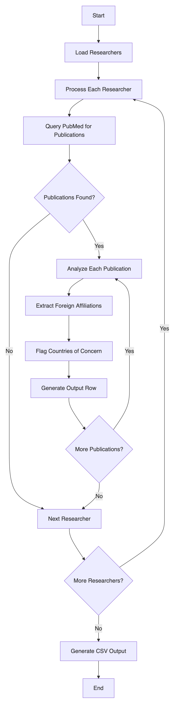

## Output Format

The output CSV file contains the following columns:

* **publication_name**: The name of the journal where the research was published
* **research_title**: The title of the research publication
* **author_name**: The name of the BCH researcher
* **organization_affiliation**: The organization affiliation (Boston Children's Hospital)
* **countries_of_origin**: Countries of origin/association
* **flagged**: Indicates whether the publication has any countries of concern (Yes/No)
* **flagged_countries**: Lists the specific countries of concern that were flagged
* **confidence_score**: Confidence score (1-10) regarding foreign involvement
* **funding_source**: Funding sources for the research

## Confidence Scoring Algorithm

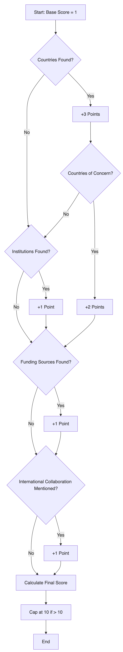

## Project Structure

* main.py: Main script for the analysis
* mcp_server_clinical_research.py: Wrapper for the Clinical Research MCP Server
* use_mcp_tool.py: Wrapper for the MCP tool functionality
* requirements.txt: Required Python dependencies
* researchers.csv: Input file containing BCH researcher names
* solution-plan.md: Implementation plan and progress tracking
* README.md: Project documentation

## Component Relationships

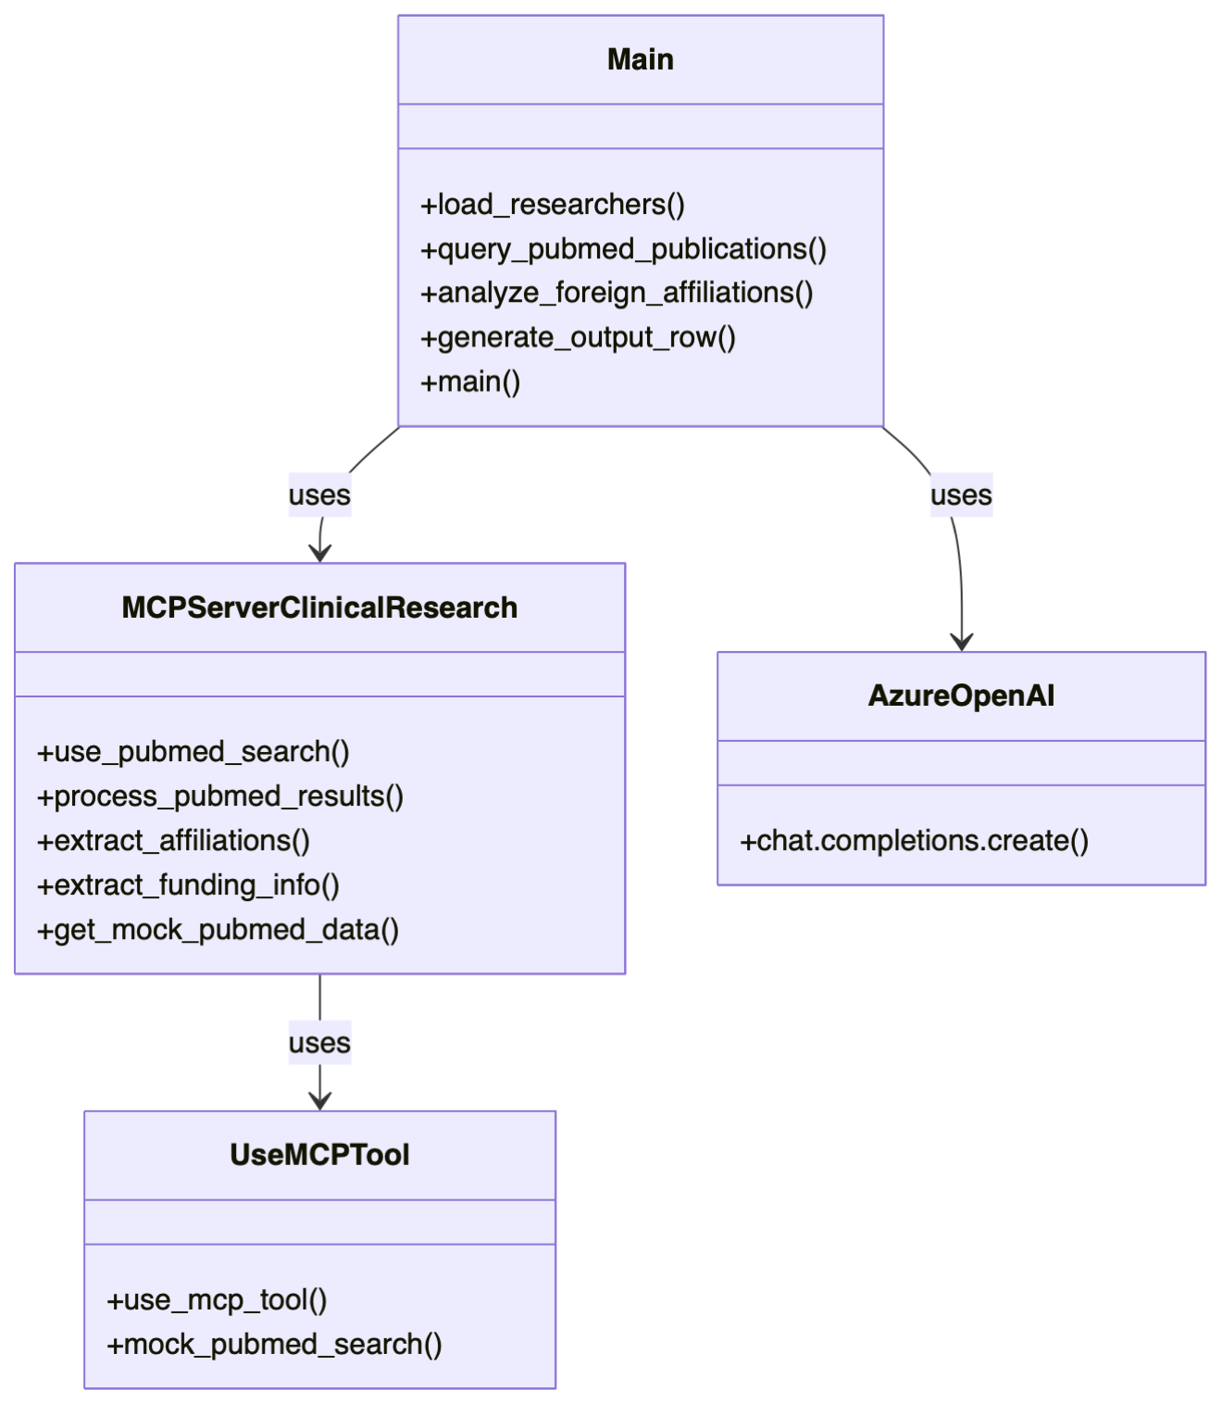

## Development

For development and testing purposes, the code includes mock implementations of the PubMed search functionality and Azure OpenAI API. This allows for testing without actual API access.

### Mock Implementation Flow

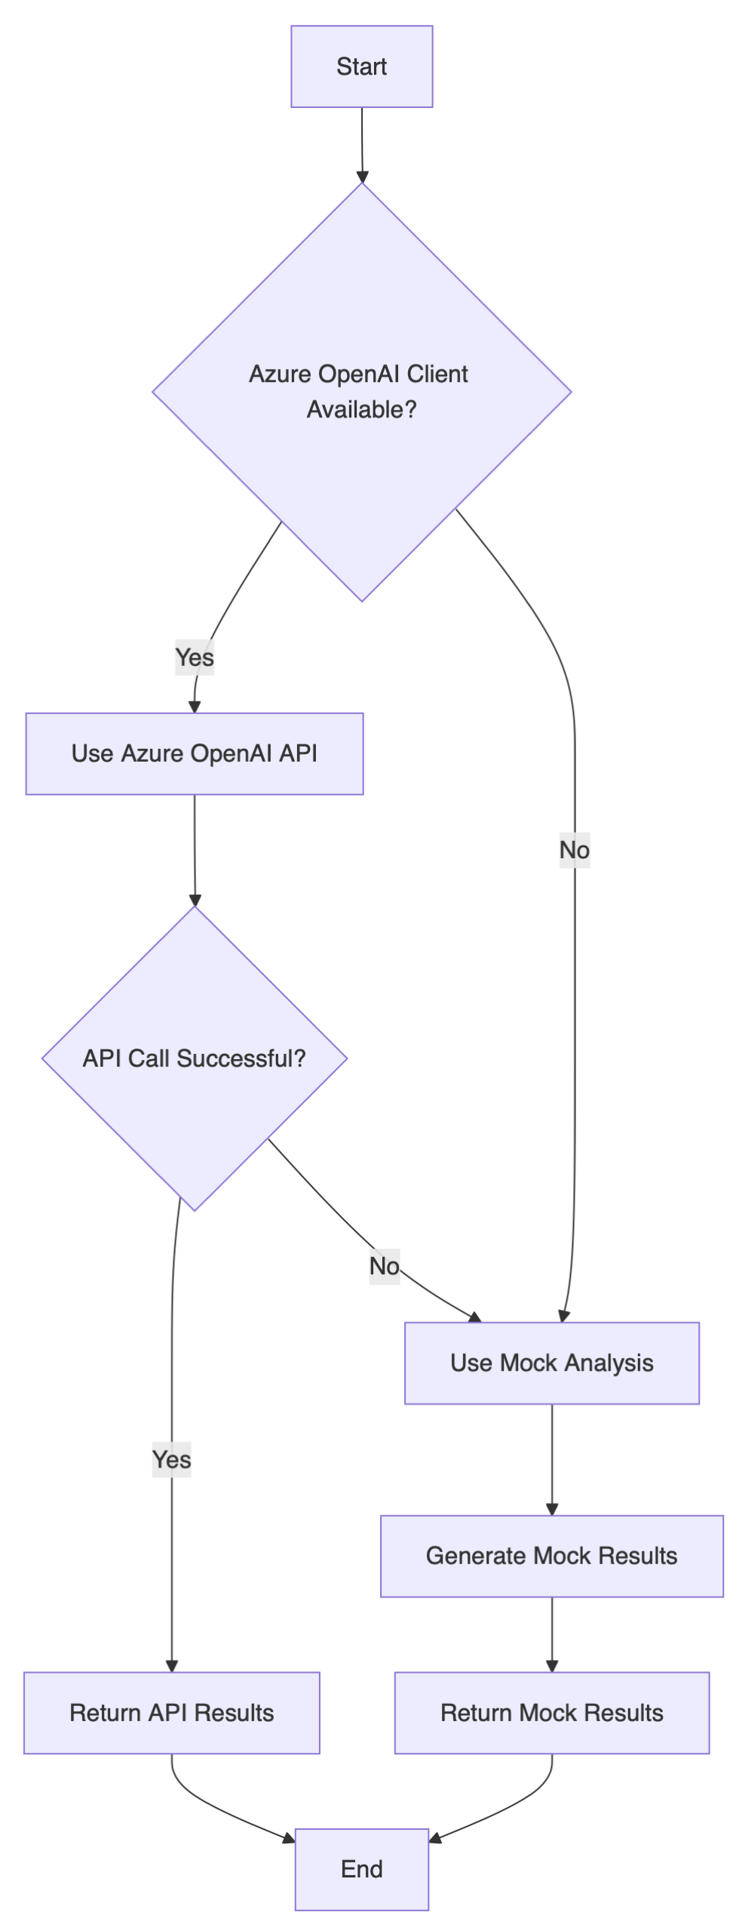

## License

[Specify your license here]

## Acknowledgments

* Boston Children's Hospital
* Azure OpenAI API
* Clinical Research MCP Server