PMOS CALCULATIONS
NOTE: Calculations were performed assuming ALL strain gauges are connected. The resistance changes as strain Gauges are disconnected. Though it should be fine if we disconnect some.
For a PMOS
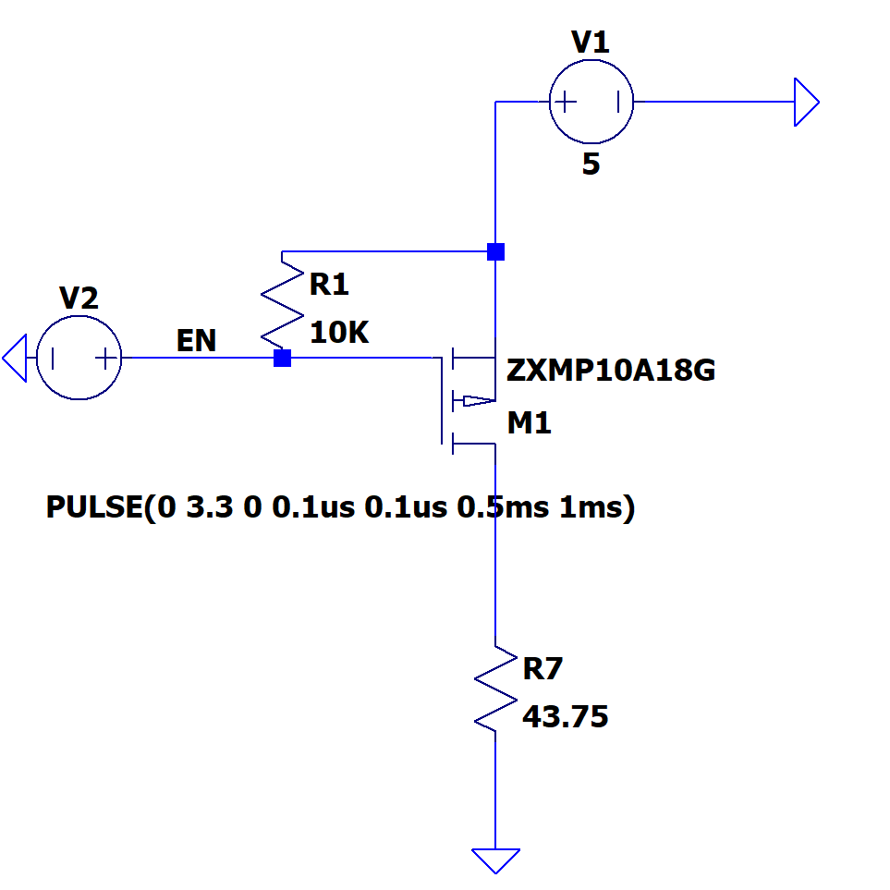
Figure 1 Similar model was run in stimulation, however not the same as what we choose
CUTOFF REGION: $V_{sg}<V_{th_min}$
$$5-3.3<2V$$
$$1.7<2V$$
YES IT can turn off

TRIODE REGION: (FULLY ON)
$$V_{sg}>V_{th_max}$$
$$5 > 4$$
$$V_{sd}<V_{sg}-|V_{th_max}|$$

ASSUME IN TRIODE REGION
Our $V_{gs} =-5V$ when turned on so we can assume $R_{ds}≅1.5Ω$
The unknown is $V_{d}$
$$i_{d}=\frac{5V}{1.5Ω+43.75Ω}=110mA$$
$$V_{d}=43.75*110mA=4.8125$$
$$V_{sd}=5-4.8125=0.1875V$$
$$V_{sd}<V_{sg}-|V_{th_max}|$$
$$0.1875<5-4$$
$$0.1875<1$$
Very ON!

Bypass capacitor calculations as PMOS switches 1KHz. Check LTSPICE documentation for more indepth stimulation

I_load = 114mA
Delta T = 0.5ms
Delta V = 0.5V <- just setting it as such

I = C dV/dT
C = I * dT/dV
C = 114mA * 0.5ms / 0.5
= 114 uF ~= 100uF
