Power supply measurement
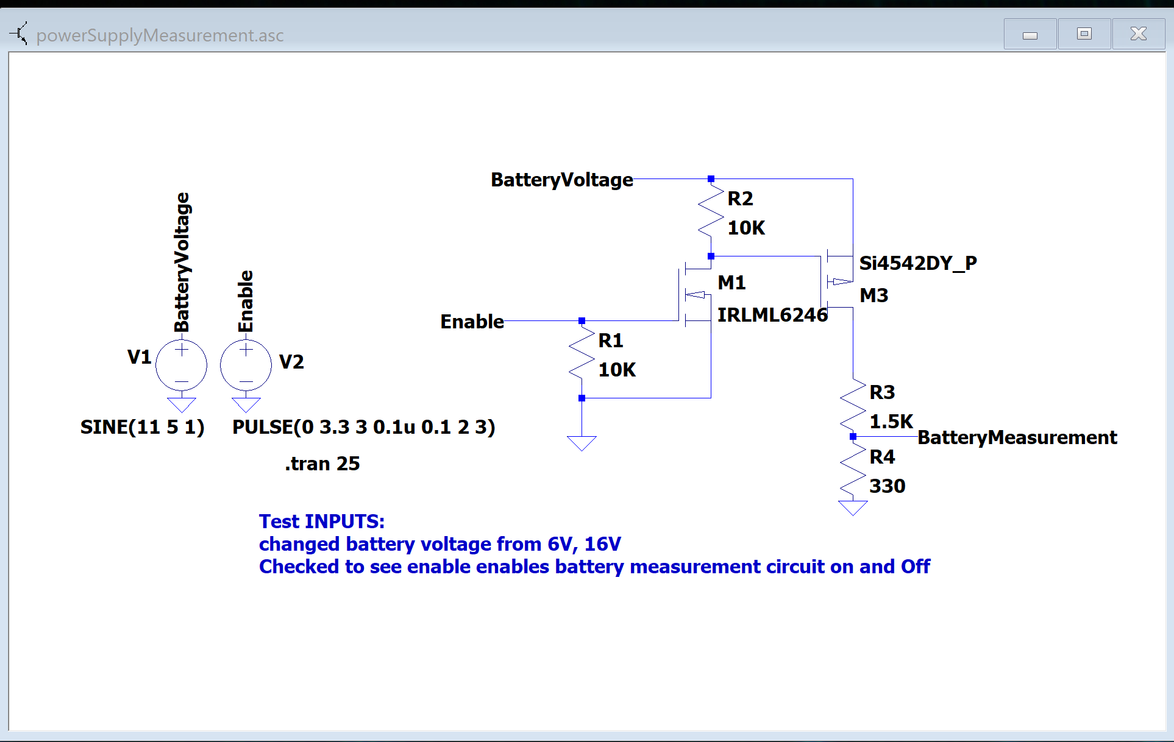
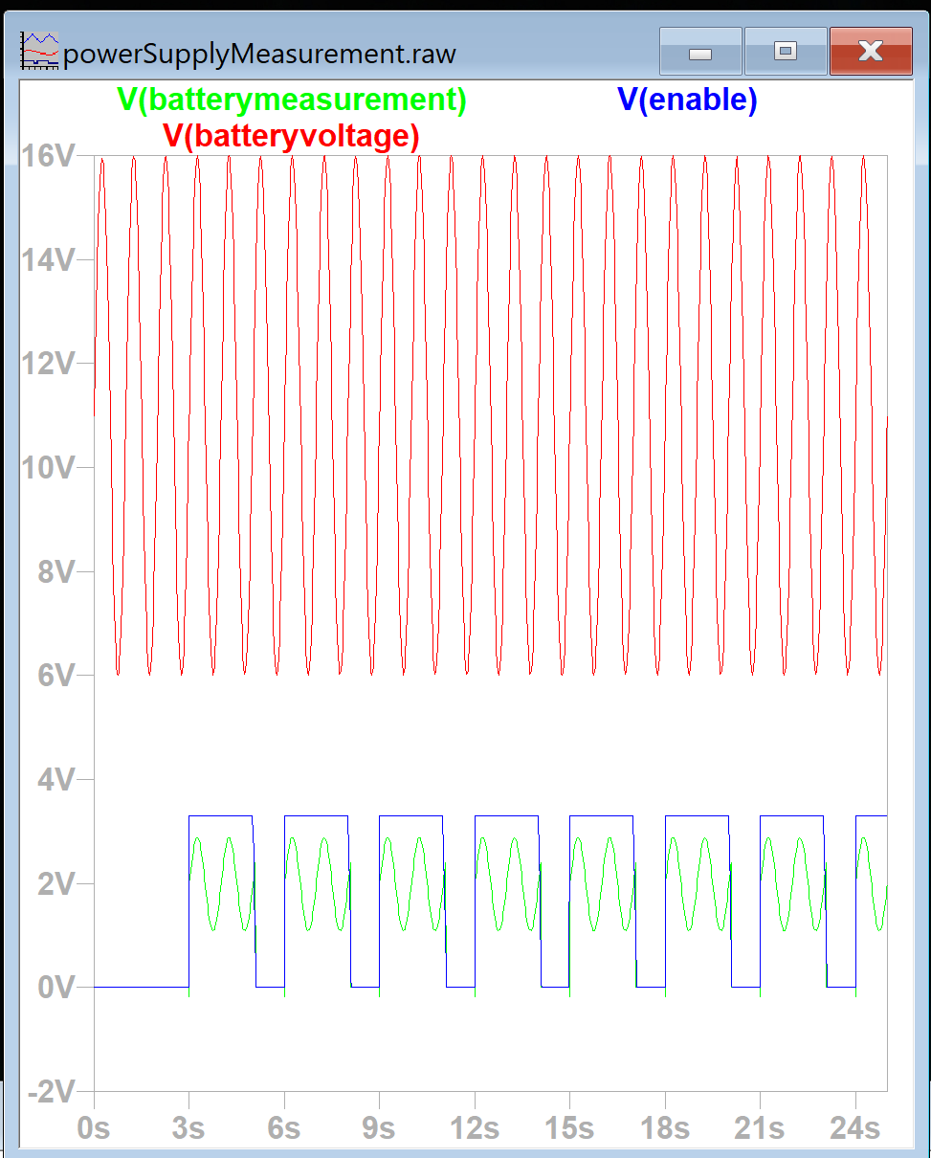

StrainGAUGE switching
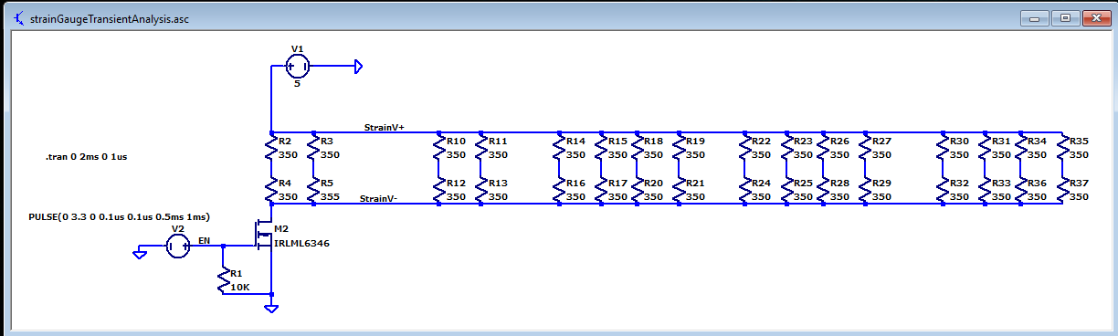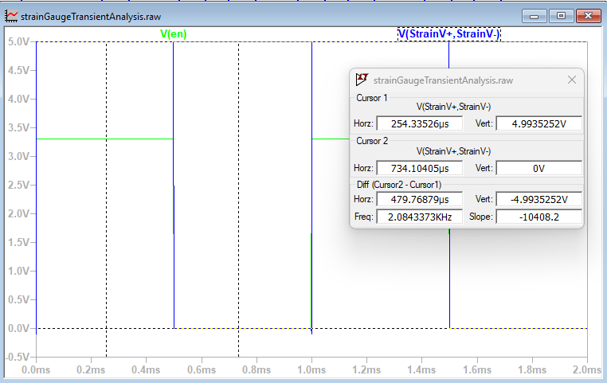

Strain gauge Amplifier
Had difficulty combining with the clamping diodes in the next circuit. Wondering if it has to do with the output current of the OP-AMP. Will need to explore this a bit further.
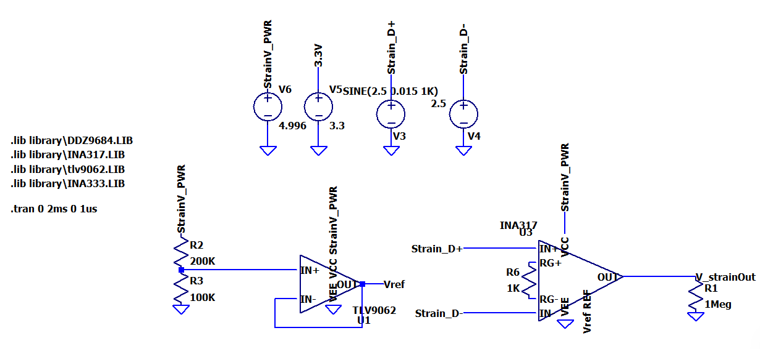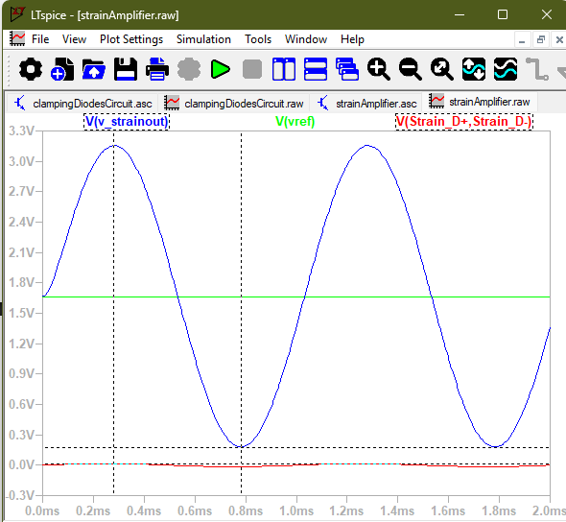

Diode clamping circuit(*Note, reverse voltage can vary quite a bit as seen by Vz on circuit)

